Legends for Supplementary figures:
EtBr-stained Agarose gel images depicting the products after amplification through Allele specific PCR. (Lane 1: 100 bp DNA ladder RTU (GeneDireX)).
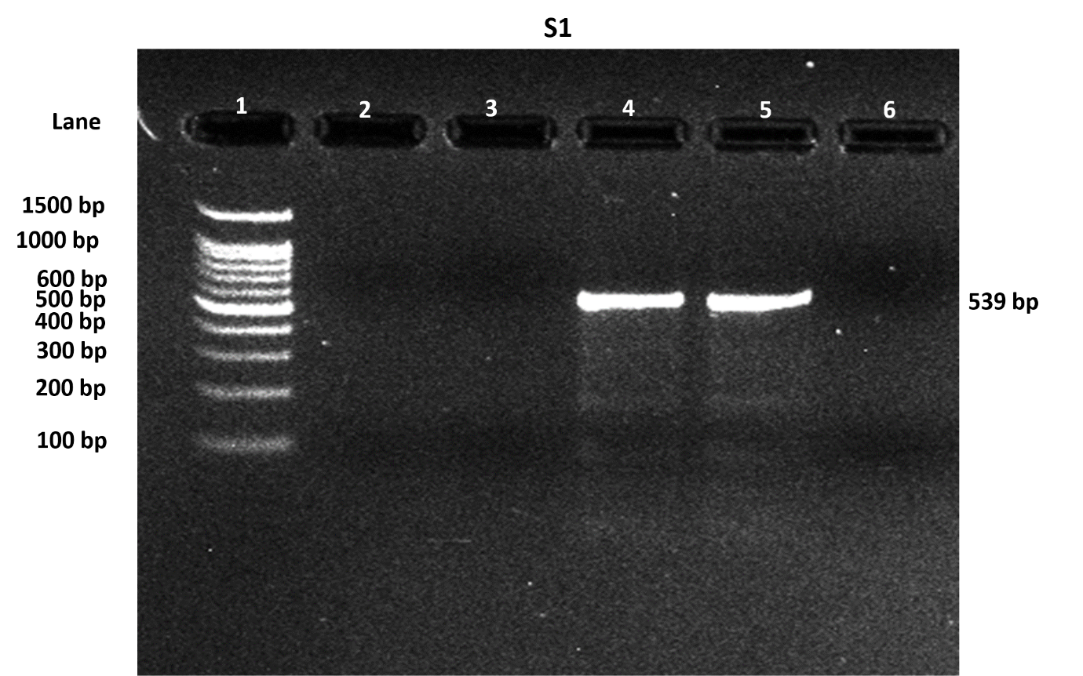
Supplementary figure 1: Showing 539bp band amplification with primers; CD3 M/N, for the confirmation of mutation Codon 3(T>C),
Lane 1 | Ladder (100bp)
Lane 2 | Negative Control without DNA sample
Lane 3 | CD3M with Wild type DNA
Lane 4 | CD3N with Wild type DNA
Lane 5 | CD3M with patient’s DNA sample
Lane 6 | CD3N with patient’s DNA sample

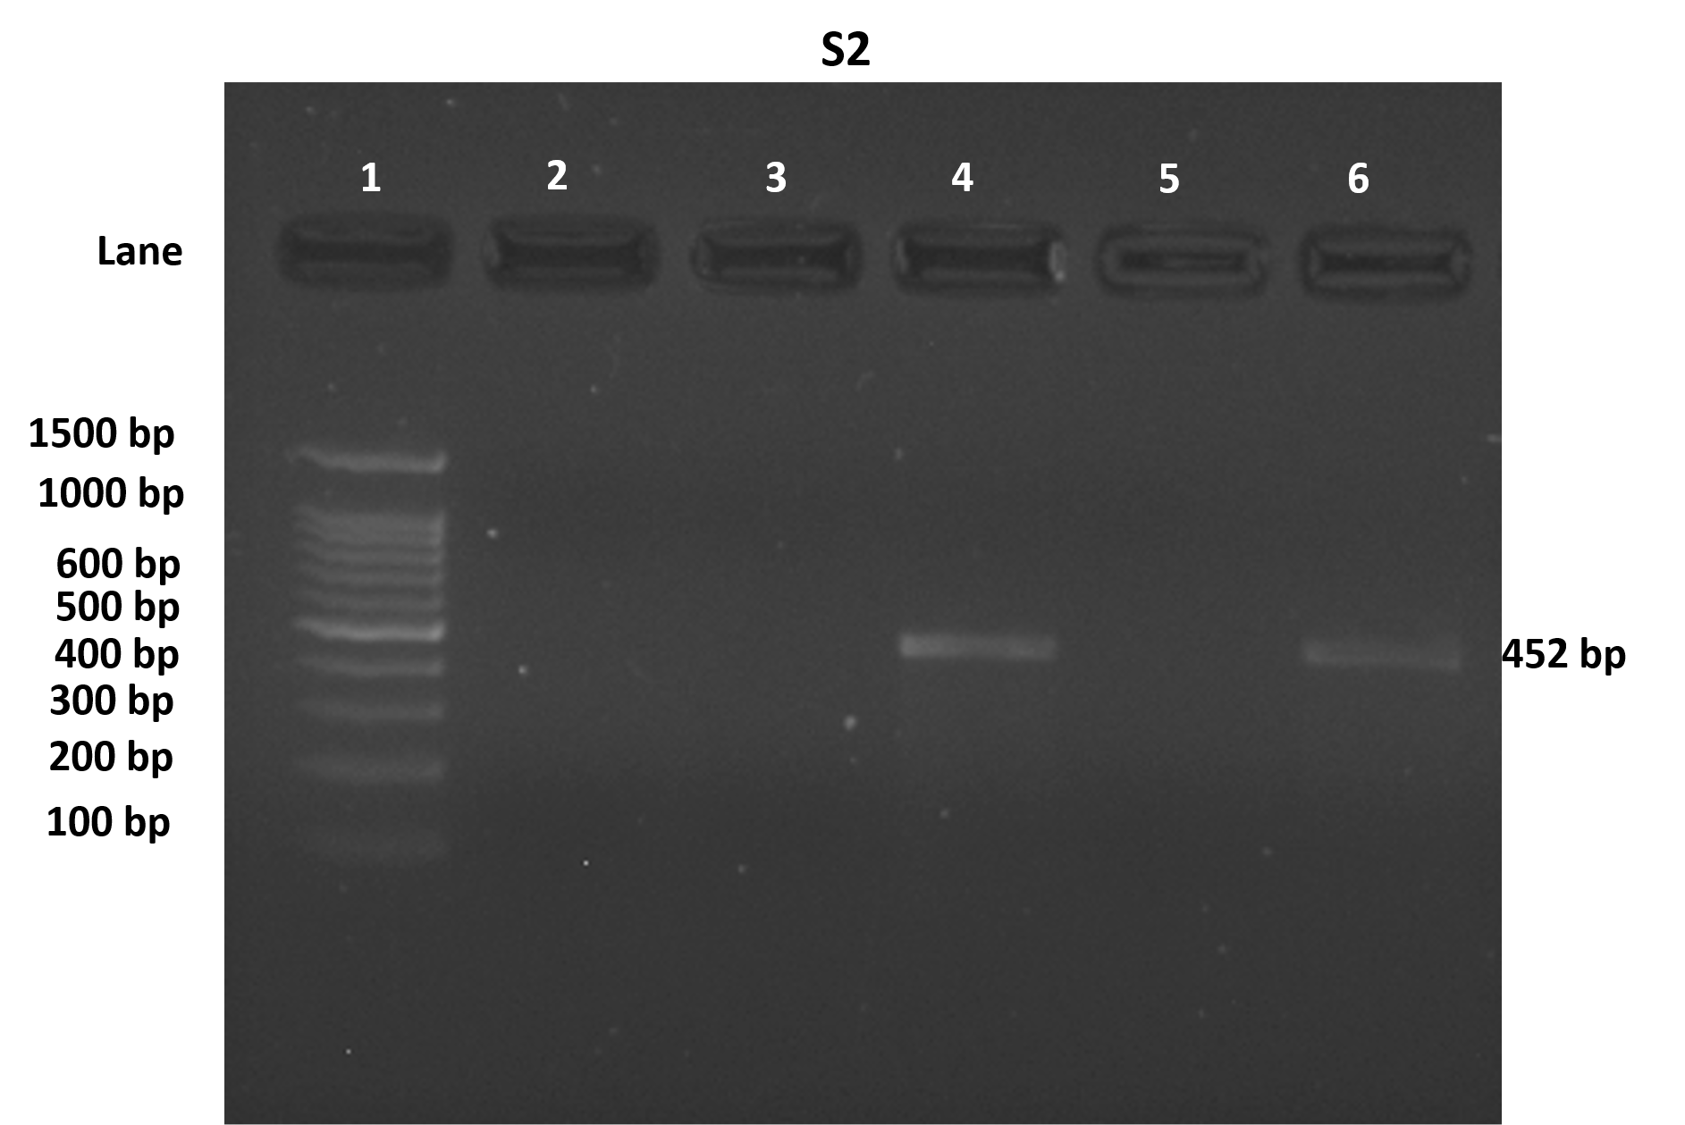
Supplementary figure 2: Depicting 452bp band amplification with primers; IVS I-5M/N, for the confirmation of mutation IVS I-5 (G>C),
Lane 1 | Ladder (100bp)
Lane 2 | Negative Control without DNA sample
Lane 3 | IVS I-5M with Wild type DNA
Lane 4 | IVS I-5N with Wild type DNA
Lane 5 | IVS I-5N with patient’s DNA sample
Lane 6 | IVS I-5M with patient’s DNA sample

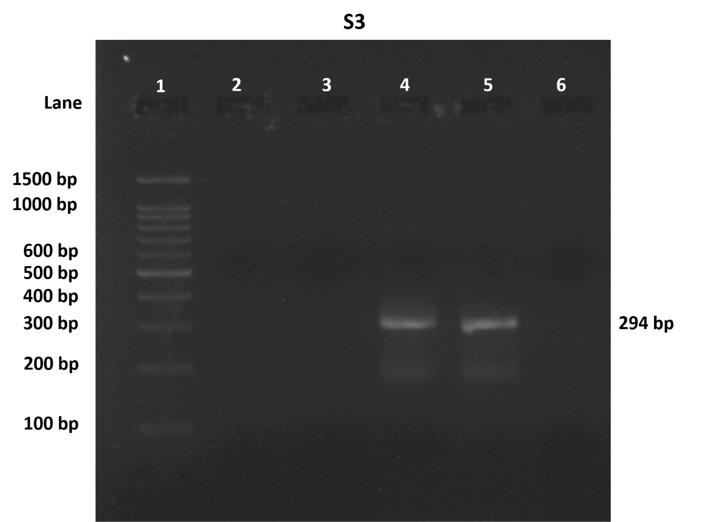
Supplementary figure 3: Depicting 294bp band amplification with primers; CD 41/42M/N, for the confirmation of mutation CD 41/42(-CTTT),
Lane 1 | Ladder (100bp)
Lane 2 | Negative Control without DNA sample
Lane 3 | CD 41/42M with Wild type DNA
Lane 4 | CD 41/42N with Wild type DNA
Lane 5 | CD 41/42M with patient’s DNA sample
Lane 6 | CD 41/42N with patient’s DNA sample

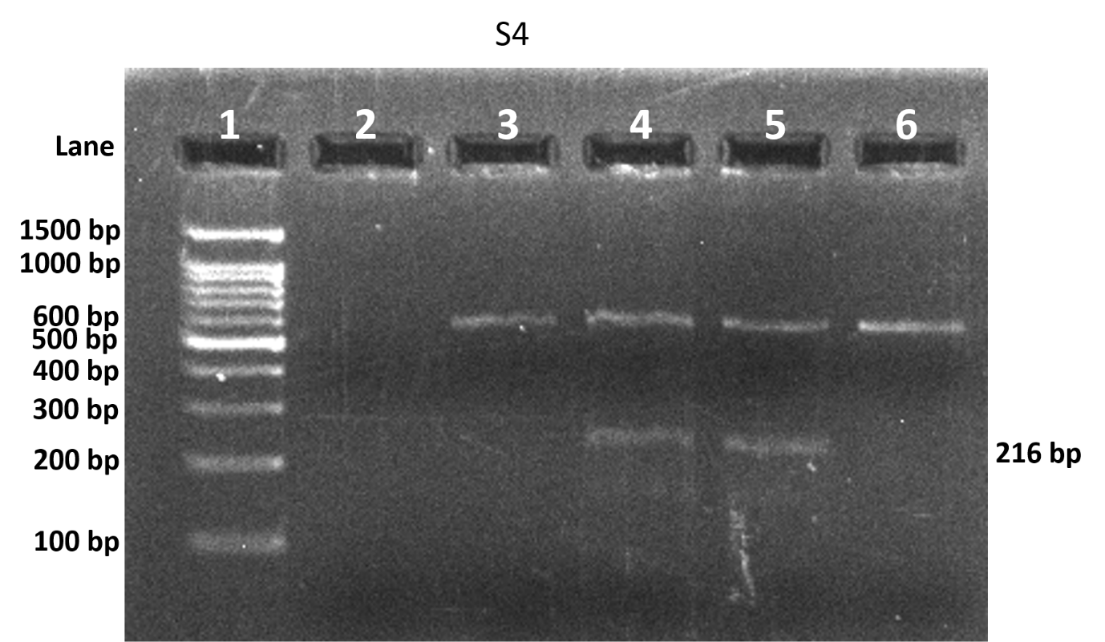
Supplementary figure 4: Depicting 216bp and 539bp band amplification with primers; Del AAAG M/N, and CD3N for the confirmation of novel mutation Cd66/67 delAAAG with internal control. (Note: CD3N, a normal primer with RC1 (reverse common primer) were used for the verification of the presence of novel mutation Cd66/67 delAAAG)

Lane 1 | Ladder (100bp)
Lane 2 | Negative Control without DNA sample
Lane 3 | Del AAAGM with Wild type DNA (CD3N for internal control)
Lane 4 | Del AAAGN with Wild type DNA (CD3N for internal control)
Lane 5 | Del AAAGM with patient’s DNA sample (CD3N for internal control)
Lane 6 | Del AAAGN with patient’s DNA sample (CD3N for internal control)

