Table S1. Characteristics of study participants by quartiles of TyG index.
 | TyG index quartiles
Variables | Q1 (≤ 8.85)  (n = 529) | Q2 (8.86 - 9.33)  (n = 532) | Q3 (9.34 - 9.92)  (n = 527) | Q4 (> 9.92)  (n = 524) | P
Age (year) | 56.25 ± 13.71 | 56.74 ± 13.69 | 56.23 ± 14.08 | 55.08 ± 13.89 | 0.252
Gender (male, n, %) | 313 (59.2) | 297 (55.8) | 311 (59.0) | 302 (57.6) | 0.666
Duration of diabetes (n, %) |  |  |  |  | 0.527
≤ 5 years | 232 (43.9) | 218 (41.0) | 228 (43.3) | 233 (44.5) | 0.527
5 < y ≤ 10 years | 129 (24.4) | 122 (22.9) | 130 (24.7) | 130 (24.8) | 0.527
10 < y ≤ 20 years | 137 (25.9) | 166 (31.2) | 135 (25.6) | 128 (24.4) | 0.527
> 20 years | 31 (5.9) | 26 (4.9) | 34 (6.5) | 33 (6.3) | 0.527
Anti-diabetic agents use  (yes, n, %) | 506 (95.7) | 510 (95.9) | 509 (96.6) | 502 (95.8) | 0.872
HR (bpm) | 80.59 ± 10.92 | 80.71 ± 12.52 | 80.18 ± 12.58 | 80.54 ± 10.94 | 0.899
SBP (mmHg) | 134.23 ± 18.19 | 135.34 ± 18.88 | 134.36 ± 18.92 | 134.58 ± 17.33 | 0.760
DBP (mmHg) | 82.32 ± 10.95 | 82.89 ± 11.47 | 82.59 ± 11.08 | 82.87 ± 11.32 | 0.819
PP (mmHg) | 51.91 ± 14.63 | 52.45 ± 15.65 | 51.77 ± 16.07 | 51.71 ± 14.17 | 0.854
Height (cm) | 167.45 ± 8.55 | 167.21 ± 8.99 | 167.50 ± 8.14 | 167.99 ± 8.36 | 0.512
Weight (Kg) | 72.24 ± 12.82 | 71.83 ± 14.68 | 72.22 ± 13.98 | 72.66 ± 14.90 | 0.819
BMI (Kg/m²) | 25.69 ± 3.81 | 25.55 ± 4.04 | 25.65 ± 4.11 | 25.62 ± 4.03 | 0.950
Smoker (yes, n, %) | 141 (26.7) | 120 (22.6) | 127 (24.1) | 146 (27.9) | 0.183
Drinker (yes, n, %) | 105 (19.8) | 99 (18.6) | 101 (19.2) | 109 (20.8) | 0.827
HbA1c (%, mol/mol) | 7.52 ± 2.09  (58.6 ± 22.8) | 7.95 ± 1.93  (63.4 ± 21.1) | 8.73 ± 2.64  (71.9 ± 28.9) | 9.68 ± 2.26  (82.3 ± 24.7) | < 0.001
FPG (mg/dL, mmol/L) | 120.56 ± 37.18  (6.70 ± 2.07) | 147.73 ± 44.71  (8.21 ± 2.48) | 175.82 ± 55.00  (9.77 ± 3.06) | 223.72 ± 65.74  (12.43 ± 3.65) | < 0.001
TC (mmol/L) | 4.31 ± 0.92 | 4.69 ± 1.77 | 4.85 ± 1.12 | 5.38 ± 1.37 | < 0.001
TG (mg/dL) | 84.81 ± 26.83 | 132.77 ± 38.89 | 186.52 ± 61.43 | 381.48 ± 186.64 | < 0.001
HDL-C (mmol/L) | 1.26 ± 0.40 | 1.09 ± 0.27 | 1.06 ± 0.39 | 0.95 ± 0.41 | < 0.001
LDL-C (mmol/L) | 2.75 ± 0.85 | 3.06 ± 0.94 | 3.17 ± 0.96 | 3.17 ± 1.13 | < 0.001
Insulin (mU/L) | 9.77 ± 5.49 | 11.03 ± 6.00 | 12.25 ± 6.22 | 14.20 ± 7.93 | < 0.001
HOMA-IR | 2.86 ± 1.69 | 3.93 ± 2.17 | 5.18 ± 2.80 | 7.72 ± 4.64 | < 0.001
DR level (n, %)
Non-DR | 373 (70.5) | 365 (68.6) | 373 (70.8) | 405 (77.3) | 0.007
Mild NPDR | 111 (21.0) | 118 (22.2) | 119 (22.6) | 98 (18.7) | 0.007
Moderate NPDR | 25 (4.7) | 27 (5.1) | 17 (3.2) | 18 (3.4) | 0.007
VTDR | 20 (3.8) | 22 (4.1) | 18 (3.4) | 3 (0.6) | 0.007
Abbreviation: TyG index, triglyceride-glucose index; HR, heart rate; SBP, systolic blood pressure; DBP, diastolic blood pressure; PP, pulse pressure; BMI, body mass index; HbA₁c, glycated hemoglobin; FPG, fasting plasma glucose; TC, total cholesterol; TG, triglyceride; HDL-C, high-density lipoprotein cholesterol; LDL-C, low-density lipoprotein cholesterol; HOMA-IR, the homeostasis model assessment of insulin resistance index; DR, diabetic retinopathy; NPDR, non-proliferative diabetic retinopathy; VTDR, vision-threatening diabetic retinopathy.

Table S2. Associations between TyG index and DR-related biochemical indexes.
 | Model 1 |  | Model 2
Variables | β | P | β | P
Age (year) | - 0.011 | 0.116 | - 0.011 | 0.180
Gender (male, n, %) | - 0.007 | 0.550 | - 0.005 | 0.620
Duration of diabetes (year) | 0.008 | 0.292 | 0.008 | 0.297
Anti-diabetic agents use  (yes, n, %) | - 0.004 | 0.624 | - 0.002 | 0.787
HR (bpm) | 0.000 | 0.994 | 0.000 | 0.984
SBP (mmHg) | 0.007 | 0.559 | 0.008 | 0.508
PP (mmHg) | - 0.006 | 0.631 | - 0.007 | 0.603
Height (cm) | - 0.029 | 0.482 | - 0.026 | 0.535
Weight (Kg) | 0.056 | 0.450 | 0.051 | 0.488
BMI (Kg/m²) | - 0.053 | 0.369 | - 0.050 | 0.392
HbA₁c (%, mmol/mol)  FPG (mg/dL, mmol/L)  TG (mg/dL)  TC (mmol/L)  Included variables † | 0.011  0.447  0.713 | 0.237  < 0.001  < 0.001 | 0.007  0.447  0.701  0.042 | 0.414  < 0.001  < 0.001  < 0.001
FPG (mg/dL, mmol/L) | 0.453 | < 0.001 | 0.451 | < 0.001
TG (mg/dL)  TC (mmol/L) | 0.713 | < 0.001 | 0.701  0.042 | < 0.001  < 0.001
Abbreviation: TyG index, triglyceride-glucose index; DR, diabetic retinopathy; HR, heart rate; SBP, systolic blood pressure; PP, pulse pressure; BMI, body mass index; HbA₁c, glycated hemoglobin; FPG, fasting plasma glucose; TG, triglyceride; TC, total cholesterol.
Model 1: adjusted by age, gender, duration of diabetes, use of anti-diabetic agents, HR, SBP, PP, height, weight, BMI, HbA₁c, FPG and TG; Model 2: adjusted by age, gender, duration of diabetes, use of anti-diabetic agents, HR, SBP, PP, height, weight, BMI, HbA₁c, FPG, TG and TC.
† The variables selection method was stepwise, which P for including was 0.05 and P for excluding was 0.1.

Table S3. Associations of any-severity DR with TyG index grouped by FPG, TG, HOMA-IR and TC levels.
Stratifying variables | No of cases / controls | TyG index by quarter † |  |  |  | P value for trend
Stratifying variables | No of cases / controls | Q1 (≤ 8.85) | Q2 (8.86 - 9.33) | Q3 (9.34 - 9.92) | Q4 (> 9.92) | P value for trend
FPG (mg/dL, mmol/L) ‡
≤ 166.79 (9.27) | 364 / 869 | 1.00 | 1.06 (0.78 to 1.43) | 0.94 (0.67 to 1.33) | 0.74 (0.45 to 1.23) | 0.304
> 166.79 (9.27) | 232 / 647 | 1.00 | 0.86 (0.43 to 1.73) | 0.90 (0.47 to 1.73) | 0.60 (0.31 to 1.16) | 0.029
Test for multiplicative interaction |  |  | P = 0.010
TG (mg/dL) ‡
≤ 195.87 | 413 / 973 | 1.00 | 1.07 (0.81 to 1.41) | 0.90 (0.64 to 1.25) | 0.42 (0.19 to 0.95) | 0.150
> 195.87 | 183 / 543 | 1.00 |  | 1.92 (0.84 to 4.40) | 1.35 (0.59 to 3.07) | 0.445
Test for multiplicative interaction |  |  | P = 0.018
HOMA-IR ‡
≤ 4.91 | 411 / 958 | 1.00 | 0.98 (0.73 to 1.31) | 0.99 (0.72 to 1.37) | 0.69 (0.44 to 1.07) | 0.187
> 4.91 | 185 / 558 | 1.00 | 1.78 (0.81 to 3.91) | 1.35 (0.63 to 2.85) | 1.07 (0.51 to 2.25) | 0.276
Test for multiplicative interaction |  |  | P = 0.027
TC (mmol/L) §
≤ 4.81 | 336 / 826 | 1.00 | 1.03 (0.74 to 1.45) | 1.19 (0.83 to 1.70) | 0.71 (0.46 to 1.11) | 0.336
> 4.81 | 260 / 690 | 1.00 | 1.01 (0.63 to 1.60) | 0.71 (0.45 to 1.12) | 0.58 (0.36 to 0.92) | 0.006
Test for multiplicative interaction |  |  | P = 0.235
Abbreviation: DR, diabetic retinopathy; TyG index, triglyceride-glucose index; FPG, fasting plasma glucose; TG, triglyceride; HOMA-IR, the homeostasis model assessment of insulin resistance index; TC, total cholesterol.
† Values are odds ratios (95% confidence interval) unless stated otherwise.
‡ Adjusted for age, gender, duration of diabetes, use of anti-diabetic agents, HR, SBP, PP, height, weight, BMI, HbA₁c and TC;
§ Adjusted for age, gender, duration of diabetes, use of anti-diabetic agents, HR, SBP, PP, height, weight, BMI and HbA₁c.
683 cases of any-DR registered during 2012 to 2018
596 cases confirmed as DR with type 2 diabetes
Three controls per case were randomly selected from the hospitalized register database matching on the index case’s year of birth and ethnicities (n = 1,788), as well as they were: 1) alive; 2) no history of DR.

596 cases confirmed as DR with type 2 diabetes and 1,516 corresponding controls, as a total of 2,112 subjects
Exclusion Criteria †
Exclusion Criteria ‡
Figure S1. Flow chart of study population.
Abbreviation: DR, diabetic retinopathy.
† Exclusion Criteria: 1) not type 2 diabetes (n = 67, 9.8%); 2) pregnancy or lactation (n = 5, 0.7%); 3) major mental or physical illness (n = 9, 1.3%); 4) incomplete information (n = 6, 0.9%).
‡ Exclusion Criteria: 1) not type 2 diabetes (n = 163, 9.1%); 2) pregnancy or lactation (n = 22, 1.2%); 3) major mental or physical illness (n = 30, 1.7%); 4) incomplete information (n = 57, 3.2%).

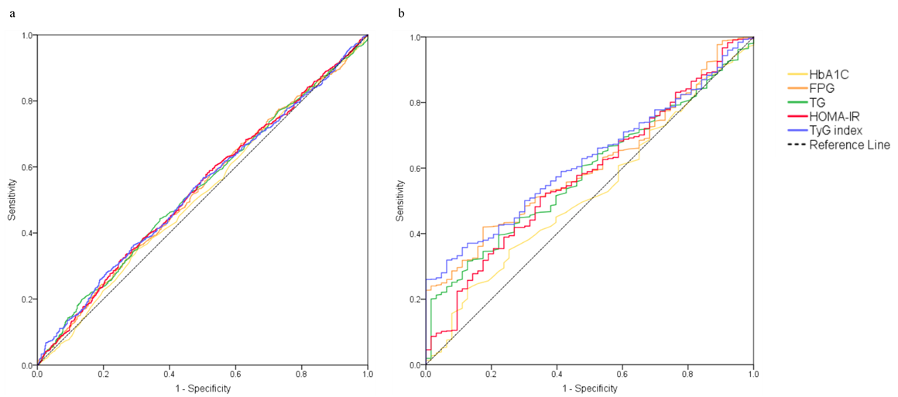
Figure S2. Prediction of DR (a) and VTDR (b) by TyG index and four biochemical blood parameters.
Abbreviation: DR, diabetic retinopathy; VTDR, vision-threatening diabetic retinopathy; TyG index, triglyceride-glucose index; HbA₁c, glycated hemoglobin; FPG, fasting plasma glucose; TG, triglyceride; HOMA-IR, the homeostasis model assessment of insulin resistance index.

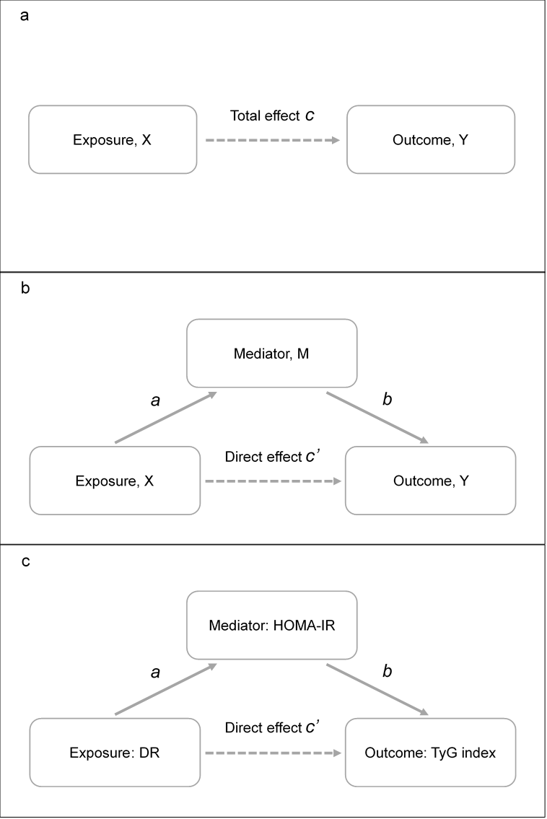
Figure S3. Associations between DR, HOMA-IR and TyG index in a mediation framework.
Abbreviation: DR, diabetic retinopathy; HOMA-IR, the homeostasis model assessment of insulin resistance index; TyG index, triglyceride-glucose index.
a: the effect of exposure X on outcome Y without considering mediator M was defined as the total effect (coefficient c);
b: the effect of X on Y with controlling for M was defined as the direct effect (coefﬁcient c’); the indirect effect of X on Y was quantiﬁed by multiplication between standardized coefﬁcient a and standardized coefﬁcient b;
c: mediation analysis based on linear regression showed the direct and indirect associations of DR (X) with TyG index (Y) through HOMA-IR (M).
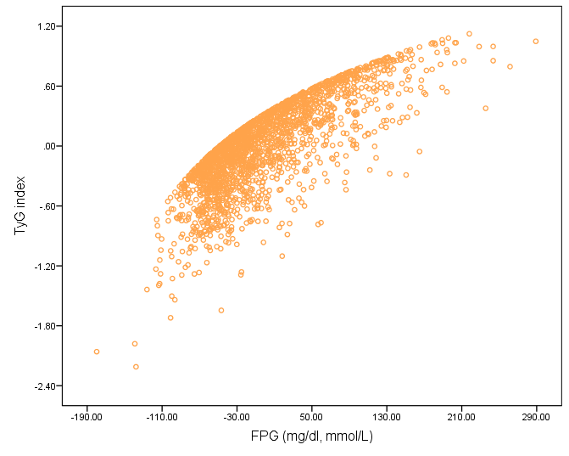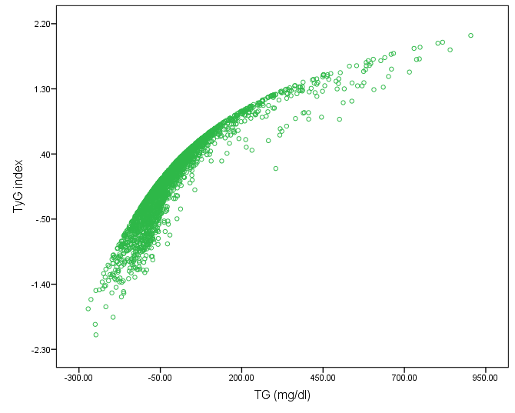
a
b
Figure S4. Partial regression between FPG (a), TG (b) and TyG index.
Abbreviation: FPG, fasting plasma glucose; TG, triglyceride; TyG index, triglyceride-glucose index.

