Supplement Fig. 1: The target site of miRNA-4715-3p (yellow arrow) on XPG (ERCC5)
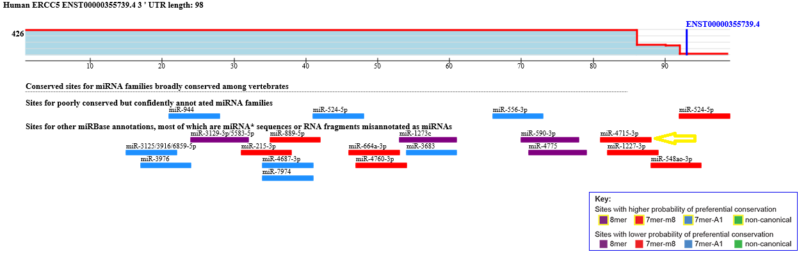

Supplement Fig. 2 : The binding site sequence of miRNA-4715-3p on XPG (ERCC5)

Supplement Fig. 3: The influence of rs873601 on miRNA-4715-3p binding activity
