Online data supplement
Mepolizumab for eosinophilic chronic obstructive pulmonary disease: analysis of METREX and METREO
Ian D. Pavord, Kenneth R. Chapman, Mona Bafadhel, Frank C. Sciurba, Eric S. Bradford, Stephanie Schweiker Harris, Bhabita Mayer, David B. Rubin, Steven W. Yancey, Pierluigi Paggiaro

Contents
Additional statistical methods 2
Figures 5
Figure E1. Study design of A) METREX and B) METREO 5
Figure E2. LS mean change from baseline in pre-bronchodilator FEV₁ over time 6
Tables 7
Table E1. Patient demographics and clinical characteristics at baseline in the mepolizumab all-doses group 7
Table E2. Overview of exacerbation endpoints 9
Table E3. Overview of HRQoL endpoints at Week 52 11
Table E4. Patient- and clinician-rated responses to therapy at Week 52 13
Table E5. Change from baseline in pre-bronchodilator FEV₁ at Week 52 14
Table E6. Exacerbation endpoints by blood eosinophil categories 15
Table E7. HRQoL change from baseline endpoints by blood eosinophil categories at Week 52 17
Table E8. SGRQ and CAT responders by blood eosinophil categories at Week 52 19
Table E9. Predicted reductions of moderate/severe exacerbations by screening blood eosinophil counts and results from corresponding subgroup analysis 21
Ethics committees 22
References 24

Additional statistical methods
Group composition
Group | Patients from METREX | Patients from METREO
Placebo | Placebo group mITT-Eos | Placebo group mITT
Mepolizumab 100 mg SC | Mepolizumab group mITT-Eos | Mepolizumab 100 mg SC group mITT
Mepolizumab  All doses | Mepolizumab group mITT-Eos | Mepolizumab 100 mg SC mITT and  Mepolizumab 300 mg SC mITT
mITT, modified intent-to-treat (randomised and received at ≥1 dose of study medication); mITT-Eos, modified intention-to-group with blood eosinophil counts ≥150 cells/µL at screening or ≥300 cells/µL in the prior year; SC, subcutaneous
Geographic regions for meta-analysis
Both METREX and METREO were multicentre studies. For covariate adjustment for the statistical analysis of the pooled data, the centres were grouped into geographical regions. These regions were defined as United States of America (USA), European Union (EU) and Rest of the World (RoW).
Covariates
The following covariates were included in the statistical analysis models for all exacerbation-related endpoints:
- Study (METREX, METREO)
- Smoking status (current vs non-smoker/ex-smoker)
- Number of exacerbations in previous year (≤2, 3, ≥4 as an ordinal variable)
- Baseline disease severity (as % predicted post-bronchodilator FEV₁)
- Geographic region (USA, EU, RoW)
Analyses carried out using a negative binomial model with an offset of log_{e} (length of time) which reflected the time for which exacerbation data was reported and included in the analysis model.
For all other endpoints, the following covariates were included in the analysis models:
- Study (METREX, METREO)
- Baseline value of response variable
- Smoking status (current vs non-smoker/ex-smoker)
- Geographic region (USA, EU, RoW)
For analyses using mixed model repeated measures, visit was fitted as a categorical variable with the effect of treatment group and baseline varying at each visit (i.e., visit by baseline and visit by treatment group interaction terms were also included in the analysis model).
Eosinophil response modelling
To model the relationship between treatment efficacy and screening blood eosinophil count, a log transformation was initially applied to blood eosinophil counts. This transformation had previously been shown to be appropriate in severe eosinophilic asthma;¹⁻³ however, the transformation was not a good fit for the data from METREX/METREO. Therefore, an additional, post hoc analysis using fractional polynomial modelling was performed to better model the relationship between treatment efficacy and screening blood eosinophil count in COPD. Interactions between treatment and each second-degree fractional polynomial (FP2) transformation of screening blood eosinophil count were assessed using the negative binomial model for exacerbations with additional covariates of smoking status (current vs never/ex), number of exacerbations in previous year, % predicted FEV₁ screening, region and study. To determine the best-fitting transformation of blood eosinophil count, the FP2 transformation that maximised the log likelihood of the model was chosen. A likelihood ratio test was used to test the interaction between blood eosinophil count and treatment in the best fitting FP2 model versus a nested model without the interaction terms.
A visual comparison of the model predicted rate ratio (RR) curve against the results of a pre-specified subgroup analysis in which RRs were estimated separately by blood eosinophil count categories of <150, ≥150–<300, ≥300–<500 and ≥500 cells/µL at screening further helped to assess the model fit.

Figures

Figure E1. Study design of A) METREX and B) METREO
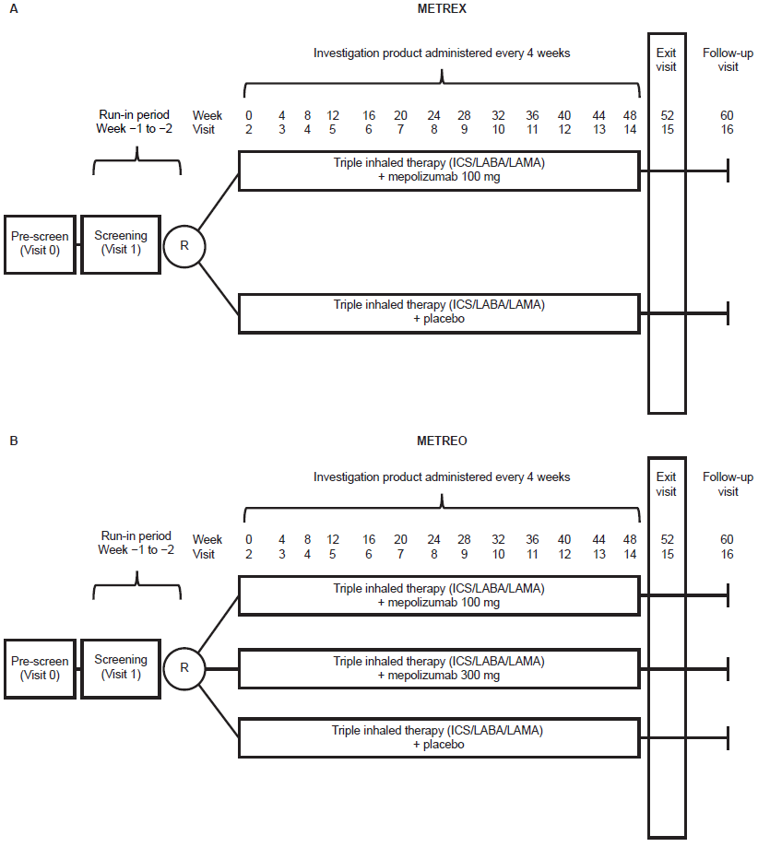
Reproduced with permission from Pavord et al, 2017⁴
METREX randomisation stratified: COPD with ≥150 cells/µL at screening or ≥300 cells/μL at any point in the previous year or COPD with <150 cells/μL at screening and no evidence of ≥300 cells/μL in the previous year.
ICS, inhaled corticosteroid; LABA, long-acting β₂-agonist; LAMA, long-acting muscarinic-receptor antagonists; R, randomisation.

Figure E2. LS mean change from baseline in pre-bronchodilator FEV₁ over time
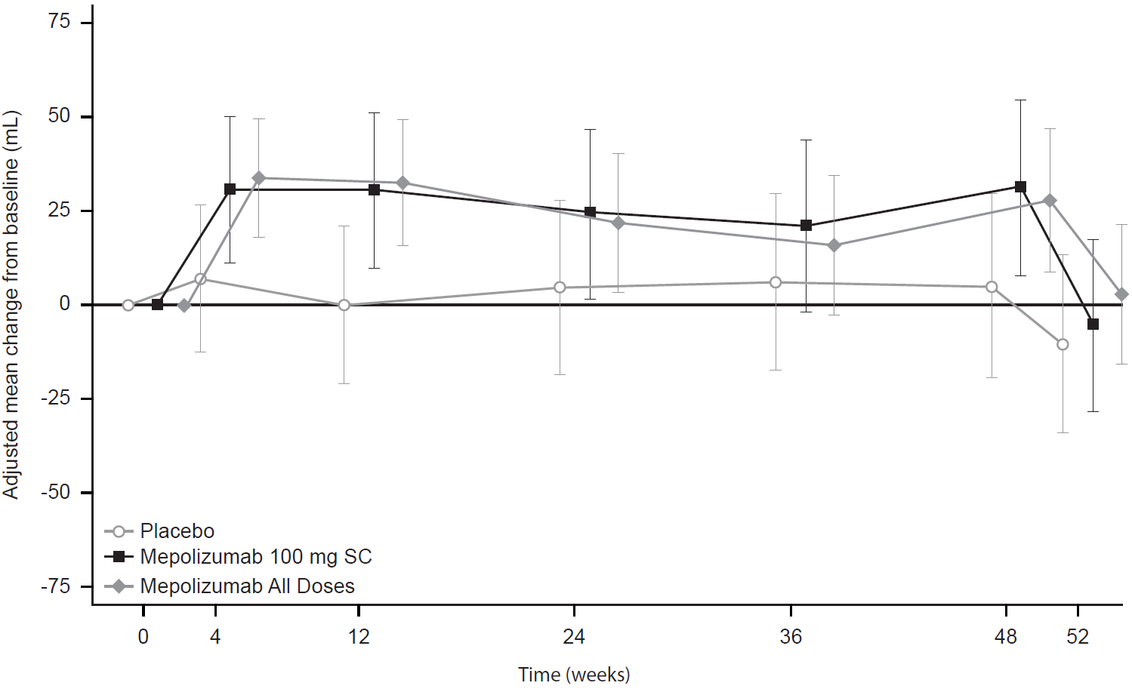
FEV₁, forced expiratory volume in 1s; LS, least squares; SC, subcutaneous.

Tables

Table E1. Patient demographics and clinical characteristics at baseline in the mepolizumab all-doses group
Characteristic | Mepolizumab  all doses (N=681) | Placebo  (N=455)
Age, years, mean (SD) | 65 (9) | 66 (9)
Gender, n (%)
Female | 242 (36) | 149 (33)
Smoking history screening, pack-years, mean (SD) | 43.09 (27.09) | 46.25 (27.11)
Non-smoker, n (%) | 18 (3) | 13 (3)
Former, n (%) | 475 (70) | 307 (67)
Current, n (%) | 188 (28) | 135 (30)
Duration of COPD, years, mean (SD) | 8.6 (6.2) | 9.1 (6.1)
Moderate/severe exacerbations
In prior year, mean events (SD) | 2.7 (1.4) | 2.6 (1.3)
≥1 moderate. exacerbation, n (%) | 588 (86) | 379 (83)
≥1 severe exacerbation, n (%) | 213 (31) | 161 (35)
GOLD group, n (%)
D | 649 (95) | 434 (95)
Severity of airflow limitation, n (%)
Mild: ≥80% predicted | 8 (1) | 4 (<1)
Moderate: ≥50–<80% predicted | 252 (37) | 156 (34)
Severe: ≥30–<50% predicted | 308 (45) | 217 (48)
Very severe: <30% predicted | 113 (17) | 78 (17)
Screening blood eosinophil counts, cells/µL, n (%)
Thresholds
<150 (and ≥300 in the prior year) | 98 (14) | 42 (9)
≥150 | 581 (85) | 412 (91)
≥300 | 249 (37) | 177 (39)
≥500 | 87 (13) | 67 (15)
Categories
≥150–<300 | 332 (49) | 235 (52)
≥300–<500 | 162 (24) | 110 (24)
Geometric mean (SD logs) | 240 (0.758) | 250 (0.739)
Health-related quality of life
SGRQ total score, mean (SD) | 53.1 (17.2) | 54.7 (16.0)
CAT score, mean (SD) | 18.9 (7.7) | 19.5 (7.6)
CAT, COPD Assessment Test; COPD, chronic obstructive pulmonary disease; GOLD, Global Initiative for Chronic Obstructive Lung Disease; SD, standard deviation; SGRQ, St George’s Respiratory Questionnaire.

Table E2. Overview of exacerbation endpoints
Endpoint | Mepolizumab 100 mg SC  (N=456) | Mepolizumab  all doses (N=681) | Placebo (N=455)
Annual rate of moderate/severe exacerbations
Annual rate (events/year) | 1.32 | 1.34 | 1.61
RR mepolizumab/placebo (95% CI) | 0.82 (0.71, 0.95) | 0.83 (0.73, 0.95)
p-value | 0.006 | 0.007
Annual rate of exacerbation leading to ED visit/hospitalisation
Annual rate (events/year) | 0.24 | 0.25 | 0.28
RR mepolizumab/placebo (95% CI) | 0.85 (0.61, 1.18) | 0.88 (0.65, 1.19)
p-value | 0.328 | 0.411
Annual rate of severe exacerbations
Annual rate (events/year) | 0.20 | 0.21 | 0.23
RR mepolizumab/placebo (95% CI) | 0.88 (0.62, 1.25) | 0.92 (0.67, 1.27)
p-value | 0.475 | 0.619
Kaplan–Meier time to first moderate/severe exacerbation
Median, days | 218 | 235 | 155
HR mepolizumab/placebo (95% CI) | 0.80 (0.68, 0.94) | 0.78 (0.67, 0.91)
p-value | 0.006 | 0.001
Kaplan–Meier time to first exacerbation leading to ED visit/hospitalisation
Median, days | Not estimable | Not estimable | Not estimable
HR (95% CI) | 0.81 (0.61, 1.09) | 0.79 (0.60, 1.03)
p-value | 0.170 | 0.083
CI, confidence interval; ED, emergency department; HR, hazard ratio; RR, rate ratio; SC, subcutaneous.

Table E3. Overview of HRQoL endpoints at Week 52
Endpoint | Mepolizumab 100 mg SC  (N=456) | Mepolizumab  all doses  (N=681) | Placebo  (N=455)
SGRQ total score at Week 52
Change from baseline, LS mean (SE) | −3.8 (0.7) | −3.7 (0.6) | −3.1 (0.7)
Treatment difference (95% CI) | −0.7 (−2.7, 1.3) | −0.6 (−2.5, 1.3)
p-value | 0.486 | 0.525
SGRQ symptom domain at Week 52
Change from baseline, LS mean (SE) | −8.6 (0.9) | −8.0 (0.7) | −5.8 (0.9)
Treatment difference (95% CI) | −2.9 (−5.3, −0.5) | −2.3 (−4.5, −0.1)
p−value | 0.020 | 0.043
SGRQ activity domain at Week 52
Change from baseline, LS mean (SE) | −2.3 (0.8) | −2.8 (0.7) | −3.0 (0.8)
Treatment difference (95% CI) | 0.7 (−1.5, 3.0) | 0.3 (−1.9, 2.4)
p-value | 0.528 | 0.815
SGRQ impact domain at Week 52
Change from baseline, LS mean (SE) | −3.3 (0.8) | −2.9 (0.7) | −2.4 (0.9)
Treatment difference (95% CI) | −1.0 (−3.3, 1.3) | −0.6 (−2.7, 1.6)
p−value | 0.413 | 0.597
SGRQ respondersª at Week 52
Number of responders (%) | 187 (42) | 272 (41) | 168 (38)
OR, mepolizumab/placebo, (95% CI) | 1.23 (0.94, 1.61) | 1.19 (0.92, 1.53)
p-value | 0.138 | 0.177
CAT score at Week 52
Change from baseline, LS mean (SE) | −1.2 (0.3) | −1.0 (0.3) | −0.3 (0.3)
Treatment difference (95% CI) | −0.9 (−1.8, 0.0) | −0.8 (−1.6, 0.0)
p-value | 0.039 | 0.062
CAT responders^{b} at Week 52
Number of responders (%) | 172 (39) | 263 (40) | 147 (33)
OR, mepolizumab/placebo, (95% CI) | 1.39 (1.04, 1.85) | 1.41 (1.08, 1.83)
p-value | 0.024 | 0.012
ªSGRQ responders are defined by ≥4-point reduction in SGRQ total score; ^{b}CAT responders are defined by ≥2-point reduction in CAT score.
CI, confidence interval; CAT, COPD Assessment Test; HRQoL, health-related quality of life; LS, least squares; OR, odds ratio; SC, subcutaneous; SE, standard error;
SGRQ, St George’s Respiratory Questionnaire.

Table E4. Patient- and clinician-rated responses to therapy at Week 52
Endpoint | Mepolizumab  100 mg SC  (N=456) | Mepolizumab  all doses  (N=681) | Placebo  (N=455)
Patient-rated response at Week 52
Significantly improved | 38 (9) | 50 (9) | 37 (10)
Moderately improved | 80 (20) | 120 (20) | 52 (14)
Mildly improved | 108 (27) | 143 (24) | 92 (25)
No change | 133 (33) | 217 (37) | 136 (38)
Mildly worse | 34 (8) | 45 (8) | 31 (9)
Moderately worse | 6 (1) | 8 (1) | 13 (4)
Significantly worse | 2 (<1) | 5 (<1) | 1 (<1)
OR (mepolizumab vs placebo), (95% CI) | 1.26 (0.97, 1.63) | 1.20 (0.94, 1.52) | -
p-value | 0.077 | 0.141 | -
Clinician-rated response at Week 52
Significantly improved | 28 (7) | 41 (7) | 21 (6)
Moderately improved | 78 (19) | 110 (18) | 45 (12)
Mildly improved | 110 (27) | 163 (27) | 99 (27)
No change | 161 (39) | 240 (40) | 170 (46)
Mildly worse | 26 (6) | 36 (6) | 30 (8)
Moderately worse | 4 (<1) | 10 (2) | 4 (1)
Significantly worse | 4 (<1) | 4 (<1) | 2 (<1)
OR (mepolizumab vs placebo), (95% CI) | 1.41 (1.09, 1.83) | 1.37 (1.08, 1.74) | -
p-value | 0.008 | 0.011 | -
CI, confidence interval; OR, odds ratio; SC, subcutaneous.

Table E5. Change from baseline in pre-bronchodilator FEV₁ at Week 52
Endpoint | Mepolizumab 100 mg SC  (N=456) | Mepolizumab all doses (N=681) | Placebo  (N=455)
Pre-bronchodilator FEV₁ at Week 52
Change from baseline, LS mean (SE) | −5 (11.6) | 3 (9.5) | −10 (12.0)
Difference (mepolizumab vs placebo), mL (95% CI) | 5 (−28, 38) | 13 (−17, 43) | -
p-value | 0.764 | 0.393 | -
CI, confidence interval; FEV₁, forced expiratory volume in 1s; LS, least squares; SC, subcutaneous; SE, standard error.

Table E6. Exacerbation endpoints by blood eosinophil categories
 | Moderate/severe exacerbations |  |  | Exacerbations requiring ED visit/hospitalisation |  |  | Severe exacerbations
 | Mepolizumab  100 mg SC (N=456) | All doses  (N=681) | Placebo  (N=455) | Mepolizumab  100 mg SC (N=456) | All doses  (N=681) | Placebo  (N=455) | Mepolizumab  100 mg SC (N=456) | All doses  (N=681) | Placebo  (N=455)
<150 (≥300 in prior year) cells/µL
n (%) | 53 (12) | 98 (14) | 42 (9) | 53 (12) | 98 (14) | 42 (9) | 53 (12) | 98 (14) | 42 (9)
Exacerbation rate  per year | 1.08 | 1.16 | 1.69 | 0.30 | 0.25 | 0.31 | 0.29 | 0.21 | 0.26
RR vs placebo (95% CI) | 0.64 (0.40, 1.03) | 0.68 (0.46, 1.03) | - | 0.96 (0.42, 2.19) | 0.80 (0.37, 1.70) | - | 1.09 (0.41, 2.90) | 0.79 (0.32, 1.94) | -
≥150–<300 cells/µL
n (%) | 237 (52) | 332 (49) | 235 (52) | 237 (52) | 332 (49) | 235 (52) | 237 (52) | 332 (49) | 235 (52)
Exacerbation rate  per year | 1.38 | 1.40 | 1.50 | 0.23 | 0.24 | 0.27 | 0.21 | 0.22 | 0.25
RR vs placebo (95% CI) | 0.92 (0.76, 1.11) | 0.93 (0.78, 1.11) | - | 0.87 (0.55, 1.37) | 0.90 (0.59, 1.38) | - | 0.82 (0.51, 1.33) | 0.88 (0.56, 1.37) | -
≥300–<500 cells/µL
n (%) | 112 (25) | 162 (24) | 110 (24) | 112 (25) | 162 (24) | 110 (24) | 112 (25) | 162 (24) | 110 (24)
Exacerbation rate  per year | 1.26 | 1.40 | 1.69 | 0.22 | 0.26 | 0.29 | 0.15 | 0.21 | 0.21
RR vs placebo (95% CI) | 0.75 (0.55, 1.00) | 0.82 (0.62, 1.08) | - | 0.77 (0.41, 1.43) | 0.90 (0.52, 1.57) | - | 0.69 (0.35, 1.38) | 0.95 (0.52, 1.75) | -
≥500 cells/µL
n (%) | 53 (12) | 87 (13) | 67 (15) | 53 (12) | 87 (13) | 67 (15) | 53 (12) | 87 (13) | 67 (15)
Exacerbation rate per year | 1.24 | 1.12 | 1.71 | 0.10 | 0.11 | 0.20 | 0.09 | 0.08 | 0.10
RR vs placebo (95% CI) | 0.72 (0.48, 1.09) | 0.67 (0.46, 0.97) | - | 0.51 (0.14, 1.86) | 0.53 (0.17, 1.71) | - | 0.90 (0.23, 3.47) | 0.78 (0.21, 2.90) | -
CI, confidence interval; ED, emergency department; RR, rate ratio; SC, subcutaneous.

Table E7. HRQoL change from baseline endpoints by blood eosinophil categories at Week 52
 | Mepolizumab  100 mg SC (N=456) | All doses  (N=681) | Placebo  (N=455) | Mepolizumab  100 mg SC (N=456) | All doses  (N=681) | Placebo  (N=455)
 | SGRQ total score change from baseline |  |  | CAT score change from baseline
<150 (≥300 in prior year) cells/µL
n (%)ª | 42 (9) | 79 (12) | 31 (7) | 40 (9) | 75 (11) | 31 (7)
LS mean change from baseline (SE) | −6.2 (2.30) | −3.2 (1.65) | −1.2 (2.59) | −3.2 (0.95) | −1.7 (0.69) | 1.7 (1.06)
Difference from placebo (95% CI) | −5.0 (−12.0, 1.9) | −2.0 (−8.1, 4.2) | - | −4.9 (−7.8, −2.1) | −3.4 (−5.9, −0.8) | -
≥150–<300 cells/µL
n (%)ª | 210 (46) | 290 (43) | 185 (41) | 204 (45) | 282 (41) | 183 (40)
LS mean change from baseline (SE) | −2.2 (0.93) | −3.0 (0.79) | −3.2 (0.98) | −0.3 (0.42) | −0.6 (0.36) | −0.5 (0.44)
Difference from placebo (95% CI) | 0.9 (−1.7, 3.6) | 0.2 (−2.2, 2.7) | - | 0.2 (−1.0, 1.3) | −0.1 (−1.2, 1.0) | -
≥300–<500 cells/µL
n (%)ª | 100 (22) | 143 (21) | 90 (20.0) | 92 (20) | 135 (20) | 84 (18)
LS mean change from baseline (SE) | −4.0 (1.49) | −2.6 (1.24) | −2.0 (1.52) | −2.0 (0.62) | −1.2 (0.52) | −0.1 (0.64)
Difference from placebo (95% CI) | −2.0 (−6.1, 2.2) | −0.7 (−4.6, 3.2) | - | −1.9 (−3.7, −0.2) | −1.1 (−2.7, 0.5) | -
≥500 cells/µL
n (%)ª | 49 (11) | 77 (11) | 53 (12) | 48 (11) | 76 (11) | 52 (11)
LS mean change from baseline (SE) | −8.1 (2.20) | −8.7 (1.73) | −5.7 (2.11) | −1.7 (0.87) | −1.7 (0.68) | −0.9 (0.83)
Difference from placebo (95% CI) | −2.4 (−8.4, 3.6) | −3.0 (−8.4, 2.5) | - | −0.8 (−3.2, 1.6) | −0.8 (−2.9, 1.3) | -
ªIncludes patients with an assessment at baseline and Week 52.
CAT, COPD Assessment Test; CI, confidence interval; COPD, chronic obstructive pulmonary disease; HRQoL, health-related quality of life; LS, least squares;
SC, subcutaneous; SE, standard error; SGRQ, St George’s Respiratory Questionnaire.

Table E8. SGRQ and CAT responders by blood eosinophil categories at Week 52
 | Mepolizumab  100 mg SC (N=456) | All doses  (N=681) | Placebo  (N=455) | Mepolizumab  100 mg SC (N=456) | All doses  (N=681) | Placebo  (N=455)
 | SGRQ respondersª |  |  | CAT responders^{b}
<150 (≥300 in prior year) cells/µL
n (%)^{c} | 52 (11) | 96 (14) | 42 (9) | 51 (11) | 95 (14) | 42 (9)
Proportion of responders, n (%) | 21 (40) | 34 (35) | 11 (26) | 25 (49) | 40 (42) | 8 (19)
OR to placebo (95% CI) | 2.05 (0.80, 5.25) | 1.64 (0.71, 3.78) | - | 5.69 (1.95, 16.57) | 3.75 (1.46, 9.66) | -
≥150–<300 cells/µL
n (%)^{c} | 234 (51) | 327 (48) | 230 (51) | 230 (50) | 322 (47) | 228 (50)
Proportion of responders, n (%) | 87 (37) | 128 (39) | 85 (37) | 78 (34) | 120 (37) | 73 (32)
OR to placebo (95% CI) | 1.05 (0.71, 1.55) | 1.10 (0.76, 1.57) | - | 1.19 (0.79, 1.80) | 1.30 (0.89, 1.91) | -
≥300–<500 cells/µL
n (%)^{c} | 108 (24) | 158 (23) | 110 (24) | 106 (23) | 156 (23) | 107 (24)
Proportion of responders, n (%) | 50 (46) | 67 (42) | 44 (40) | 47 (44) | 66 (42) | 37 (35)
OR to placebo (95% CI) | 1.31 (0.76, 2.26) | 1.19 (0.71, 1.98) | - | 1.57 (0.88, 2.79) | 1.49 (0.87, 2.54) | -
≥500 cells/µL
n (%)^{c} | 53 (12) | 87 (13) | 65 (14) | 52 (11) | 86 (13) | 64 (14
Proportion of responders, n (%) | 28 (53) | 42 (48) | 27 (42) | 21 (40) | 36 (42) | 28 (44)
OR to placebo (95% CI) | 1.63 (0.75, 3.56) | 1.55 (0.76, 3.17) | - | 0.91 (0.41, 1.98) | 0.97 (0.48, 1.96) | -
ªSGRQ responders are defined by ≥4-point reduction in SGRQ total score; ^{b}CAT responders are defined by ≥2-point reduction in the CAT score; ^{c}includes patients with an assessment at baseline and Week 52.
CAT, COPD Assessment Test; CI, confidence interval; COPD, chronic obstructive pulmonary disease; OR, odds ratio; SC, subcutaneous; SGRQ, St George’s Respiratory Questionnaire.

Table E9. Predicted reductions of moderate/severe exacerbations by screening blood eosinophil counts and results from corresponding subgroup analysis
Continuous variable modelling |  | Subgroup analysis
Blood eosinophil count (cells/µL) | RR (mepolizumab 100 mg vs placebo) (95% CI) | Blood eosinophil count category (cells/µL) | RR (mepolizumab 100 mg vs placebo) (95% CI)
100 | 1.09 (0.93, 1.28) | <150 | 1.10 (0.91, 1.34)
150 | 1.01 (0.88, 1.14) | <150 | 1.10 (0.91, 1.34)
200 | 0.95 (0.84, 1.07) | ≥150–<300 | 0.92 (0.76, 1.11)
300 | 0.86 (0.75, 0.99) | ≥150–<300 | 0.92 (0.76, 1.11)
400 | 0.81 (0.68, 0.96) | ≥300–<500 | 0.75 (0.55, 1.00)
500 | 0.77 (0.63, 0.93) | ≥300–<500 | 0.75 (0.55, 1.00)
750 | 0.70 (0.55, 0.90) | ≥500 | 0.72 (0.48, 1.09)
CI, confidence interval; RR, rate ratio.

Ethics committees
METREX: Australia: Flinders Medical Centre, Human Research Ethics Committee¸ Bedford Park, South Australia; Monash Health, Research Directorate, Clayton, Victoria; Bellberry Limited, Dulwich, South Australia; The Southern Adelaide Clinical Human Research Ethics Committee, Flinders Medical Centre, Bedford Park, South Australia; Belgium: Centre Hospitalier Universitaire de Liège, Comité d'Ethique Hospiatalo-Faculatire Universitaire de Liège, Domaine Universitaire Du Sart-Tilman Bâtiment B35, Liège, Belgium; Canada: Comité d’éthique de la Recherche de l’HSCM, Montréal, Québec; Institutional Review Board Services, Aurora, Ontario; Concordia Hospital Ethics Committee, Winnipeg, Manitoba; Conjoint Health Research Ethics Board (CHREB), Calgary, Alberta; Comite d'ethique de la Recherche de l'hopital, Quebec; Research Ethics Review Committee, Edmonton, Alberta; Comite d'ethique de la Recherche du CHUM, Montréal, Québec; Czech Republic: Fakultni nemocnice Kralovske Vinohrady, Eticka komise, Prague; Nemocnice Tabor, Eticka komise, Kpt. Tabor; Estonia: National Institute For Health Development, Tallinn; France: CPP Sud-Est III - HCL GH Edouard Herriot, Lyon; Greece: National Ethics Committee, Athens; Italy: Comitato Etico Aziende Sanitarie dell'Umbria, Segreteria Scientifico-Amministrativa, Umbria; Comitato Etico Per Parma, C/O Azienda Ospedaliero Universitaria di Parma, Parma, Emilia-Romagna; Comitato Etico S.U.N. - A.O.R.N. "Ospedali dei Colli", Segreteria Scientifico-Amministrativa, Campania; Comitato Etico IRCCS Multimedica, Sez. del Comitato Etico Centrale IRCCS Lombardia, Segreteria Scientifico-Amministrativa, Sesto San Giovanni, Lombardia; Comitato Etico Regione Liguria, C/O IRCCS A.O.U. San Martino -IST Istituto Nazionale per la Ricerca sul Cancro, Genova, Liguria; Com. Etico Reg. Toscano "Area Vasta Nord Ovest", Segreteria Scientifico-Amministrativa - Azienda Ospedaliero-Universitaria Pisana, Pisa, Toscana; Comitato Etico per la Sperimentazione dell'Azienda Ospedaliera di Padova, Padova; Mexico: Ethics Committee in Research of Oaxaca Site Management Organization SC, Oaxaca; Winsett Rethman S.A. de C.V. Althian, Capitan Lorenzo Aguilar Sur Monterrey, Nuevo León; Biomedical Research G&L, SRL De CV, Zapopan, Jalisco; Instituto Jalisciense de Investigación Clínica, S.A. de C.V., Guadalajara, Jalisco; Comité Bioético para la Investigación Clínica S.C., Mexico City; Instituto Jalisciense de Investigación Clínica S.A. de C.V., Guadalajara, Jalisco; Unidad de Investigación Clínica en Medicina S.C., Monterrey NL, Nuevo León; Comité Bioético para la Investigación Clínica S.C., Mexico City; Comité de Ética en Investigación del Hospital Y Clínica OCA S.A De C.V, Colonia Centro, Monterrey, Nuevo León; Norway: REK, Regionale Komiteer for medisinsk og helsefaglig forskningsetikk, Blindern, Oslo; Peru: Comite Institucional de Bioteica (CIS) Via Libre, Lima; Comité Institucional de Ética En Investigación, Lima; Poland: Komisja Bioetyczna Przy Okregowej Izbie Lekarskiej, Gdansk; Russian Federation: Siberian State Medical University, Tomsk; Regional Clinical Hospital, Local Ethics Committee of State Budget Institution of Ryazan Region, Ryazan; City Clinical Hospital #4, Chelyabinsk; Independent Ethics Committee Pharmnadzor, Saint Petersburg; Local Ethics Committee of Regional Clinical Hospital n.a. Semashko, Nizhny Novgorod; Municipal Health Care Institution Clinical Hospital for Emergency Medical Care, Yaroslavl; Center of Professional Pathology, Saint Petersburg; City Clinical Hospital No. 3, Kemerovo; GOU VPO St.Petersburg State Medical University "I.P.Pavlova", Saint Petersburg; Spain: Puerta De Hierro, Secretaría Técnica Del Ceic, Pasillo Unidades Administrativas (Peines 6-7), Majadahonda, Madrid; Sweden: Regionala Etikprövningsnämnden I Stockholm, Karolinska Institutet Solna, Solna; Regionala Etikprövningsnämnden I Stockholm, Solna; USA: Chesapeake Institutional Review Board Inc., Columbia, Maryland; Mayo Clinic Institutional Review Board, Rochester, Minnesota; Duke University Health System Institutional Review Board, Durham, North Carolina; Icahn School Of Medicine At Mount Sinai, Division Of Pulmonary, Critical Care & Sleep Medicine, Program for the Protection of Human Subjects, New York
METREO: Argentina: CEFC- Comitè De Ética En Farmacologia Clinica de la Fundacion CIDEA, Ciudad Autonoma de Buenos Aires; Hospital Municipal de Agudos de Bahia Blanca "Dr. Leonidas Lucero", Bahia Blanca; Investigaciones en Alergia Y Enfermedades Respiratorias, Buenos Aires; Comité de Ética en Investigación CER Salud de la Fundación Respirar Salud, Quilmes, Buenos Aires; Escuela Latinoamericana de Bioética, Comité de Bioética, La Plata, Buenos Aires; Comité De Ética en Investigación, Ciudad Autónoma de Buenos Aires; Avenida Pulmo, Mar del Plata, Buenos Aires; Australia: Bellberry Limited, Eastwood, South Australia; Canada: Institutional Review Board Services, Aurora, Ontario; Capital Health Research Ethics Board, Centre For Clinical Research, Halifax, Nova Scotia; Chile: Comité de Etica Cientifico del Servicio de Salud Metropolitano Oriente, Providencia/Santiago; Comité de Evaluación Ético Científico, Quinto Piso, Valparaíso; Comité de Evaluación Ético Científico, Servicio de Salud Metropolitano Sur Oriente - SSMSO, Santiago, Región Metro De Santiago; Comité de Ética Científico Servicio de Salud del Maule, Talca, Región Del Maule; Comité de Etica de la Investigación Servicio de Salud Metropolitano Norte, Independencia/Santiago, Región Metro De Santiago; Denmark: De Videnskabsetiske Komitéer for Region Hovedstaden, Hillerød; Germany: Ethik-Kommission Der Landesaerztekammer Hessen, Frankfurt, Hessen; Japan: Nihonbashi Sakura Clinic, 5F, Nihonbashikayabacho, Chuo-Ku, Tokyo; Juntendo Tokyo Koto Geriatric Medical Center, Koto-Ku, Tokyo; Shin-Nihonbashi Ishii Clinic, Institutional Review Board, Nihonbashi, Chuo-Ku, Tokyo; Okayama Rosai Hospital, Minami-Ku, Okayama-City, Okayama; Matsusaka City Hospital, Institutional Review Board, Matsusaka-City, Mie; Iwata City Hospital, Institutional Review Board, Iwata-City, Shizuoka; National Hospital Organization, Central Review Board, Meguro-Ku, Tokyo; Hiroshima Prefectural Hospital, Minami-Ku, Hiroshima-City, Hiroshima; University of Fukui Hospital, Eiheiji-Cho, Yoshida-Gun, Fukui; Shimane University Hospital, Izumo-City, Shimane; Oji General Hospital, Tomakomai-City, Hokkaido; Tokyo-Eki Center-Building Clinic, Institutional Review Board, Nihombashi, Chuo-Ku, Tokyo; Onomichi Municipal Hospital, Onomichi-City, Hiroshima; Sakaide City Hospital, Sakaide-City, Kagawa; St. Luke's International Hospital, Chuo-Ku, Tokyo; Clinical Research Tokyo Hospital, Institutional Review Board, Shinjuku-Ku, Tokyo; Showa University Hospital, Institutional Review Board, Shinagawa-Ku, Tokyo; Tohoku University Hospital, Sendai-City, Miyagi; Tohoku University Hospital, Sendai-City, Miyagi; Kinki University Hospital, Osakasayama-City, Osaka; Kobe City Medical Center General Hospital, Chuo-Ku, Kobe-City, Hyogo; National Hospital Organization, Central Review Board, Meguro-Ku, Tokyo; Korea: Asan Medical Center, Songpa-Gu, Seoul; Chung-Ang University Hospital, Dongjak-Gu, Seoul; Hallym University Sacred Heart Hospital, Anyang-Si Gyeonggi-Do; Chungbuk National University Hospital, Heungdeok-Gu, Cheongju-Si, Chungcheongbuk-Do; Yeungnam University Medical Center, Respiratory Department, Respiratory Center, Nam-Gu, Daegu; Saint Paul's Hospital, Dongdaemun-Gu, Seoul; Dong-A University Medical Center, Seo-Gu, Busan; Chonbuk National University Hospital, Dukjin-Gu, Jeonju; Soon Chun Hyang University Hospital Bu Cheon, Wonmi-Gu, Bucheon-Si, Gyeonggi-Do; Severance Hospital, Seodaemun-Gu, Seoul; Kyung Hee University Medical Center, Dongdaemun-Gu, Seoul; The Catholic University of Korea, Incheon Saint Mary's Hospital, Bupyeong-Gu, Incheon; SoonChunHyang University Seoul Hospital, Yongsan-Gu, Seoul; Yonsei University Wonju Severance Christian Hospital, Gangwon-Do; The Netherlands: Instiutional Review Board/Ethics Committee, Eindhoven; Romania: Comisia Nationala de Bioetica a Medicamentelor si a Dispozitivelor Medicale, Spitalul Clinic Colentina, Bucuresti; Slovakia: EK Pri VUC Kosice, Kosice; Taiwan: Research Ethics Review Committee Far Eastern Memorial Hospital, New Taipei; China Medical University Hospital, Taichung; Chang Gung Memorial Hospital-Institutional Review Board, Jiou Lu Tsuen, Kuei Shan Hsiangm; Taipei Veterans General Hospital, Taipei; E-Da Hospital, Jiaosu Village, Yanchao District, Kaohsiung; Ukraine: Kharkiv City Hospital #13, Department of Pulmonology, Kharkiv; Institute of Phthisiatry and Pulmonology, Local Ethic Committee, Kyiv; City Clinical Hospital # 1, Therapeutic, Mykolayiv; City Clinical Hospital # 6, Dnipropetrovsk; Vinnitsa Regional Clinical Hospital named after N.I. Pirogov, Vascular, Vinnytsia; UK: East Midlands Nottingham 2, The Old Chapel, Nottingham; USA: Chesapeake Institutional Review Board, Columbia, Maryland; Penn State College of Medicine Institutional Review Board/Human Subjects Protection Office, Hershey, Pennsylvania; Western Institutional Review Board, Puyallup, Washington; McGuire Institutional Review Board, McGuire VA Medical Center, Richmond, Virginia; University of Florida Institutional Review Board, Health Science Centre, Gainesville, Florida

References
1. Chupp GL, Bradford ES, Albers FC, et al. Efficacy of mepolizumab add-on therapy on health-related quality of life and markers of asthma control in severe eosinophilic asthma (MUSCA): a randomised, double-blind, placebo-controlled, parallel-group, multicentre, phase 3b trial. Lancet Respir Med. 2017;5(5):390–400.
2. Ortega HG, Liu MC, Pavord ID, et al. Mepolizumab treatment in patients with severe eosinophilic asthma. N Engl J Med. 2014;371(13):1198–1207.
3. Pavord ID, Korn S, Howarth P, et al. Mepolizumab for severe eosinophilic asthma (DREAM): a multicentre, double-blind, placebo-controlled trial. Lancet. 2012;380(9842):651–659.
4. Pavord ID, Chanez P, Criner GJ, et al. Mepolizumab for eosinophilic chronic obstructive pulmonary disease. N Engl J Med. 2017;377(17):1613–1629.

