Supplementary data

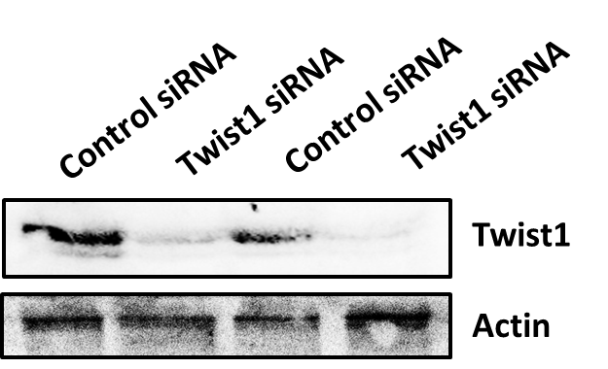
Figure S1: Twist1 expression in the SCC4/control-siRNA and SCC4/Twist1-siRNA cells was detected by Western blot assay.

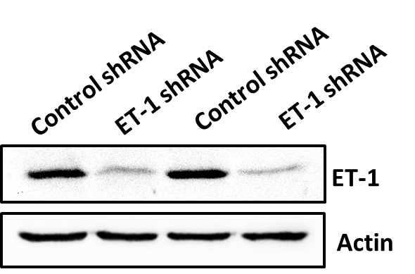
Figure S2: ET-1 proteins expression in the SCC4/control-shRNA and SCC4/ET-1-shRNA cells was detected by Western blot assay.

Figure S3: ET-1 mRNA expression in the SCC4/control-shRNA and SCC4/ET-1-shRNA cells was detected by q-PCR assay.

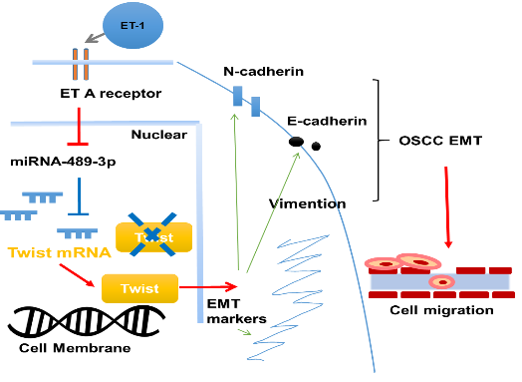
Figure S4: A schematic model depicting how ET-1 regulates EMT functioning in OSCC cells. The modeling shows two potential signaling pathways underlying OSCC-derived ET-1 regulation of EMT activation: (1) ET-1 induces Twist1 expression via the ETAR signaling pathway, which in turn activates EMT functioning; (2) ET-1 also inhibits miR-489-3p-induced downregulation of Twist1 mRNA translation and thus stimulates Twsit1 protein expression and EMT activation.

Table S1: List of mRNA primers
mRNA Primer
Glyceraldehyde-3-phosphate dehydrogenase (GAPDH):
(Forward) 5’-AGCCACATCGCTCAGACAC-3’
(Reverse) 5’-GCCCAATACGACCAAATCC-3’
Endothelin-1(ET-1):
(Forward) 5’-CCGAGCACGTTGTTCCGTAT-3'
(Reverse) 5’-CATGGTCTCCGACCTGGTTT-3'
E-cadherin:
(Forward) 5’-CCCACCACGTACAAGGGTC-3'
(Reverse) 5'-CTGGGGTATTGGGGGCATC-3'
N-cadherin:
(Forward) 5'-CAACTTGCCAGAAAACTCCAGG-3'
(Reverse)5'-ATGAAACCGGGCTATCTGCTC-3'
Twist:
(Forward) 5'-GTCCGCAGTCTTACGAGGAG-3'
(Reverse) 5'-GCTTGAGGGTCTGAATCTTGCT-3'
Vimentin:
(Forward)5'-CGCCAGATGCGTGAAATGG-3'
(Reverse)5'-ACCAGAGGGAGTGAATCCAGA-3'

Table S2: List of miRNA primers
microRNA primer
miR-27a: 5’-TTCACAGTGGCTAAGTTCCGC-3’
miR-27b: 5’-TTCACAGTGGCTAAGTTCTGC-3’
miR-33a: 5’-GTGCATTGTAGTTGCATTGCA-3’
miR-33b: 5’-GTGCATTGCTGTTGCATTGC-3’
miR-300: 5’-TATACAAGGGCAGACTCTCTCT-3’
miR-410: 5’-AATATAACACAGATGGCCTGT-3’
miR-494: 5’-TGAAACATACACGGGAAACCTC-3’

