Supplementary materials
Se@SiO₂ nanocomposite exerts neuroprotection in ICH mice. Yong Yang et al.
A selenium nanocomposite protects the mouse brain from oxidative injury following intracerebral hemorrhage

Yong Yang^{1,}*, Guoying Deng^{2,}*, Peng Wang¹, Guangzhao Lv¹, Rui Mao¹, Yuhao Sun³, Baofeng Wang³, Xijian Liu⁴, Liuguan Bian³, Dong Zhou¹

¹ Department of Neurosurgery, Guangdong Provincial People’s Hospital, Guangdong Academy of Medical Sciences, Guangzhou 510080, China
² Trauma Center, Shanghai General Hospital, Shanghai Jiao Tong University, School of Medicine,
Shanghai 201620, China
³ Department of Neurosurgery, Ruijin Hospital, Shanghai Jiao Tong University, School of Medicine, Shanghai 200025, China
⁴ College of Chemistry and Chemical Engineering, Shanghai University of Engineering Science, Shanghai, 201620, China

*These authors contribute equally to this work.

Correspondence:

Liuguan Bian, M.D., Ph.D.
Department of Neurosurgery, Ruijin Hospital,
Shanghai Jiao Tong University, School of Medicine,
197 Rui Jin Er Road, Shanghai 200025, China.
Tel: +86 21 64370045 666091
Fax: +86 21 64333548
E-mail: blg11118@rjh.com.cn

Dong Zhou, M.D., Ph.D.
Department of Neurosurgery, Guangdong Provincial People’s Hospital, Guangdong Academy of Medical Sciences,
No.106 Zhongshan Er Road, Yuexiu District, Guangzhou, 510080, China.
E-mail: zhoudong5413@163.com
Tel: +86 20 83827812 61521

Evaluation of the BBB penetration of Se@SiO₂
Se@SiO₂ was given to 56 control mice and 56 ICH (1d post induction) mice by intraperitoneal injection at a dose of 1 mg/kg. Then the mice were sacrificed at timepoint 0, 1, 3, 6, 12, 24, 48 h post injection. The venous blood was removed from the brain tissue by perfusion with saline through the left ventricle. Then the whole brain was weighted and solubilized by aqua regia for ICP-AES measurement to determine the Se content. In additional experiment, Se@SiO₂ was given to 10 control mice by intraperitoneal injection at a dose of 1 mg/kg. The mice were sacrificed at 3 h post injection. Following perfusion, the brain tissues were harvested and the cortex, striatum, hippocampus and cerebellum were separated under a stereomicroscope. Then Se content was measured in the separated tissues. The concentration of Se was expressed in Se content (μg) / tissue weight (g) / Se@SiO₂ injected (mg). The results were expressed as the mean ± standard deviation and presented in Figure S1.

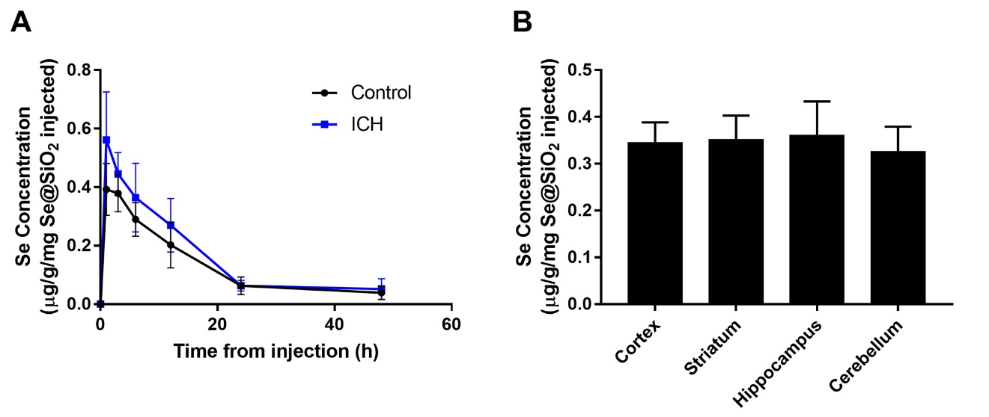
Figure S1 Se concentration detected in the whole brain and tissues from different brain regions of the mice received Se@SiO₂ intraperitoneal injection.
Notes: (A) Se concentration detected in the whole brain of control and ICH mice at the time point of 0, 1, 3, 6, 12, 24, 48 h post intraperitoneal injection of 1 mg/kg Se@SiO₂. The mean concentration was plotted into histogram (n=8). No significance between control and ICH group was found. (B) Se concentration detected in the cortex, striatum, hippocampus and cerebellum of control mice at the time point of 3 h post intraperitoneal injection of 1 mg/kg Se@SiO₂. The mean concentration was plotted into histogram (n=10). No significance between different brain regions was found.

