Supplementary materials

Supplement 1: Flowchart
Supplement 2: Performance of non-imputed machine learning models
Supplement 3: Missing variables
Supplement 4: Distribution of blood culture through the admission period

Supplement 1: Flowchart
Figure S1 Flowchart
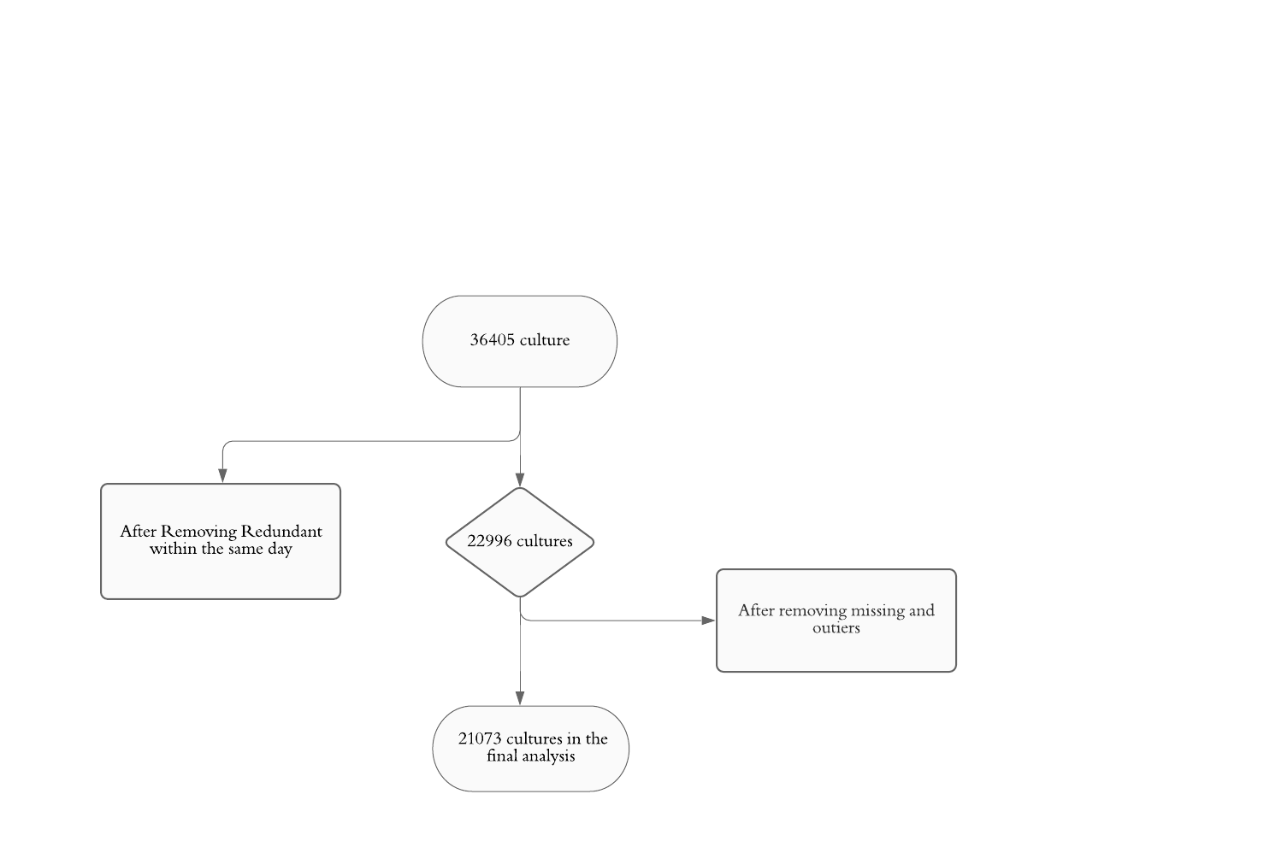
Supplement 2: Performance of non-imputed machine learning models (n = 10516)
Table S1 Performance of non-imputed machine learning models (n = 10516)
Algorithm | Accuracy | Precision | Specificity | Sensitivity | AUC
Decision Tree | 0.80 | 0.08 | 0.85 | 0.15 | 0.50
SVM | 0.92 | - | 1 | 0 | 0.50
Random Forest | 0.77 | 0.13 | 0.81 | 0.35 | 0.58
Logistic Regression | 0.67 | 0.11 | 0.69 | 0.45 | 0.57
NN | 0.75 | 0.14 | 0.78 | 0.40 | 0.59
NB | 0.80 | 0.11 | 0.85 | 0.23 | 0.54
Abbreviations: SVM: Support Vector Machine, NN: Neural Networks, NB: naïve Bayes.

Supplement 3: Missing variables
Among data for 22996 episodes of blood cultures, those are the missing numbers of the variables.

Table S2 Missing variables
Among data for 22996 episodes of blood cultures, those are the missing numbers of the variables.

Variable | Number of missing
Platelet Count | 2191
White Blood Cell Count | 2191
Albumin Level | 5109
Creatinine Level | 2203
Sodium Level, Serum | 2220
Respiratory rate | 892
SBR | 1154
TEMP | 1267
DBR | 1152
HR | 931
Lactic Acid Level | 14855
CRP Level | 18621
Procalcitonin Level | 21846
- SBR: Systolic blood pressure, DBR: diastolic blood pressure, HR: heart rate.
Supplement 4: Distribution of blood culture through the admission period
Figure S2 Distribution of blood culture through the admission period

