ORIGINAL RESEARCH

Supporting Information

Enzyme-functionalized mesoporous silica nanoparticles to target Staphylococcus aureus and disperse biofilms

Henry Devlin^{1, *}, Stephanie Fulaz^{1, *}, Dishon Hiebner¹, James P O'Gara², Eoin Casey¹

¹ UCD School of Chemical and Bioprocess Engineering, University College Dublin, Ireland;
² Department of Microbiology, School of Natural Sciences, National University of Ireland, Galway, Ireland.

*These authors contributed equally to this work.

Correspondence: Eoin Casey
UCD School of Chemical and Bioprocess Engineering, University College Dublin, Belfield, Dublin 4, Ireland
Email eoin.casey@ucd.ie
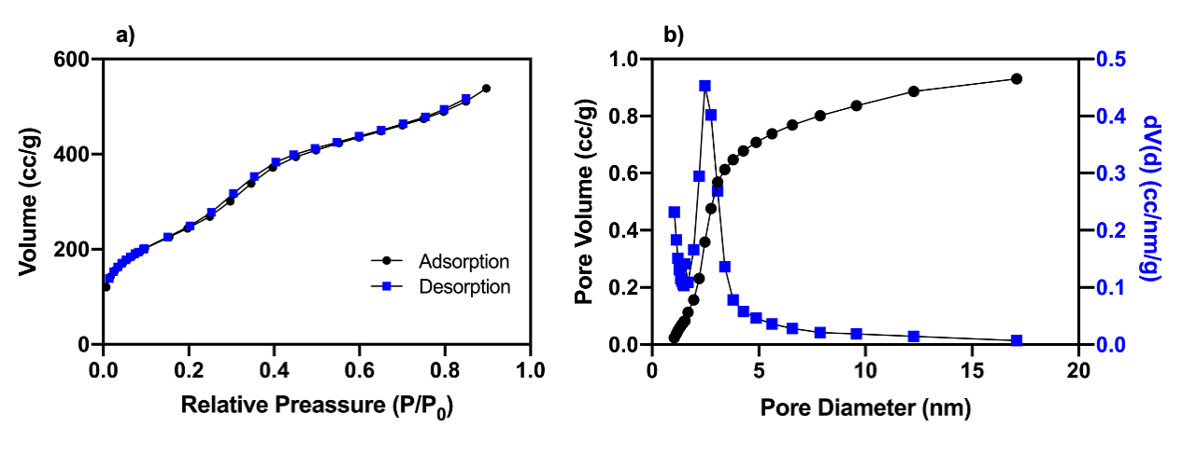
Figure S1. (a) BET nitrogen adsorption-desorption isotherms and (b) BJH pore size distribution of MSNs.
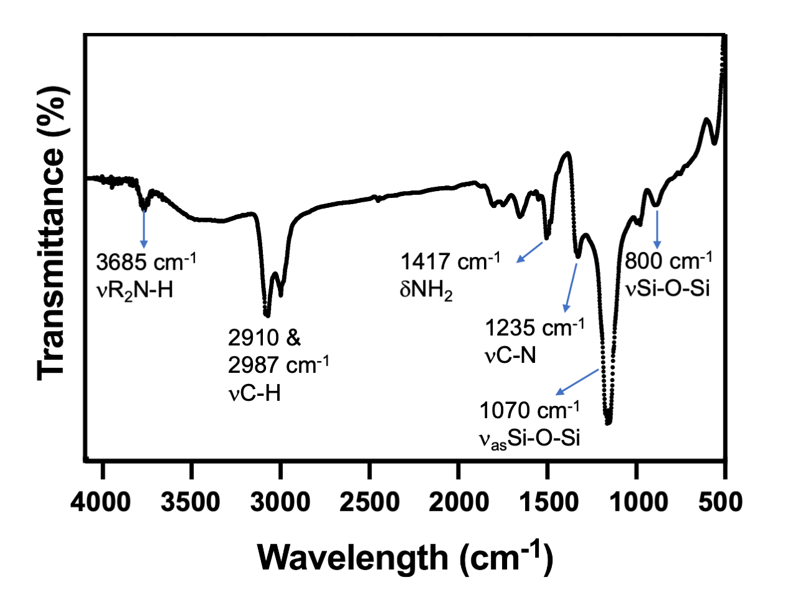
Figure S2. FT-IR spectrum of Amine-functionalized MSNs.
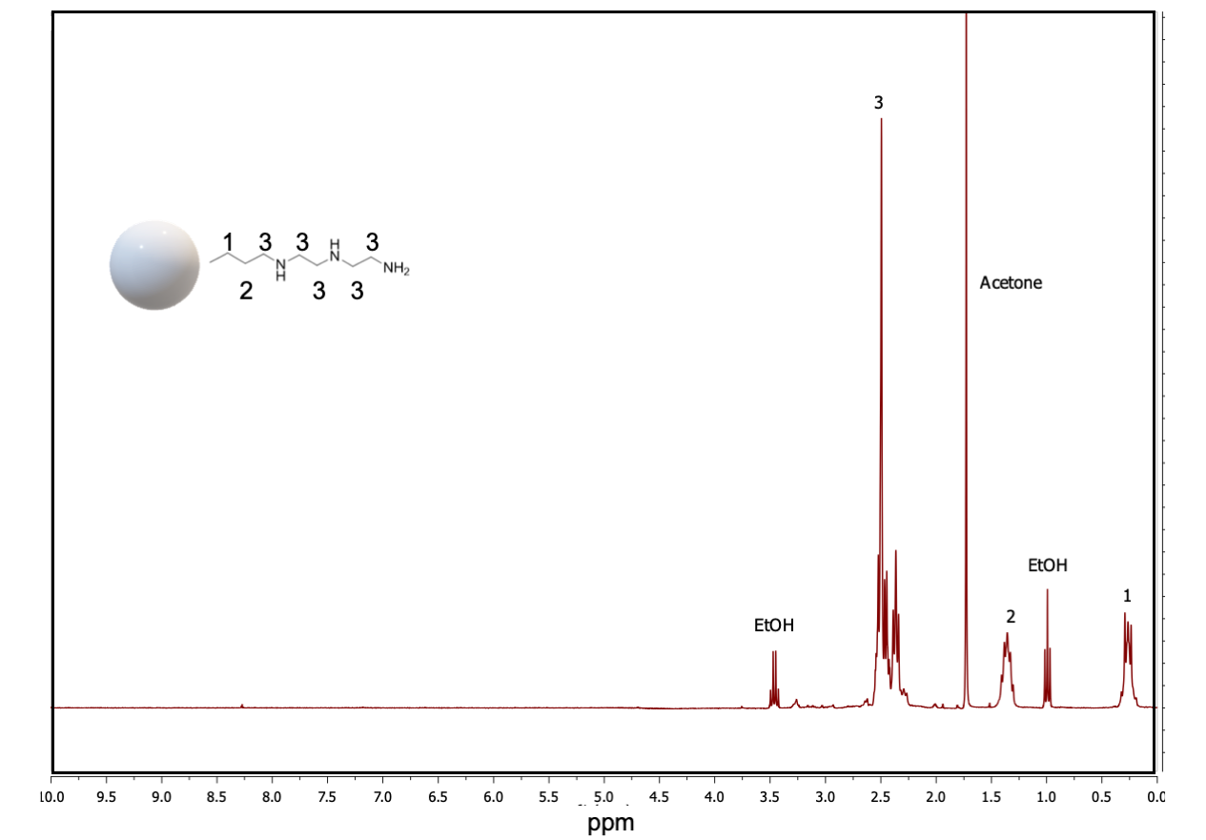
Figure S3. ¹H NMR spectrum of Amine-functionalized MSNs.

Table S1. Antimicrobial effects of free Lysostaphin, Serrapeptase and DNase I and enzyme loaded MSNs against MRSA and MSSA planktonic bacteria determined by minimum inhibitory concentration (MIC) and minimum biofilm inhibitory concentration (MBIC). Values for MIC and MBIC in relation to the final concentration of enzyme used (µg mL⁻¹).

 | Lys  (µg mL⁻¹) |  | Ser  (µg mL⁻¹) |  | DNase I  (µg mL⁻¹) |  | Lys@MSN  (µg mL⁻¹) |  | Ser@MSN  (µg mL⁻¹) |  | DN@MSN  (µg mL⁻¹) |  | MSN unloaded  (µg mL⁻¹)
Strain | MIC | MBIC | MIC | MBIC | MIC | MBIC | MIC | MBIC | MIC | MBIC | MIC | MBIC | MIC | MBIC
MRSA | 0.15 | 0.2 | N/A | 20 | N/A | 7 | 0.02 | 0.04 | N/A | 4.3 | N/A | 2.2 | >1000 | >1000
MSSA | 0.1 | 0.15 | N/A | 35 | N/A | 40 | 0.02 | 0.04 | N/A | 10.8 | N/A | 5.9 | >1000 | >1000
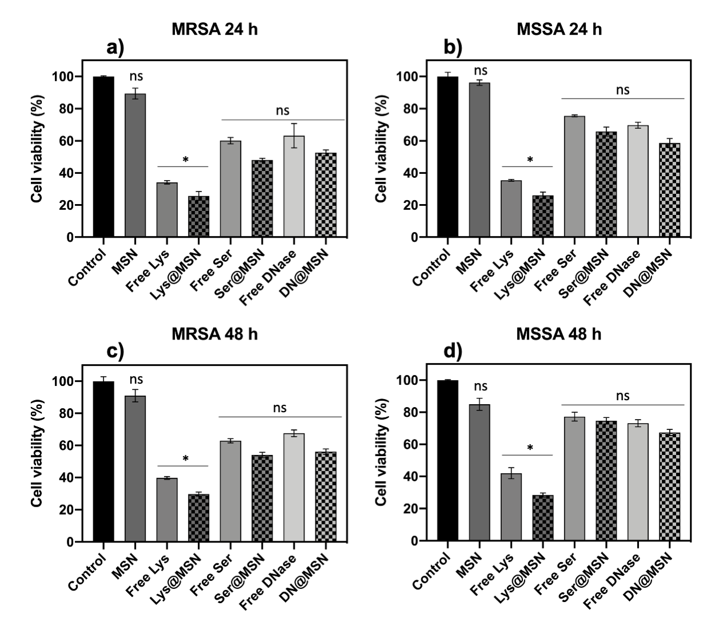
Figure S4. Cell viability of (a) 24 h MRSA, (b) 24 h MSSA (c) 48 h MRSA and (d) 48 h MSSA biofilm cells after exposure enzyme-loaded MSNs (0.5 mg mL⁻¹) and free enzymes (at a concentration equal to that loaded on to the MSNs), as determined by MTT assay. Error bars represent standard error of the mean (n = 3). * represent a significant difference in antibacterial activity between test conditions, ns represents no significant difference between test conditions, p < 0.05.

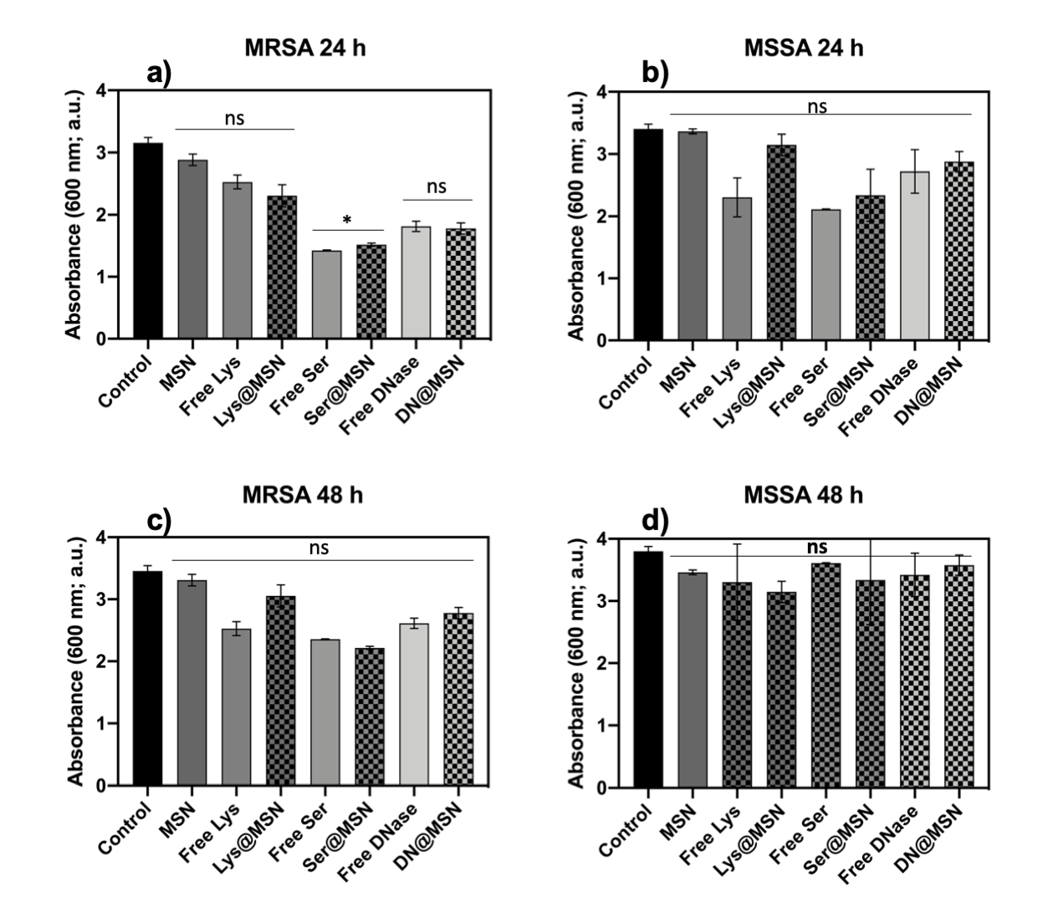
Figure S5. Biomass removal of (a) 24 h MRSA, (b) 24 h MSSA (c) 48 h MRSA and (d) 48 h MSSA biofilm cells after exposure enzyme-loaded MSNs (0.5 mg mL⁻¹) and free enzymes (at a concentration equal to that loaded on to the MSNs), as determined by CV staining. Error bars represent standard error of the mean (n = 3).* represent a significant difference in antibacterial activity between test conditions, ns represents no significant difference between test conditions, p < 0.05.

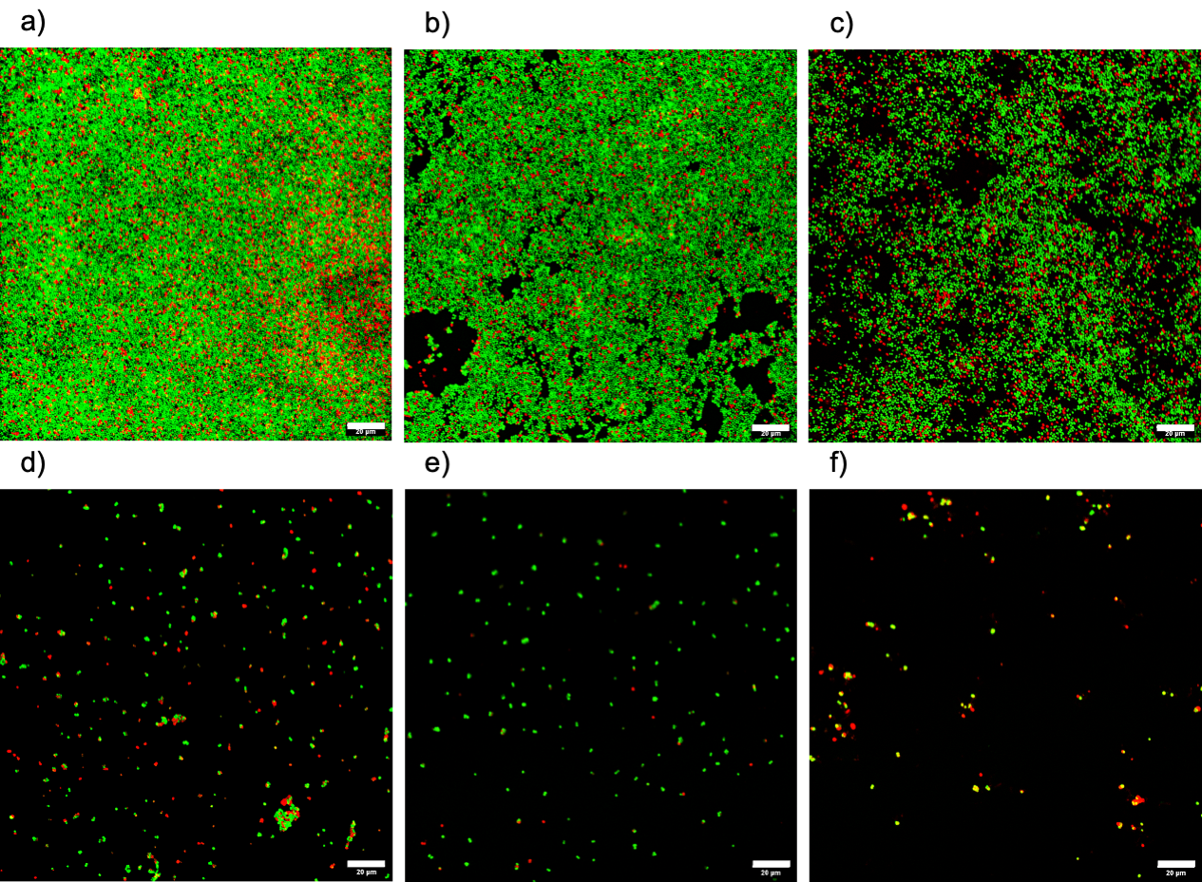
Figure S6. CLSM images of 48 h MRSA biofilms after exposure to enzyme-loaded MSNs (all concentrations in mg mL⁻¹), for 24 h. a) control, b) 0.25 (Lys + DNase I) MSNs, c) 0.5 (Lys + DNase I) MSNs, d) 0.25 (Lys + Ser) MSNs, e) 0.5 (Lys + Ser) MSNs and f) 0.33 (Lys + Ser + DNase I) MSNs. Live bacterial cells (green) are stained using SYTO 9 while dead cells (red) are stained with Propidium iodide. Scale bars represent 20 μm.
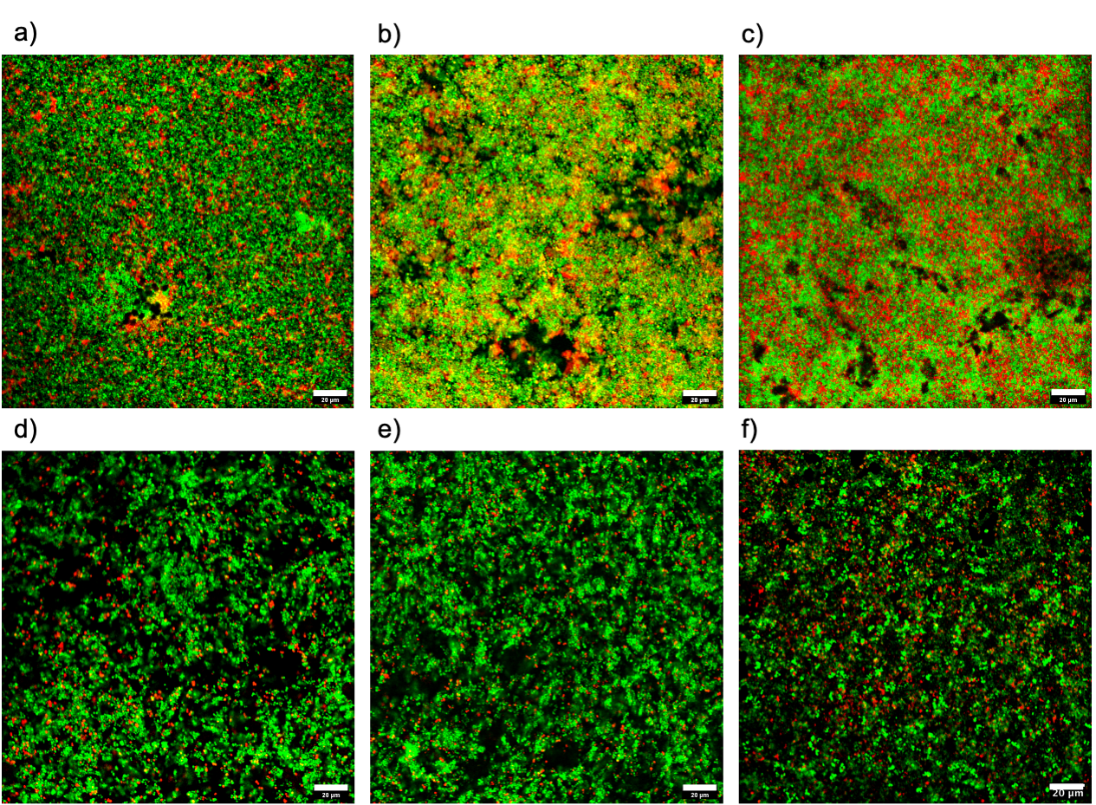
Figure S7. CLSM images of 48 h MSSA biofilms after exposure to enzyme-loaded MSNs (all concentrations in mg mL⁻¹), for 24 h. a) control, b) 0.25 (Lys + DNase I) MSNs, c) 0.5 (Lys + DNase I) MSNs, d) 0.25 (Lys + Ser) MSNs, e) 0.5 (Lys + Ser) MSNs and f) 0.33 (Lys + Ser + DNase I) MSNs. Live bacterial cells (green) are stained using SYTO 9 while dead cells (red) are stained with Propidium iodide. Scale bars represent 20 μm.

