Supplementary Figure 1 Examples of screens available in Uveite.pt
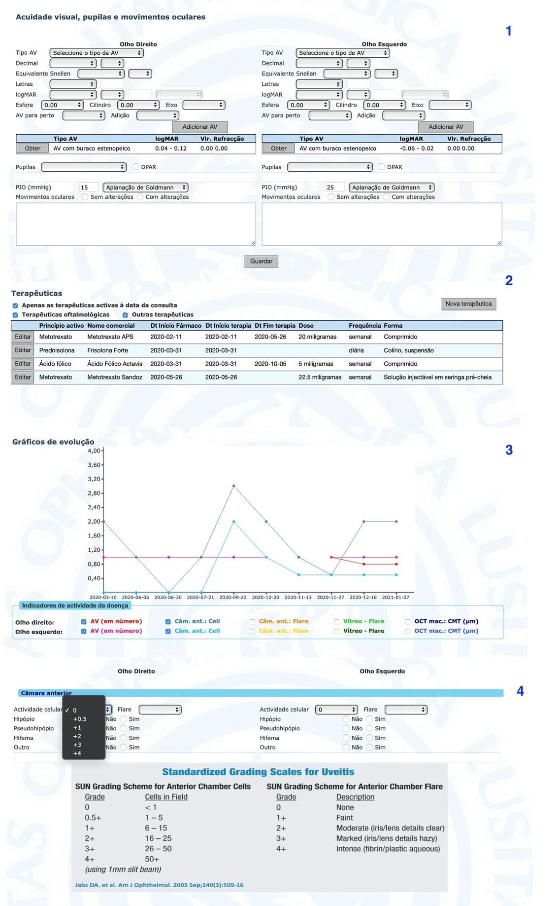
From Top to bottom: 1) visual acuity and intra-ocular pressure screen, 2) table with treatment history screen (name, data of onset and termination, dose and frequency of drugs that have been prescribed), 3) Follow-up automatically generated graphs with possibility of visualizing visual acuity, anterior chamber cell, anterior chamber flare, vitreous haze and central macular thickness in time 4) anterior chamber cell and flare records screen

