Supplementary table S1: Relation between oral steroid use (A)/antibiotic use (B)/overnight hospital stays (C)/emergency department visits (D) and SABA use adjusted for confounders (n=736)

Predictors | Coefficients (SE) | p-value | OR | 95% CI for OR
 |  |  |  | Lower | Upper
A: Relation between oral steroid use and SABA use adjusted for confounders
SABA use  (0= low SABA users; 1= high SABA user) | 1.056 (0.189) | P<0.001 | 2.874 | 1.984 | 4.162
Age | 0.003 (0.009) | 0.109 | 1.003 | 0.985 | 1.022
Gender (0= male; 1= female) | -0.759 (0.198) | P<0.001 | 0.468 | 0.318 | 0.689
Using ICS containing treatment  (0= not using ICS; 1= using ICS) | 0.303 (0.202) | 0.135 | 1.354 | 0.910 | 2.012
Years since asthma diagnosis  (0= <1 years ago; 1= ≥1 years ago) | 0.592 (0.376) | 0.116 | 1.898 | 0.864 | 3.780
Comorbidity Index | 0.268 (0.116) | 0.021 | 1.307 | 1.042 | 1.640
B: Relation between antibiotic use and SABA use adjusted for confounders
SABA use  (0= low SABA users; 1= high SABA user) | 0.562 (0.157) | P<0.001 | 1.754 | 1.289 | 2.387
Age | -0.003 (0.008) | 0.706 | 0.997 | 0.981 | 1.013
Gender (0= male; 1= female) | -0.204 (0.175) | 0.244 | 0.815 | 0.578 | 1.150
Using ICS containing treatment  (0= not using ICS; 1= using ICS) | 0.087 (0.172) | 0.613 | 1.091 | 0.779 | 1.529
Smoking status (0= no smoker; 1= smoker) | 0.251 (0.177) | 0.156 | 1.286 | 0.909 | 1.818
Comorbidity Index | 0.430 (0.116) | P<0.001 | 1.537 | 1.226 | 1.928
C: Relation between overnight hospital stays and SABA use adjusted for confounders
SABA use  (0= low SABA users; 1= high SABA user) | 1.850 (0.539) | 0.001 | 6.360 | 2.211 | 18.294
Gender (0= male; 1= female) | -1.356 (0.349) | P<0.001 | 0.258 | 0.130 | 0.511
Using ICS containing treatment  (0= not using ICS; 1= using ICS) | -0.562 (0.355) | 0.113 | 0.570 | 0.284 | 1.142
Comorbidity Index | 0.490 (0.184) | 0.008 | 1.633 | 1.139 | 2.342
D: Relation between emergency department visits and SABA use adjusted for confounders
SABA use  (0= low SABA users; 1= high SABA user) | 1.530 (0.356) | P<0.001 | 4.616 | 2.296 | 9.282
Gender (0= male; 1= female) | -1.283 (0.268) | P<0.001 | 0.277 | 0.164 | 0.469
Using ICS containing treatment  (0= not using ICS; 1= using ICS) | -0.073 (0.286) | 0.800 | 0.930 | 0.531 | 1.630
Comorbidity Index | 0.617 (0.143) | P<0.000 | 1.854 | 1.401 | 2.453

Abbreviations: SABA, Short-acting Beta-agonist; SE, standard error; OR, Odds ratio; CI, Confidence interval; ICS, Inhaled corticosteroids
Notes: The confounders comorbidity index, smoking status and number of years since asthma diagnosis were added to the models based on their relation (p<0.20) with the dependent or independent variable. The variable age was not added to model B since the linearity assumption was not met.

Supplementary Table S2: Demographics and characteristics as reported by respondents, of the total group of asthma patients including those with co-diagnosis of COPD (n=817), according to SABA use
 | Respondents with <3 SABA (low-SABA users) in the last week  38.2% (n=312) | Respondents with ≥3 SABA (high-SABA users) in the last week  61.8% (n=505) | P valuesª
Gender, % (n)
Female | 75.0% (n=234) | 70.7% (n=357) | P=0.181
Male | 25.0% (n=78) | 29.3% (n=148) | P=0.181
Age, years, median [range] | 35 [26-43] | 39 [29-45] | P<0.001
Age range, years, % (n)
18 – 25 | 24.0% (n=75) | 15.6% (n=79) | P=0.003
26 – 40 | 42.3% (n=132) | 39.6% (n=200) | P=0.003
41 – 50 | 33.7% (n=105) | 44.8% (n=226) | P=0.003
Year since asthma diagnosis, % (n)
Data available | 83.0% (n=259) | 87.5% (n=442)
1 or less | 5.4% (n=14) | 7.7% (n=34) | P=0.158
2 – 5 | 13.1% (n=34) | 10.0% (n=44) | P=0.158
6 – 10 | 16.2% (n=42) | 12.2% (n=54) | P=0.158
11 or more | 65.3 (n=169) | 70.1% (n=310) | P=0.158
Current smokers, % (n) | 26.0% (n=81) | 27.3% (n=138) | P=0.365
Co-morbidities*, % (n)
COPD | 5.8% (n=18) | 12.5% (n=63) | P=0.002
Diabetes | 4.8% (n=15) | 8.9% (n=45) | P=0.029
Depression | 15.7% (n=49) | 17.4% (n=88) | P=0.522
Heart disease | 2.2% (n=7) | 4.2% (n=21) | P=0.144
High blood pressure | 8.3% (n=26) | 14.7% (n=74) | P=0.007
Rheumatoid arthritis | 5.1% (n=16) | 10.7% (n=54) | P=0.006
Cancer | 0.6% (n=2) | 2.8% (n=14) | P=0.033
Comorbidity Index
0 | 0.0% (n=0) | 0.0% (n=0) | P=0.338
1 | 33.3% (n=6) | 38.1% (n=24) | P=0.338
2 | 33.3% (n=6) | 38.1% (n=24) | P=0.338
3 | 16.7% (n=3) | 9.5% (n=6) | P=0.338
4 | 11.1% (n=2) | 1.6% (n=1) | P=0.338
5 | 0.0% (n=0) | 0.0% (n=0) | P=0.338
6 | 5.6% (n=1) | 4.8% (n=3) | P=0.338
7 | 0.0% (n=0) | 0.0% (n=0) | P=0.338
8 | 0.0% (n=0) | 7.9% (n=5) | P=0.338
Treatment type#, % (n)
Reliever (SABA) | 75.0% (n=234) | 74.3% (n=375) | P=0.942
Preventer (ICS) | 41.3% (n=129) | 48.5% (n=245) | P=0.051
Combination inhaler (ICS/LABA) | 26.0% (n=81) | 34.9% (n=176) | P=0.008
Oral treatment | 7.1% (n=22) | 20.4% (n=103) | P<0.001
Other asthma medication | 5.8% (n=18) | 16.0% (n=81) | P<0.001
Abbreviations: SABA, short-acting beta2 agonist; COPD, chronic obstructive pulmonary disease; ICS, inhaled corticosteroids; LABA, long acting beta2 agonist; *, self-reported as having been diagnosed by a doctor; ª, p values are two sided for the difference between <3 SABA and ≥3 SABA groups;
# Which of the following treatments do you currently take to help manage your asthma? - multiple answers possible

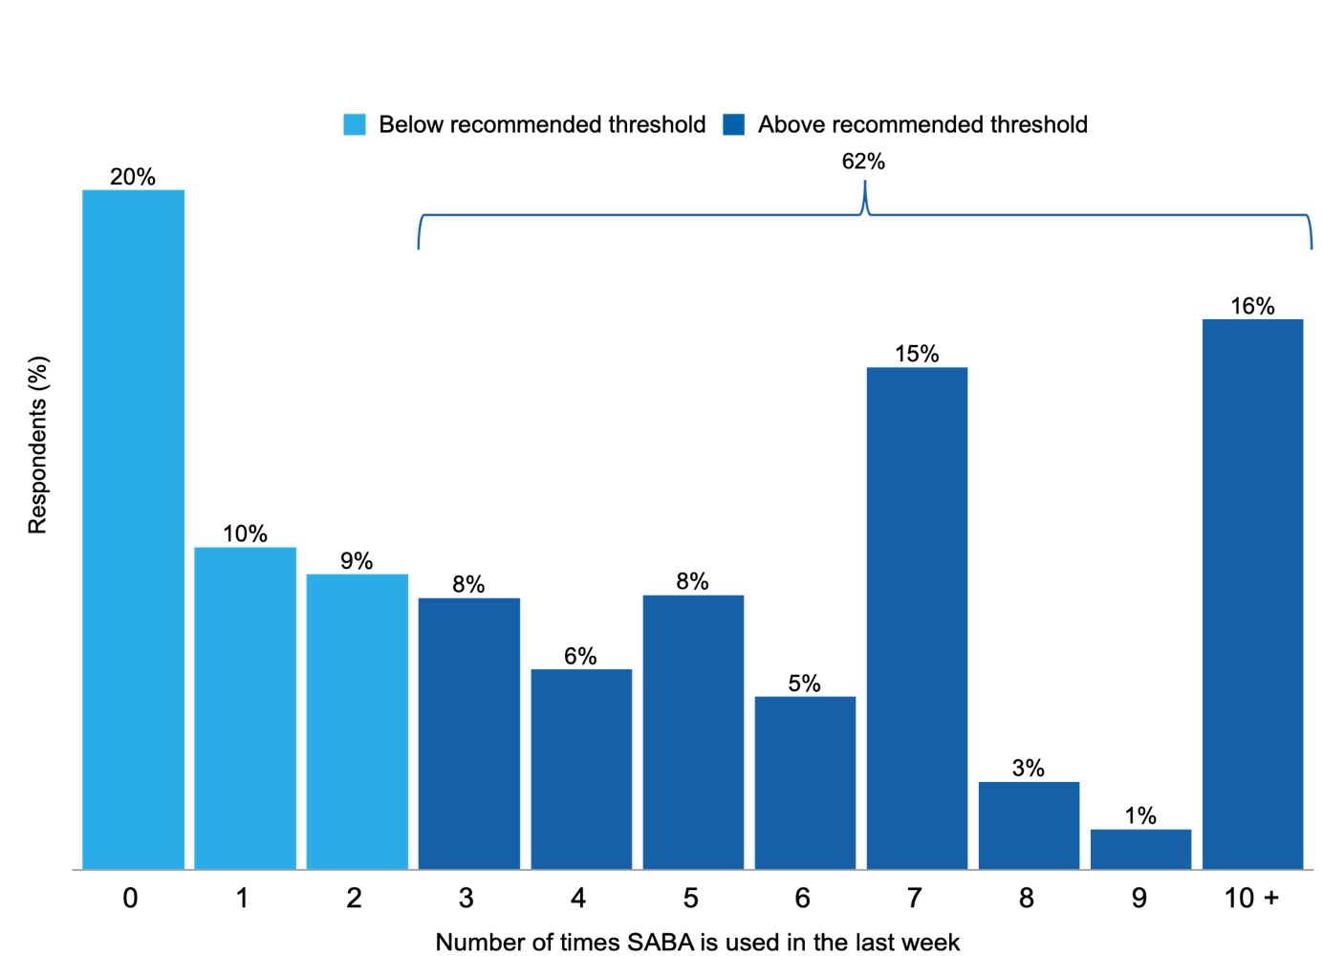

Supplementary Figure S1: SABA usage in the last week of the total group of asthma patients including those with co-diagnosis of COPD (n=817)
Notes: Survey question: “Thinking about the last week. How many times have you used your reliever inhaler? (This is usually a blue colour)”; The reported percentages are rounded to whole numbers

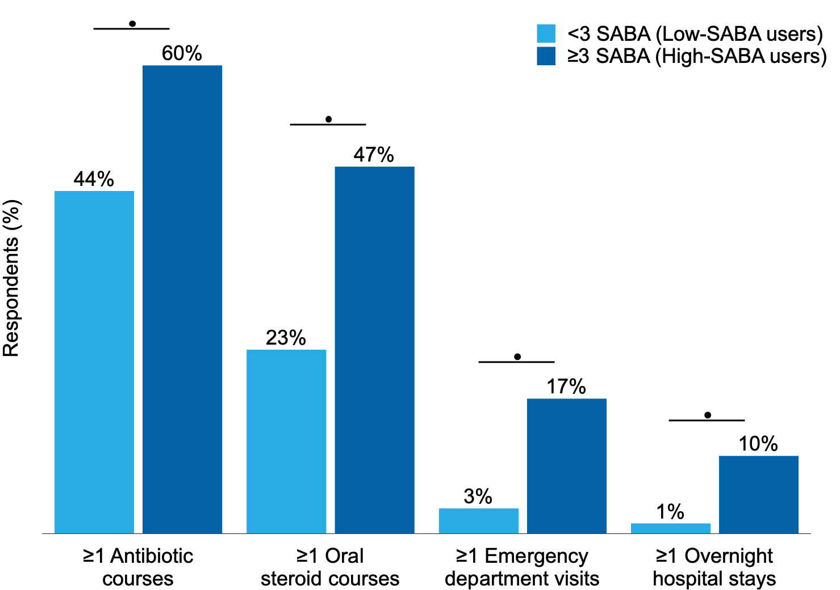
Supplementary Figure S2: Indicators of exacerbations, of the total group of asthma patients including those with co-diagnosis of COPD (n=817), according to SABA use (<3 times or ≥3 times/week)

Abbreviations: , significant difference p<0.001
Notes: <3 SABA (Low-SABA users) n=312; ≥ 3 SABA (High-SABA users) n=505; P values are two sided; The reported percentages are rounded to whole numbers

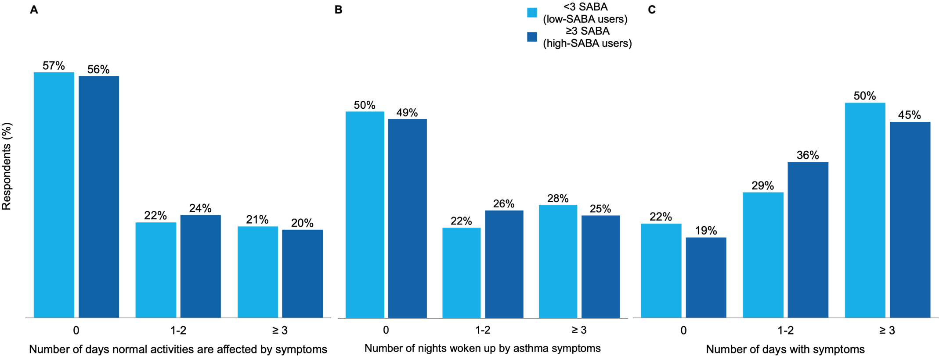

Supplementary Figure S3: Indicators of asthma symptoms, of the total group of asthma patients including those with co-diagnosis of COPD (n=817) according to SABA use (<3 or ≥3 times/week)
Notes: <3 SABA (Low-SABA users) n=312; ≥3 SABA(High-SABA users) n=505;
P values are two sided, A: p=0.858, B: p=0.377, C: p= 0.081; The reported percentages are rounded to whole numbers

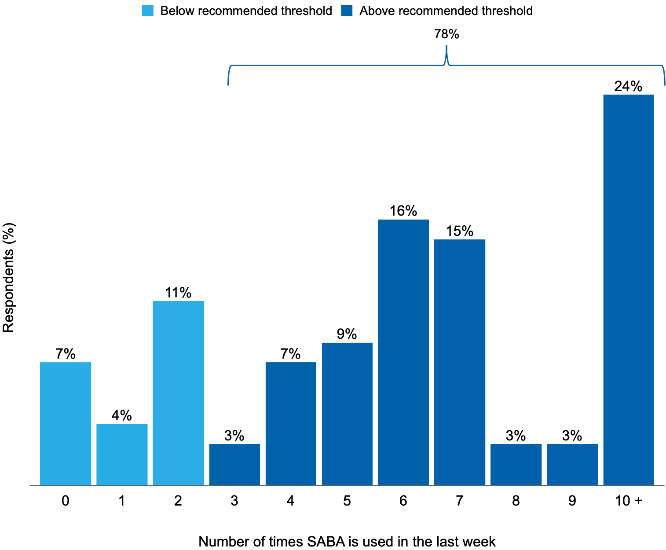

Supplementary figure S4: SABA usage in the last week (n=81)
Notes: Survey question: “Thinking about the last week. How many times have you used your reliever inhaler? (This is usually a blue colour)”; The reported percentages are rounded to whole numbers

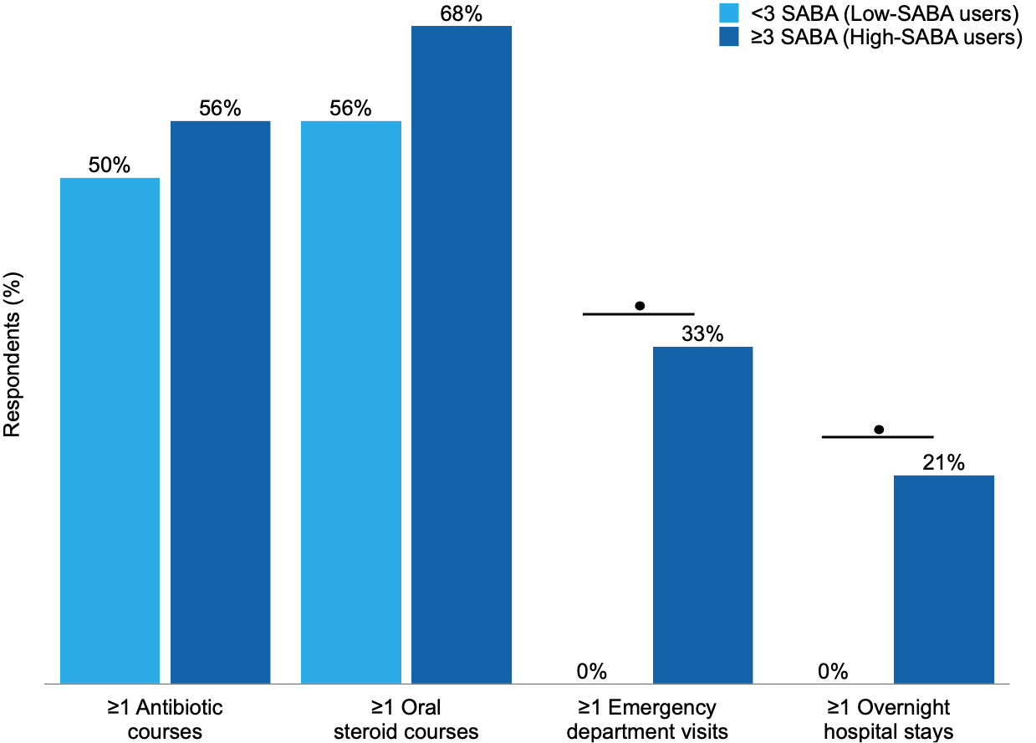

Supplementary figure S5: Indicators of exacerbations (n=81), according to SABA use (<3 times or ≥3 times/week)
Abbreviations: , significant difference p<0.001
Notes: <3 SABA (Low-SABA users) n=18; ≥ 3 SABA (High-SABA users) n=63;
P values are two sided; The reported percentages are rounded to whole numbers

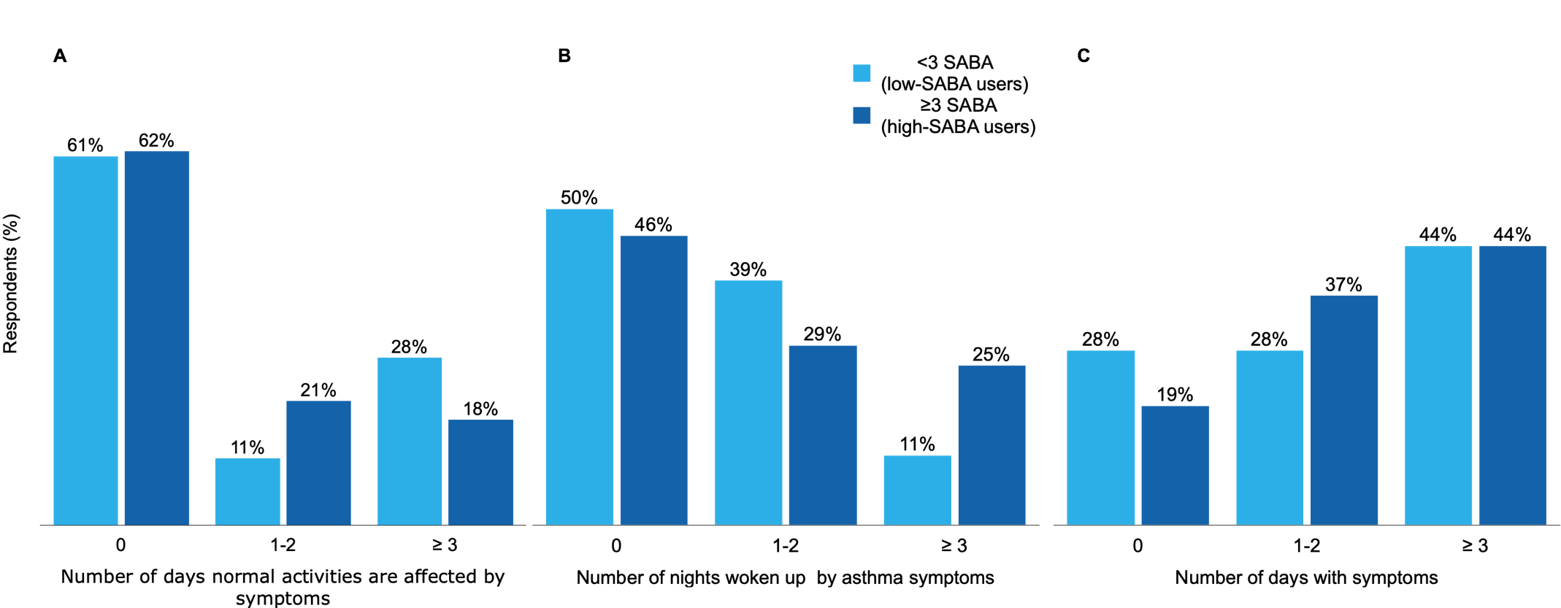

Supplementary figure S6: Indicators of asthma symptoms (n=81), according to SABA use (<3 or ≥3 times/week)
Notes: <3 SABA (Low-SABA users) n=18; ≥3 SABA(High-SABA users) n=63;
P values are two sided, A: p=0.486, B: p=0.403, C: p= 0.665; The reported percentages are rounded to whole numbers

