Synthesis of Michael adducts as key building blocks for potential analgesic drugs. In-vitro, in-vivo and in-silico explorations
Sajjad Ahmad¹, Mater H. Mahnashi², Bandar A. Alyami², Yahya S. Alqahtani², Farhat Ullah¹, Muhammad Ayaz¹, Muhammad Tariq³, Abdul Sadiq*¹, Umer Rashid⁴**

¹Department of Pharmacy, Faculty of Biological Sciences, University of Malakand, Chakdara, 18000 Dir (L), KP Pakistan.
²Department of Pharmaceutical Chemistry, College of Pharmacy, Najran University, Najran, Saudi Arabia.
³Department PCB, Rokhan University, Jalalabad, Nangrahar, Afghanistan.
⁴Department of Chemistry, COMSATS University Islamabad, Abbottabad Campus, 22060 Abbottabad, Pakistan.

Corresponding authors:
*Dr. Abdul Sadiq, Associate Professor, Department of Pharmacy, Faculty of Biological Sciences, University of Malakand, Chakdara, 18000 Dir (L), KP Pakistan
Contact: 0092 301 2297 102; Email: sadiquom@yahoo.com;
**Dr. Umer Rashid (umerrashid@cuiatd.edu.pk)

Supporting information

Figure S1: ¹H NMR spectrum of (S)-2-((S)-2,5-dioxo-1-phenylpyrrolidin-3-yl)-2-methylpentanal (Compound 4).

Figure S2: HPLC spectrum of achiral compound showing the separated enantiomers and diastereomers (Compound 4).
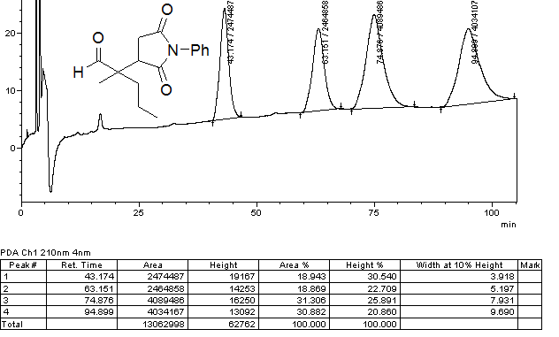
Figure S3: HPLC spectrum of chiral compound after crystallization showing the enantiopure single diastereomer (Compound 4).
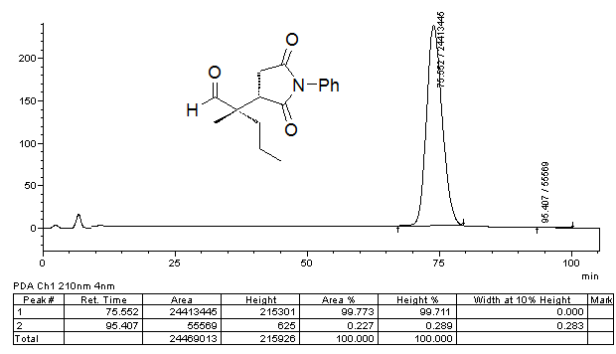

Figure S4: ¹H NMR spectrum of compound 9.
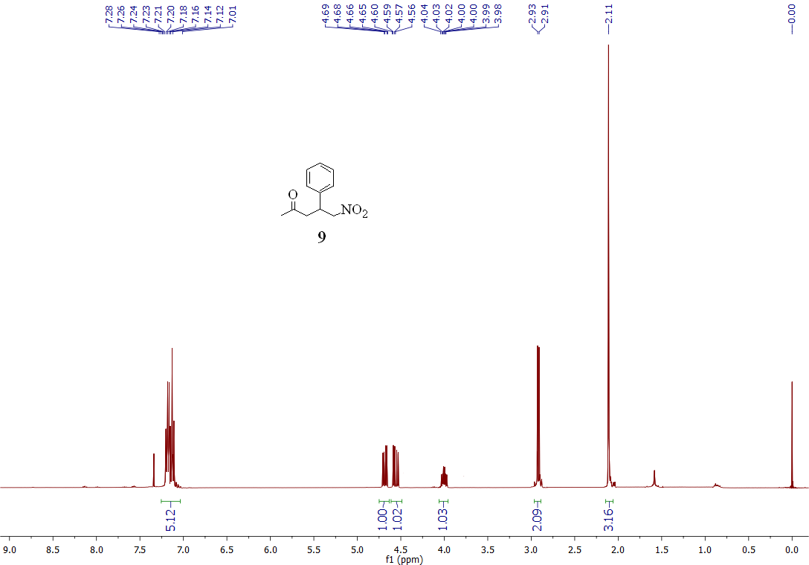

Figure S5: ¹H NMR spectrum of compound 10.

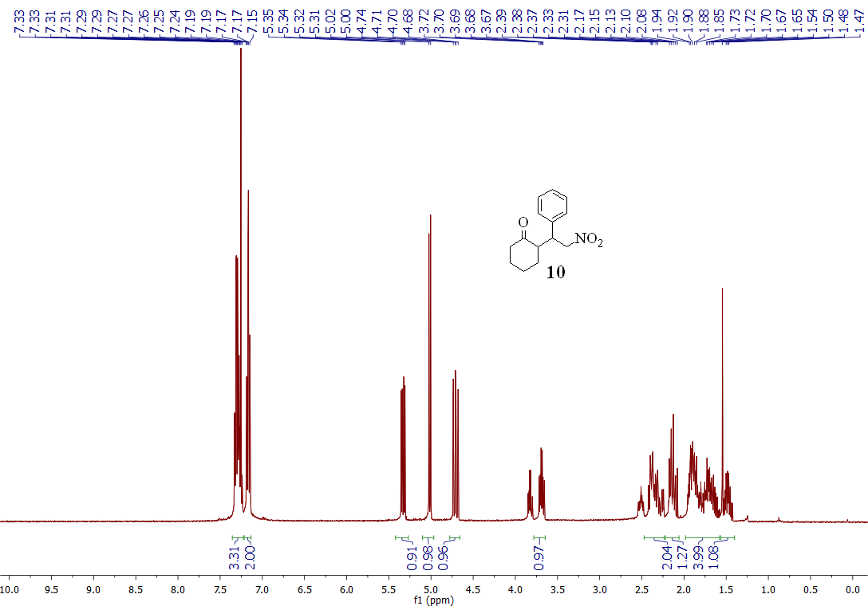

Table S-1: Meta-Pred Web Server prediction results of site of metabolism for enzyme UGT
Date of prediction is 2017-08-11
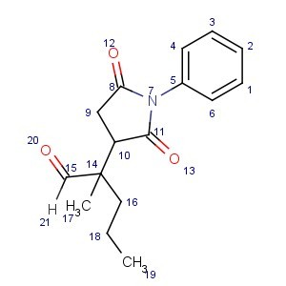

Atom Number | Rank | DeltaP
14 | 1 | -0,832
10 | 2 | -0,701
16 | 3 | -0,582
4 | 4 | -0,559
6 | 4 | -0,559
18 | 5 | -0,464
1 | 6 | -0,436
3 | 6 | -0,436
5 | 7 | -0,379
11 | 8 | -0,357
8 | 9 | -0,327
2 | 10 | -0,263
19 | 11 | -0,260
9 | 12 | -0,228
15 | 13 | -0,178
17 | 14 | -0,162
7 | 15 | -0,063
13 | 16 | -0,060
20 | 17 | -0,058
12 | 18 | -0,040
21 | 19 | -0,028

Table S-2: Meta-Pred Web Server prediction results of site of metabolism for enzyme CYP3A4
Date of prediction is 2017-08-11

Atom Number | Rank | DeltaP
15 | 1 | 0,874
16 | 2 | 0,183
18 | 3 | 0,164
2 | 4 | 0,043
17 | 5 | 0,008
7 | 6 | -0,929
12 | 7 | -0,874
11 | 8 | -0,873
8 | 9 | -0,815
5 | 10 | -0,764
20 | 11 | -0,676
13 | 12 | -0,663
10 | 13 | -0,625
14 | 14 | -0,509
4 | 15 | -0,398
6 | 15 | -0,398
9 | 16 | -0,378
21 | 17 | -0,291
1 | 18 | -0,156
3 | 18 | -0,156
19 | 19 | -0,038

Table S-3: Meta-Pred Web Server prediction results of site of metabolism for enzyme CYP2D6
Date of prediction is 2017-08-11

Atom Number | Rank | DeltaP
15 | 1 | 0,853
18 | 2 | 0,259
2 | 3 | 0,108
16 | 4 | 0,071
7 | 5 | -0,924
11 | 6 | -0,809
5 | 7 | -0,698
12 | 8 | -0,666
13 | 8 | -0,666
8 | 9 | -0,653
20 | 10 | -0,592
10 | 11 | -0,586
4 | 12 | -0,468
6 | 12 | -0,468
14 | 13 | -0,415
21 | 14 | -0,290
9 | 15 | -0,245
19 | 16 | -0,114
17 | 17 | -0,060
1 | 18 | -0,059
3 | 18 | -0,059

Table S-4: Meta-Pred Web Server prediction results of site of metabolism for enzyme CYP2C9
Date of prediction is 2017-08-11

Atom Number | Rank | DeltaP
15 | 1 | 0,869
18 | 2 | 0,388
16 | 3 | 0,222
17 | 4 | 0,221
19 | 5 | 0,188
2 | 6 | 0,063
11 | 7 | -0,878
5 | 8 | -0,840
7 | 9 | -0,779
8 | 10 | -0,758
12 | 11 | -0,629
13 | 12 | -0,606
4 | 13 | -0,590
6 | 13 | -0,590
10 | 14 | -0,513
9 | 15 | -0,321
1 | 16 | -0,259
3 | 16 | -0,259
14 | 17 | -0,212
21 | 18 | -0,154
20 | 19 | -0,005

Table S-5: Meta-Pred Web Server prediction results of site of metabolism for enzyme CYP2C19
Date of prediction is 2017-08-11

Atom Number | Rank | DeltaP
15 | 1 | 0,376
18 | 2 | 0,370
19 | 3 | 0,242
2 | 4 | 0,156
9 | 5 | 0,042
16 | 6 | 0,014
7 | 7 | -0,887
5 | 8 | -0,715
12 | 9 | -0,651
11 | 10 | -0,643
8 | 11 | -0,603
20 | 12 | -0,506
13 | 13 | -0,467
4 | 14 | -0,452
6 | 14 | -0,452
14 | 15 | -0,243
10 | 16 | -0,145
1 | 17 | -0,124
3 | 17 | -0,124
21 | 18 | -0,051
17 | 19 | -0,014

Table S-6: Meta-Pred Web Server prediction results of site of metabolism for enzyme CYP1A2
Date of prediction is 2017-08-11

Atom Number | Rank | DeltaP
15 | 1 | 0,319
18 | 2 | 0,158
2 | 3 | 0,119
19 | 4 | 0,012
7 | 5 | -0,793
11 | 6 | -0,642
12 | 7 | -0,610
8 | 8 | -0,538
20 | 9 | -0,512
13 | 10 | -0,501
5 | 11 | -0,465
14 | 12 | -0,311
10 | 13 | -0,283
17 | 14 | -0,235
4 | 15 | -0,208
6 | 15 | -0,208
21 | 16 | -0,196
16 | 17 | -0,152
9 | 18 | -0,100
1 | 19 | -0,028
3 | 19 | -0,028

