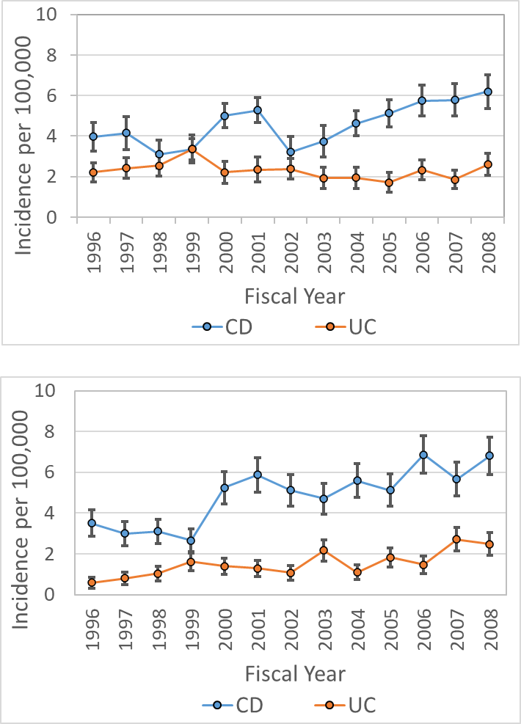
A

B

Supplemental Figure 1 Incidence and prevalence of Crohn’s disease and ulcerative colitis in BC.
Age and sex-standardized incidence of Crohn’s disease (CD, blue) and ulcerative colitis (UC, orange) per 100,000 population in BC estimated in the administrative data cohort (A) and the BCCH clinical registry data cohort (B). Vertical lines represent 95% confidence intervals using gamma distribution.

