SUPPLEMENTAL MATERIAL
SUPPLEMENTAL METHODS AND RESULTS
Subject Details
Testing is done without dilation of the pupils.
Arrows Test
The system automatically recognizes and tabulates whether the subject follows the arrows sequentially or departs from the path. When the subject passes the exit door, the path of arrows disappears and the subject is asked to look again for the starting platform to begin the next test.
Arrows and Obstacles Test
To better understand the mechanistic underpinnings of the patients’ performance, simple shapes and visual attributes were favored, instead of a visually complex virtual scenery, thus limiting main variables to luminance, position and size of objects in the virtual space. To precisely control the luminance of each surface, instead of physics-based lighting, the course presents the arrows, obstacles, and start indicator with unlit rendering. To enable perspective, which is otherwise impossible without a gradient along the surface of an object, a pure black mesh is presented on each object.
Technical Details
The HTC VIVE hardware consists of a wireless headset that can be tracked 360° through which the subject views a 91 mm wide (diagonally) ‘screen’ where two organic LEDs (OLEDs) with a resolution of 2100 x 1200 pixels (90Hz refresh rate) are located in front of each eye.
Scoring the VR Test
The collisions (intersection of a tracker with coordinates of the virtual objects) are measured by each of the 5 trackers worn by the subject (on head, hands and feet). Thus, if the head bumps into a hanging object, that is scored as a collision. Similarly, if either hand or foot collides with an object, that is also scored as a collision. In cases where multiple body parts (both feet or both hands and/or head) intersected with a given object, only the first collision was counted for a given object. For the situation where a subject tries to step over the “stepover” obstacle but strikes it in the process, the foot trackers provide information about the height that each leg was raised. If each leg lift distance is above a “stepover threshold,” then the stepover collision is voided. Similarly, if the subject attempts to duck below a hanging object by dropping his/her head a few inches but grazes it in the process, the designation of collision is voided.
Collisions with all different objects were tabulated but were only counted once for each obstacle. Because the courses were densely packed with obstacles (each course contained 17 different obstacles), it was often difficult even for controls to obtain a perfect collision-free score. For example, while leaning to step over the “stepover obstacle” it was often difficult to avoid bumping one’s hand into a neighboring box. Thus, we counted scores with <3 collisions as passes (as long as the time to complete the test was less than 60 secs).
Videos of the VR-O&M test performances were generated from the custom software built with Unity and captured using IceCream Screen Recorder and then reformatted to MPEG-4 files using The Video Converter software.
Additional Results
General
Volunteers with normal (n=3) vision and patients with severe IRDs (LCA due to CEP290 or RPE65 mutations, n=8) volunteered to test early evolving versions of a VR-O&M test (Supplemental Table 1). The feedback of the participants was used to fine-tune variables of the emerging VR-O&M course, including the overall size of the course, the size and luminance of the starting platform, the range of light levels incorporated and features of the obstacles. For example, the introduction of obstacles resembling open doors on overhead cabinets or drawers below the waist height.
Virtual Reality Orientation and Mobility Performance, Arrow-Only Tests
At the dimmest luminances, patients were allowed to try for about a minute to find the starting platform and if they failed they were guided verbally to orient to the area where the platform stood.
Arrows Plus Objects Tests
The automatic scoring algorithm recognized the incidents appropriately in the majority of the cases. Evaluation errors arose from overcalled collisions. Examples include occasions when an individual swerved or ducked to avoid an obstacle but touched the obstacle in the process, or if a subject waived their arms and inadvertently touched an object they had cleared as they moved forward, as well as instances where the subject swerved to avoid an object and in doing so, accidentally touched another one. Errors did not depend on the height of the patients. We believe that in future studies, accidental collisions can be avoided by reducing the number of obstacles.
Unlike control subjects, untreated patients often needed guidance or extra time in order to find the starting platform and orient themselves to the path (Video S3-pre; S4-pre).
As shown in representative Video S3-pre, this RPE65 subject, VR21, has trouble seeing the obstacles and fails both on the basis of speed and accuracy. Although there was no penalty for time taken before taking the first step, it took 7 secs for the subject to decide where to take that step. This test took a total of 65 secs and involved multiple (>4) collisions and several episodes of going off the path.
Scoring
The design and implementation of the VR-O&M was not without challenges. Although the desire was to have fully-automated detection of the collisions with objects or departures from the path of arrows, there were frequent examples of collisions overcalled by the software that required correction by manual supervision of the videos, which introduces a bias. Several solutions to this problem may involve changes in hardware such as adding additional or different reference points for the software to monitor the position of the subject in space, the introduction of additional controllers as well as software modifications (which have already been implemented) intended to modify the thresholds for detection.

SUPPLEMENTAL TABLE 1
Supplemental Table 1. Subjects that underwent testing during design stages

Pt ID | Age*/ Gender |  | Diagnosis | Visual acuity†
 |  |  |  | OD | OS
VR4 | 43/F |  | CEP290-LCA | HM | HM
VR5 | 29/M |  | RPE65-LCA | 20/125 | 20/40
VR9 | 25/M |  | RPE65-LCA | 20/500 | 20/500
VR12 | 18/F |  | RPE65-LCA | 20/40 | 20/125
VR14 | 37/M‡ |  | RPE65-LCA | LP | LP
VR18 | 27/M |  | RPE65-LCA | 20/1000 | 20/630
VR13 | 37/M‡ |  | RPE65-LCA | 20/1536 | 20/920
VR8 | 17/M |  | RPE65-LCA | 20/1312 | 20/515
VR2 | 35/M |  | Normal | 20/20 | 20/20
VR1 | 18/F |  | Normal | 20/20 | 20/20
VR0 | 64/F |  | Normal | 20/20 | 20/20

* Age in years
† HM, hand motions; LP, light perception.
‡ Patients are siblings: VR13 and VR14.

SUPPLEMENTAL FIGURE 1.
RPE65-LCA Family Pedigree. The affected individuals (VR21, VR24 and VR25) enrolled in this VR study are indicated.
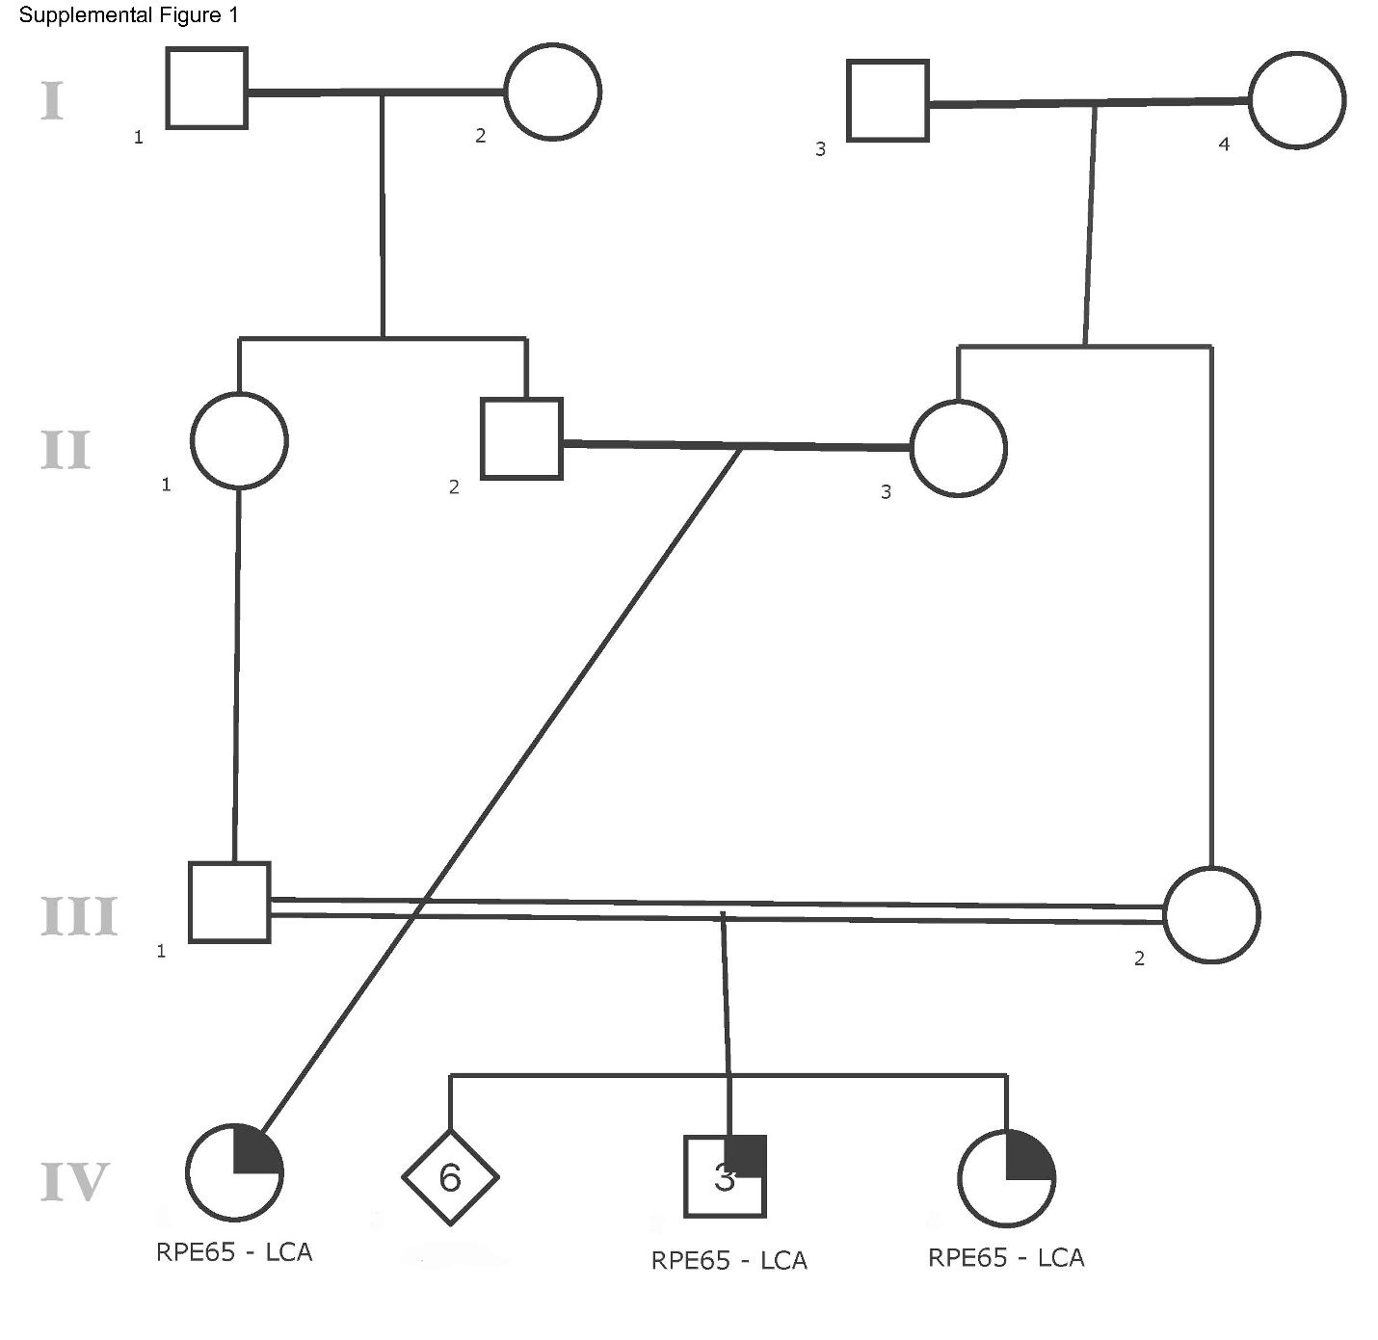

SUPPLEMENTAL FIGURE 2.
Goldmann kinetic visual field in before and after gene therapy for the right eye of both treated RPE65-LCA patients.
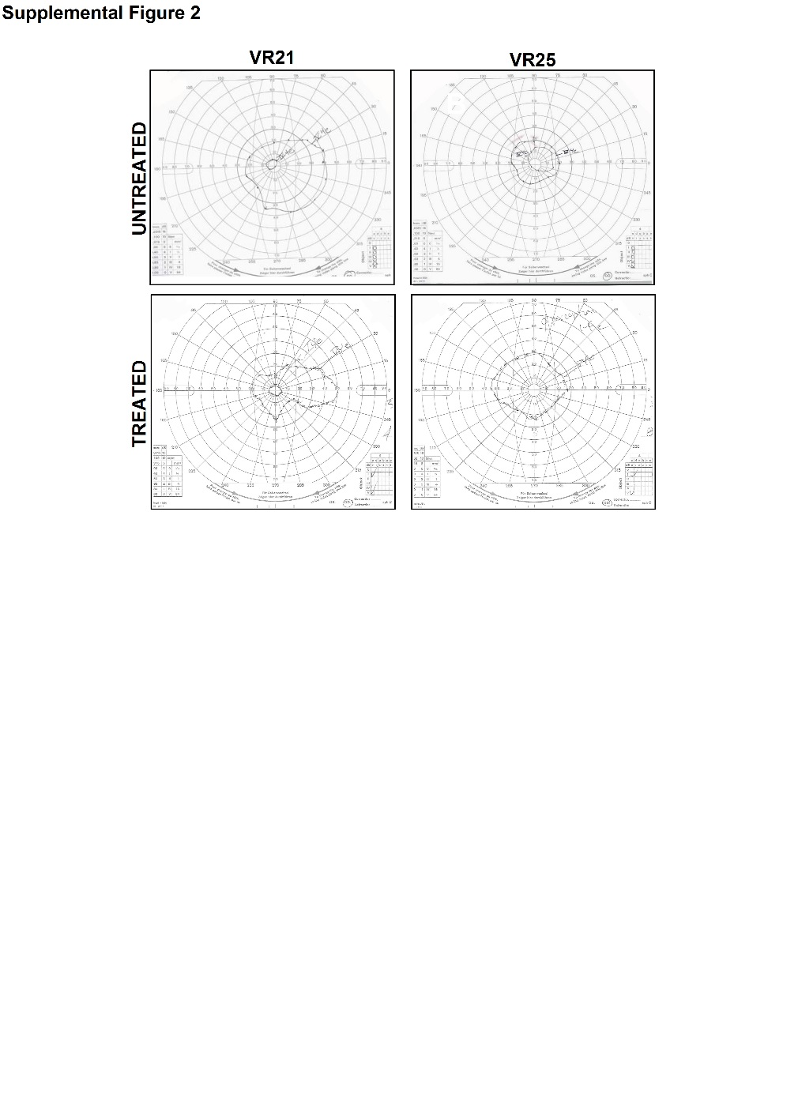

SUPPLEMENTAL VIDEO S1. Test giver’s view of a representative VR-O&M practice course showing the virtual obstacles, including holes in the floor and the moving pendulum. Each individual obstacle can be highlighted during the practice session for training purposes.

SUPPLEMENTAL VIDEO S2. Test giver’s view of a representative VR-O&M course navigated by a normally-sighted subject (VR30). A. Navigation through arrow-only course. Obstacles are visible to the observer but not the subject. Collisions with obstacles are shown (indicated by a red circle with a green arrow pointing in the direction of movement of the tracker). The ratio of collisions compared to number of obstacles can be used to calculate the probability that a visually impaired person would collide with an obstacle. B. Navigation through arrows plus obstacle course, with obstacles now visible to the subject.

SUPPLEMENTAL VIDEO S3. Test giver’s view of VR Mobility Test Performance of VR25 prior to (A) and following (B) treatment with Luxturna. A. The subject pre-treatment had a great deal of difficulty navigating the test (including the 9s delay when deciding to take the first step) and frequently went off course. It required a total of 133 seconds to complete the test and there were collisions (sometimes multiple) with 9 different obstacles. Collisions with obstacles are shown (indicated by a red circle with a green arrow pointing in the direction of movement of the tracker). B. After bilateral treatment with Luxturna and under conditions whereby objects were at greatly reduced luminance compared to baseline (5 cd.m⁻² instead of 13 cd.m⁻²), VR25 rapidly assessed the course layout and took decisive steps (within 4 secs of starting) in the direction of the arrows. He avoided colliding with most of the obstacles. This test was graded as a “Pass”, lasting 29 seconds and colliding with 3 different obstacles.

SUPPLEMENTAL VIDEO S4. Test giver’s view of post-intervention VR Mobility Test Performance of VR21 using each eye individually under dim (2.03 cd.m⁻²) illumination. VR21 successfully navigated the course in 26 secs monocularly with both his right eye and left eye after intervention, bumping into only one obstacle in each test. Collisions with obstacles are shown (indicated by a red circle with a green arrow pointing in the direction of movement of the tracker).

