Supplementary Figures and Tables
Supplementary Figure 1
1

Supplementary Figure 2
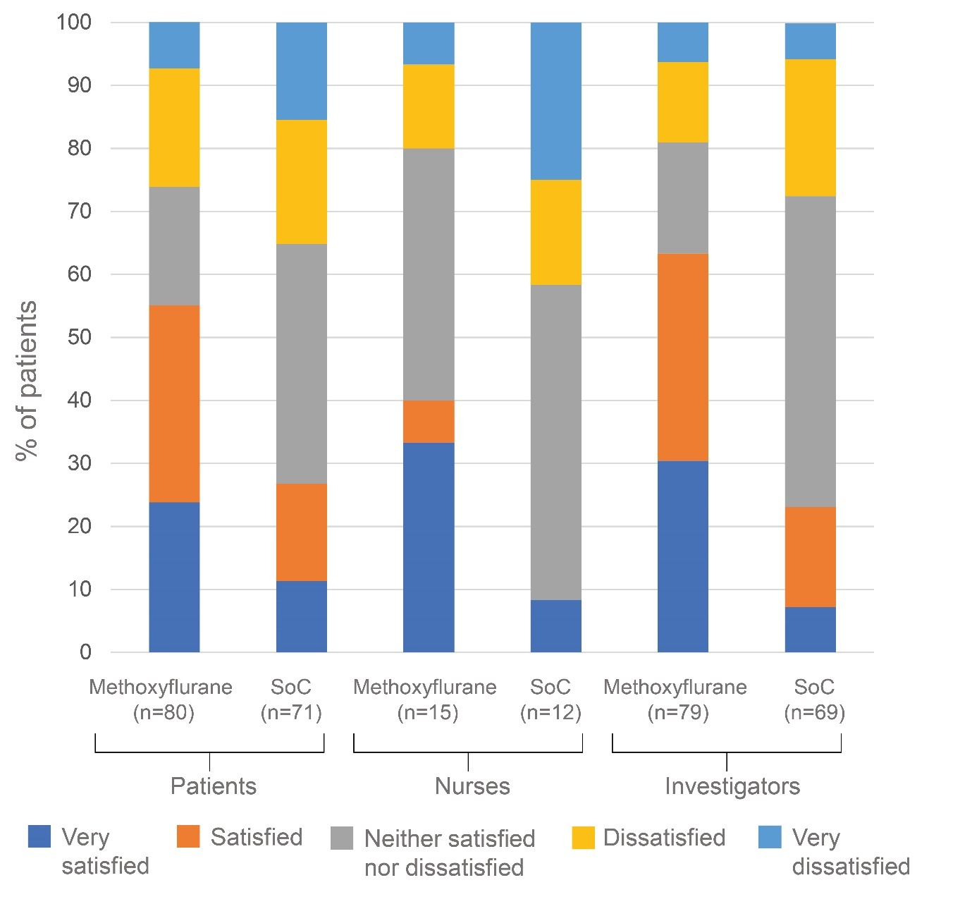

Figure Legends
Supplementary Figure 1 Pain intensity difference (elderly population)
Abbreviations: CI, confidence interval; NSAIDs, non-steroidal anti-inflammatory drugs; SoC, standard of care; T₅, 5 minutes after treatment initiation; T₁₀, 10 minutes after treatment initiation, etc.

Supplementary Figure 2 Treatment satisfaction (elderly population).
Abbreviations: SoC, standard of care.

Supplementary Table 1 Patient disposition (elderly population)
Population |  | Methoxyflurane  (N=85) | Standard of care ± placebo |  |  |  |  | Total  (N=158)
 |  | Methoxyflurane  (N=85) | No treatment  (N=17) | Paracetamol  (N=17) | NSAID  (N=20) | Opioid  (N=19) | All  (N=73) | Total  (N=158)
MAP1
n |  | 85 | 17 | 17 | 20 | 19 | 73 | 158
Included, n (%) |  | 82 (96.5%) | 16 (94.1%) | 17 (100%) | 20 (100%) | 19 (100%) | 72 (98.6%) | 154 (97.5%)
Excluded, n (%) |  | 3 (3.5%) | 1 (5.9%) | 0 (0.0) | 0 (0.0) | 0 (0.0) | 1 (1.4%) | 4 (2.5%)
 | Received SoC within 1 min of inhaling methoxyflurane | 1 (33.3%) | 0 (0.0) | 0 (0.0) | 0 (0.0) | 0 (0.0) | 0 (0.0) | 29 (17.1)
 | VAS <30 at T₀ | 2 (66.7%) | 1 (10.0) | 0 (0.0) | 0 (0.0) | 0 (0.0) | 1 (100.0) | 3 (75.0)
Safety
n |  | 84 | 17 | 17 | 20 | 19 | 73 | 157
Included, n (%) |  | 84 (100.0) | 17 (100.0) | 17 (100.0) | 20 (100.0) | 19 (100.0) | 73 (100.0) | 157 (100.0)
Abbreviations: NSAID, non-steroidal anti-inflammatory drug; SoC, standard of care; T₀, time of treatment initiation; VAS, visual analogue scale

Supplementary Table 2 Patient demographics (elderly population)
 |  | Methoxyflurane  (N=82) | Standard of care ± placebo |  |  |  |  | Total  (N=154)
 |  | Methoxyflurane  (N=82) | No treatment  (N=16) | Paracetamol  (N=17) | NSAID  (N=20) | Opioid  (N=19) | All  (N=72) | Total  (N=154)
Age, years
 | Mean (SD) | 73.8 (6.9) | 73.1 (6.0) | 76.0 (8.0) | 73.5 (6.0) | 77.8 (7.4) | 75.1 (7.0) | 74.4 (7.0)
 | Range | 65.9 - 96.3 | 65.0 - 84.0 | 65.2 - 95.2 | 66.0 - 86.0 | 66.4 - 95.1 | 65.0 - 95.2 | 65.0 - 96.3
Sex, n (%)
 | Female | 62 (75.6) | 6 (37.5) | 14 (82.4) | 11 (55.0) | 16 (84.2) | 47 (65.3) | 109 (70.8)
 | Male | 20 (24.4) | 10 (62.5) | 3 (17.6) | 9 (45.0) | 3 (15.8) | 25 (34.7) | 45 (29.2)
VAS score at randomization, mean (SD) |  | 72.8 (16.6) | 67.8 (10.6) | 58.6 (16.1) | 69.3 (19.1) | 83.1 (11.9) | 70.1 (17.1) | 71.5 (16.9)
VAS score at T₀, mean (SD) |  | 74.2 (17.7) | 69.8 (16.3) | 68.5 (16.6) | 69.3 (19.1) | 84.7 (12.3) | 73.3 (17.4) | 73.8 (17.5)
Location of primary injury, n (%)
 | n | 82 | 15 | 17 | 20 | 19 | 71 | 153
 | Upper limb | 44 (53.7) | 10 (66.7) | 10 (58.8) | 7 (35.0) | 11 (57.9) | 38 (53.5) | 82 (53.6)
 | Lower limb | 26 (31.7) | 4 (26.7) | 6 (35.3) | 7 (35.0) | 7 (36.8) | 24 (33.8) | 50 (32.7)
 | Chest | 9 (11.0) | 0 (0.0) | 1 (5.9) | 4 (20.0) | 1 (5.3) | 6 (8.5) | 15 (9.8)
 | Face | 3 (3.7) | 1 (6.7) | 0 (0.0) | 2 (10.0) | 0 (0.0) | 3 (4.2) | 6 (3.9)
Type of primary injury, n (%)
 | n | 82 | 16 | 17 | 20 | 19 | 72 | 154
 | Fracture | 43 (52.4) | 9 (56.3) | 9 (52.9) | 6 (30.0) | 12 (63.2) | 36 (50.0) | 79 (51.3)
 | Contusion | 27 (32.9) | 3 (18.8) | 4 (23.5) | 9 (45.0) | 5 (26.3) | 21 (29.2) | 48 (31.2)
 | Dislocation | 6 (7.3) | 0 (0.0) | 3 (17.6) | 1 (5.0) | 2 (10.5) | 6 (8.3) | 12 (7.8)
 | Other | 3 (3.7) | 0 (0.0) | 1 (5.9) | 1 (5.0) | 0 (0.0) | 2 (2.8) | 5 (3.2)
 | Wound | 2 (2.4) | 2 (12.5) | 0 (0.0) | 1 (5.0) | 0 (0.0) | 3 (4.2) | 5 (3.2)
 | Sprain | 1 (1.2) | 1 (6.3) | 0 (0.0) | 2 (10.0) | 0 (0.0) | 3 (4.2) | 4 (2.6)
 | Burn | 0 (0.0) | 1 (6.3) | 0 (0.0) | 0 (0.0) | 0 (0.0) | 1 (1.4) | 1 (0.6)
Abbreviations: NSAID, non-steroidal anti-inflammatory drug; SD, standard deviation; T₀, time of treatment initiation; VAS, visual analogue scale

Supplementary Table 3 Response criteria (elderly population): changes in pain intensity over time
 |  | Methoxyflurane  (N = 82) | Standard of care ± placebo
 |  | Methoxyflurane  (N = 82) | No treatment  (N = 16) |  | Paracetamol  (N = 17) |  | NSAID  (N = 20) |  | Opioid  (N = 19) |  | All  (N = 72)
Pain intensity  ≤30 mm, n (%) |  |  |  | P valueª |  | P valueª |  | P valueª |  | P valueª |  | P valueª
 | T₅ | 9 (11.0)  n=82 | 0 (0.0)  n=16 | 0.0982 | 1 (5.9)  n=17 | 0.5385 | 5 (25.0)  n=20 | 0.1376 | 1 (5.3)  n=19 | 0.6034 | 7 (9.7)  n=72 | 0.8804
 | T₁₀ | 20 (25.0)  n=80 | 3 (21.4)  n=14 | 0.8858 | 4 (23.5)  n=17 | 0.8020 | 6 (30.0)  n=20 | 0.8539 | 1 (5.3)  n=19 | 0.1473 | 14 (20.0)  n=70 | 0.5068
 | T₁₅ | 28 (35.0)  n=80 | 3 (13.3)  n=15 | 0.0949 | 6 (35.3)  n=17 | 0.6302 | 7 (35.0)  n=20 | 0.5987 | 1 (5.3)  n=19 | 0.0629 | 16 (22.5)  n=71 | 0.1086
 | T₂₀ | 34 (42.5)  n=80 | 3 (21.4)  n=14 | 0.2053 | 6 (35.3)  n=17 | 0.9151 | 9 (45.0)  n=20 | 0.4537 | 2 (10.5)  n=19 | 0.0545 | 20 (28.6)  n=70 | 0.0893
 | T₃₀ | 46 (56.8)  n=81 | 3 (18.8)  n=16 | 0.0430 | 7 (43.8)  n=16 | 0.4481 | 11 (55.0)  n=20 | 0.3957 | 5 (35.7)  n=14 | 0.1614 | 26 (39.4)  n=66 | 0.0346
Relative reduction ≥30%, n (%)
 | T₅ | 27 (32.9)  n=82 | 1 (6.3)  n=16 | 0.0982 | 3 (17.6)  n=17 | 0.4146 | 6 (30.0)  n=20 | 0.3336 | 1 (5.3)  n=19 | 0.0611 | 11 (15.3)  n=72 | 0.0162
 | T₁₀ | 46 (57.5)  n=80 | 5 (35.7)  n=14 | 0.1598 | 8 (47.1)  n=17 | 0.5606 | 6 (30.0)  n=20 | 0.0176 | 5 (26.3)  n=19 | 0.0430 | 24 (34.3)  n=71 | 0.0056
 | T₁₅ | 52 (65.0)  n=80 | 6 (40.0)  n=15 | 0.0952 | 10 (58.8)  n=17 | 0.8423 | 9 (45.0)  n=20 | 0.0423 | 5 (26.3)  n=19 | 0.3248 | 34 (47.9)  n=63 | 0.0367
 | T₂₀ | 56 (70.0)  n=80 | 5 (35.7)  n=14 | 0.0454 | 10 (58.8)  n=17 | 0.6573 | 13 (65.0)  n=20 | 0.8164 | 12 (63.2)  n=19 | 0.9205 | 40 (57.1)  n=66 | 0.1039
 | T₃₀ | 63 (77.8)  n=81 | 5 (31.3)  n=16 | 0.0021 | 12 (75.0)  n=16 | 0.8168 | 15 (75.0)  n=20 | 0.6567 | 11 (78.6)  n=14 | 0.0988 | 43 (65.2)  n=70 | 0.0812
Relative reduction ≥50%, n (%)
 | T₅ | 24 (41.4)  n=66 | 1 (6.3)  n=15 | 0.0982 | 1 (6.7)  n=15 | 0.7747 | 1 (6.7)  n=15 | 0.1298 | 0 (0.0)  n=18 | 0.0611 | 2 (3.2)  n=63 | 0.0303
 | T₁₀ | 31 (52.5)  n=59 | 5 (35.7)  n=11 | 0.2669 | 4 (30.8)  n=13 | 0.9281 | 4 (22.2)  n=18 | 0.0286 | 1 (6.7)  n=15 | 0.0693 | 11 (19.3)  n=57 | 0.0140
 | T₁₅ | 31 (52.5)  n=59 | 6 (40.0)  n=11 | 0.0668 | 7 (50.0)  n=14 | 0.6756 | 8 (42.1)  n=19 | 0.0970 | 3 (23.1)  n=13 | 0.1778 | 20 (35.1)  n=57 | 0.0598
 | T₂₀ | 40 (62.5)  n=64 | 5 (35.7)  n=12 | 0.0779 | 7 (50.0)  n=14 | 0.7000 | 10 (58.8)  n=17 | 0.1806 | 8 (53.3)  n=15 | 0.8621 | 28 (48.3)  n=58 | 0.1210
 | T₃₀ | 49 (73.1)  n=67 | 4 (26.7)  n=15 | 0.0072 | 10 (71.4)  n=14 | 0.9296 | 12 (70.6)  n=17 | 0.6302 | 10 (76.9)  n=13 | 0.8048 | 36 (61.0)  n=59 | 0.1400
Note: ªP value vs methoxyflurane.
Abbreviations: T₅, 5 minutes after treatment initiation; T₁₀, 10 minutes after treatment initiation, etc.

Supplementary Table 4 Time to pain relief (elderly population)
 |  | Methoxyflurane  (N=82) | Standard of care ± placebo
 |  | Methoxyflurane  (N=82) | No treatment  (N=16) | Paracetamol  (N=17) | NSAID  (N=20) | Opioid  (N=19) | All  (N=72)
Patient-declared time to pain relief
 | Median (95% CI), mins | 9 (6, 11) | NE (11, NE) | 13 (9, NE) | 12 (5, 14) | 12 (10, 15) | 13 (11, 15)
 | HR (95% CI) vs methoxyflurane | - | 0.49 (0.21, 1.12) | 0.76 (0.40, 1.46) | 0.49 (0.28, 0.86) | 0.76 (0.43, 1.33) | 1.64 (1.13, 2.38)
 | P value | - | 0.0901 | 0.4145 | 0.0137 | 0.3370 | 0.0087
Time to ≥30% reduction in pain
 | Median (95% CI), mins | 10 (10, 15) | NE (10, NE) | 13 (9, 30) | 20 (5, 30) | 15 (12, 29) | 20 (15, 24)
 | HR (95% CI) vs methoxyflurane | - | 0.29 (0.12, 0.67) | 0.89 (0.49, 1.64) | 0.67 (0.38, 1.18) | 0.75 (0.42, 1.34) | 1.59 (1.10, 2.29)
 | P value | - | 0.0041 | 0.7184 | 0.1650 | 0.3256 | 0.0132
Abbreviations: CI, confidence interval; HR, hazard ratio; NE, not evaluable; NSAID, non-steroidal anti-inflammatory drug

