Supplementary Material:
Figure S1. Concentrations used by Compusyn to calculate synergy between IC₅₀ doxorubicin (DOX at 0.565 and 0.121 µM for MDA-MB-231 and MDA-MB-468) and abemaciclib (ABE). Fractional inhibition (Fa) was calculated for DOX (0.1-20 µM for MDA-MB-231 and 0.01-20 µM for MDA-MB-468), ABE (1-6 µM and 1-2.5 µM), and DOX IC₅₀ with ABE. Bars represent the mean values (n=6) along with the standard error on the mean. and

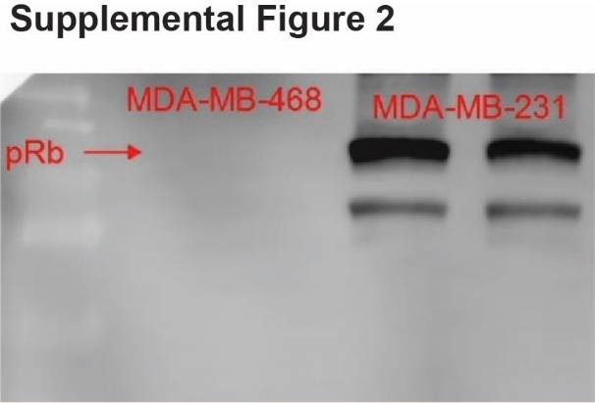
Figure S2: Western blot image of phosphorylated retinoblastoma protein (pRb; Ser780) in MDA-MB-468 (negative control) and MDA-MB-231 (positive control) cells. Samples were run in duplicate.

Table S1: Summary of clinical doxorubicin data used for population pharmacokinetic analysis.
Dose (mg/m²) | BSA (m²) | Dox Presented | Infusion Time (hr) | Data | Measurement Technique | LOQ (μg/mL) | Reference
10 | 1.71 | Total DOX | 0.25 | Mean (n=9) | HPLC | 0.01 | [1]
20 | 1.71 | Total DOX | 0.25 | Mean (n=9) | HPLC | 0.01 | [1]
25 | 1.71 | Free DOX | 0.167 | Mean (n=3) | HPLC | 0.025 | [2]
25 | 1.71 | L_DOX | 0.167 | Mean (n=8) | HPLC | 0.025 | [2]
40 | 1.71 | Total DOX | 0.25 | Mean (n=9) | HPLC | 0.01 | [1]
50 | 1.71 | L_DOX | 0.167 | Mean (n=14) | HPLC | 0.025 | [2]
50 | 1.531 | Total DOX | 1 | Mean (n=24) | LC-MS/MS | 0.25 | [3]
50 | 1.508 | Total DOX | 1 | Mean (n=41) | LC-MS/MS | 0.25 | [3]
50 | 1.531 | L_DOX | 1 | Mean (n=24) | LC-MS/MS | 1 | [3]
50 | 1.508 | L_DOX | 1 | Mean (n=41) | LC-MS/MS | 1 | [3]
50 | 1.75 | Free DOX | 0.25 | Mean (n=12) | HPLC | 0.001 | [4]
60 | 1.67 | Free DOX | 0.667 | Mean (n=3) | HPLC | 0.01 | [5]
60 | 1.9 | Free DOX | 0.167 | Mean (n=19) | HPLC | 0.001 | [6]
60 | 1.71 | Free DOX | 0.083 | Mean (n=8) | HPLC | 0.0025 | [7]
60 | 1.71 | Free DOX | 0.25 | Mean (n=11) | HPLC | 0.01 | [8]
75 | 1.71 | Free DOX | 0.25 | Mean (n=10) | HPLC | 0.001 | [9]
LOQ, the lower limit of quantification
DOX, free doxorubicin; Free DOX = bDOX + uDOX
uDOX = f_{u} ∙ DOX; bDOX = (1-f_{u}) ∙ DOX
f_{u} = 0.75 [10]
L_DOX, pegylated liposomal doxorubicin.
Total DOX = Free DOX + L_DOX

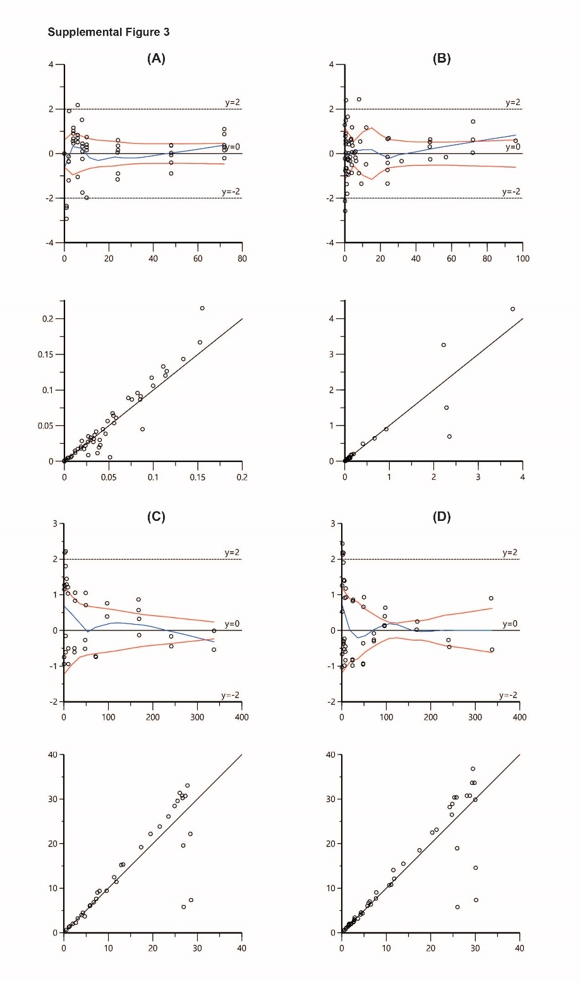
Figure S3: Goodness-of-fit plots for the final population pharmacokinetic models for (A) abemaciclib, (B) free doxorubicin, (C) pegylated liposomal doxorubicin, and (D) total doxorubicin. In the upper plots, the x-axes represent time (hour), the y-axes represent conditional weighted residuals, and the blue lines represent the observed trend of the data. In the lower plots, the x-axes represent time individual predicted concentrations (µg/mL), the y-axes represent observed drug concentrations in the plasma (µg/mL), and the solid black lines represent the reference line in the diagnostic plot.

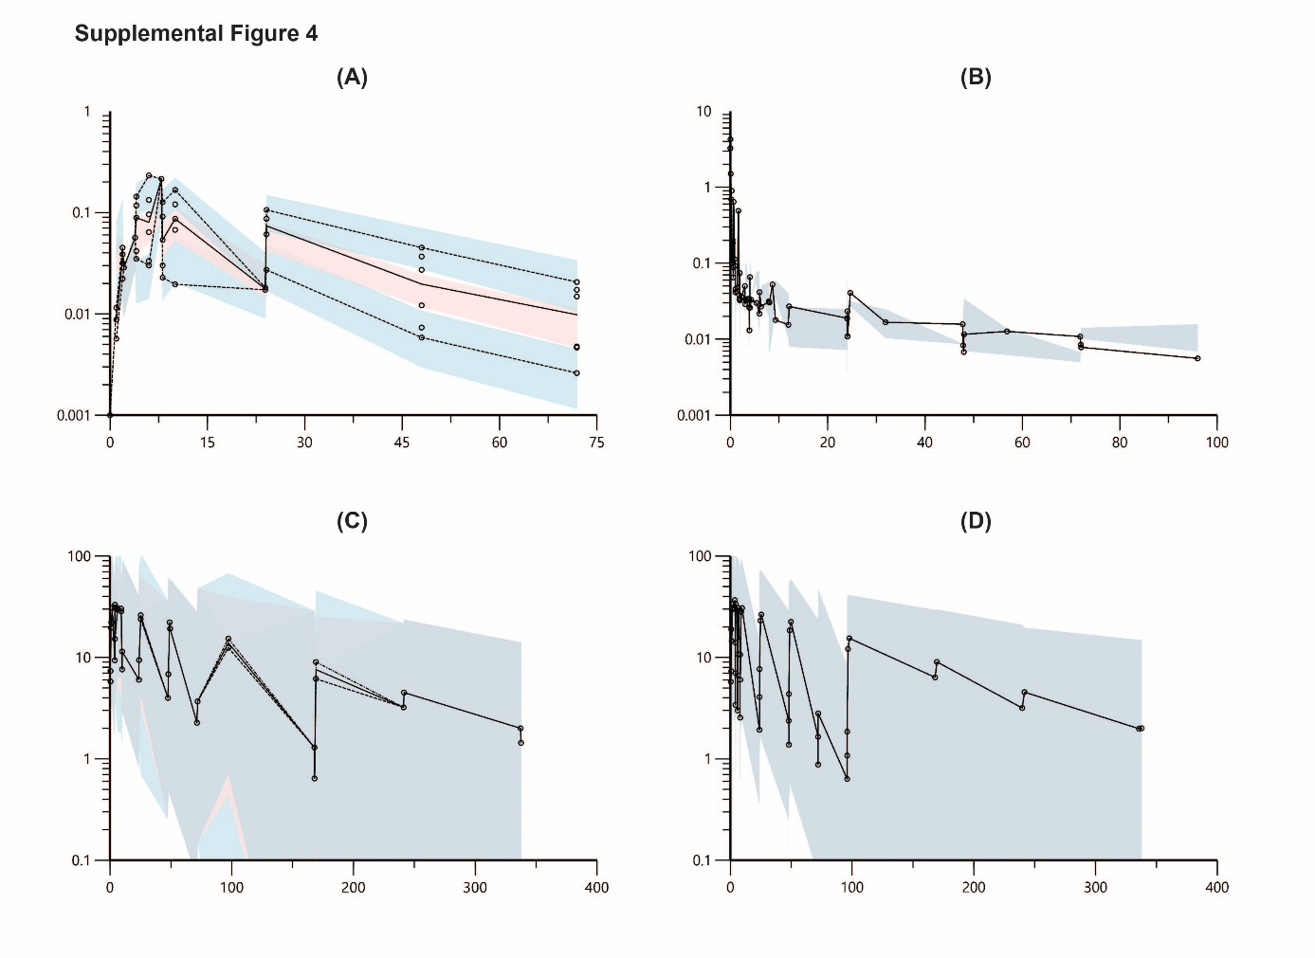
Figure S4: Visual predictive check (VPC) for the final population pharmacokinetic models for (A) abemaciclib, (B) free doxorubicin, (C) pegylated liposomal doxorubicin, and (D) total doxorubicin. The x axes represents time (hr), and the y axes represent drug concentrations (µg/mL).The solid black lines represent the 50th observed percentile of the observations, and the dashed lines represent the 5th and 95th percentiles of observations. The red-shaded area represents the 95% confidence interval (95% CI) for the 50th percentile of the simulated data, and the blue shaded area is the 95% CI for 5th and 95th percentiles of the simulated data.

References
1. Northfelt DW, Martin FJ, Working P, Volberding PA, Russell J, Newman M, Amantea MA, Kaplan LD: Doxorubicin encapsulated in liposomes containing surface-bound polyethylene glycol: pharmacokinetics, tumor localization, and safety in patients with AIDS-related Kaposi's sarcoma. Journal of clinical pharmacology 1996, 36(1):55-63.
2. Gabizon A, Catane R, Uziely B, Kaufman B, Safra T, Cohen R, Martin F, Huang A, Barenholz Y: Prolonged circulation time and enhanced accumulation in malignant exudates of doxorubicin encapsulated in polyethylene-glycol coated liposomes. Cancer research 1994, 54(4):987-992.
3. Bhowmik S, Bhowmick S, Maiti K, Chakra A, Shahi P, Jain D, Rajamannar T: Two multicenter Phase I randomized trials to compare the bioequivalence and safety of a generic doxorubicin hydrochloride liposome injection with Doxil((R)) or Caelyx((R)) in advanced ovarian cancer. Cancer chemotherapy and pharmacology 2018, 82(3):521-532.
4. Rosing H, ten Bokkel Huinink WW, van Gijn R, Rombouts RF, Bult A, Beijnen JH: Comparative open, randomized, cross-over bioequivalence study of two intravenous dexrazoxane formulations (Cardioxane and ICRF-187) in patients with advanced breast cancer, treated with 5-fluorouracil-doxorubicin-cyclophosphamide (FDC). European journal of drug metabolism and pharmacokinetics 1999, 24(1):69-77.
5. Barpe DR, Rosa DD, Froehlich PE: Pharmacokinetic evaluation of doxorubicin plasma levels in normal and overweight patients with breast cancer and simulation of dose adjustment by different indexes of body mass. European journal of pharmaceutical sciences : official journal of the European Federation for Pharmaceutical Sciences 2010, 41(3-4):458-463.
6. Blaes A, Duprez D, Defor T, Shanley R, Beckwith H, Haddad T, Potter D, Yee D, Sanghavi K, Jacobson P: Angiotensin Converting Enzyme Inhibitors (ACEI) and doxorubicin pharmacokinetics in women receiving adjuvant breast cancer treatment. SpringerPlus 2015, 4:32.
7. Gianni L, Vigano L, Locatelli A, Capri G, Giani A, Tarenzi E, Bonadonna G: Human pharmacokinetic characterization and in vitro study of the interaction between doxorubicin and paclitaxel in patients with breast cancer. Journal of clinical oncology : official journal of the American Society of Clinical Oncology 1997, 15(5):1906-1915.
8. Wurz GT, Soc L, Emshoff VD, Cadman TB, DeGregorio MW: Pharmacokinetic analysis of high-dose toremifene in combination with doxorubicin. Cancer chemotherapy and pharmacology 1998, 42(5):363-366.
9. Greene RF, Collins JM, Jenkins JF, Speyer JL, Myers CE: Plasma pharmacokinetics of adriamycin and adriamycinol: implications for the design of in vitro experiments and treatment protocols. Cancer research 1983, 43(7):3417-3421.
10. Doxorubicin Hydrochloride for Injection, USP. In. Edited by Company PU. Kalamazoo, MI; 2003.

