Supplementary material
Low dose curcumin administered in hyaluronic acid-based nanocapsules induces hypotensive effect in hypertensive rats
Izabela Czyzynska-Cichon^{1,‡}, Małgorzata Janik-Hazuka^{2,‡}, Joanna Szafraniec-Szczęsny^{2,3}, Krzysztof Jasinski⁴, Władysław P. Węglarz⁴, Szczepan Zapotoczny^{2,*}, Stefan Chlopicki^{1,5,*}

¹ Jagiellonian University, Jagiellonian Centre for Experimental Therapeutics (JCET), Bobrzynskiego 14, 30-384 Krakow, Poland
² Jagiellonian University, Faculty of Chemistry, Gronostajowa 2, 30-387 Krakow, Poland
³ Jagiellonian University Medical College, Faculty of Pharmacy, Department of Pharmaceutical Technology and Biopharmaceutics, Medyczna 9, 30-688 Krakow, Poland
⁴ Institute of Nuclear Physics Polish Academy of Sciences, Department of Magnetic Resonance Imaging, Radzikowskiego 152, 31-342 Krakow, Poland
⁵ Jagiellonian University Medical College, Faculty of Medicine, Department of Pharmacology, Grzegorzecka 16, 31-531, Krakow, Poland
‡ Those authors equally contributed to the work

First authors: Izabela Czyzynska-Cichon, Małgorzata Janik-Hazuka

Correspondence:
Stefan Chlopicki - stefan.chlopicki@jcet.eu
Szczepan Zapotoczny - zapotocz@chemia.uj.edu.pl

Methods
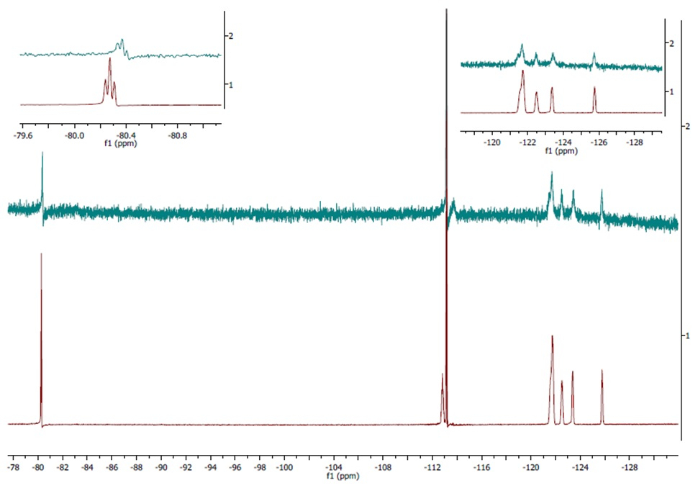
Figure S1. ¹⁹F NMR spectra of FC10 (red) in DMSO-d6 and HyFC10 (green) in a mixture of D₂O and DMSO-d6 (2:1, v/v) (chemical shifts vs. monofluorobenzene, δ = -113.15 ppm).
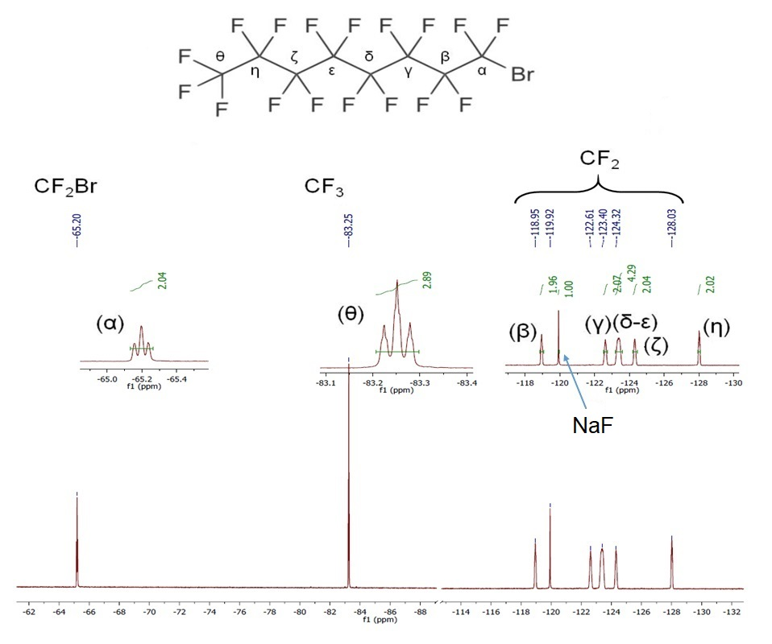
Figure S2. HyFC10-PFOB nanocapsules in 20% D₂O measured with a Bruker Advance III HD 400 MHz spectrometer with described PFOB fluorine atoms signals (NaF as a reference).

Results
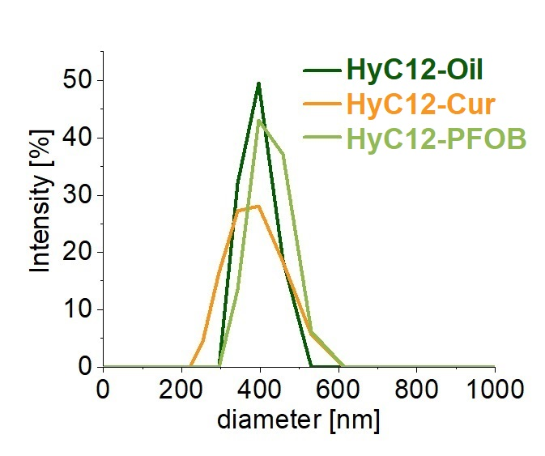
Figure S3. Intensity-weighted size distribution of nanocapsules based on HA derivatives with no cargo and loaded with curcumin of PFOB.
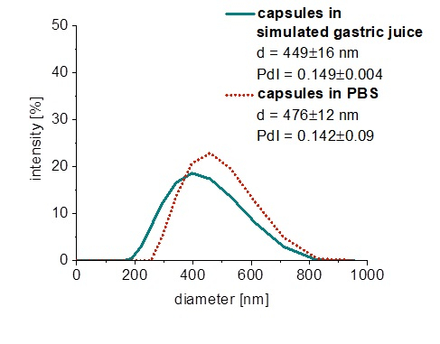
Figure S4. The comparison of the size of nanocapsules (HyC12-Cur) incubated in PBS and with simulated gastric juice for 2h.

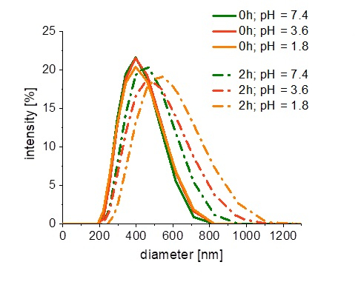
Figure S5. Size distributions of the HyC12-Cur nanocapsules in neutral and acidic pH conditions - freshly prepared samples (solid lines) and after 2h incubation (dotted lines).
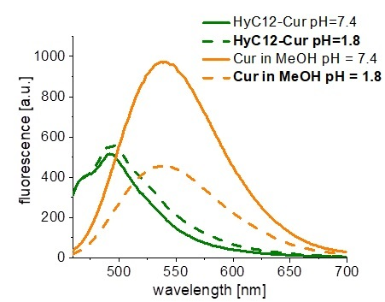
Figure S6. Fluorescence intensity (λex = 420 nm) of HyC12-Cur nanocapsules and curcumin in MeOH in neutral and acidic pH.

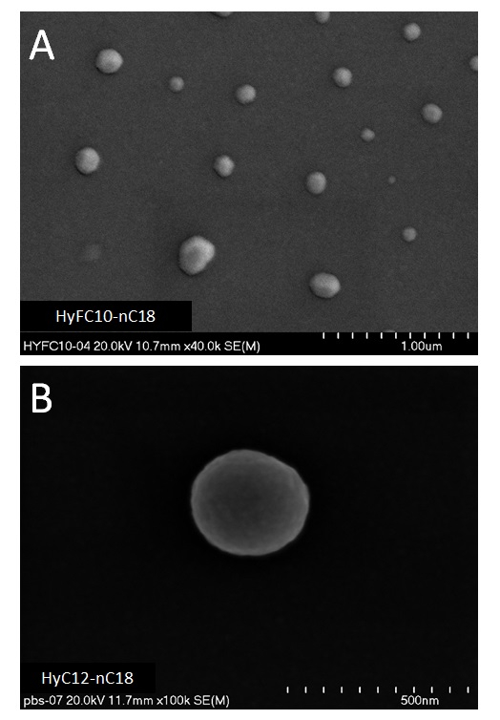
Figure S7. SEM images of the capsules stabilized by HyFC10 (A) and HyC12 (B) templated on n-octadecane (nC18) core.

