SUPPLEMENTARY DATA
Therapeutic success of tiotropium/olodaterol, measured using the Clinical COPD Questionnaire (CCQ), in routine clinical practice: a multinational non-interventional study
Arschang Valipour¹, Sergey Avdeev,² Adam Barczyk,³ Valentina Bayer,⁴ Zvi Fridlender,⁵ Mariela Georgieva,⁶ Ondřej Kudela,⁷ Alexey Medvedchikov,⁸ Ramona Miron,⁹ Maria Sanzharovskaya,⁸ Virginija Šileikienė,¹⁰ Jurij Šorli,¹¹ Marc Spielmanns,¹² Zsuzsanna Szalai¹³
¹Karl-Landsteiner-Institute for Lung Research and Pulmonary Oncology, Klinik Floridsdorf, Vienna, Austria; ²I.M. Sechenov First Moscow State Medical University (Sechenov University), Moscow, Russia; ³Wydział Nauk Medycznych Śląskiego Uniwersytetu Medycznego, Katowice, Poland; ⁴Boehringer Ingelheim Pharmaceuticals, Inc., Ridgefield, CT, USA; ⁵Hadassah-Hebrew University Medical Center, Jerusalem, Israel; ⁶Medical Center "Sv.Ivan Rilski" OOD, Vidin, Bulgaria; ⁷Department of Pneumology, University Hospital Hradec Kralove, Charles University in Prague, Faculty of Medicine in Hradec Kralove, Hradec Kralove, Czech Republic; ⁸Boehringer Ingelheim RCV GmbH & Co. KG, Vienna, Austria; ⁹Clinical Pneumophtysiology Hospital Iasi, Iasi, Romania; ¹⁰Clinic of Chest Diseases, Immunology and Allergology, Institute of Clinical Medicine, Faculty of Medicine, Vilnius University, Vilnius, Lithuania; ¹¹Bolnišnica Topolšica, Topolšica, Slovenia; ¹²Zürcher RehaZentrum Wald, Wald, Switzerland; ¹³Petz Aladar County Teaching Hospital, Gyor, Hungary
Supplementary Text S1
The study was submitted to the ethics committee of participating countries according to national regulations. Sites could only participate if independent ethics committee approval in their country was issued. Written informed consent was required by all study subjects prior to participation. Approvals were as follows: Bulgaria (Republic of Bulgaria Ministry of Health Ethical Commission for Clinical Trials; positive vote on 20 March 2019), Czech Republic (no approval needed), Hungary (Medical Research Council Scientific and Research Ethics Commission; positive vote on 29 August 2018), Israel (Meir Medical Center Helsinki Committee; positive vote separately for each site; first approval on 06 November 2018), Lithuania (Lithuanian Bioethics Committee; positive vote on 07 August 2018), Poland (no approval needed, acknowledgement of notification on 10 July 2018), Romania (National Commission for Bioethics of Medicines and Medical Devices; positive vote on 19 January 2016), Russia (Independent Interdisciplinary Committee on Ethical Review of Clinical Trials; positive vote of the main ethics committee on 24 August 2018), Slovenia (Commission of the Republic of Slovenia for Medical Ethics; positive vote on 23 July 2018), Switzerland (Cantonal Ethics Committee of Zurich; positive vote on 27 November 2018) and Ukraine (Ethics Commission at the Lviv Municipal Institution regional council; positive vote separately for each site; first approval on 24 September 2018).
Supplementary Table S1: Visit flow chart and data collection parameters
Parameter | Visit 1; baseline visit | Visit 2; approx. 6 weeks after baseline visit
Informed consent | X
Inclusion/exclusion criteria | X
Patient demographics (age, gender, height, and weight) | X
Start of COPD | X
Number of exacerbations in the last 12 months | X
Number of exacerbations leading to hospitalization in the last 12 months | X
mMRC breathlessness scale, completed by the patient | X
Past COPD therapies (6 weeks before Visit 1) | X
Respimat® training (yes/no) | X
COPD severity based on GOLD assessmentª | X
GOLD spirometric classification, if available^{b} | X
Smoking status/history | X | X
Concomitant diseases/comorbidities | X | X
COPD-related and other relevant concomitant medication | X | X
Health and functional status by CCQ questionnaire, completed by patient | X | X
Patient-reported daily average number of puffs per day of COPD rescue medication (eg, SABA, such as salbutamol) at the week before Visit 1 and the week before Visit 2 | X | X
General condition of patient evaluated by PGE, completed by the physician | X | X
Safety: adverse drug reactions (serious and non-serious), fatal adverse events, pregnancy | X | X
Patient satisfaction with tiotropium/olodaterol Respimat®, completed by the patient |  | X
Rationale for tiotropium/olodaterol Respimat® treatment discontinuation (if applicable) |  | X
Continuation or discontinuation of treatment with tiotropium/olodaterol Respimat® after the study (yes/no) |  | X
ªGOLD patient group (B, C or D) was automatically calculated within the eCRF based on available exacerbation history and mMRC. ^{b}GOLD stage 1–4 spirometric classification of airflow limitation based on post-bronchodilator FEV₁ if available.
CCQ, Clinical COPD Questionnaire; COPD, chronic obstructive pulmonary disease; eCRF, electronic case report form; FEV₁, forced expiratory volume in 1 second; GOLD, Global Initiative for Chronic Obstructive Lung Disease; mMRC, modified Medical Research Council; PGE, Physician’s Global Evaluation; SABA, short-acting β₂-agonist.
Supplementary Table S2: Absolute reductions in CCQ domain scores, stratified by treatment pathway (full analysis set)
CCQ domain | Treatment group | n | Mean reduction | 95% CI | SD
Total score | Treatment-naïve | 2,678 | 1.17 | 1.13–1.20 | 0.92
Total score | Pretreated (LABA only, LAMA only) | 1,322 | 0.78 | 0.74–0.82 | 0.73
Total score | Pretreated (LABA/ICS) | 523 | 0.95 | 0.88–1.03 | 0.83
Symptom | Treatment-naïve | 2,678 | 1.26 | 1.22–1.29 | 1.01
Symptom | Pretreated (LABA only, LAMA only) | 1,322 | 0.83 | 0.79–0.88 | 0.83
Symptom | Pretreated (LABA/ICS) | 523 | 1.01 | 0.92–1.09 | 0.99
Functional state | Treatment-naïve | 2,678 | 1.07 | 1.04–1.11 | 1.02
Functional state | Pretreated (LABA only, LAMA only) | 1,322 | 0.72 | 0.68–0.76 | 0.80
Functional state | Pretreated (LABA/ICS) | 523 | 0.88 | 0.80–0.95 | 0.91
Mental state | Treatment-naïve | 2,678 | 1.17 | 1.12–1.22 | 1.27
Mental state | Pretreated (LABA only, LAMA only) | 1,322 | 0.81 | 0.75–0.87 | 1.08
Mental state | Pretreated (LABA/ICS) | 523 | 1.00 | 0.90–1.10 | 1.14
CCQ, Clinical COPD Questionnaire; CI, confidence interval; ICS, inhaled corticosteroids; LABA, long-acting β₂-agonist; LAMA, long-acting muscarinic antagonist; SD, standard deviation.
Due to the low number of patients who switched from pre-existing treatments to a combination of tiotropium/olodaterol plus a separate ICS, this group was excluded from the subgroup analysis. Patients on other prior therapies were also excluded.
Supplementary Table S3: Change in general condition of the patient, evaluated using the PGE, between baseline and Week 6, stratified by treatment pathway (full analysis set)
PGE score | Treatment-naïve (%)  (n=2,678) |  | Pretreated (LABA only, LAMA only) (%)  (n=1,322) |  | Pretreated (LABA/ICS) (%)  (n=523)
PGE score | Baseline | Week 6 | Baseline | Week 6 | Baseline | Week 6
1 | 1.19 | 0.11 | 0.76 | 0 | 0.19 | 0
2 | 11.61 | 0.93 | 6.81 | 0.68 | 8.99 | 1.72
3 | 25.91 | 3.66 | 22.01 | 4.39 | 26.39 | 8.60
4 | 30.58 | 14.04 | 29.88 | 13.84 | 30.98 | 13.19
5 | 17.66 | 27.04 | 20.88 | 25.04 | 20.65 | 23.52
6 | 10.31 | 30.92 | 14.90 | 31.69 | 10.13 | 31.55
7 | 2.35 | 18.71 | 4.46 | 20.80 | 2.68 | 17.40
8 | 0.37 | 4.59 | 0.30 | 3.56 | 0 | 3.82
Missing | 0 | 0 | 0 | 0 | 0 | 0.19
Due to the low number of patients who switched from pre-existing treatments to a combination of tiotropium/olodaterol plus a separate ICS, this group was excluded from the subgroup analysis. Patients on other prior therapies were also excluded.
ICS, inhaled corticosteroids; LABA, long-acting β₂-agonist; LAMA, long-acting muscarinic antagonist; PGE, Physician’s Global Evaluation.
Supplementary Table S4: Change in average daily use of rescue medication between the week before baseline and the week before Week 6, all patients and stratified by treatment pathway (full analysis set)
 | Mean decrease in patient-reported puffs/day | 95% CI | SD
All patients  (n=4,700) | 1.25 | 1.19–1.31 | 2.14
Treatment-naïve (n=2,678) | 1.38 | 1.29–1.47 | 2.33
Pretreated (LABA only, LAMA only) (n=1,322) | 1.01 | 0.92–1.11 | 1.78
Pretreated (LABA/ICS)  (n=523) | 1.17 | 1.01–1.33 | 1.89
Due to the low number of patients who switched from pre-existing treatments to a combination of tiotropium/olodaterol plus a separate ICS, this group was excluded from the subgroup analysis. Patients on other prior therapies were also excluded.
CI, confidence interval; ICS, inhaled corticosteroids; LABA, long-acting β₂-agonist; LAMA, long-acting muscarinic antagonist; SD, standard deviation.

Supplementary Table S5. Summary of adverse events
 |  | N | %
Number of patients |  | 4819 | 100
Patients with investigator-defined AE |  | 36 | 0.74
Patients with investigator-defined drug-related AE |  | 29 | 0.60
Patients with investigator-defined drug-related AE leading to discontinuation of trial drug |  | 19 | 0.39
Patients with serious AE* |  | 7 | 0.15
Reason for seriousness | Results in death | 7 | 0.15
Reason for seriousness | Immediately life threatening | 2 | 0.04
Reason for seriousness | Hospitalization required/prolonged | 1 | 0.02
Patients with serious AE leading to discontinuation |  | 3 | 0.06
AE, adverse event.
*Only serious adverse events leading to a fatal outcome were collected.

Supplementary Figure S1: Patient satisfaction with tiotropium/olodaterol and device, all patients and stratified by treatment pathway (full analysis set)
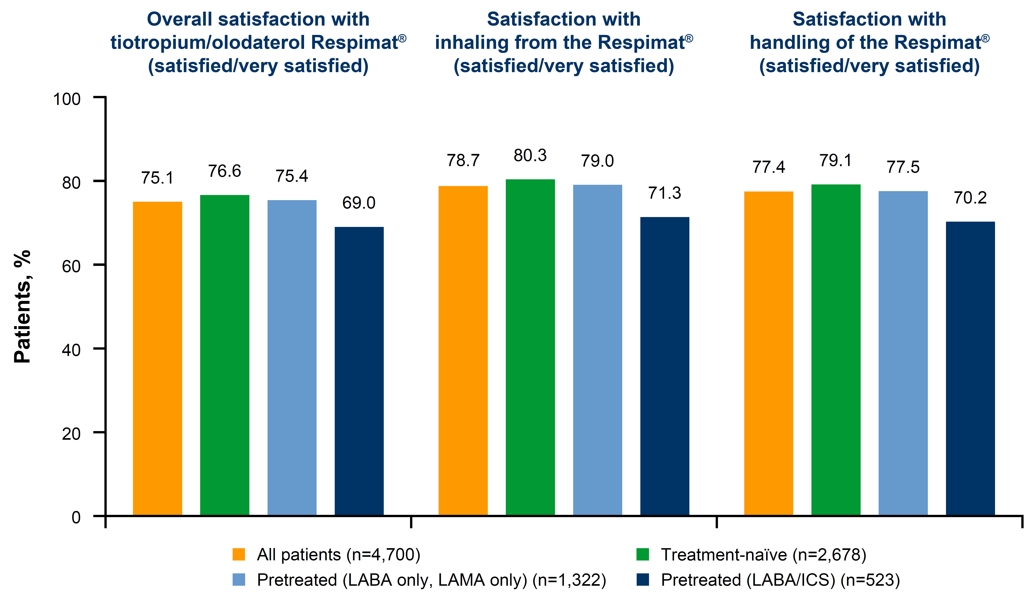
Due to the low number of patients who switched from pre-existing treatments to a combination of tiotropium/olodaterol plus a separate ICS, this group was excluded from the subgroup analysis. Patients on other prior therapies were also excluded.
ICS, inhaled corticosteroids; LABA, long-acting β₂-agonist; LAMA, long-acting muscarinic antagonist.

