Supplementary Figure 1. Swimmer plots depicting best RECISTv1.1 response and duration of time on treatment. Individual patients are represented by horizontal bars on the Y-axis and duration of time on treatment is depicted in months on the X-axis. Sixty one of 82 patients had at least one post-baseline scan and were evaluable for response. A. Results for dose escalation patients (N=35); B. Results for dose expansion patients (N=26).
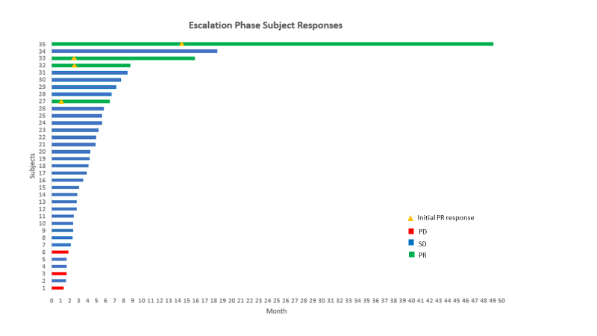
A.

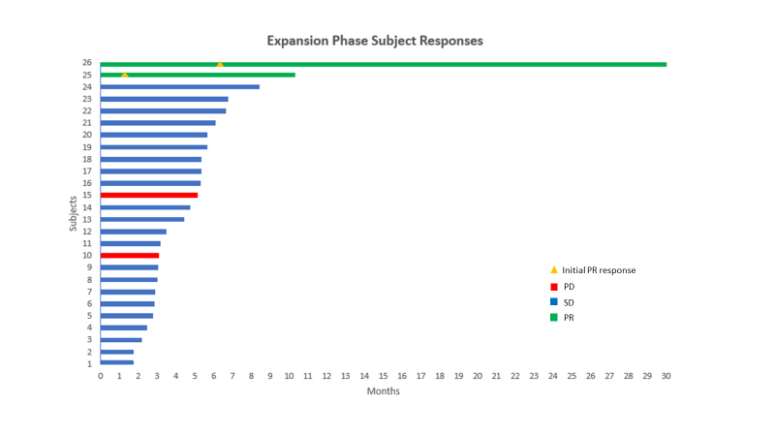
B.

