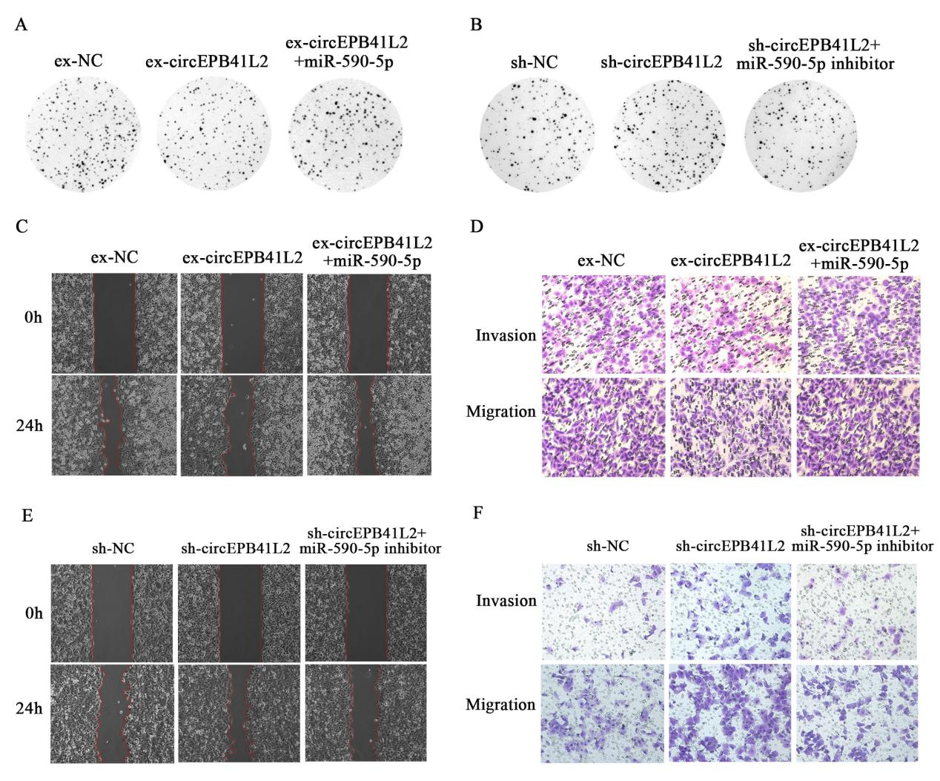

Figure S1 (A) The representative images of proliferation in ex-circEPB41L2-SMMC-7721 treated with miR-590-5p or NC by colony formation assay. (B) The representative images of proliferation in sh-circEPB41L2-Hep3B treated with miR-590-5p inhibitor or NC by and colony formation assay. The representative images of migration and invasion in ex-circEPB41L2-SMMC-7721 treated with miR-590-5p or NC by wound healing assay (C) and transwell assay (D). The representative images of migration and invasion in sh-circEPB41L2-Hep3B treated with miR-590-5p inhibitor or NC by wound healing assay (E) and transwell assay(F).

