Thiazole Based Thiosemicarbazones: Synthesis, Cytotoxicity Evaluation and Molecular Docking Study

Supplementary data

Figure S1. Biochemical pathway of human Rab7b protein

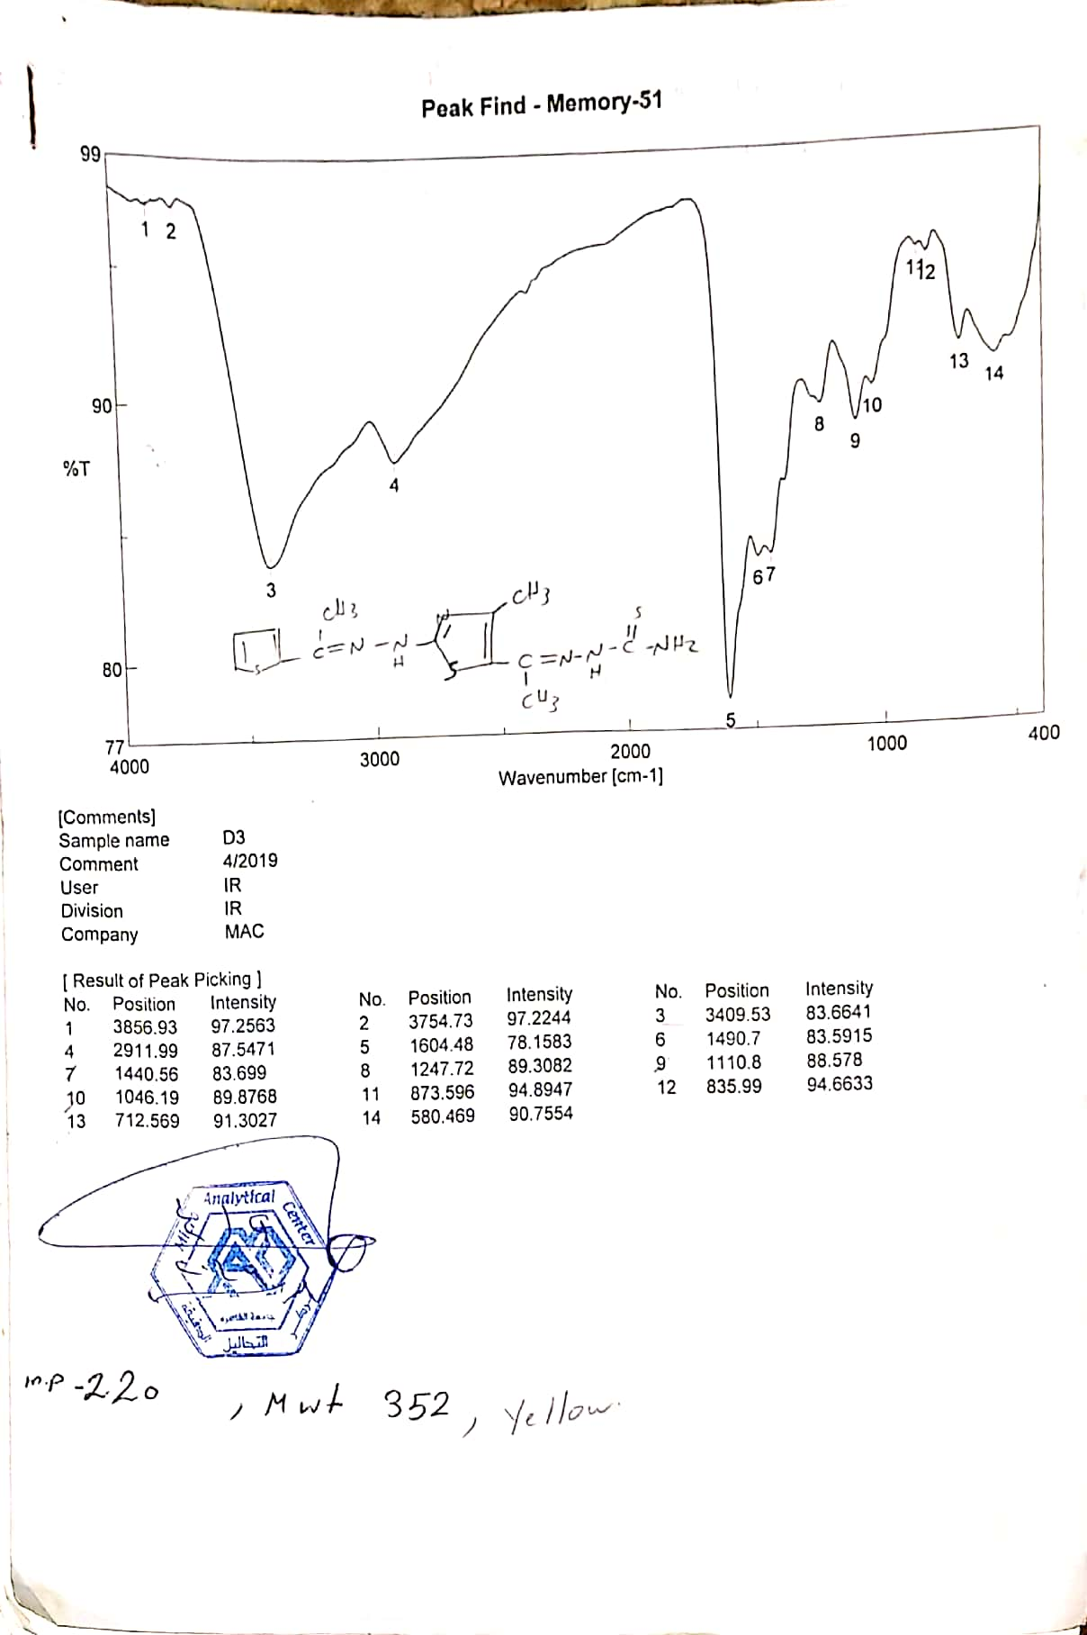
IR of compound 3

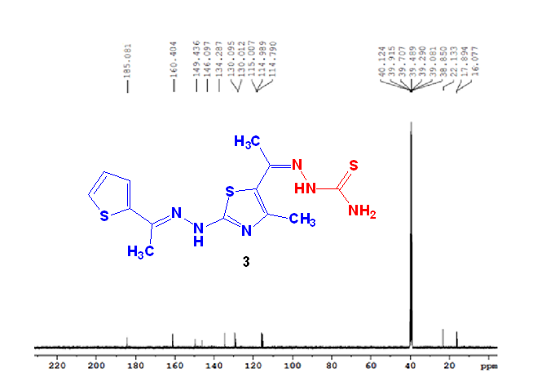
¹³C-NMR of compound 3

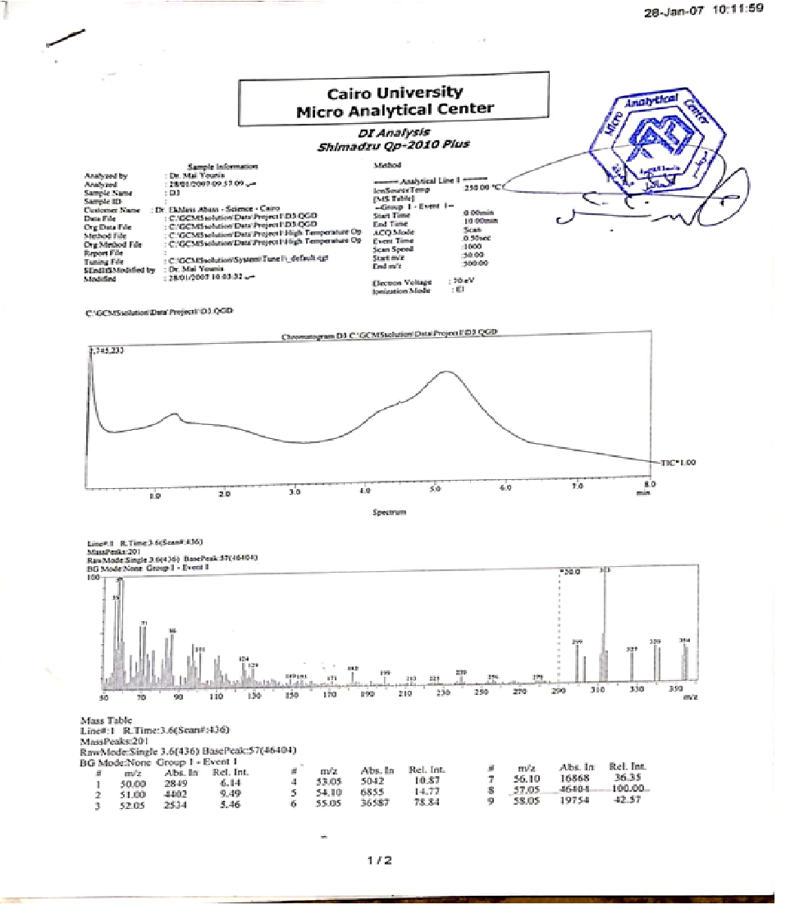

Mass of compound 3

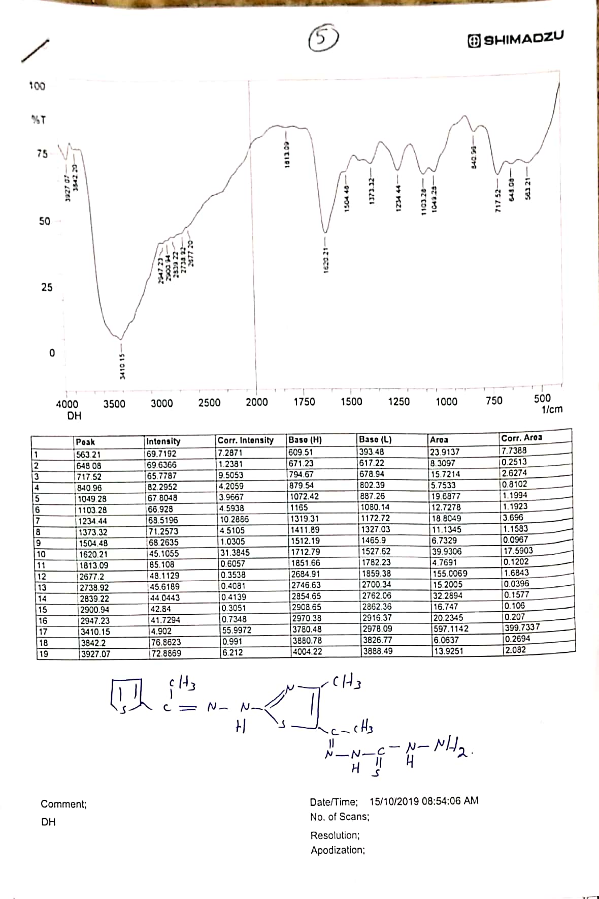

IR of compound 5

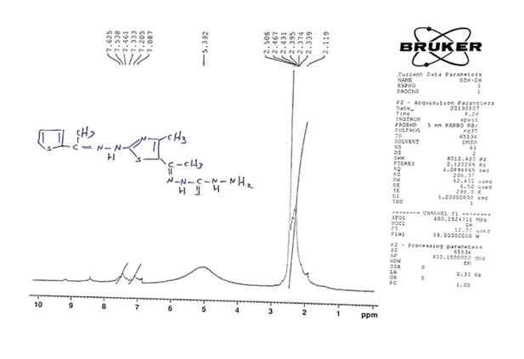
¹H-NMR of compound 5

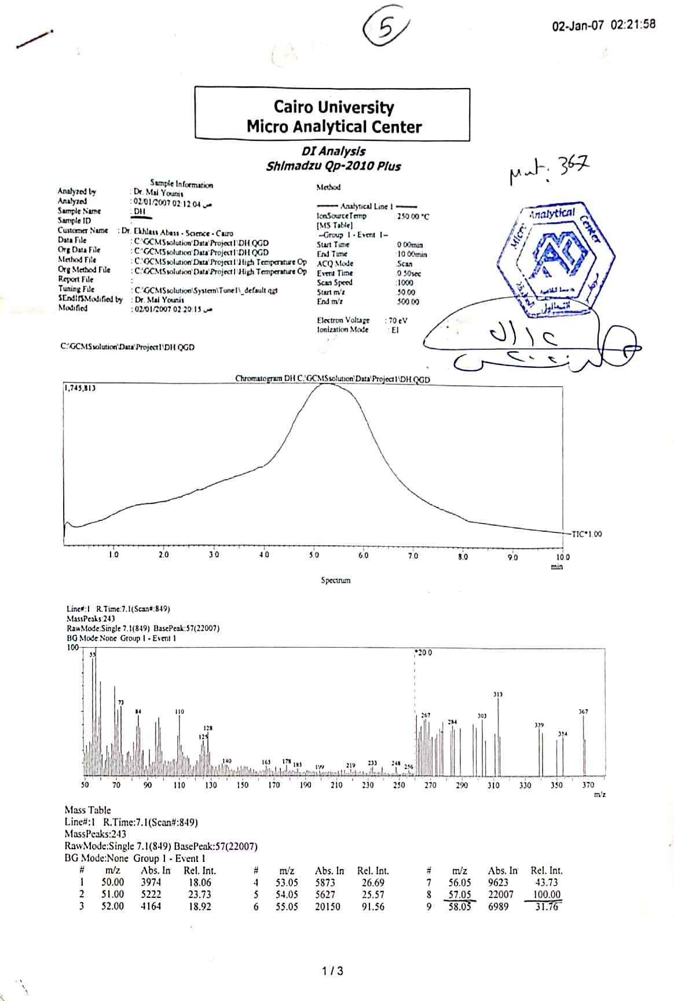
Mass of compound 5

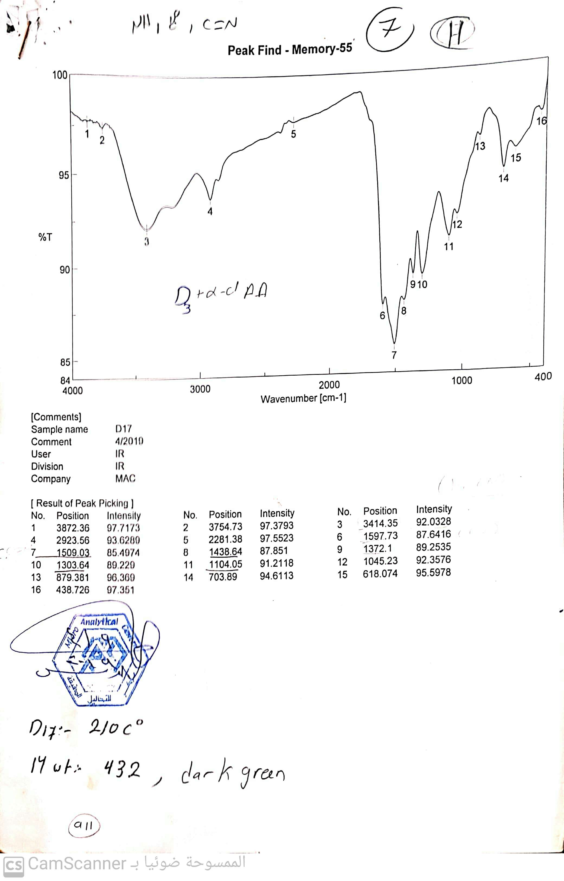
IR of compound 7

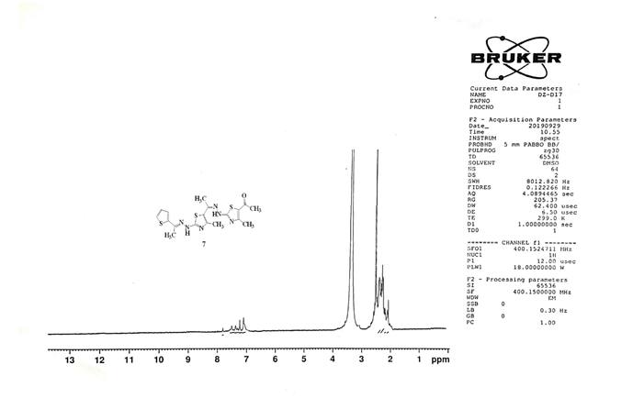
¹H-NMR of compound 7

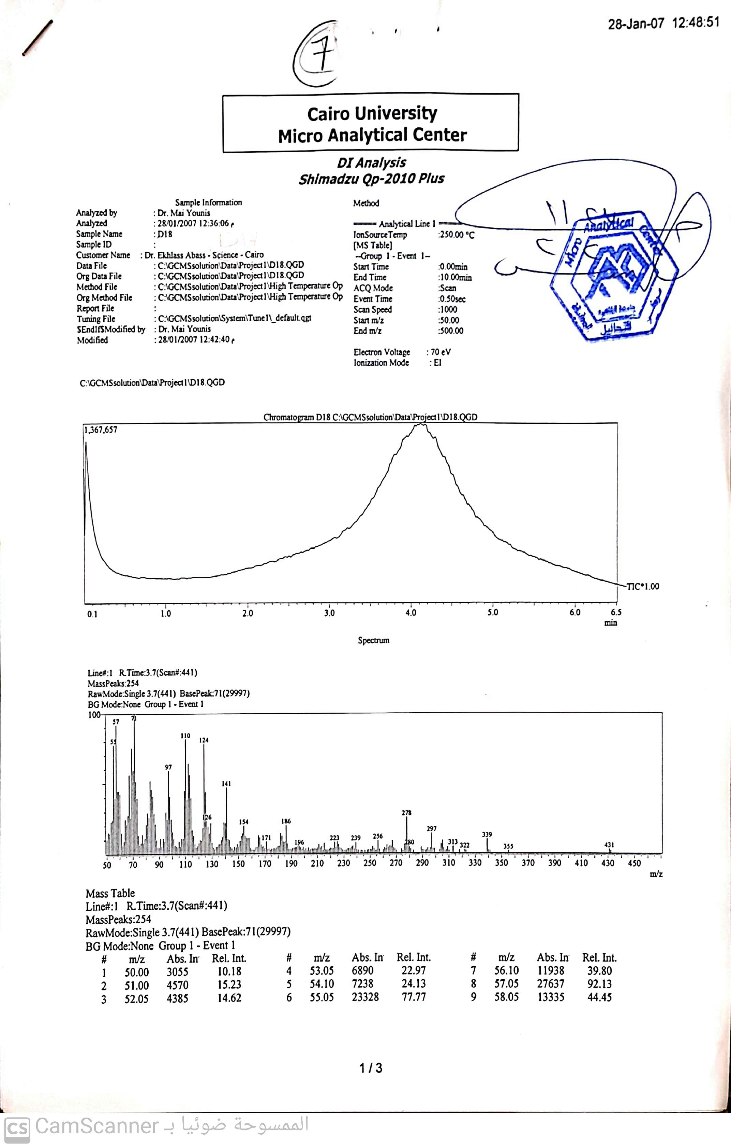
Mass of compound 7

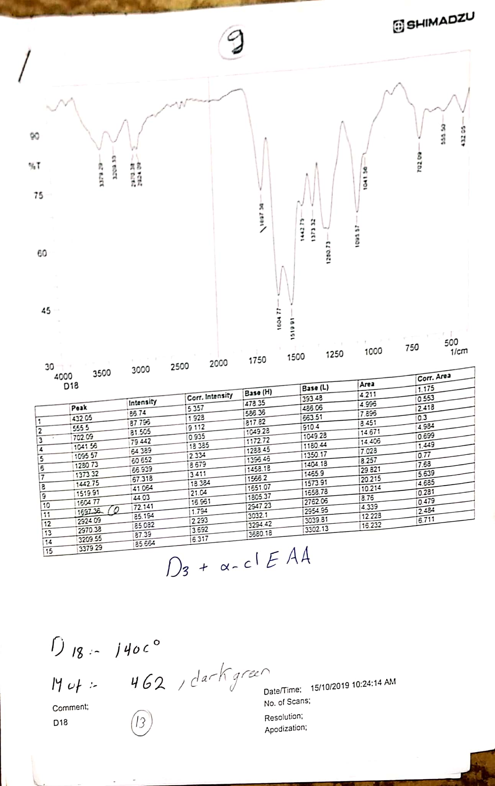

IR of compound 9

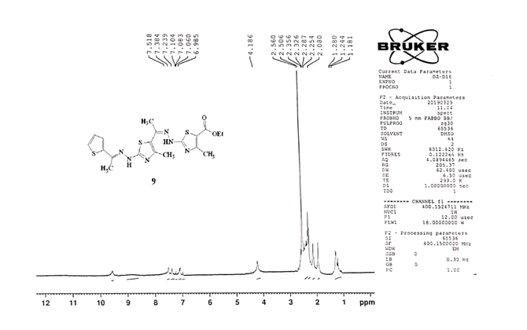
¹H-NMR of compound 9

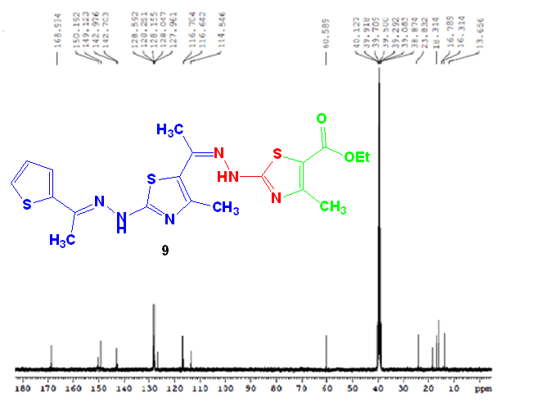

¹³C-NMR of compound 9

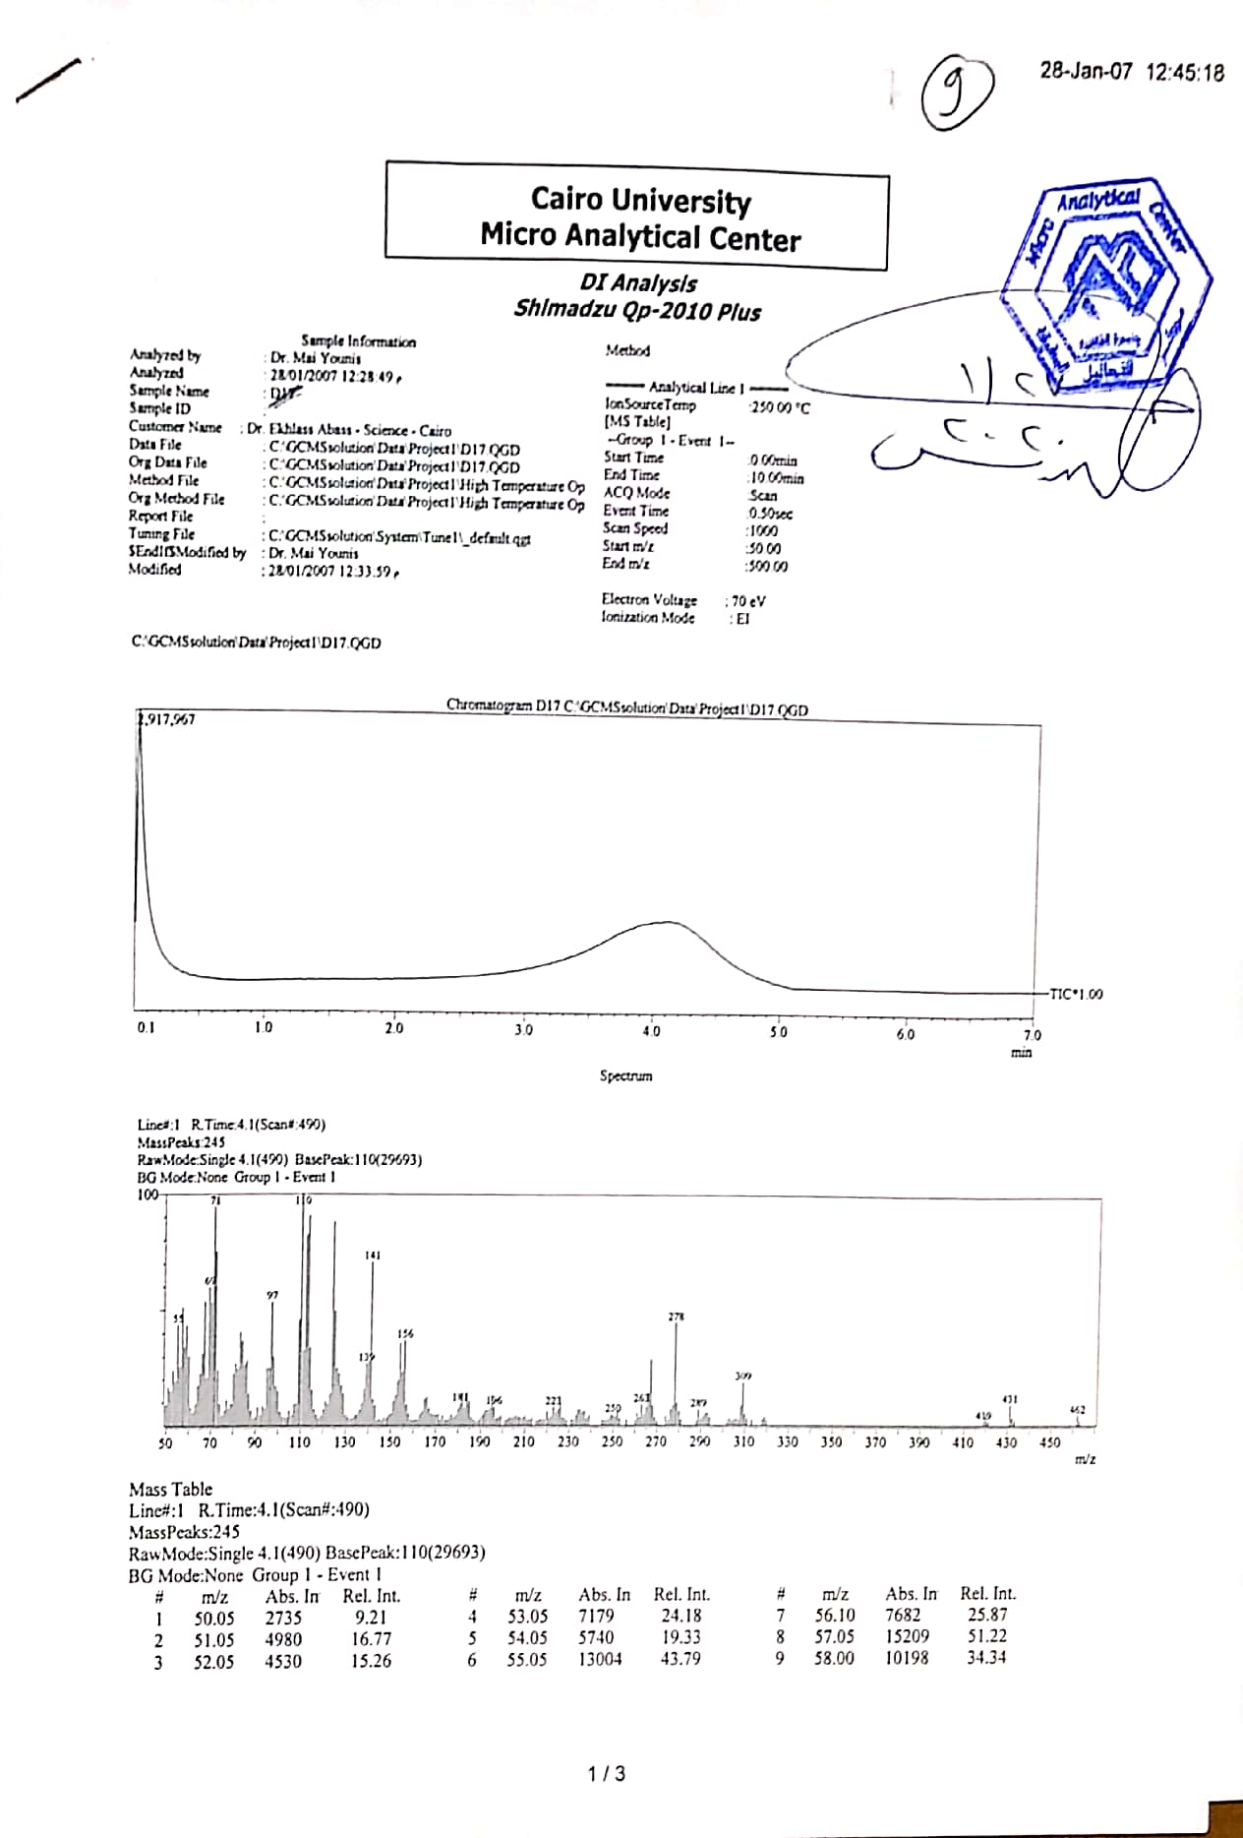

Mass of compound 9

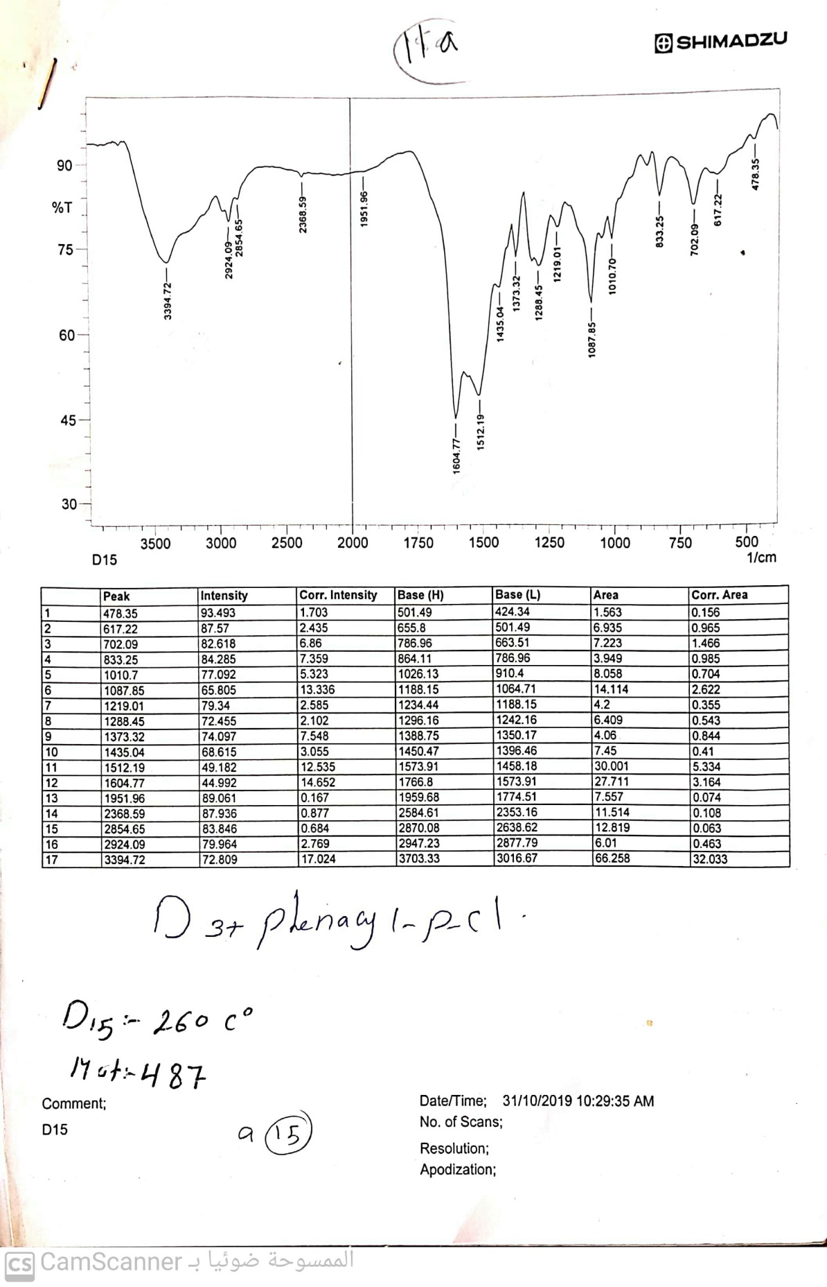
IR of compound 11a

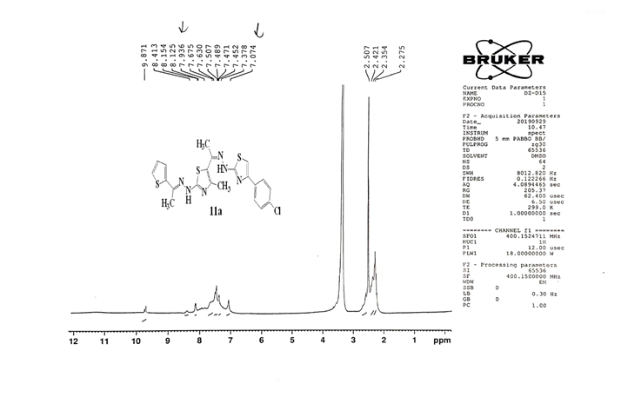
¹H-NMR of compound 11a

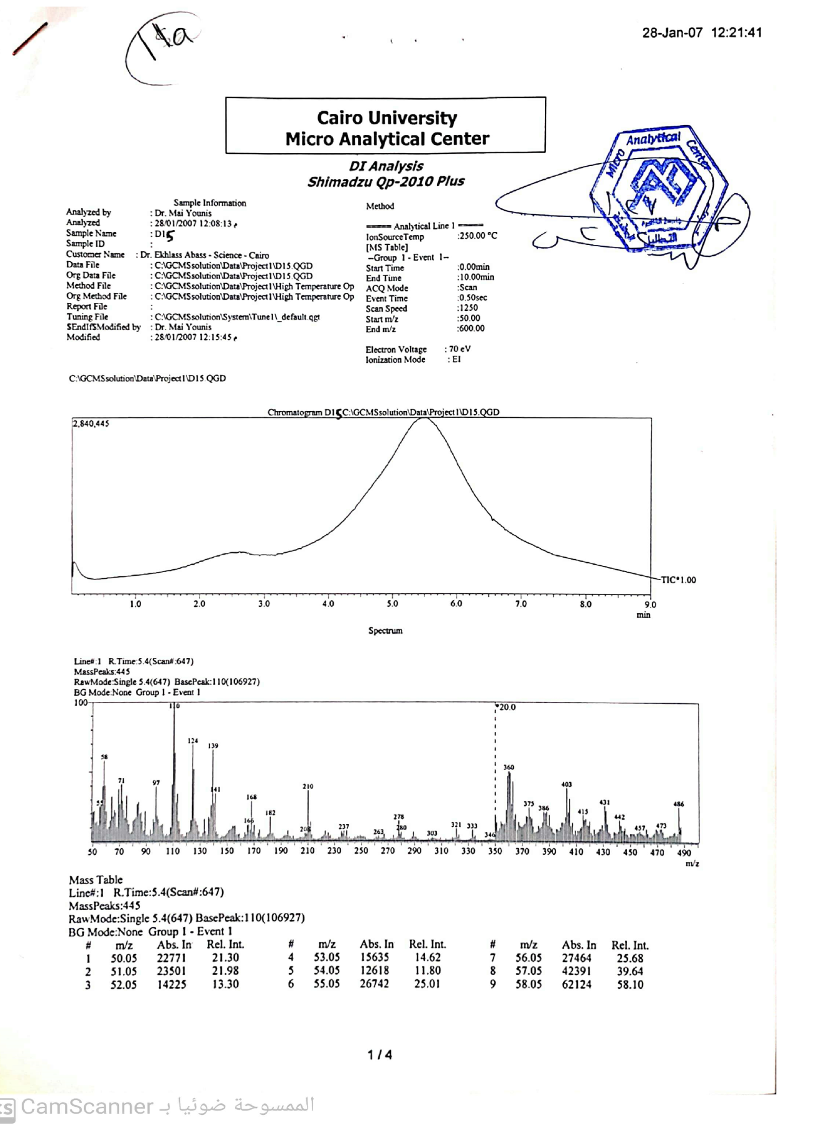
Mass of compound 11a

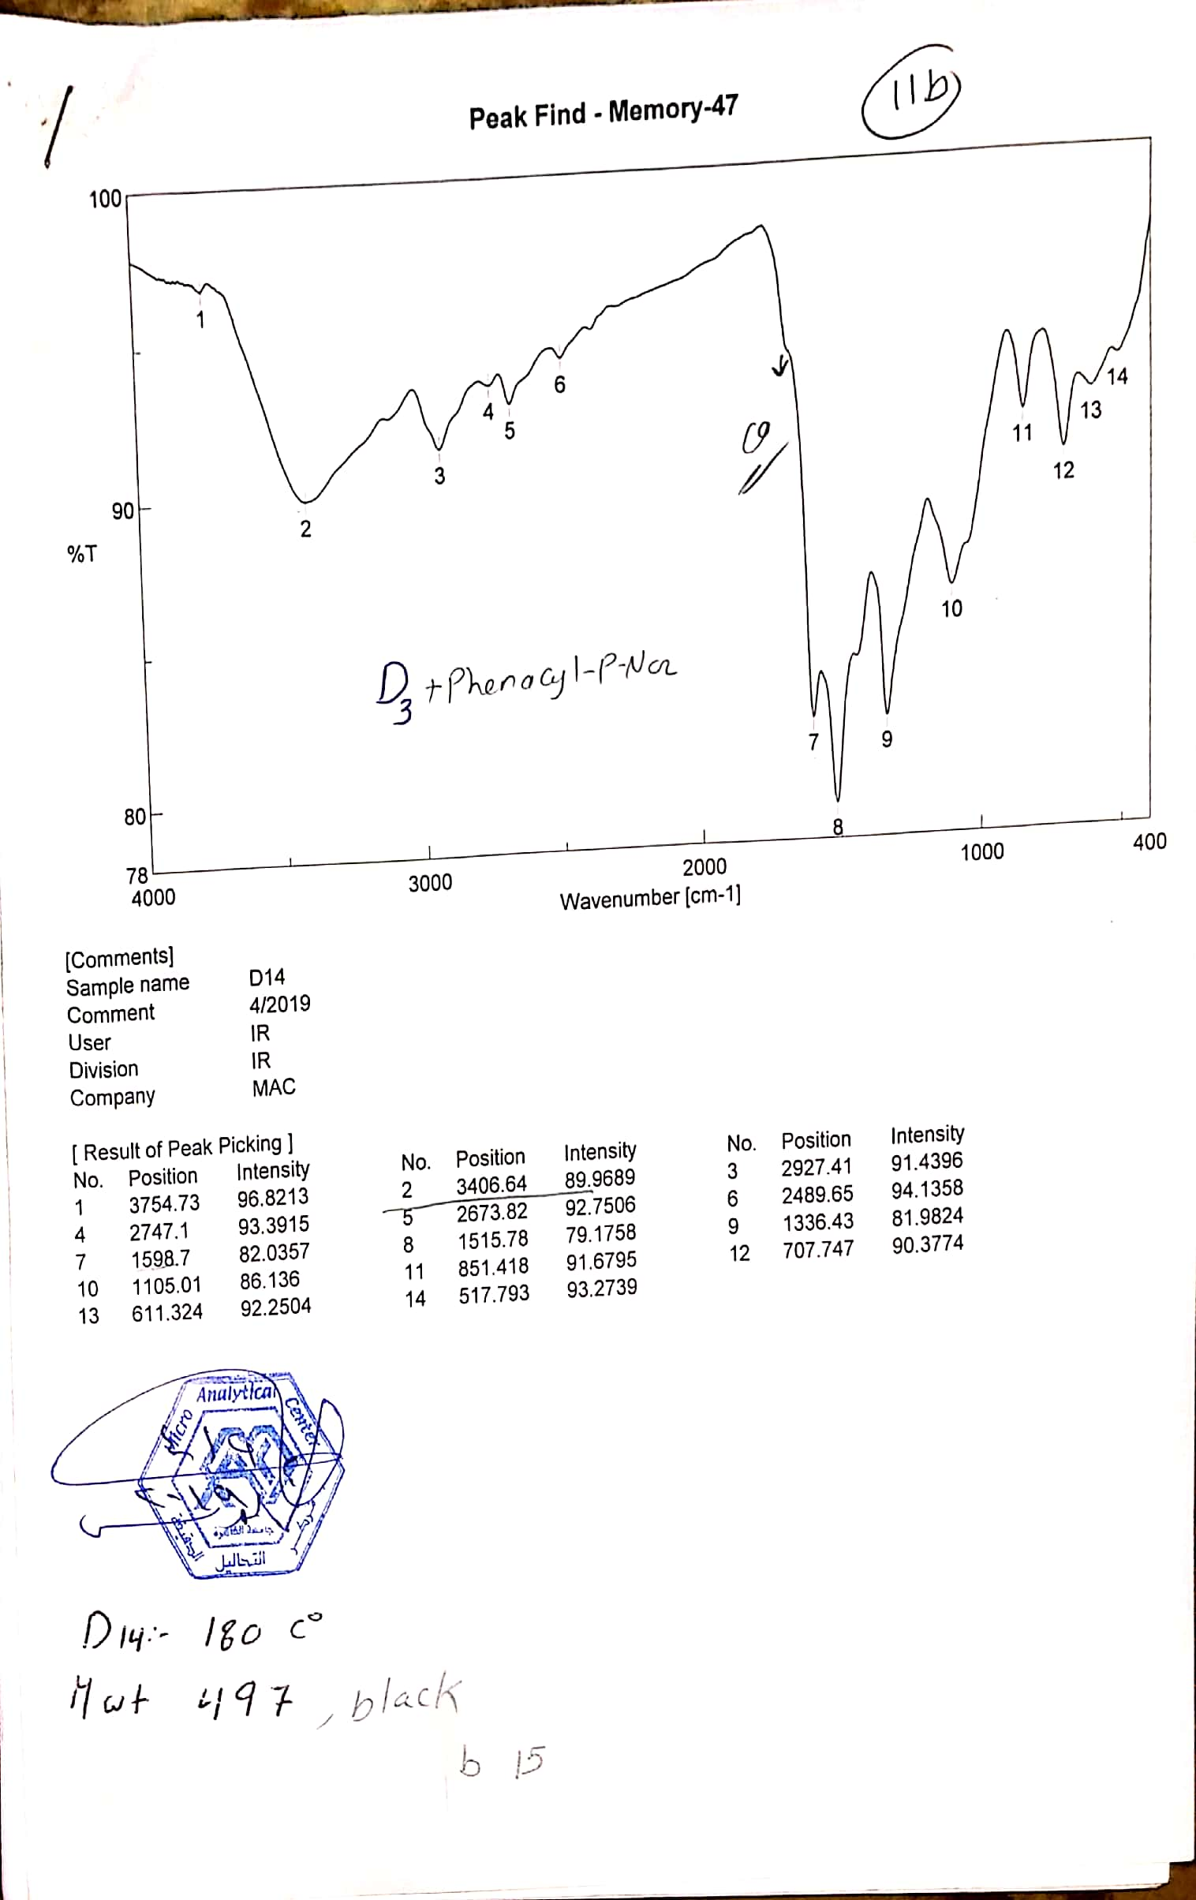
IR of compound 11b

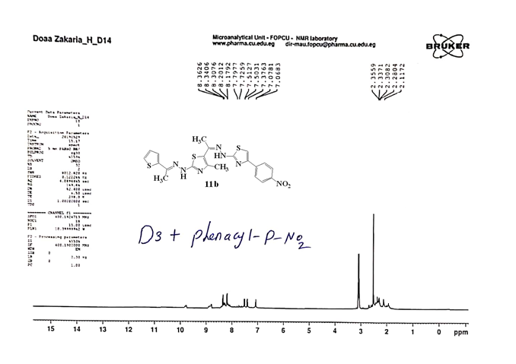
¹H-NMR of compound 11b

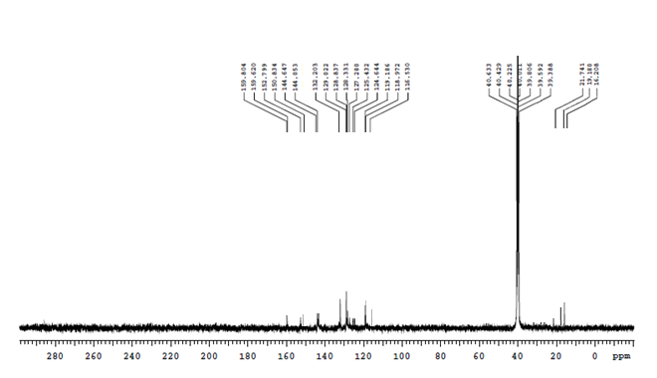
¹³C-NMR of compound 11b

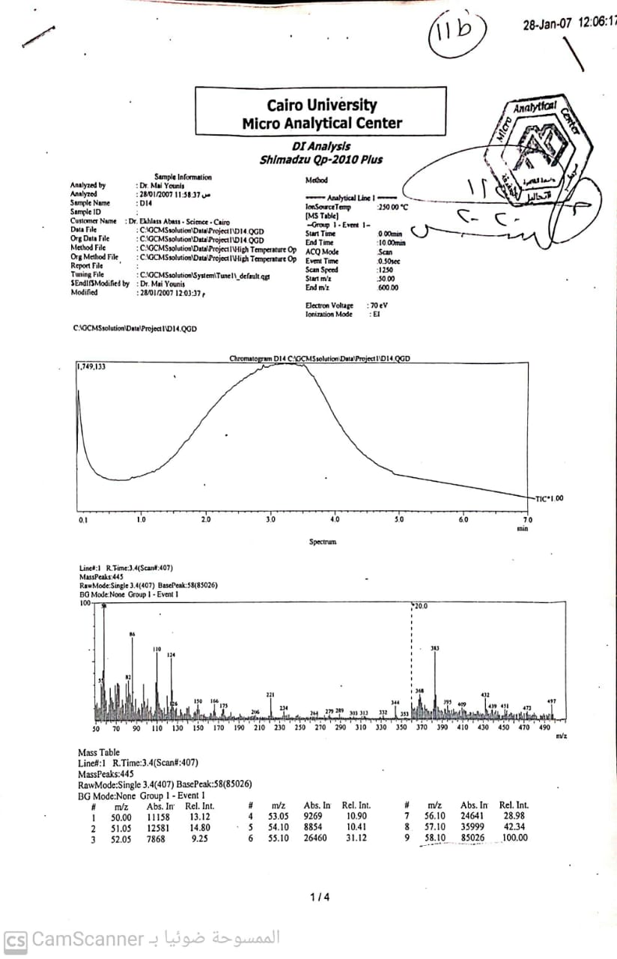

Mass of compound 11b

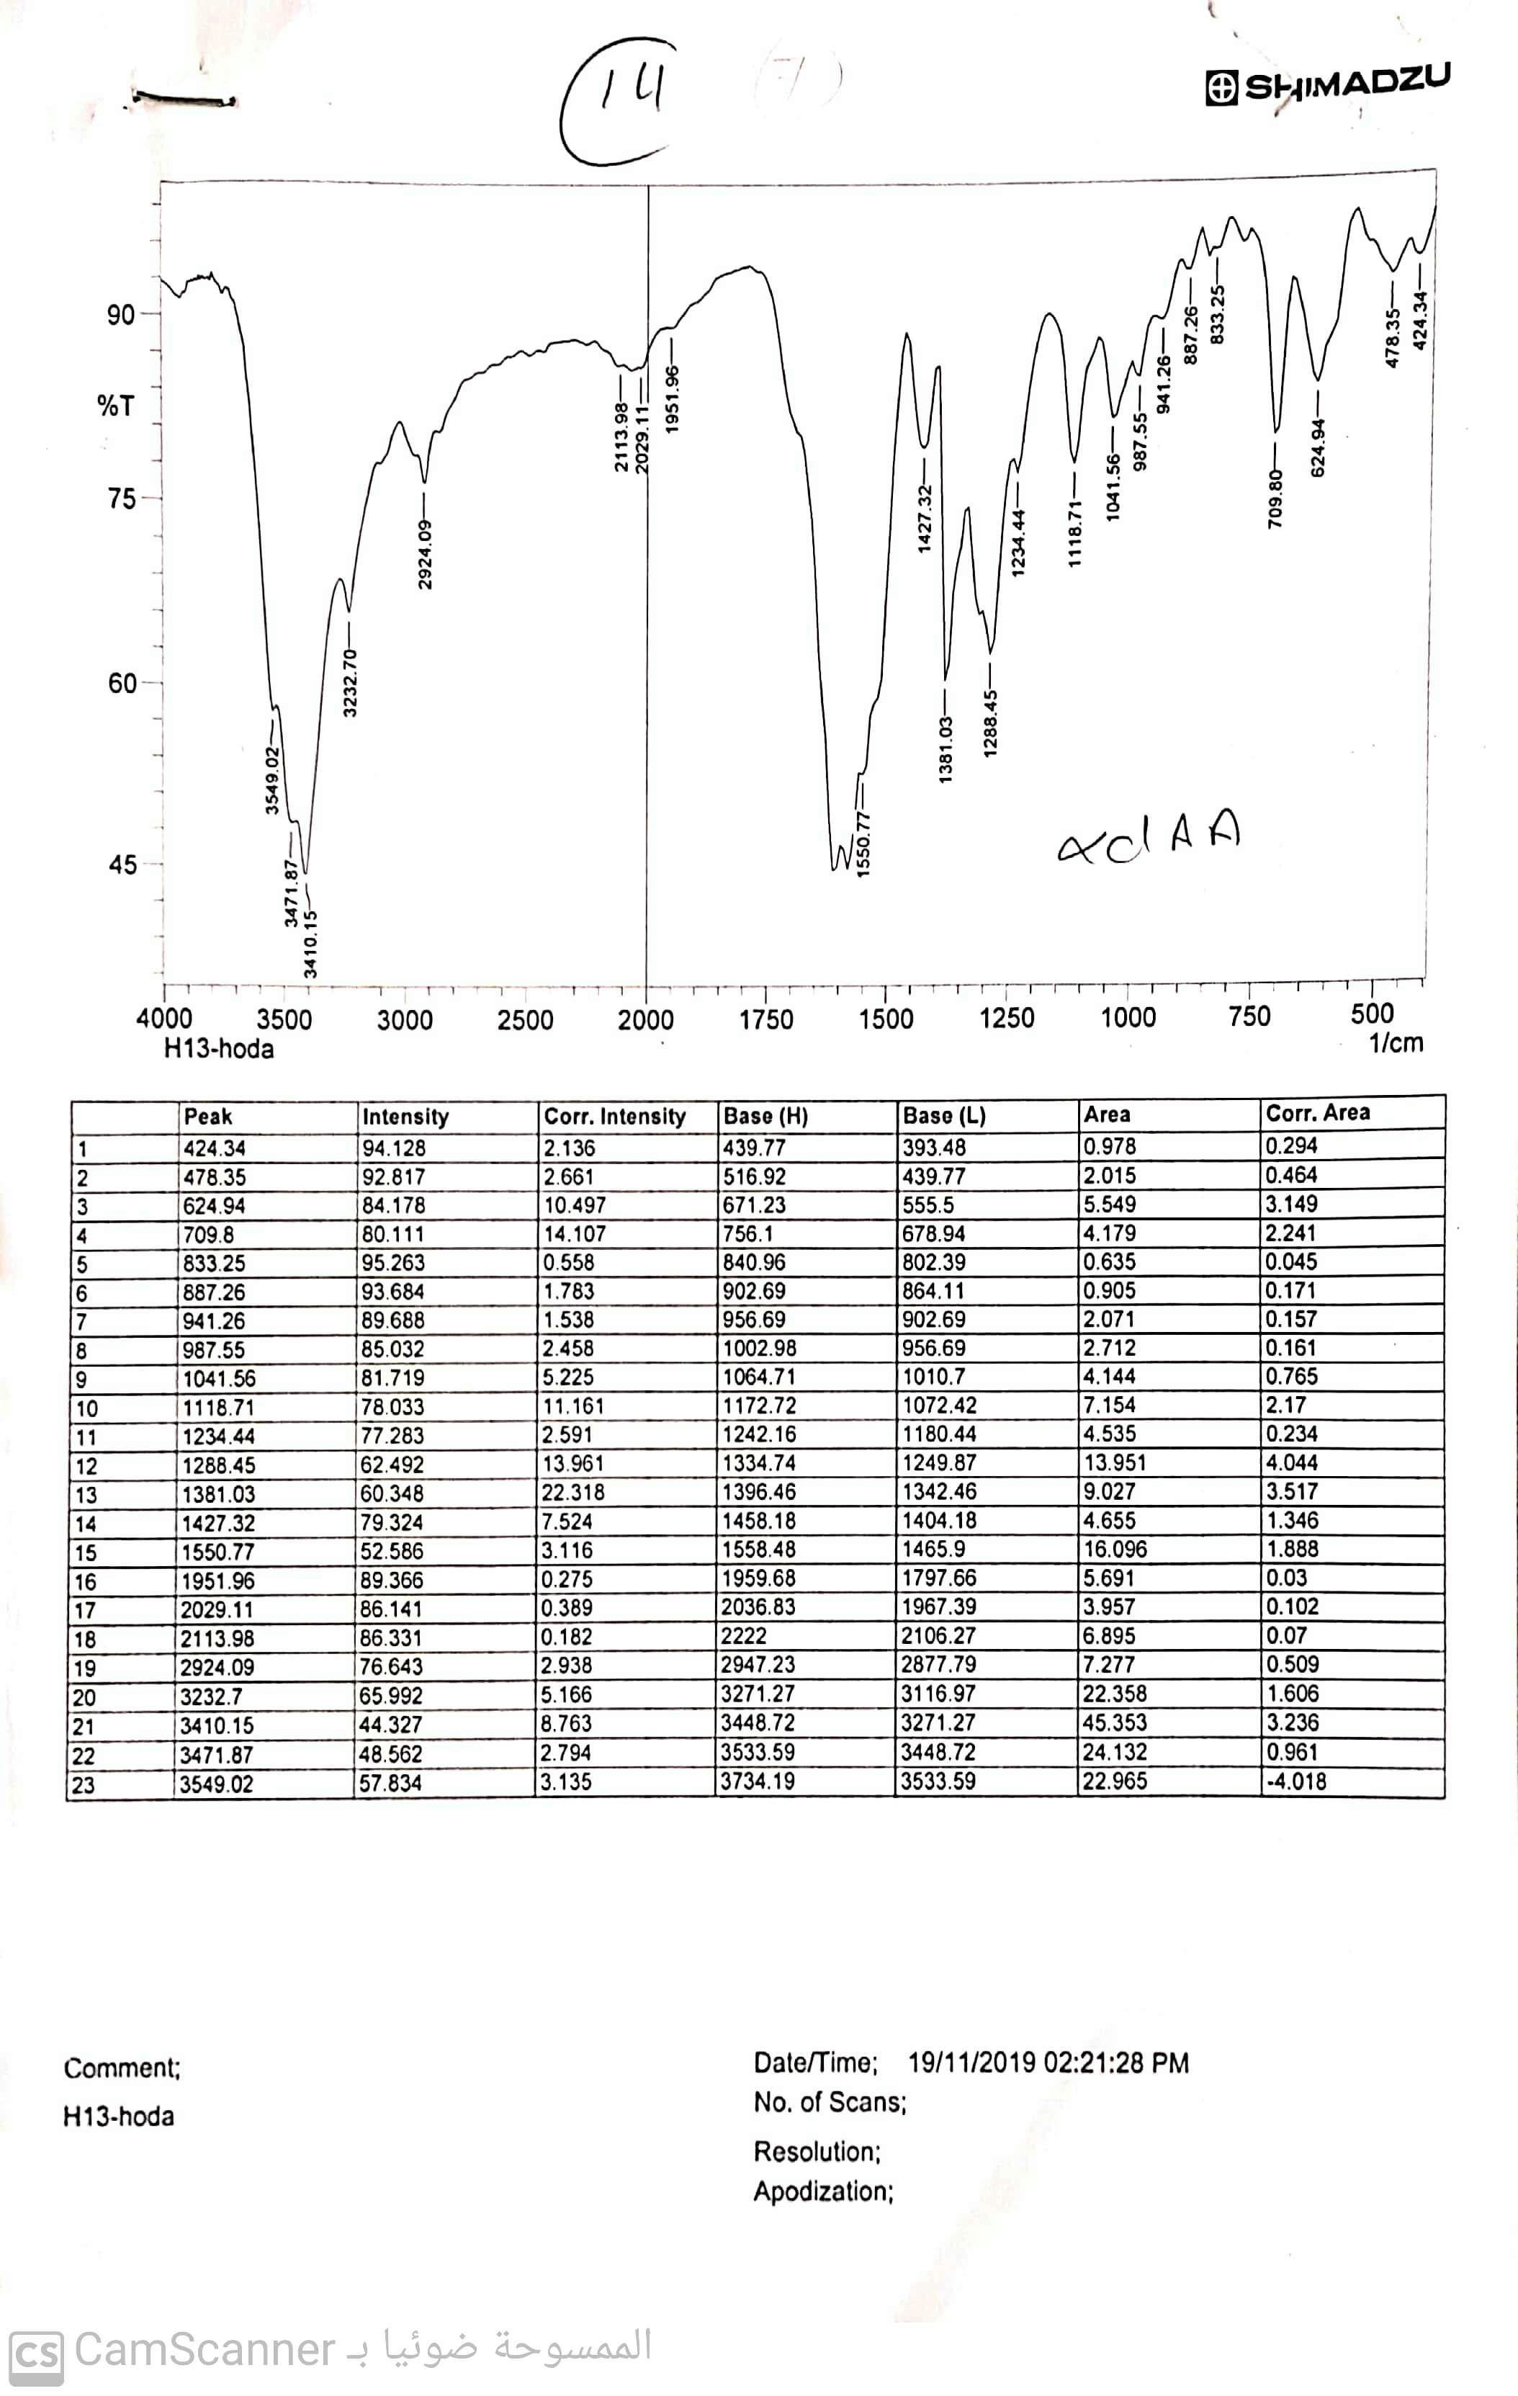

IR of compound 14

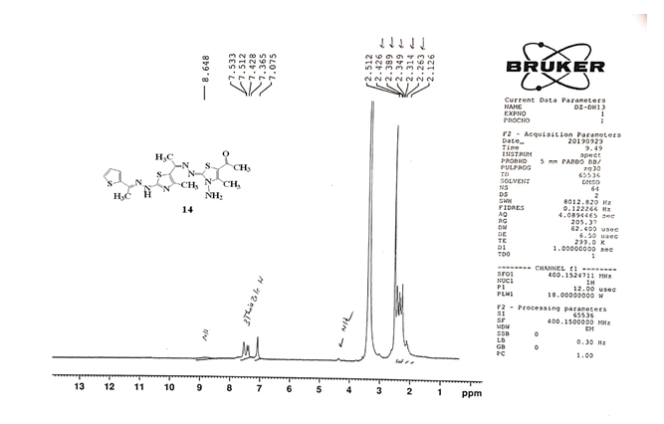
¹H-NMR of compound 14

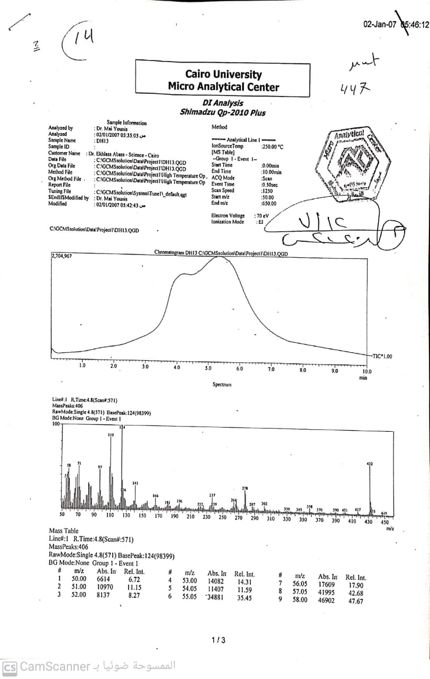

Mass of compound 14

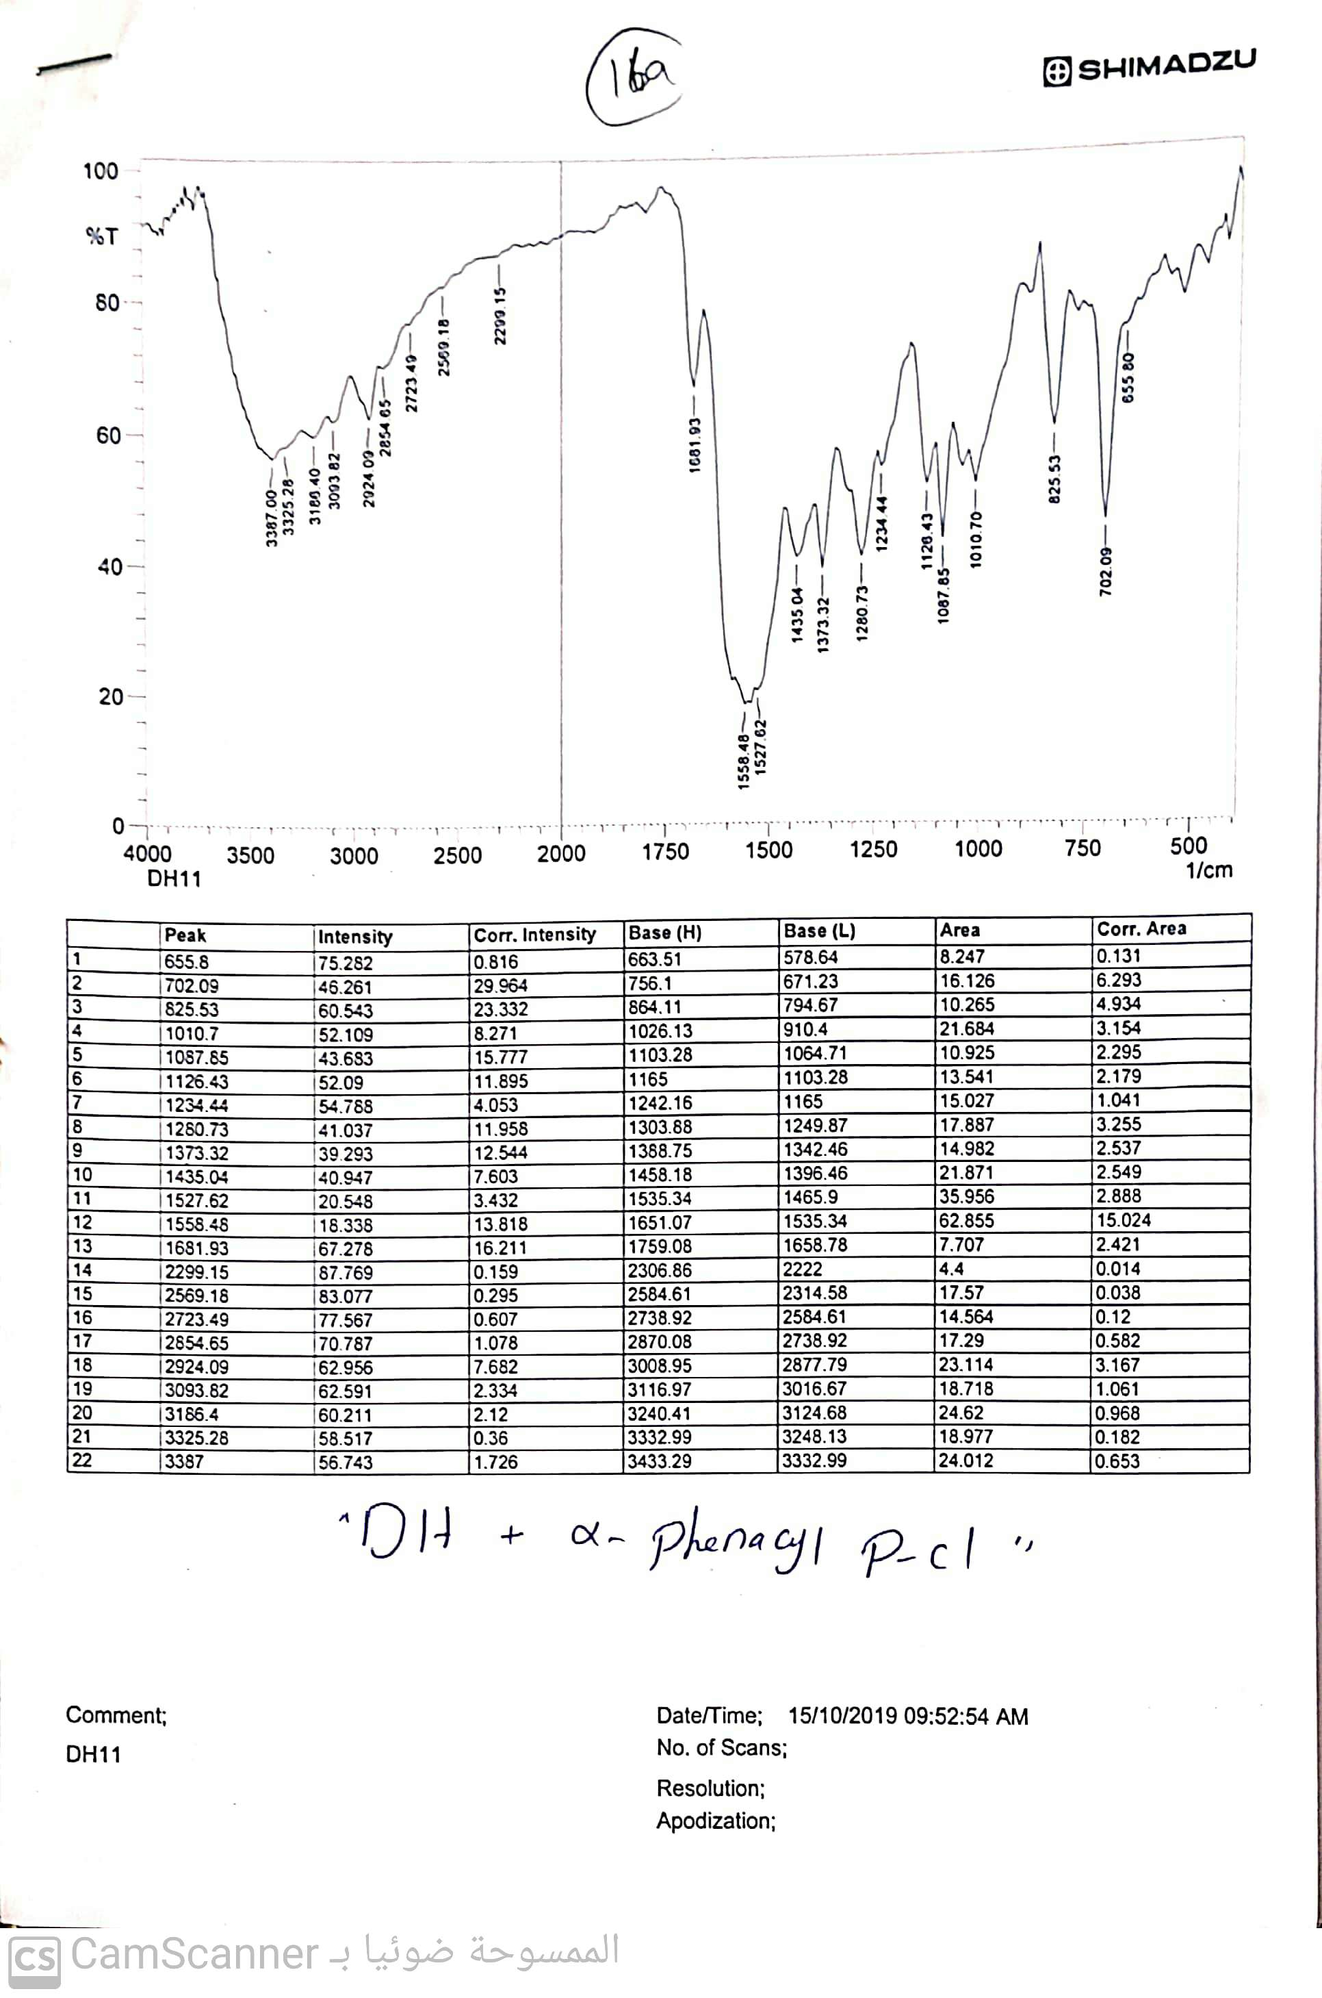
IR of compound 16a

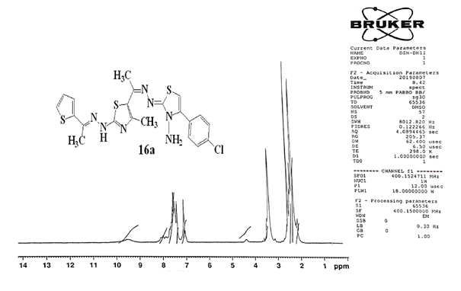
¹H-NMR of compound 16a

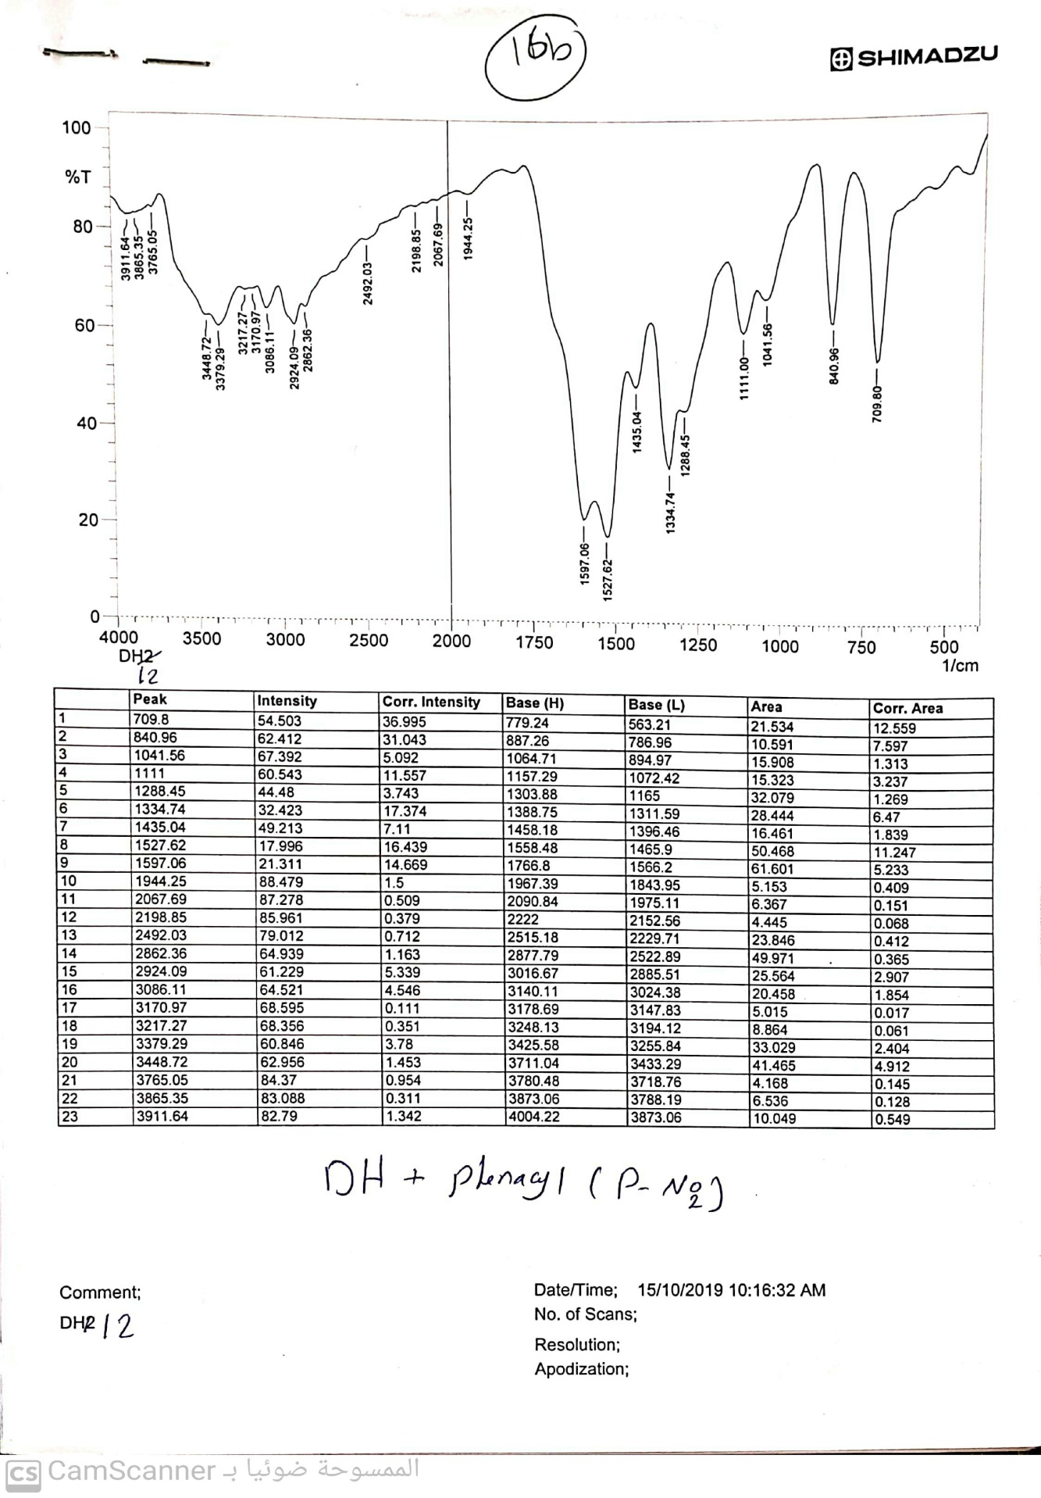
IR of compound 16b
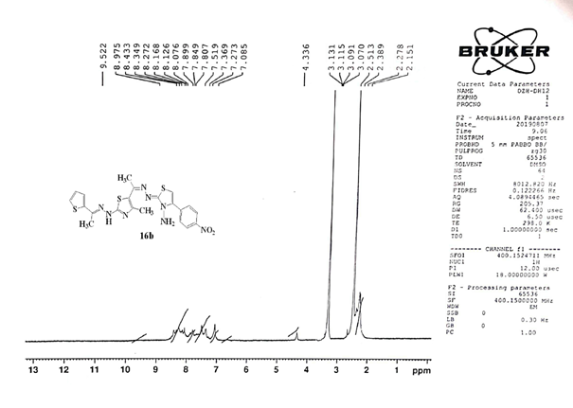
¹H-NMR of compound 16b

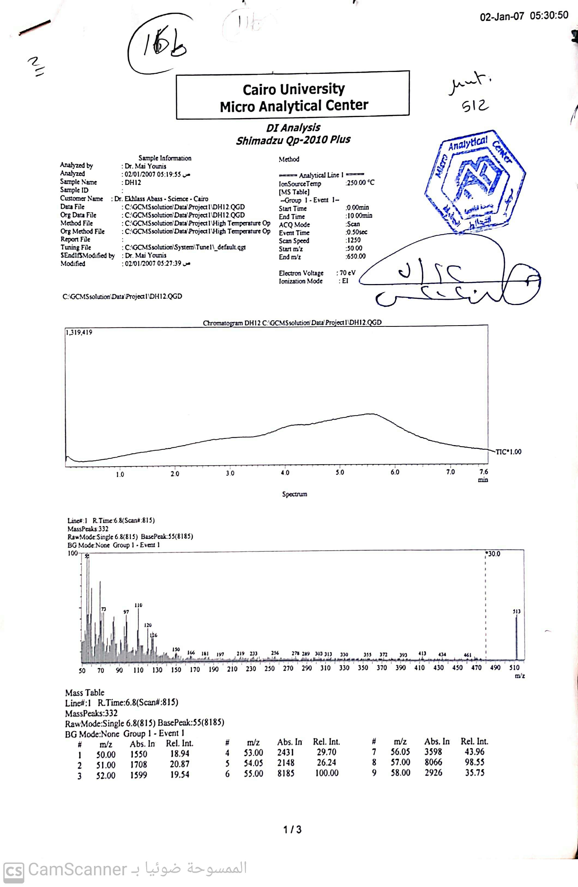
Mass of compound 16b
Figure S2. Spectral data for some compounds.
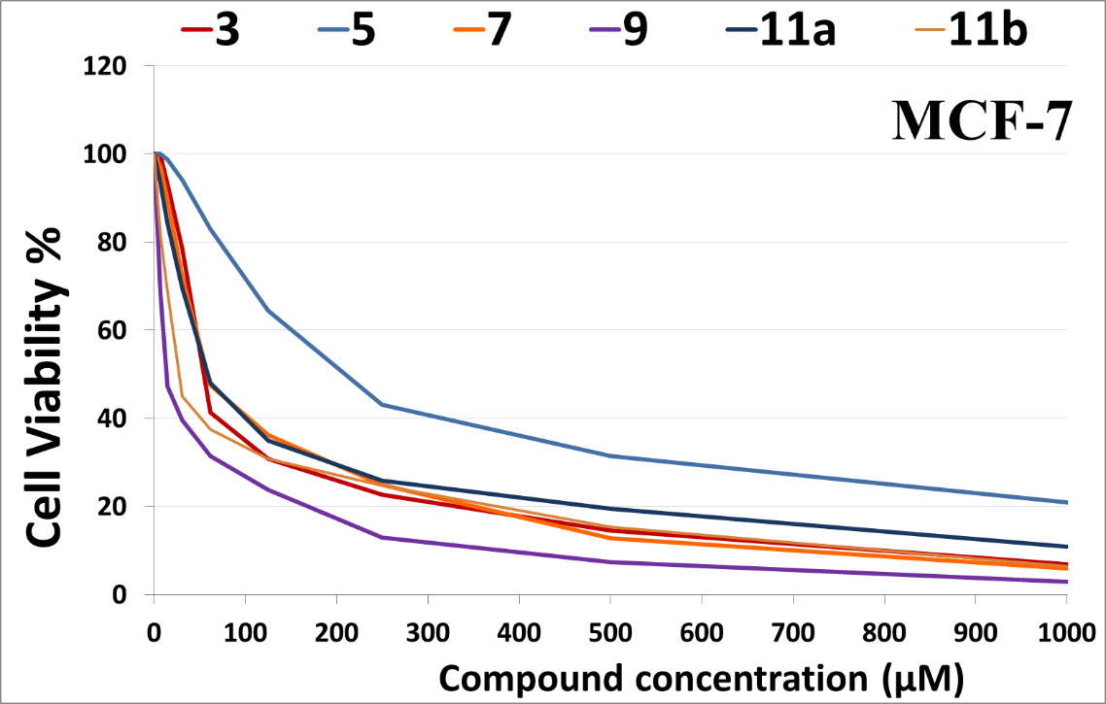
Figure S3a. Cell viability% of compounds 3, 5, 7, 9, 11a and 11b versus compound concentration (µM)

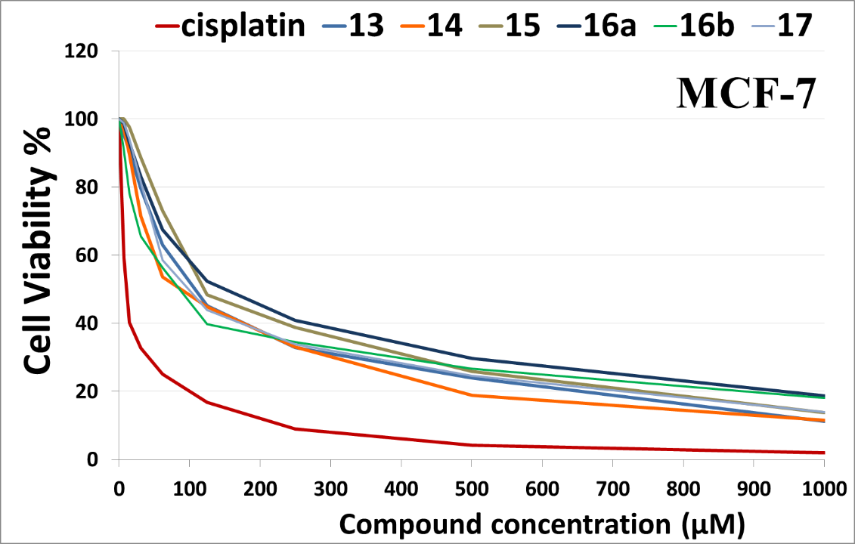

Figure S3b. Cell viability% of compounds 13, 14, 15, 16a, 16b and 17versus compound concentration (µM)

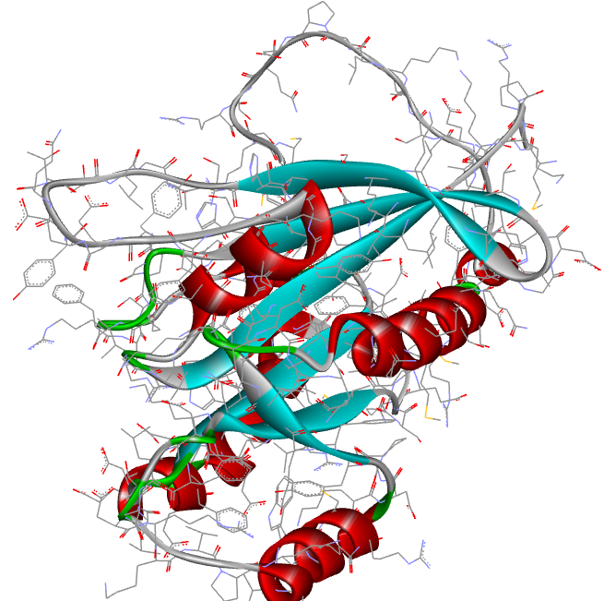
Figure S4. The 3D structure of Rab7b protein

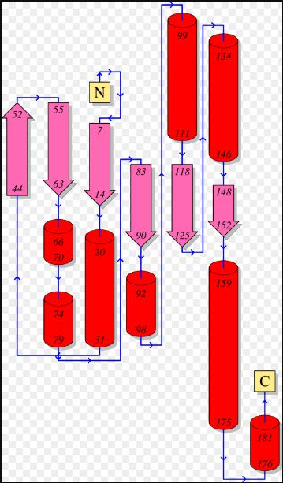
Figure S5. The homology model of the target consists of 8 α-helices and 6 β-strands

Figure S6. The abundance of amino acids in Rab7b protein

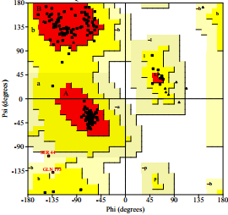
Figure S7. Ramachandran plot of the modeled Rab7b. Red color represents the most favored regions, while yellow color represents the allowed regions

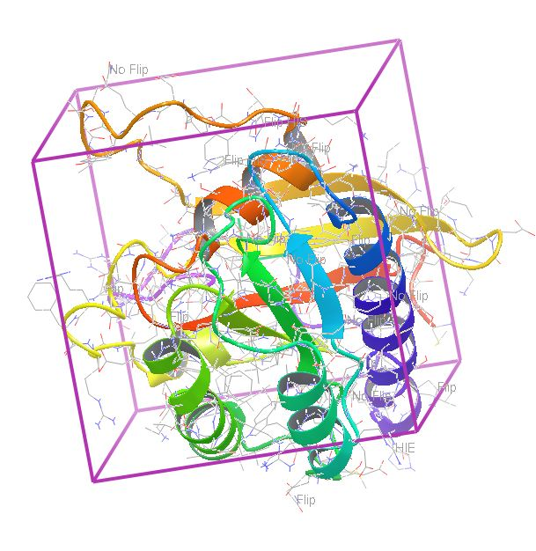
Figure S8. Grid box around the binding site cavity

