SUPPLYMENTARY MATERIALS
Table S1. Clinical characteristics of influenza type A and type B patients from ZHWU
Characteristics | Influenza A (n=1291) | Influenza B (n=602) | p value
Demographic
Age, years | 8 [5, 12] | 8 [5, 12] | 0.78
Gender, male, n (%) | 700 (54.4) | 338 (55.7) | 0.62
Clinical data
Vital signs
SBP (mmHg, normal range: 90-140) | 118 [102, 123] | 118 [112, 123] | 0.80
DBP (mmHg, normal range: 60-90) | 73 [69, 81] | 74 [72, 78] | 0.50
RR, (breaths per minute, normal range: 12-20) | 20 [17, 22] | 22 [20, 25] | 0.20
SpO₂ (%, normal range: ≥ 94) | 96 [95, 97] | 96 [95, 98] | 0.29
Temperature, (°C, normal range: 36.2-37.3) | 38.2 [36.9, 38.8] | 38.0 [37.4, 38.8] | 0.84
Symptoms
Fever, n (%) | 1247 (97.0) | 591 (97.4) | 0.77
Cough, n (%) | 850 (66.1) | 450 (74.1) | <0.001
Fatigue, n (%) | 693 (53.9) | 328 (54.0) | 0.96
Headache, n (%) | 670 (52.1) | 312 (51.4) | 0.81
Myalgia, n (%) | 315 (24.5) | 147 (24.2) | 0.91
Laboratory findings
Blood cell counts
Leucocytes (1×10⁹/L, normal range: 3.5-9.5) | 7.13 [5.71, 8.85] | 7.01 [5.80, 8.61] | 0.46
Neutrophils (1×10⁹/L, normal range: 1.8-6.3) | 4.81 [3.57, 6.39] | 4.71 [3.55, 6.21] | 0.27
Erythrocytes (1×10¹²/L, normal range: 4.3-5.8) | 4.68 [4.46, 4.95] | 4.70 [4.46, 4.96] | 0.73
Hemoglobin (g/L, normal range: 130-175) | 131 [125, 139] | 131 [124, 138] | 0.30
Platelet (1×10⁹/L, normal range: 125-350) | 220 [188, 260] | 217 [189, 255] | 0.53
Monocytes (1×10⁹/L, normal range 0.1-0.6) | 0.79 [0.62, 1.00] | 0.78 [0.59, 1.01] | 0.29
Lymphocytes (1×10⁹/L, normal range 1.1-3.2) | 1.29 [0.91, 1.77] | 1.21 [0.86, 1.74] | 0.20
Blood biochemistry
AST (U/L, normal range: 15.0-40.0) | 52 [34, 59] | 38 [32, 40] | 0.41
ALT (U/L, normal range: 9.0-50.0) | 14 [12, 20] | 15 [14, 16] | 0.90
BUN (mmol/L, normal range: 2.8-7.6) | 4.0 [3.6, 5.0] | 3.7 [3.0, 4.5] | 0.61
Creatinine (μmol/L, normal range: 64.0-104.0) | 49.0 [31.6, 94.6] | 60.5 [52.7, 68.3] | 0.86
hsTnI (pg/mL, normal range: 0.0-26.2) | 1.3 [0.9, 3.8] | 0.9 [0.7, 1.0] | 0.27
LDH (U/L, normal range: 125-243) | 234 [206, 300] | 193 [179, 246] | 0.51
CK-MB (U/L, normal range: 0-25) | 7 [1, 14] | 13 [4, 16] | 0.15
Coagulation function
APTT (s, normal range: 28.0-43.5) | 35.6 [33.3, 39.4] | 36.2 [32.6, 39.1] | 0.43
PT (s, normal range: 11.0-16.0) | 14.8 [13.8, 16.1] | 14.5 [13.3, 15.9] | 0.80
D-dimer (ng/mL, normal range: 0.0-500.0) | 128.0 [110.8, 291.5] | 125.5 [114.0, 136.7] | 0.19
Infection markers
hsCRP (mg/L, normal range: 0.0-3.0) | 2.2 [0.5, 6.7] | 2.2 [0.5, 7.1] | 0.80
Procalcitonin (ng/mL, normal range < 0.5) | 0.10 [0.06, 98.81] | 0.16 [0.12, 3.16] | 0.22
Data are expressed as counts with percentage, otherwise median [IQR]. ALT: alanine aminotransferase, APTT: activated partial thromboplastin time, AST: aspartate transaminase, BUN: blood urea nitrogen, CK-MB: creatine kinase isoenzyme MB, DBP: diastolic blood pressure, hsCRP: high-sensitivity C-reactive protein, hsTnI: high-sensitivity Troponin I, LDH: lactate dehydrogenase, NT-proBNP: N-terminal pro b-type natriuretic peptide, PT: prothrombin time, RR: respiration rate, SBP: systolic blood pressure, SpO2: pulse oxygen saturation.

Table S2. The features considered, how they are represented in our model, and whether they are included for analysis.
Category | Features | Representation | Included
Demographic  (n=2) | Age | Computed based on mid-year of year of birth | Yes
 | Gender | Binary variable: male or female | Yes
Life style  (n=3) | Body mass index (BMI) | BMI based on height and most recent weight | No
Life style  (n=3) | Smoking status | Categorical variable: non-smoker, ex-smoker, current smoker | Yes
Life style  (n=3) | Alcohol intake | Categorical variable: non-drinker, ex-drinker, current-drinker | Yes
Comorbidities  (n=10) | Hypertension, cardiovascular disease, heart failure, atrial fibrillation, chronic obstructive pulmonary disease (COPD), chronic kidney disease, chronic liver disease, diabetes, hyperlipidemia, neurological disorders | One separate binary variable (yes/no) for each disease | Yes
Clinical signs  (n=8) | Systolic blood pressure, diastolic blood pressure, pulse, body temperature, heart rate, respiration rate, pulse oxygen saturation (SpO₂) | Numeric variable for the first record after visit | Yes
 | Level of consciousness | Categorical variable: awake, confusion, delirium, somnolence, stupor, coma | Yes
Symptoms  (n=14) | Fever, nausea, abdominal pain, diarrhea, dyspnea, myalgia, cough, vomiting, fatigue, headache, dizziness, chest pain, anorexia, sore throat | Binary variable (yes/no) for if recorded | Yes
Laboratory tests  (n=73) | Basophils, basophils proportion, hematocrit, hemoglobin, leukocyte, lymphocyte, lymphocyte proportion, mean platelet volume, mean corpuscular hemoglobin concentration, mean corpuscular hemoglobin, mean corpuscular volume, monocytes, monocyte proportion, neutrophils, neutrophil proportion, platelets, red blood cell distribution width (coefficient of variation), red blood cell distribution width (standard deviation) | Numeric variable for the first record after hospital visit | Yes
Laboratory tests  (n=73) | Na⁺, K⁺, Mg²⁺, Ca²⁺, Cl⁻ | Numeric variable for the first record after hospital visit | No
Laboratory tests  (n=73) | pH, PaO₂, PaCO₂, HCO₃⁻, base excess (BE) | Numeric variable for the first record after hospital visit | No
Laboratory tests  (n=73) | Lactate | Numeric variable for the first record after hospital visit | No
Laboratory tests  (n=73) | Aspartate transaminase (AST), alanine aminotransferase (ALT), AST/ALT ratio, albumin (ALB), globulin (GLB), ALB/GLB ratio, alkaline phosphatase, | Numeric variable for the first record after hospital visit | No
Laboratory tests  (n=73) | Blood urea nitrogen (BUN), creatinine, β2 microglobulin (β2-MG), creatinine clearance (CCr), cystatin C (Cys-C) | Numeric variable for the first record after hospital visit | No
Laboratory tests  (n=73) | High-sensitivity Troponin I (hsTnI) | Numeric variable for the first record after hospital visit | No
Laboratory tests  (n=73) | N-terminal pro b-type natriuretic peptide (NT-proBNP) | Numeric variable for the first record after hospital visit | No
Laboratory tests  (n=73) | Lactate dehydrogenase (LDH) | Numeric variable for the first record after hospital visit | No
Laboratory tests  (n=73) | Creatine kinase isoenzyme MB (CK-MB) | Numeric variable for the first record after hospital visit | No
Laboratory tests  (n=73) | Lipase, amylase | Numeric variable for the first record after hospital visit | No
Laboratory tests  (n=73) | Creatine kinase (CK) | Numeric variable for the first record after hospital visit | No
Laboratory tests  (n=73) | Glucose | Numeric variable for the first record after hospital visit | Yes
Laboratory tests  (n=73) | Triglycerides (TG), total cholesterol (TC), lipoprotein (LP(a)), high-density lipoprotein (HDL), low-density lipoprotein (LDL), apolipoprotein AI (ApoA I), ApoB, free fatty acid (FFA) | Numeric variable for the first record after hospital visit | No
Laboratory tests  (n=73) | Thrombin time (TT), activated partial thromboplastin time (APTT), prothrombin time (PT), fibrinogen, international normalized ratio(INR), D-dimer | Numeric variable for the first record after hospital visit | No
Laboratory tests  (n=73) | high sensitivity C-reactive protein (hsCRP) | Numeric variable for the first record after hospital visit | Yes
Laboratory tests  (n=73) | C-reactive protein (CRP) | Numeric variable for the first record after hospital visit | Yes
Laboratory tests  (n=73) | Procalcitonin (PCT) | Numeric variable for the first record after hospital visit | Yes
Laboratory tests  (n=73) | Erythrocyte sedimentation rate (ESR) | Numeric variable for the first record after hospital visit | No
Laboratory tests  (n=73) | Interleukin-6 (IL-2), IL-4, IL-6, IL-10, tumor necrosis factor-alpha (TNF-α), interferon-gamma (IFN-γ) | Numeric variable for the first record after hospital visit | No
The initial analysis considered 110 features based on the corresponding feasibility and timeliness, among which 52 features were excluded for subsequent analysis due to data missing. Finally, 58 features were included for subsequent analysis.
Figure S1. Contribution of features (top 10) on prediction model.
Age was the most important indicator for prediction. hsCRP: high-sensitivity C-reactive protein, MONO: monocytes, MCHC: mean corpuscular hemoglobin concentration, RDW.SD: red blood cell distribution width (standard deviation), LYMPH%: lymphocyte proportion, MCH: mean corpuscular hemoglobin, RDW.CV: red blood cell distribution width (coefficient of variation), MONO%: monocyte proportion, LYMPH: lymphocyte.

Table S3. AUC scores of multi-tree XGBoost for different combination of features for prediction
Number | Features | AUC for training set (95%CI) | AUC for testing set (95%CI)
1 | Age | 0.92 (0.92, 0.92) | 0.91 (0.91, 0.92)
2 | Age + hsCRP | 0.94 (0.94, 0.94) | 0.91 (0.91, 0.92)
3 | Age + hsCRP + MONO | 0.96 (0.96, 0.97) | 0.93 (0.93, 0.93)
4 | Age + hsCRP + MONO + MCHC | 0.97 (0.97, 0.97) | 0.93 (0.93, 0.94)
5 | Age + hsCRP + MONO + MCHC + RDW.SD | 0.98 (0.98, 0.98) | 0.94 (0.93, 0.94)
6 | Age + hsCRP + MONO + MCHC + RDW.SD + LYMPH% | 0.99 (0.99, 0.99) | 0.94 (0.94, 0.94)
7 | Age + hsCRP + MONO + MCHC + RDW.SD + LYMPH% + MCH | 0.99 (0.99, 0.99) | 0.94 (0.94, 0.94)
8 | Age + hsCRP + MONO + MCHC + RDW.SD + LYMPH% + MCH + RDW.CV | 0.99 (0.99, 0.99) | 0.94 (0.94, 0.94)
9 | Age + hsCRP + MONO + MCHC + RDW.SD + LYMPH% + MCH + RDW.CV + MONO% | 0.99 (0.99, 0.99) | 0.94 (0.94, 0.94)
10 | Age + hsCRP + MONO + MCHC + RDW.SD + LYMPH% + MCH + RDW.CV + MONO% + LYMPH | 0.99 (0.99, 0.99) | 0.94 (0.94, 0.94)
hsCRP: high-sensitivity C-reactive protein, MONO: monocytes, MCHC: mean corpuscular hemoglobin concentration, RDW.SD: red blood cell distribution width (standard deviation), LYMPH%: lymphocyte proportion, MCH: mean corpuscular hemoglobin, RDW.CV: red blood cell distribution width (coefficient of variation), MONO%: monocyte proportion, LYMPH: lymphocyte.

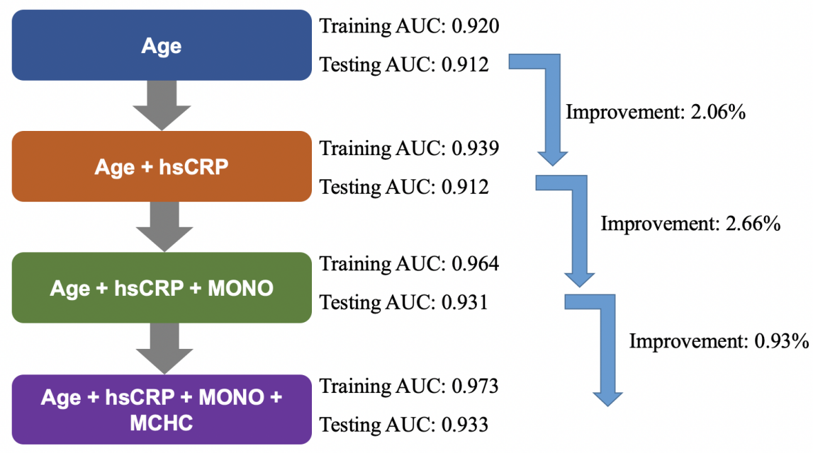
Figure S2. Illustration of AUC scores using multi-tree XGBoost. hsCRP: high-sensitivity C-reactive protein, MONO: monocyte, MCHC: mean corpuscular hemoglobin concentration, AUC: area under the receiver operating characteristic curve.
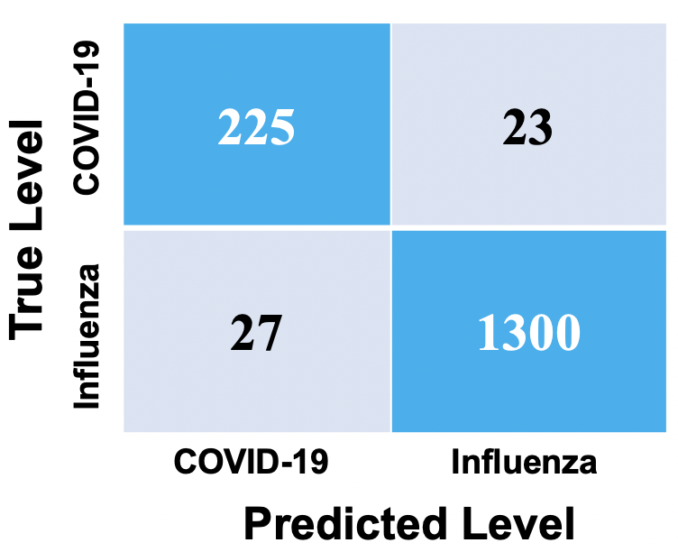
Figure S3. Confusion matrix for the training dataset using the single-tree XGBoost algorithm. 27 predicted COVID-19 cases were laboratory confirmed influenza cases, whereas 23 predicted influenza cases were laboratory confirmed COVID-19 cases.

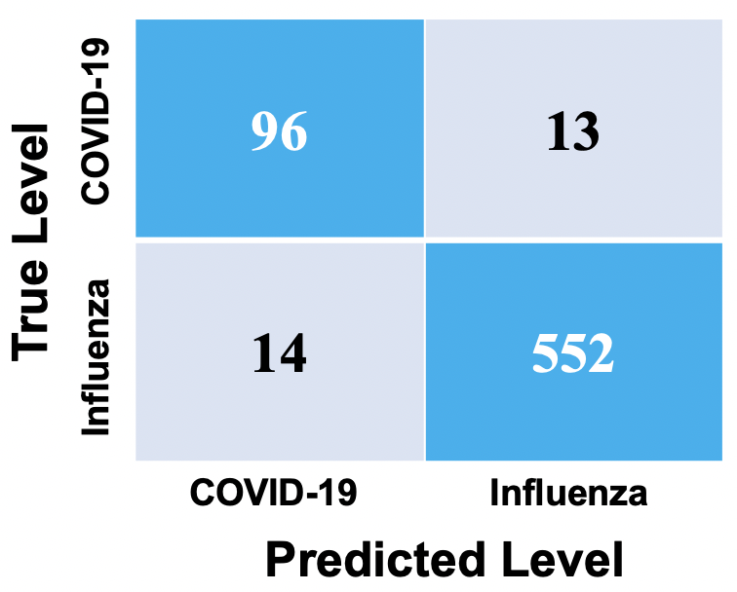
Figure S4. Confusion matrix for the testing dataset using the single-tree XGBoost algorithm. 14 predicted COVID-19 cases were laboratory confirmed influenza cases, whereas 13 predicted influenza cases were laboratory confirmed COVID-19 cases.

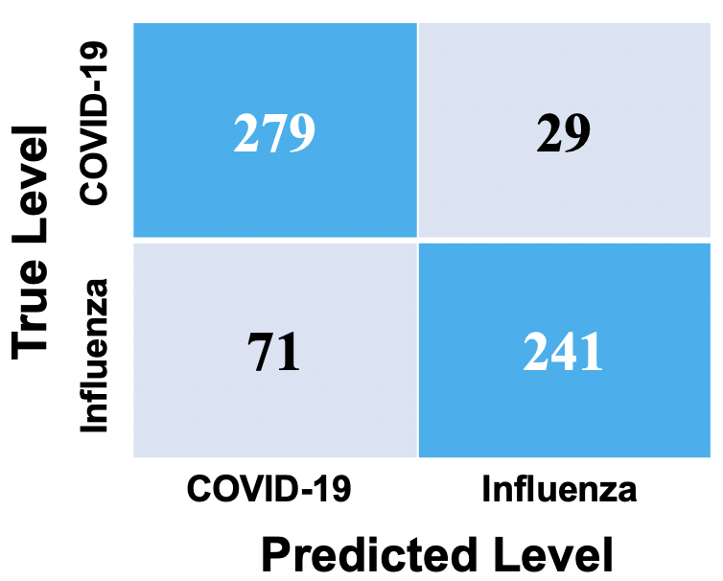
Figure S5. Confusion matrix for the external test dataset using the single-tree XGBoost algorithm. 71 predicted COVID-19 cases were laboratory confirmed influenza cases, whereas 29 predicted influenza cases were laboratory confirmed COVID-19 cases.

Table S4. Comparison of AUC scores of the testing set using multi-tree, single-tree XGBoost and logistic regression
 | Cross-validation AUC for training set | Cross-validation AUC for testing set
Multi-tree XGBoost for all features | 1.00 ± 0.00 | 0.95 ± 0.01
Single-tree XGBoost for 3 key features | 0.94 ± 0.01 | 0.92 ± 0.02
Logistic for all features | 0.91 ± 0.01 | 0.88 ± 0.03
Data are expressed as mean ± SD. Comparison of the proposed algorithm on both training and testing datasets using all or three features with logistic regression using 100-round 5-fold cross validation. AUC: area under the receiver operating characteristic curve.
Figure S6. Receiver operating characteristic curves. (A), (C) and (E) indicate the results of multi-tree, single-tree XGBoost algorithm and logistic regression for training set, respectively. (B), (D) and (F) shows the results of testing set. AUC: area under the receiver operating characteristic curve.

Table S5. Performance of the single-tree XGBoost algorithm for identifying COVID-19 from influenza type A.
Specificity (95%CI) | Sensitivity (95%CI) | NPV (95%CI) | PPV (95%CI) | Accuracy (95%CI) | AUC score (95%CI)
0.98 (0.97, 0.99) | 0.90 (0.87, 0.93) | 0.97 (0.96, 0.98) | 0.92 (0.89, 0.95) | 0.96 (0.96, 0.96) | 0.94 (0.92, 0.96)
NPV: negative prediction value; PPV: positive prediction value.

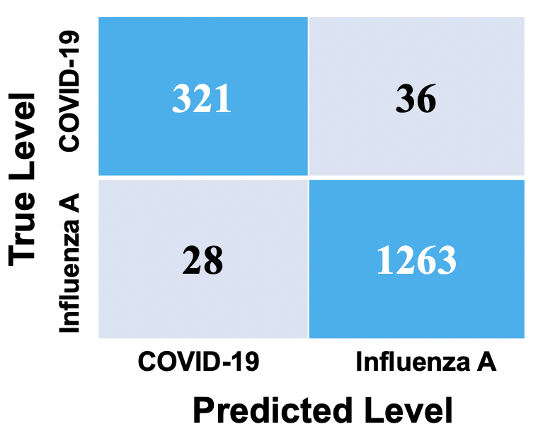
Figure S7. Confusion matrix for the testing dataset (data from COVID-19 and influenza A) using the single-tree XGBoost algorithm. 28 predicted COVID-19 cases were laboratory confirmed influenza type A cases, whereas 36 predicted influenza type A cases were laboratory confirmed COVID-19 cases.
Figure S8. Receiver operating characteristic curves. This indicates the results for testing set for identifying COVID-19 from influenza type A. AUC: area under the receiver operating characteristic curve.

Table S6. Performance of the single-tree XGBoost algorithm for identifying COVID-19 from influenza type B.
Specificity (95%CI) | Sensitivity (95%CI) | NPV (95%CI) | PPV (95%CI) | Accuracy (95%CI) | AUC score (95%CI)
0.98 (0.97, 0.99) | 0.90 (0.87, 0.93) | 0.94 (0.92, 0.96) | 0.96 (0.94, 0.98) | 0.95 (0.95, 0.95) | 0.94 (0.92, 0.96)
NPV: negative prediction value; PPV: positive prediction value.

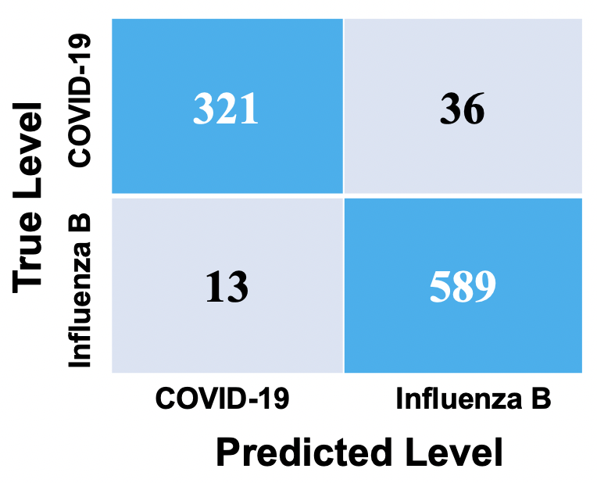
Figure S9. Confusion matrix for the testing dataset (data from COVID-19 and influenza B) using the single-tree XGBoost algorithm. 13 predicted COVID-19 cases were laboratory confirmed influenza type B cases, whereas 36 predicted influenza type B cases were laboratory confirmed COVID-19 cases.

Figure S10. Receiver operating characteristic curves. This indicates the results for testing set for identifying COVID-19 from influenza type B. AUC: area under the receiver operating characteristic curve.

Table S7. Analysis of incorrectly classified COVID-19 cases by the proposed interpretable decision tree
 | Case Number | Age (years) | hsCRP (mg/L, ref: 0.0-3.0) | Monocytes (1×10⁹/L, ref: 0.1-0.6) | Disease severity
Age ≤ 16 years
 | 1 | 6 | 1.39 | 0.56 | Mild
 | 2 | 8 | 0.54 | 0.49 | Mild
 | 3 | 9 | 2.19 | 0.29 | Mild
Age > 16 years
hsCRP ≤ 14.2 mg/L
Monocytes > 0.68 ×10⁹/L
 | 1 | 61 | 7.4 | 1.33 | Common
 | 2 | 59 | 7.07 | 0.78 | Common
 | 3 | 73 | 6.83 | 0.69 | Mild
 | 4 | 37 | 3.93 | 1.25 | Mild
 | 5 | 47 | 0.53 | 0.94 | Mild
 | 6 | 40 | 0.50 | 1.70 | Mild
 | 7 | 47 | 0.50 | 1.09 | Mild
 | 8 | 33 | 0.50 | 0.75 | Mild
 | 9 | 63 | 9.9 | 0.90 | Mild
 | 10 | 43 | 1.2 | 1.24 | Mild
 | 11 | 63 | 9.99 | 0.81 | Common
 | 12 | 62 | 3.11 | 1.34 | Mild
 | 13 | 27 | 5.23 | 0.93 | Mild
 | 14 | 29 | 1.65 | 0.82 | Mild
 | 15 | 55 | 1.55 | 0.99 | Mild
 | 16 | 67 | 11.4 | 0.70 | Common
 | 17 | 53 | 3.51 | 0.72 | Mild
 | 18 | 31 | 6.39 | 0.98 | Mild
 | 19 | 33 | 12.2 | 0.82 | Mild
 | 20 | 74 | 6.82 | 1.14 | Common
 | 21 | 57 | 9.99 | 1.35 | Mild
 | 22 | 30 | 3.11 | 1.34 | Mild
 | 23 | 42 | 10.30 | 0.90 | Mild
 | 24 | 30 | 3.11 | 0.72 | Mild
 | 25 | 45 | 3.11 | 0.78 | Mild
 | 26 | 25 | 3.11 | 1.09 | Mild
 | 27 | 49 | 3.11 | 0.71 | Mild
 | 28 | 59 | 3.11 | 0.71 | Mild
 | 29 | 57 | 3.11 | 0.91 | Mild
 | 30 | 49 | 3.11 | 1.07 | Mild
 | 31 | 70 | 3.11 | 0.88 | Mild
 | 32 | 51 | 12.00 | 0.88 | Common
 | 33 | 63 | 11.80 | 0.70 | Common
 | 34 | 37 | 8.49 | 0.89 | Mild
 | 35 | 39 | 3.11 | 0.85 | Mild
 | 36 | 38 | 9.88 | 0.82 | Mild
 | 37 | 38 | 0.78 | 0.79 | Mild
Patients with COVID-19 was categorized as mild, common, severe, and critical. Mild: mild symptoms and no pneumonia on imaging, Common: respiratory tract symptoms and imaging with pneumonia, Severe: respiratory distress and respiratory frequency ≥ 30/min, blood oxygen saturation ≤ 93% at rest, PaO₂/FiO₂ ratio ≤ 300 mmHg or lung infiltrates > 50% within 24–48 h, Critical: respiratory failure occurs and require mechanical ventilation, shock or combined with other organ failure and requires ICU admission.

