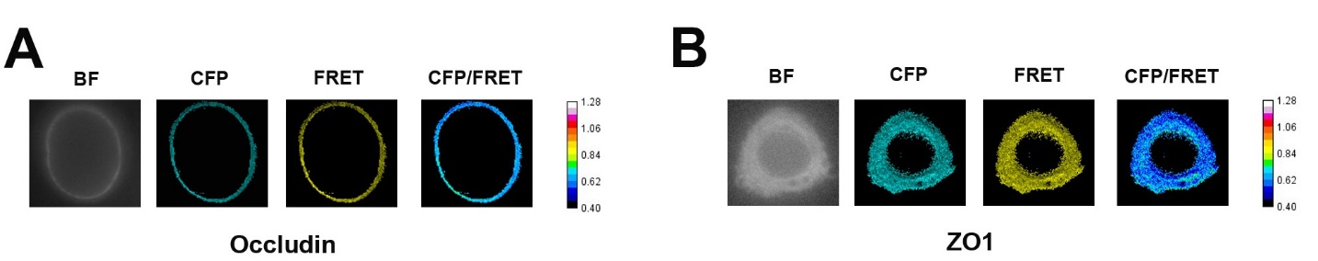

Figure S1. Fluorescence images of occludin/ ZO1 probes in different signals in isotonic condition. A. Representative fluorescence images of occludin probe-transfected HBMEC cells under bright field, CFP (cyan), FRET (yellow), and CFP/FRET signals. B. Representative fluorescence images of ZO1 probe-transfected HBMEC cells under bright field, CFP (cyan), FRET (yellow), and CFP / FRET signals.

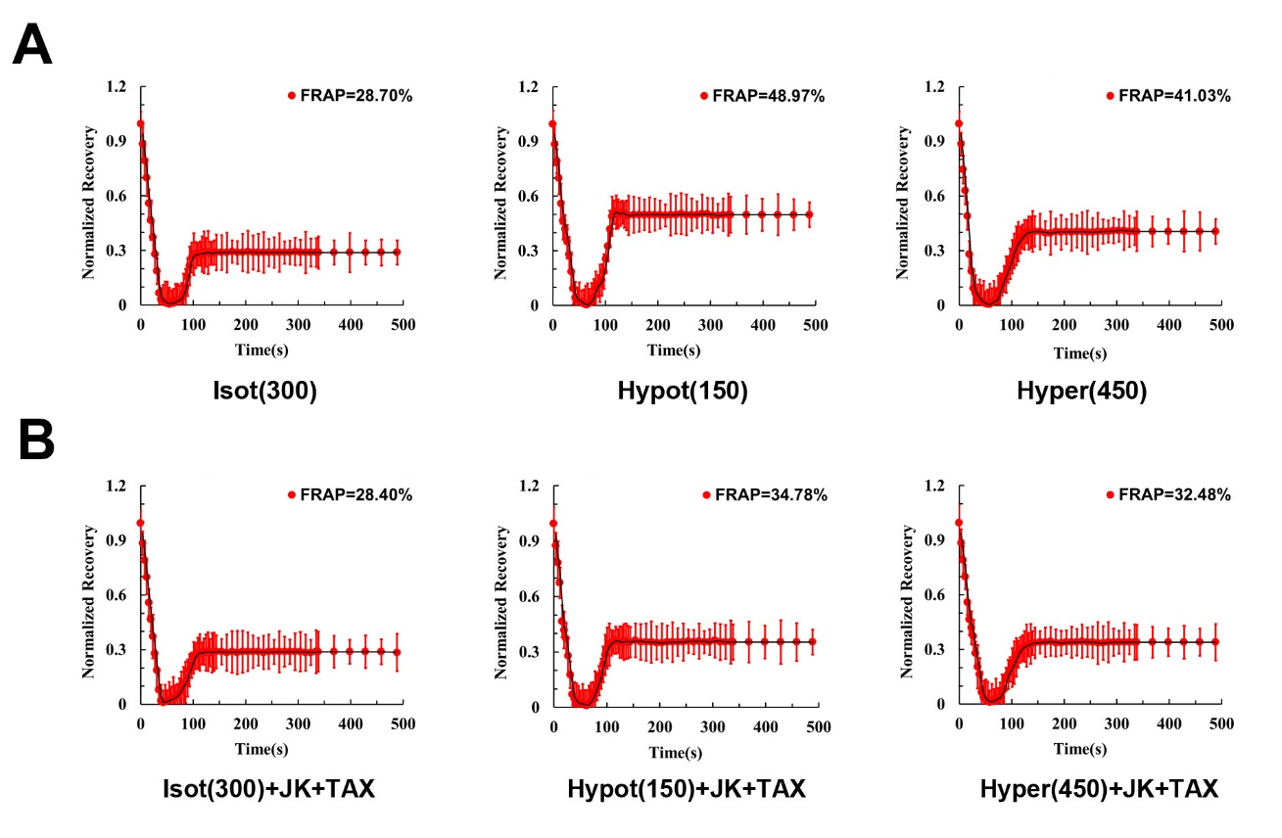

Figure S2. Mobility of occludin probe on cytomembranes determined by FRAP tests under different OPs. A. Normalized FRAP ratio of occludin probe on the cytomembrane in HBMEC cells in isotonic (300 mOsm/kg), hypotonic (150 mOsm/kg), and hypertonic (450 mOsm/kg) solution, for 500 s. B. Normalized FRAP ratio of occludin probe on the cytomembrane in HBMEC cells in isotonic(300)+JK+TAX, hypotonic(150)+JK+TAX, and hypertonic(450)+JK+TAX solution for 500 s (n = 8).

