Supporting Information

Integration of dual targeting and dual therapeutic modules endows self-assembled nanoparticles with anti-tumor growth and metastasis functions

Biao Chen¹, Xiaoqi Dong², Xiyuan Dong¹, Quan Wang², Meng Wu¹, Jun Wu ², Xiaoding Lou², Fan Xia², Wenwen Wang ^{1*}, Jun Dai ^{1*}, Shixuan Wang ¹

¹ Department of Obstetrics and Gynecology, Tongji Hospital, Tongji Medical College, Huazhong University of Science and Technology, Wuhan 430030, China.
² Engineering Research Center of Nano-Geomaterials of the Ministry of Education, Faculty of Materials Science and Chemistry, China University of Geosciences, Wuhan 430074, China.

* Corresponding author:
petrawang@163.com (Wenwen Wang);
dj_hust1987@sina.com (Jun Dai);

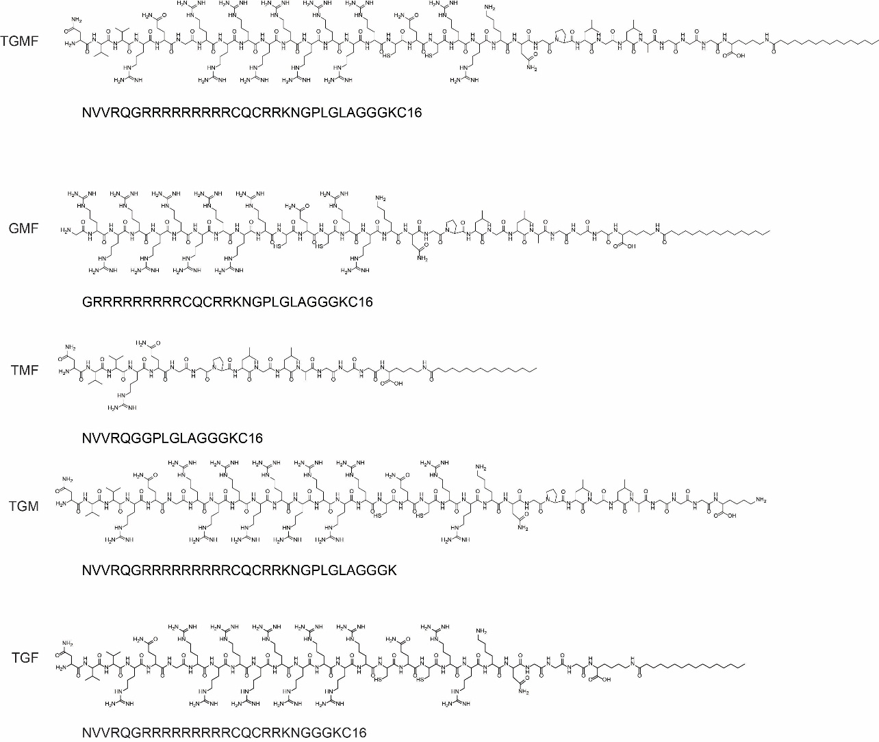
Figure S1. Chemical structures of TGMF, GMF, TMF, TGM and TGF.

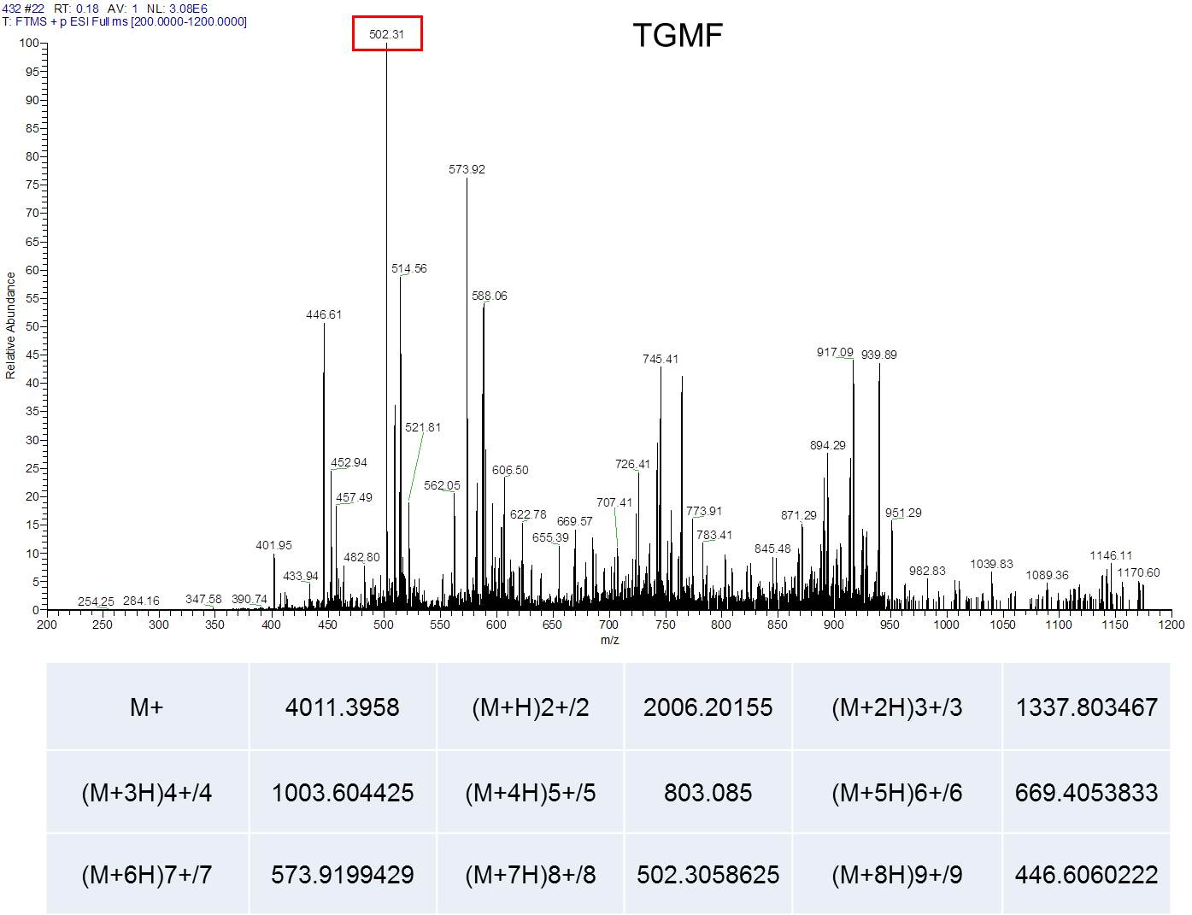
Figure S2. HRMS spectrum (MALDI-TOF) of compound TGMF.

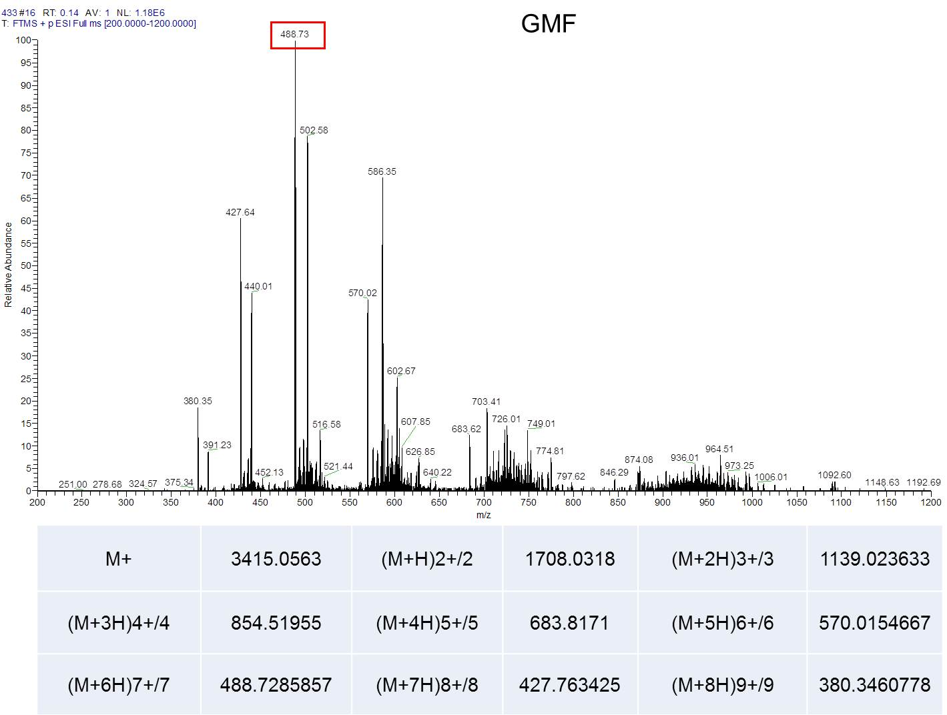
Figure S3. HRMS spectrum (MALDI-TOF) of compound GMF.

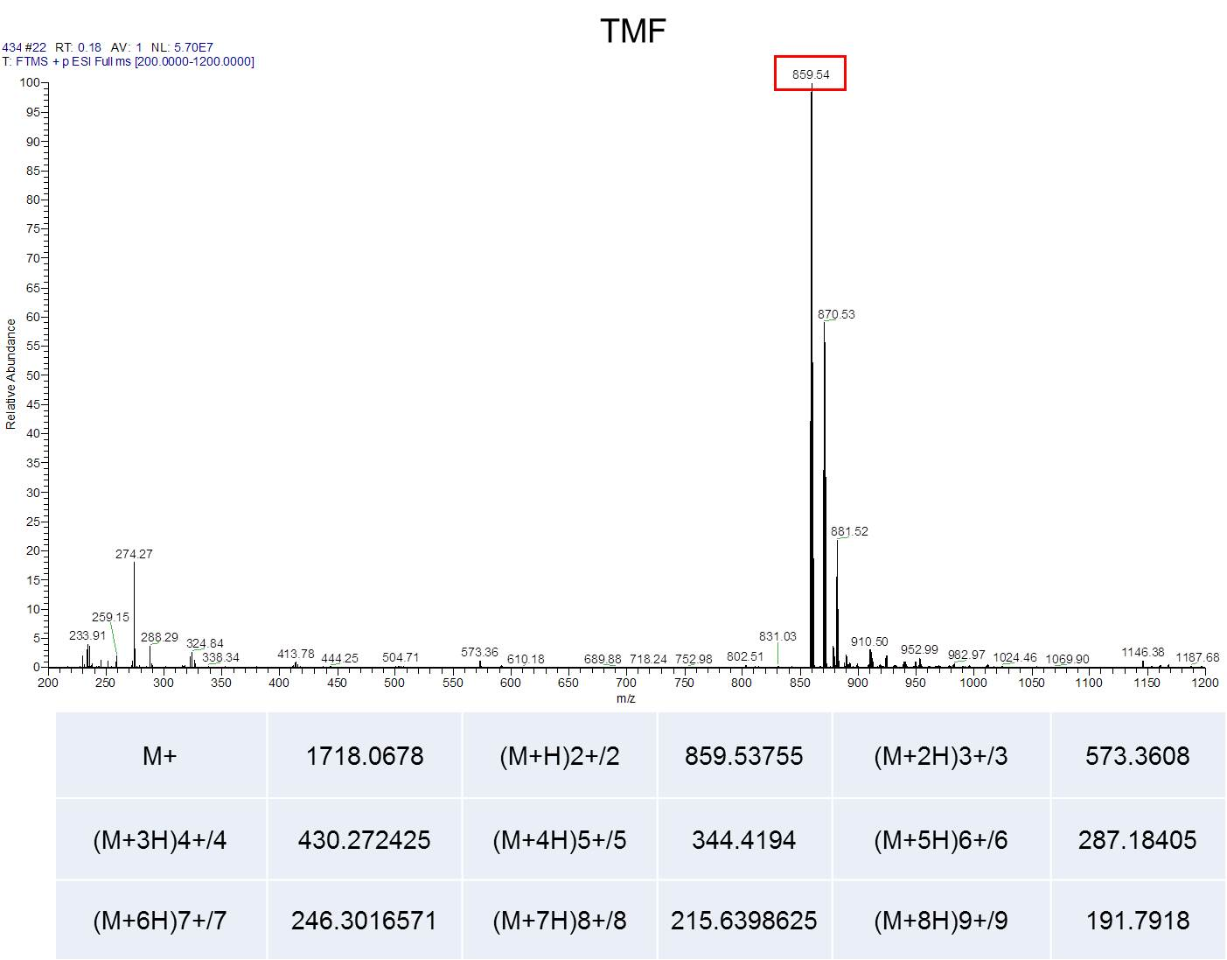
Figure S4. HRMS spectrum (MALDI-TOF) of compound TMF.

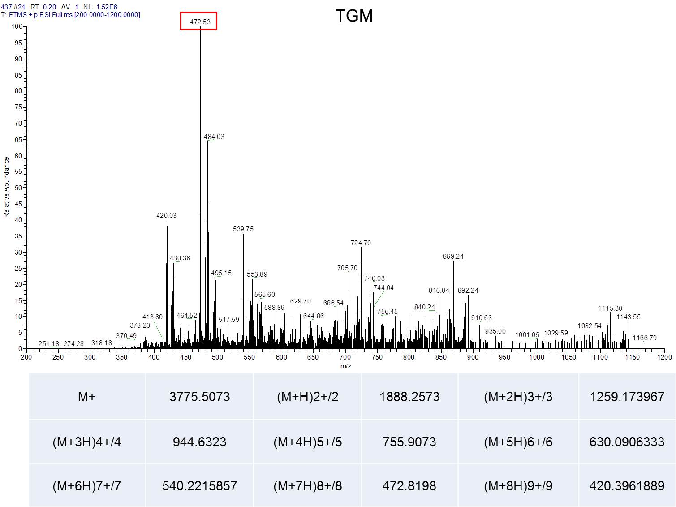
Figure S5. HRMS spectrum (MALDI-TOF) of compound TGM.

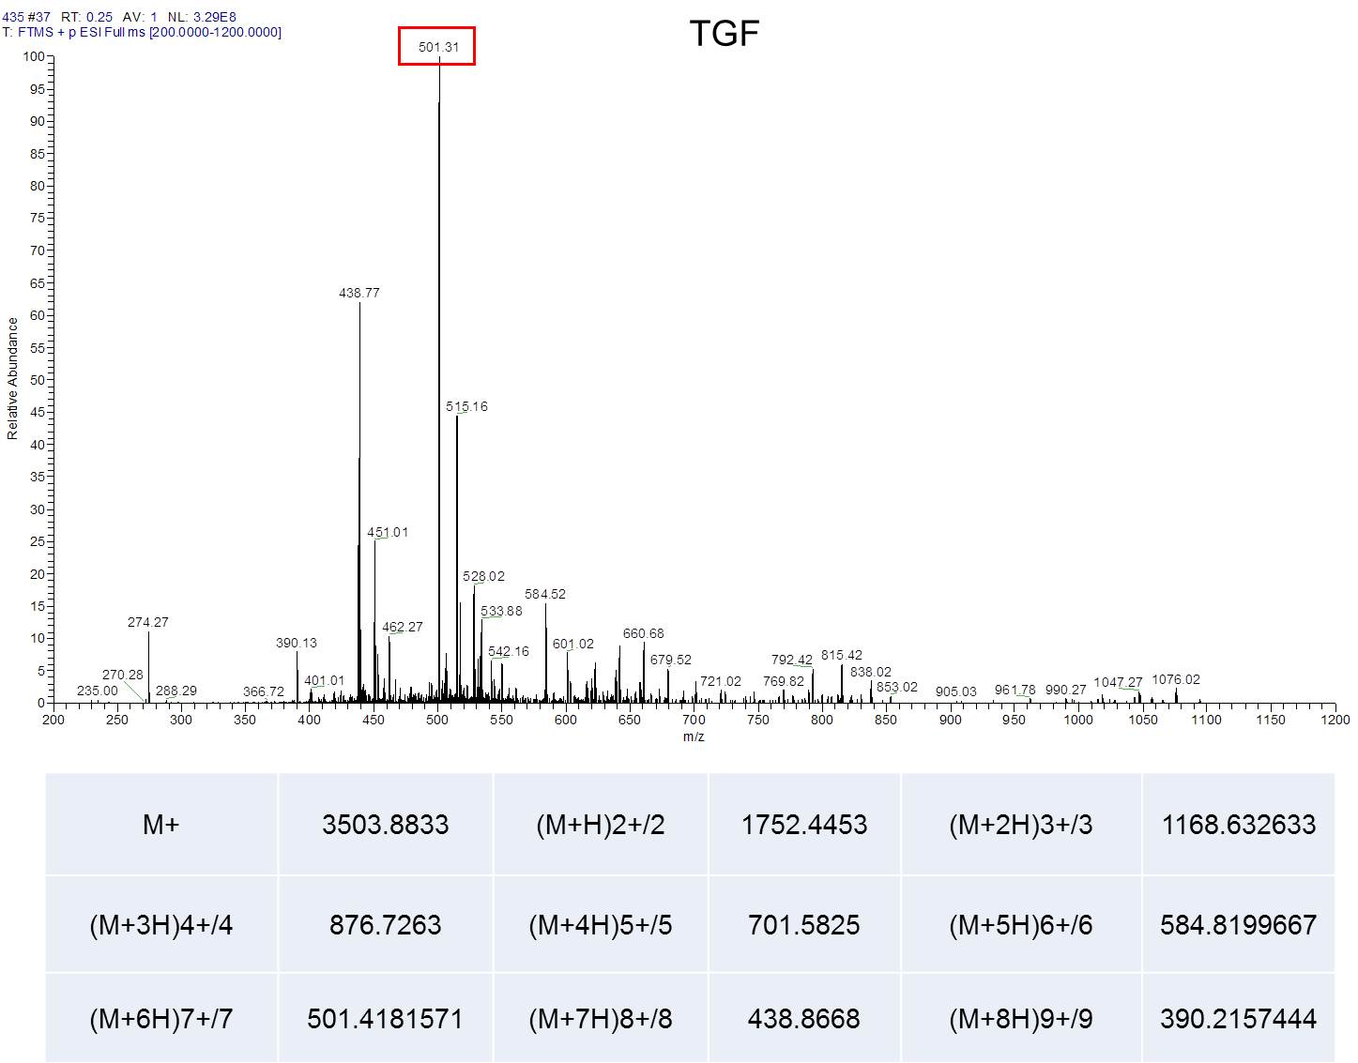
Figure S6. HRMS spectrum (MALDI-TOF) of compound TGF.

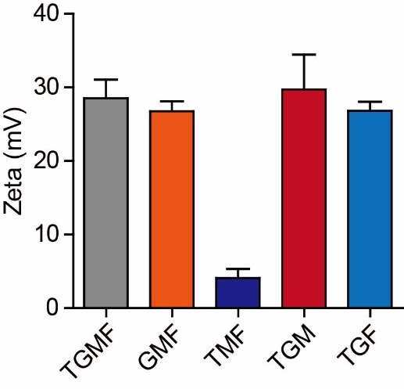
Figure S7. Zeta potential of TGMF (10 μM), GMF (10 μM), TMF (10 μM), TGM (10 μM) and TGF (10 μM), respectively.

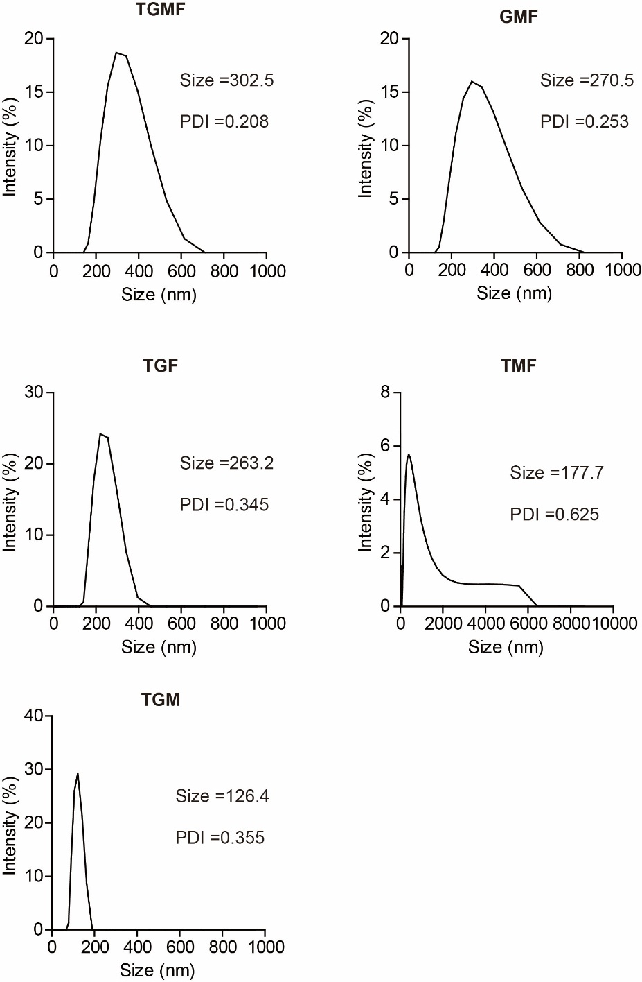
Figure S8. The particle size distribution of TGMF, GMF, TGF, TMF and TGM in aqueous solution was determined by dynamic light scattering (DLS).

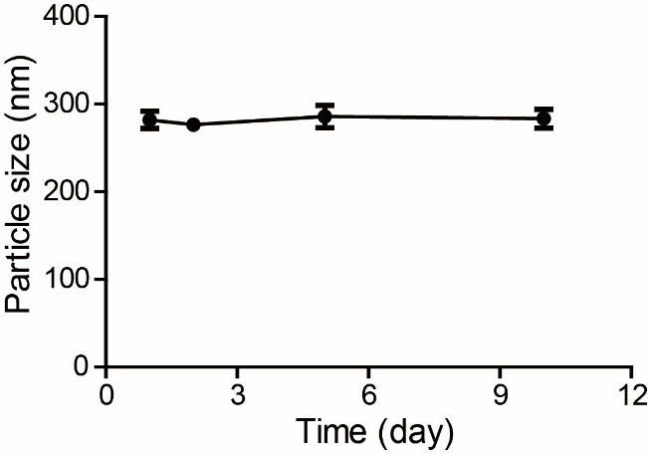
Figure S9. The stability of TGMF NPs in PBS solution was determined by dynamic light scattering (DLS).

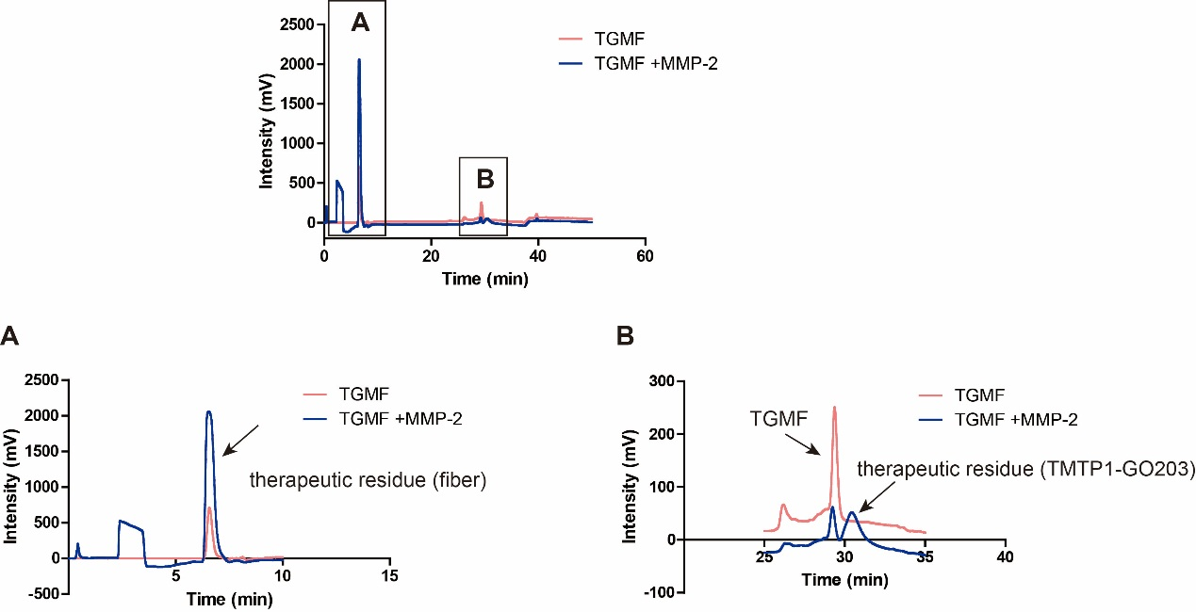
Figure S10. After TGMF was cleaved by MMP-2, the therapeutic residues were released. (A) Release of nanofiber therapeutic residues. (B) Release of GO-203 therapeutic residues.

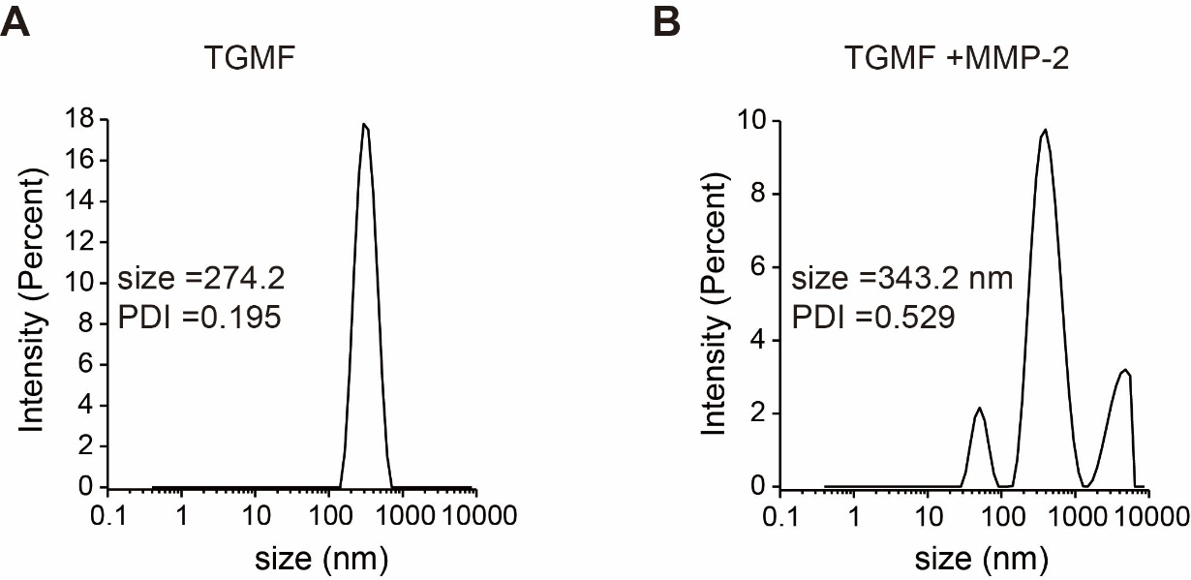
Figure S11. The particle size distribution of TGMF (A) before and (B) after MMP-2 treatment.

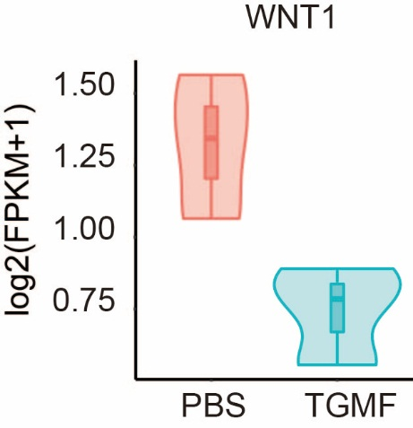
Figure S12. The expression of WNT1 decreased in TGMF treated HeLa cells.

