Supplementary Material
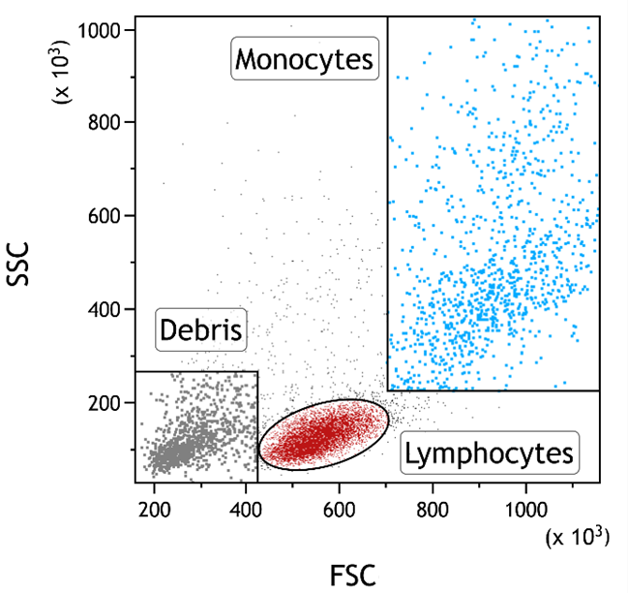

Figure S1 Gating strategy for subsequent analysis on peripheral blood mononuclear cells (PBMCs). Flow cytometry dot plot FSC vs. SSC presenting gating strategy for PBMCs to evaluate NT_{B}700 effect on lymphocyte (red) and monocyte (light blue) populations.

