Supporting Information

Nanosonosensitizer-augmented sonodynamic therapy combined with checkpoint blockade for cancer immunotherapy

Xiaoning Lin^{1‡}, Rong Huang^{3‡}, Yanlin Huang^{1‡}, Kai Wang⁴, Heng Li¹, Yiheng Bao¹, Chaohui Wu⁵, Yi Zhang⁶, Xinhua Tian^{1*}, Xiaomin Wang^{2*}

¹ Department of Neurosurgery, Zhongshan Hospital Xiamen University, Xiamen, 361004, China.
² Fujian Provincial Key Laboratory of Chronic Liver Disease and Hepatocellular Carcinoma, Xiamen University Affiliated Zhongshan Hospital, Xiamen 361004, China.
³ Department of Child Health, Women and Children's Hospital, Xiamen University, Xiamen, 361003, China.
⁴ School of Public Health, Xiamen University, Xiamen 361102, China.
⁵ Department of Thoracic Surgery, Zhongshan Hospital Xiamen University, Xiamen, 361004, China.
⁶ Department of Breast Surgery, Xiamen TCM Hospital, Xiamen, 361001, China.

Figure S1. The fluorescent intensities of DCF-DA in hepa1-6 cells after various treatments analyzed by CLSM. Data are expressed as means ± SD (n = 3). **P < 0.01.

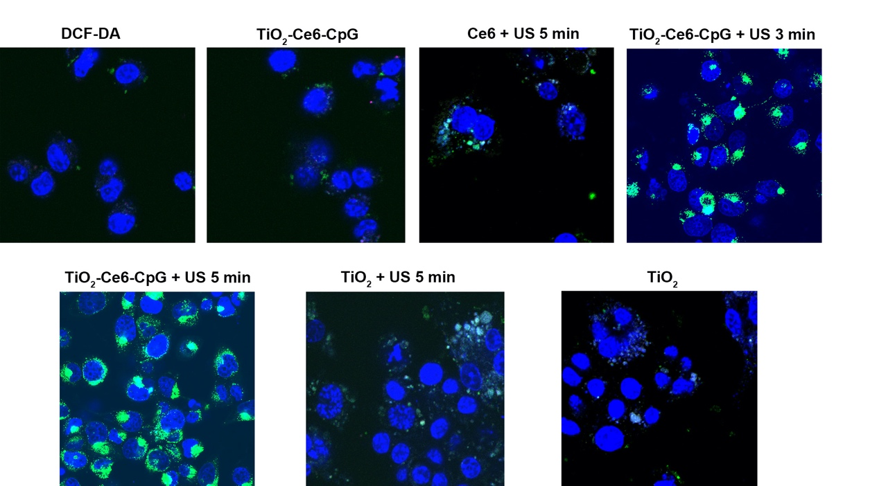
Figure S2. The confocal images of ROS generated in hepa1-6 cells after various treatment.

Figure S3. Blood routine test after treatments in tumor-bearing mice. The control group was untreated healthy mice. Blood routine data including red blood cell (RBC) and platelets (PLT) were measured. Data are expressed as means ± SD (n = 3).

Figure S4. Analysis of blood urea nitrogen (BUN) after treatments in tumor-bearing mice. The control group was untreated healthy mice. Data are expressed as means ± SD (n = 3).

Figure S5. Analysis of liver function after treatments in tumor-bearing mice at different times. Data are expressed as means ± SD (n = 3). ALT, alanine aminotransferase. AST, aspartate aminotransferase.

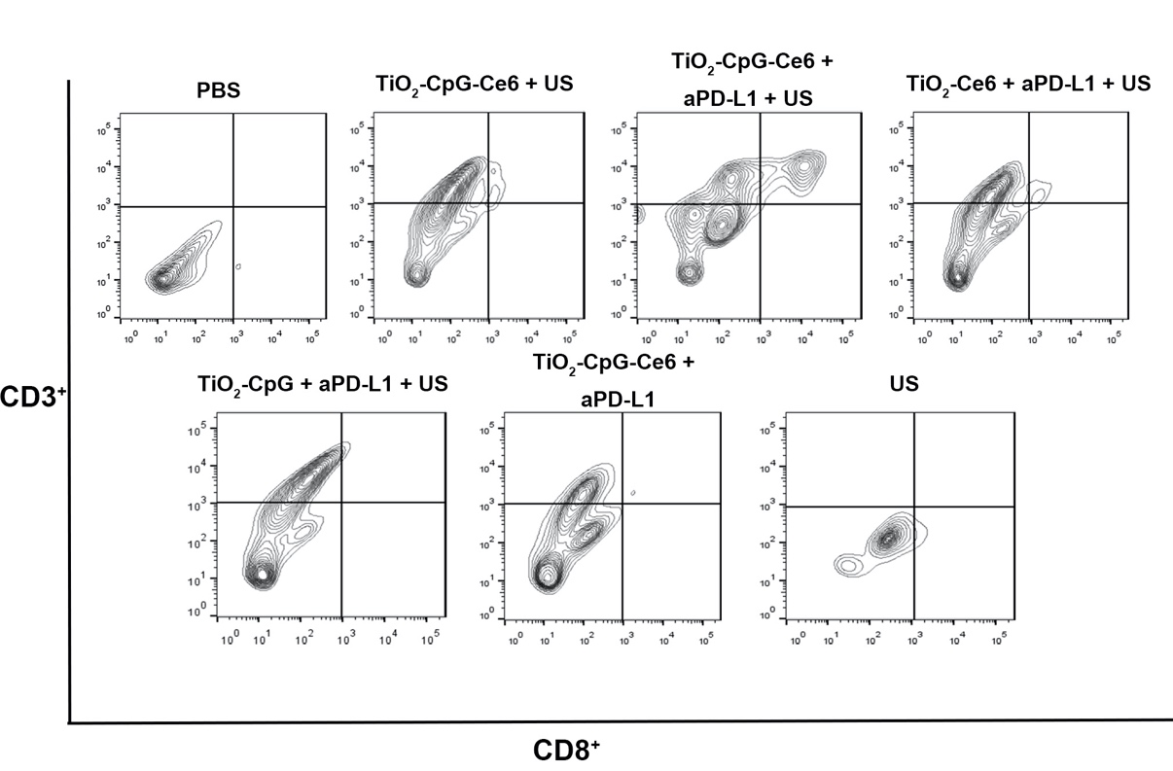
Figure S6: Flow cytometric detection of CD8⁺ T cells in the secondary tumors.

