Hummingbird Study Supplementary Appendix
s-Figure 1 Study design.
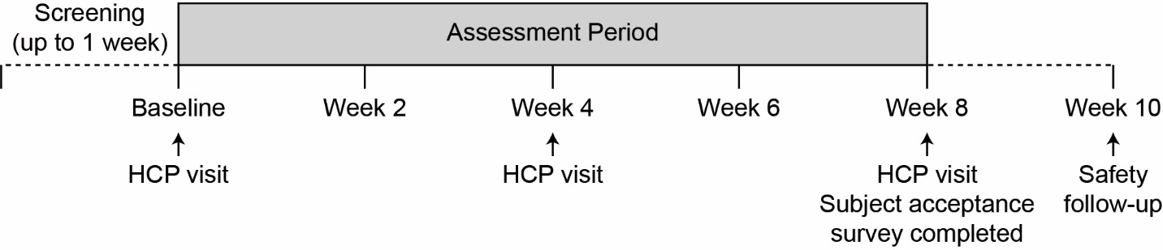
Abbreviation: HCP, healthcare provider.

s-Table 1 Subject Usability and Satisfaction Scale survey at week 8
(intent-to-treat population).
Survey questions and response options | Enrolled subjects  (n = 43)ª
Ease of applying patch on the body
Very easy | 13 (30.2)
Easy | 12 (27.9)
Somewhat easy | 4 (9.3)
Neutral | 6 (14.0)
Somewhat difficult | 2 (4.7)
Difficult | 1 (2.3)
Extremely difficult | 1 (2.3)
Ease of pairing patch with the mobile application
Extremely easy | 5 (11.6)
Easy | 4 (9.3)
Somewhat easy | 8 (18.6)
Neutral | 6 (14.0)
Somewhat difficult | 7 (16.3)
Difficult | 6 (14.0)
Extremely difficult | 3 (7.0)
Ease of using the mobile application
Extremely easy | 14 (32.6)
Easy | 6 (14.0)
Somewhat easy | 6 (14.0)
Neutral | 4 (9.3)
Somewhat difficult | 4 (9.3)
Difficult | 2 (4.7)
Extremely difficult | 3 (7.0)
Ease of using the DMS^{b}
Extremely easy | 12 (27.9)
Easy | 11 (25.6)
Somewhat easy | 7 (16.3)
Neutral | 4 (9.3)
Somewhat difficult | 0
Difficult | 4 (9.3)
Extremely difficult | 1 (2.3)
Did not mind wearing the patch
Strongly agree | 14 (32.6)
Agree | 7 (16.3)
Somewhat agree | 5 (11.6)
Neutral | 3 (7.0)
Somewhat disagree | 2 (4.7)
Disagree | 7 (16.3)
Strongly disagree | 1 (2.3)
Needed assistance in changing and pairing patches
No | 14 (32.6)
Yes | 25 (58.1)
Ease of using the entire DMS^{c}
Extremely easy | 5 (11.6)
Easy | 6 (14.0)
Somewhat easy | 14 (32.6)
Neutral | 3 (7.0)
Somewhat difficult | 4 (9.3)
Difficult | 4 (9.3)
Extremely difficult | 3 (7.0)
Found the DMS helpful in managing their condition
Extremely helpful | 8 (18.6)
Helpful | 0
Somewhat helpful | 14 (32.6)
Neutral | 7 (16.3)
Somewhat unhelpful | 4 (9.3)
Unhelpful | 3 (7.0)
Extremely unhelpful | 3 (7.0)
Found the DMS helpful for sharing data
Extremely helpful | 10 (23.3)
Helpful | 8 (18.6)
Somewhat helpful | 5 (11.6)
Neutral | 12 (28.0)
Somewhat unhelpful | 1 (2.3)
Unhelpful | 2 (4.7)
Extremely unhelpful | 1 (2.3)
Found the DMS helpful in improving discussions
Extremely helpful | 3 (7.0
Helpful | 5 (11.6)
Somewhat helpful | 5 (11.6)
Neutral | 19 (44.2)
Somewhat unhelpful | 0
Unhelpful | 4 (9.3)
Extremely unhelpful | 2 (4.7)
Satisfaction with the DMS
Extremely satisfied | 7 (16.3)
Satisfied | 12 (28.0)
Somewhat satisfied | 4 (9.3)
Neutral | 4 (9.3)
Somewhat unsatisfied | 2 (4.7)
Unsatisfied | 9 (20.9)
Extremely unsatisfied | 1 (2.3)
Willingness to use the DMS in the future
Extremely likely | 8 (18.6)
Likely | 9 (20.9)
Somewhat likely | 6 (14.0)
Neutral | 2 (4.7)
Somewhat unlikely | 5 (11.6)
Unlikely | 5 (11.6)
Extremely unlikely | 4 (9.3)
Data are presented as n (%).
ª4 Subjects did not respond to the survey.
^{b}As asked in the “usability” section of the survey.
^{c}As asked in the “satisfaction” section of the survey.
Abbreviation: DMS, digital medicine system.

