Supplementary materials

Table S1. Demographic and clinicopathological characteristics of rectal cancer patients.
Characteristic | Normal Preoperative CEA  （n=627） | Normalized Postoperative CEA（n=255） | Elevated Postoperative CEA（n=67） | P-value
Age (years) | 59.00 (49.00-66.00) | 60.00 (51.00-66.00) | 62.00 (49.00-68.50) | 0.31
BMI | 22.66 (20.76-24.96) | 22.06 (20.76-24.38) | 21.55 (20.56-23.98) | 0.10
Preoperative CEA, ng/mL | 2.32 (1.50- 3.46) | 9.97 (6.49-17.49) | 15.35 (9.12-50.75) | <0.001
Postoperative CEA, ng/mL | 1.49 (1.01- 2.20) | 2.26 (1.52- 3.14) | 7.38 (6.03-20.68) | <0.001
Sex, no. (%) of patients |  |  |  | 0.10
Male | 338 (53.91%) | 156 (61.18%) | 41 (61.19%)
Female | 289 (46.09%) | 99 (38.82%) | 26 (38.81%)
Tumor location |  |  |  | 0.12
High | 140 (22.33%) | 53 (20.78%) | 11 (16.42%)
Mid | 293 (46.73%) | 138 (54.12%) | 40 (59.70%)
Low | 194 (30.94%) | 64 (25.10%) | 16 (23.88%)
Surgical approach |  |  |  | 0.14
OR | 368 (58.69%) | 160 (62.75%) | 47 (70.15%)
LR | 259 (41.31%) | 95 (37.25%) | 20 (29.85%)
Surgical procedure |  |  |  | 0.94
LAR | 513 (81.82%) | 210 (82.35%) | 54 (80.60%)
APR | 114 (18.18%) | 45 (17.65%) | 13 (19.40%)
Tumor differentiation, no. (%) of patients |  |  |  | 0.003
Well | 40 ( 6.38%) | 18 ( 7.06%) | 1 ( 1.49%)
Moderate | 382 (60.93%) | 154 (60.39%) | 35 (52.24%)
Poor-undifferentiated | 139 (22.17%) | 72 (28.24%) | 26 (38.81%)
Unknown | 66 (10.53%) | 11 ( 4.31%) | 5 ( 7.46%)
Histological type, no. (%) of patients |  |  |  | 0.41
Adenocarcinomas | 609 (97.13%) | 245 (96.08%) | 65 (97.01%)
Mucinous adenocarcinomas | 14 ( 2.23%) | 10 ( 3.92%) | 2 ( 2.99%)
Signet-ring cell carcinomas | 4 ( 0.64%) | 0 ( 0.00%) | 0 ( 0.00%)
T stage, no. (%) of patients |  |  |  | <0.001
T1 | 96 (15.31%) | 10 ( 3.92%) | 4 ( 5.97%)
T2 | 169 (26.95%) | 35 (13.73%) | 2 ( 2.99%)
T3 | 347 (55.34%) | 202 (79.22%) | 59 (88.06%)
T4 | 15 ( 2.39%) | 8 ( 3.14%) | 2 ( 2.99%)
N stage, no. (%) of patients |  |  |  | <0.001
N0 | 422 (67.30%) | 137 (53.73%) | 15 (22.39%)
N1 | 126 (20.10%) | 78 (30.59%) | 28 (41.79%)
N2 | 79 (12.60%) | 40 (15.69%) | 24 (35.82%)
AJCC 7th ed. stage, no. (%) of patients |  |  |  | <0.001
I | 227 (36.20%) | 32 (12.55%) | 4 ( 5.97%)
II | 199 (31.74%) | 106 (41.57%) | 11 (16.42%)
III | 201 (32.06%) | 117 (45.88%) | 52 (77.61%)
LVI |  |  |  | <0.001
Yes | 49 ( 7.81%) | 26 (10.20%) | 20 (29.85%)
No | 578 (92.19%) | 229 (89.80%) | 47 (70.15%)
PNI |  |  |  | 0.001
Yes | 22 ( 3.51%) | 15 ( 5.88%) | 9 (13.43%)
No | 605 (96.49%) | 240 (94.12%) | 58 (86.57%)
Tumor deposit, no. (%) of patients |  |  |  | <0.001
Yes | 28 ( 4.47%) | 21 ( 8.24%) | 15 (22.39%)
No | 599 (95.53%) | 234 (91.76%) | 52 (77.61%)
Adjuvant chemotherapy, no. (%) of patients |  |  |  | <0.001
Yes | 306 (48.80%) | 63 (24.71%) | 22 (32.84%)
No | 321 (51.20%) | 192 (75.29%) | 45 (67.16%)
Note：1 Data are median (IQR) or n (%).
2Abbreviations: APR, abdominoperineal resection; BMI, Body Mass Index; CEA, carcinoembryonic antigen; LAR, low anterior resection;LR, laparoscopic resection; LVI, lymphovascular invasion; OR, open resection; PNI, perineural invasion.
3 OR included 5 cases LR conversion to OR.
4 P value, using Wilcoxon Mann-Whitney test, chi-square test or exact Fisher test depending on whether the variable is continuous or categorical.
Table S2. Analysis of sites of metastatic recurrence in relation to CEA status
Recurrence | Normal Preoperative CEA |  |  | Normalized Postoperative CEA |  |  | Elevated Postoperative CEA |  | P-valueª
Recurrence | N (%) | % of group  (N =627) |  | N (%) | % of group  (N =255) |  | N (%) | % of group  (N =67) | P-valueª
All sites | 115 | 20.25 |  | 70 | 27.45 |  | 39 | 58.21
Liver |  |  |  |  |  |  |  |  | 0.61
Present | 32 (27.83) | 5.10 |  | 24(34.29) | 9.41 |  | 13 (33.33) | 19.40
Absent | 83 (72.17) | 13.24 |  | 46(65.71) | 18.04 |  | 26 (66.67) | 38.81
Lung |  |  |  |  |  |  |  |  | 0.38
Present | 52 (45.22) | 8.29 |  | 32 (45.71) | 12.55 |  | 13 (33.33) | 19.40
Absent | 63 (54.78) | 10.05 |  | 38 (54.29) | 14.90 |  | 26 (66.67) | 38.81
Local |  |  |  |  |  |  |  |  | 0.22
Present | 38 (33.04) | 6.06 |  | 15 (21.43) | 5.88 |  | 10 (25.64) | 14.93
Absent | 77 (66.96) | 12.28 |  | 55 (78.57) | 21.57 |  | 29 (74.36) | 43.28
Other sites^{b} |  |  |  |  |  |  |  |  | 0.002
Present | 22 (19.13) | 3.51 |  | 14 (20.00) | 5.49 |  | 19 (48.72) | 28.36
Absent | 93 (80.87) | 14.83 |  | 56 (80.00) | 21.96 |  | 20 (51.28) | 29.85
Note: ª P-values were calculated using the χ² test.
^{b} Other sites included peritoneum, lymph node, ovary, bone, and kidney.
Abbreviations: CEA, carcinoembryonic antigen.

Table S3. Adjusted hazard ratios of 3-year RFS by CEA
CEA | N | Events (%) | Model 1ª |  | Model 2^{b} |  | Model 3^{c}
CEA | N | Events (%) | HR (95% CI) | P-value | HR (95% CI) | P Value | HR (95% CI) | P-value
Normal Preoperative CEA | 627 | 93(14.83) | 1.0 (Ref.) |  | 1.0 (Ref.) |  | 1.0 (Ref.)
Normalized Postoperative CEA | 255 | 61(23.92) | 1.68 (1.22, 2.33) | 0.002 | 1.69 (1.22, 2.34) | 0.002 | 1.39 (1.00, 1.95) | 0.05
Elevated Postoperative CEA | 67 | 36(53.73) | 5.04 (3.43, 7.42) | <0.001 | 5.09 (3.45, 7.50) | <0.001 | 3.08 (2.02, 4.68) | <0.001

Note : Abbreviations: HR, hazard ratios; Ref., reference.
ª Model 1 was unadjusted.
^{b} Model 2 was adjusted for age (<60 vs. ≥60), body mass index (<24 vs. ≥24), and sex (male vs. female).
^{c} Model 3 was adjusted for age (<60 vs. ≥60), body mass index (<24 vs. ≥24), sex (male vs. female), surgery procedure(abdominoperineal resection v low anterior resection), surgical approach (open resection vs. laparoscopic resection), location (high vs. middle vs. low), tumor differentiation (well vs. moderate vs. poor-undifferentiated), mucinous type (yes vs. no), pathology T stage (T4 vs. T3 vs. T2 vs. T1) pathology N stage (N2 vs. N1 vs. N0), lymphovascular invasion (yes vs. no), perineural invasion (yes vs. no), and tumor deposit (yes vs. no).

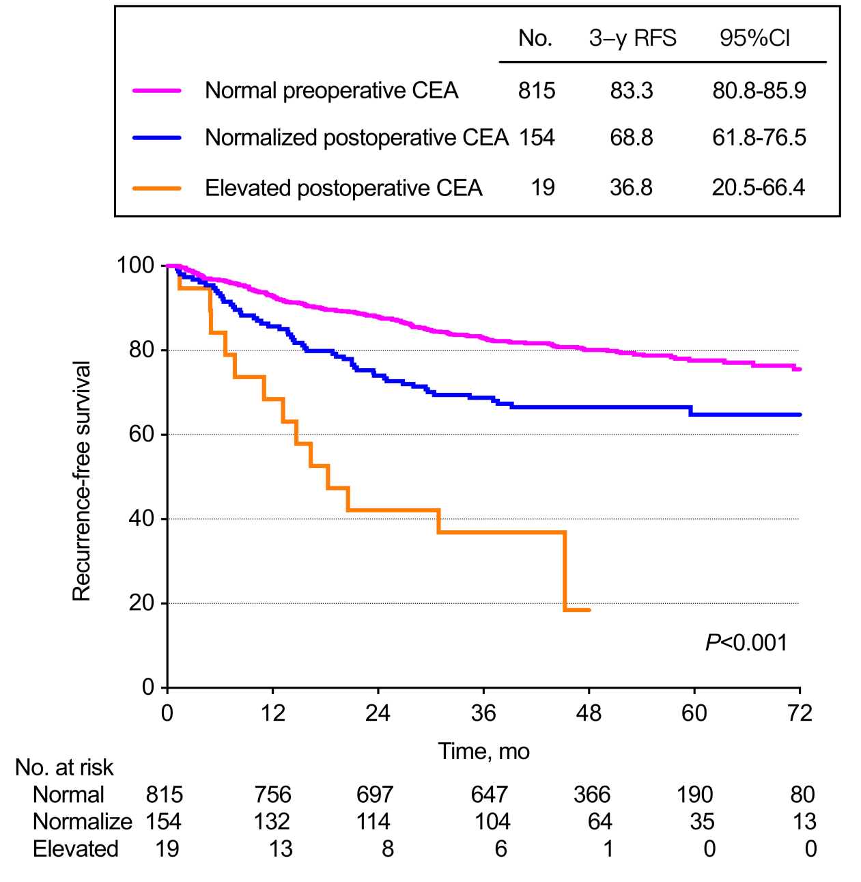
eFigure 1. Kaplan-Meier Curves for RFS in Patients With Normal Preoperative, Normalized Postoperative, or Elevated Postoperative CEA Using a Cutoff of 10 ng/mL

eFigure 2A：Stage N0
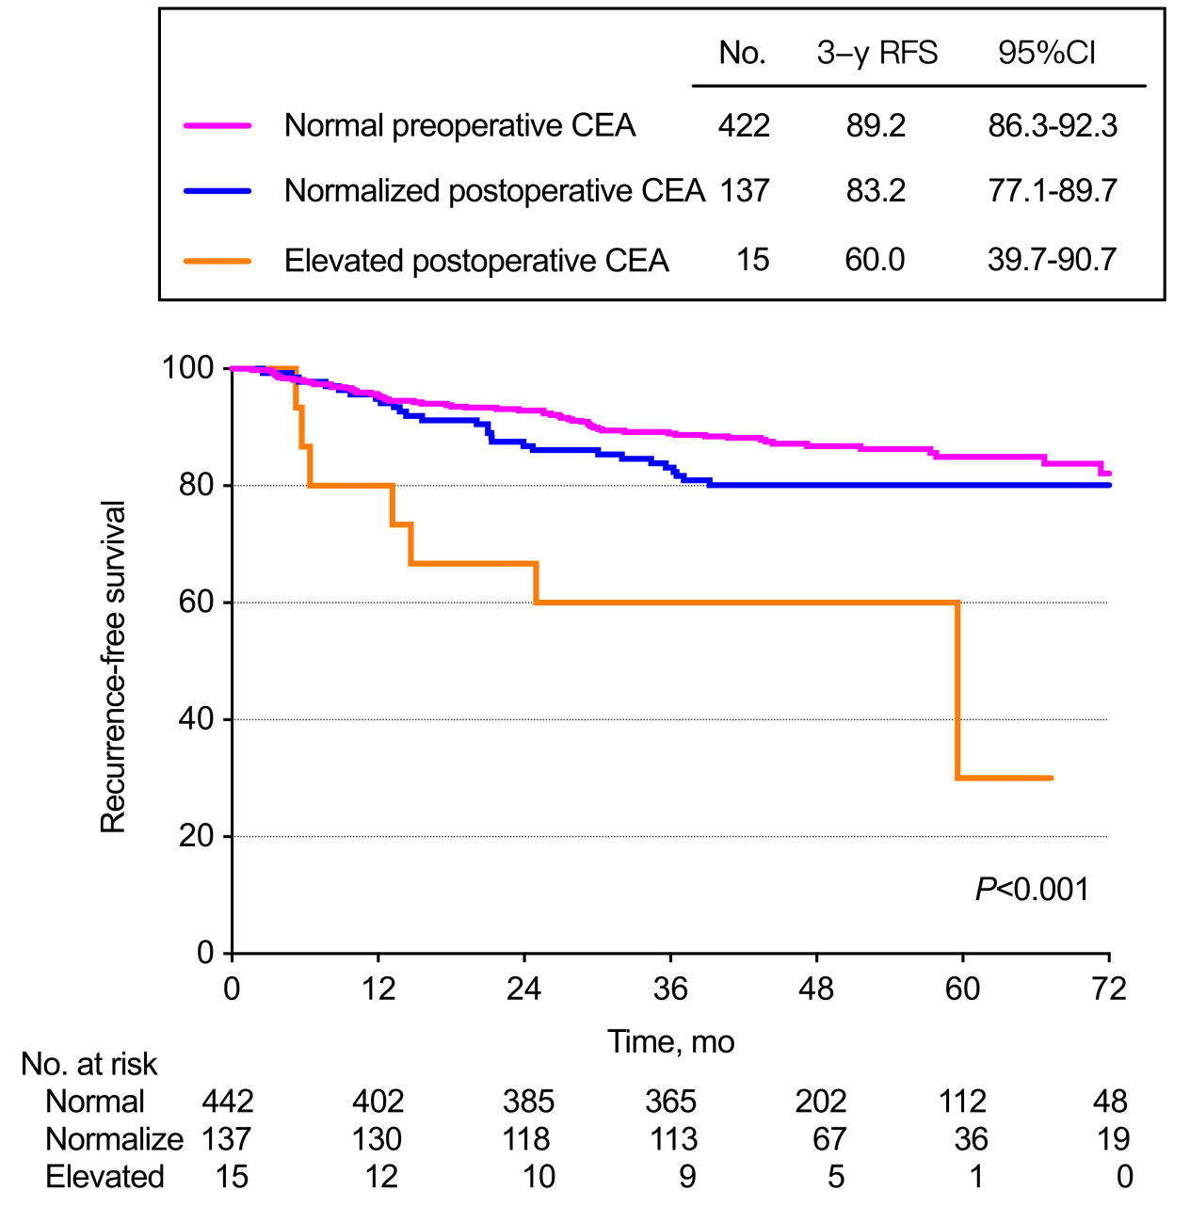

eFigure 2B：Stage N1

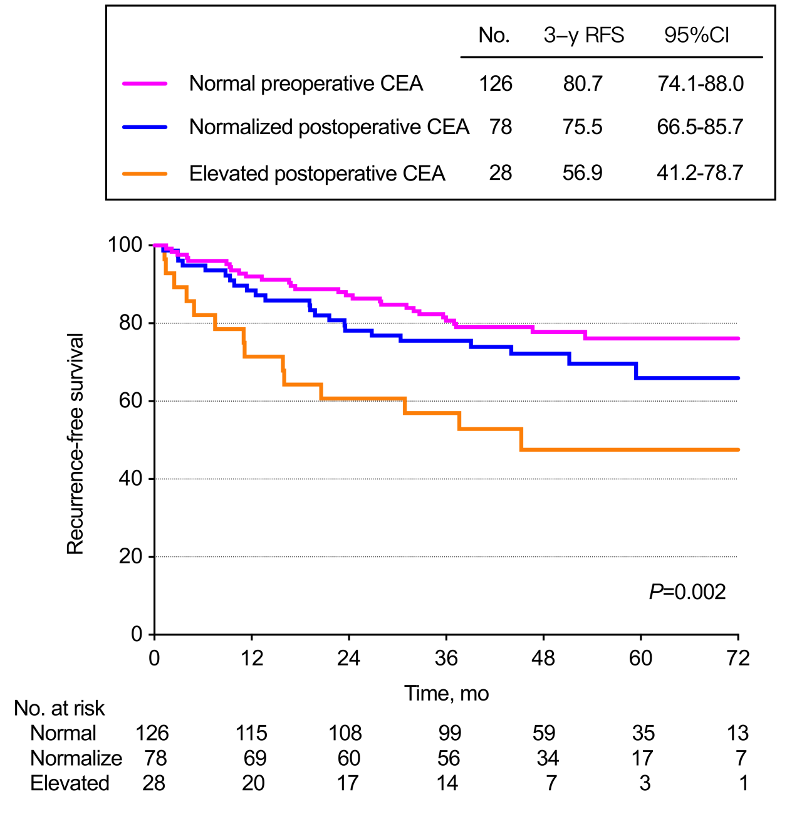

eFigure 2C：Stage N2

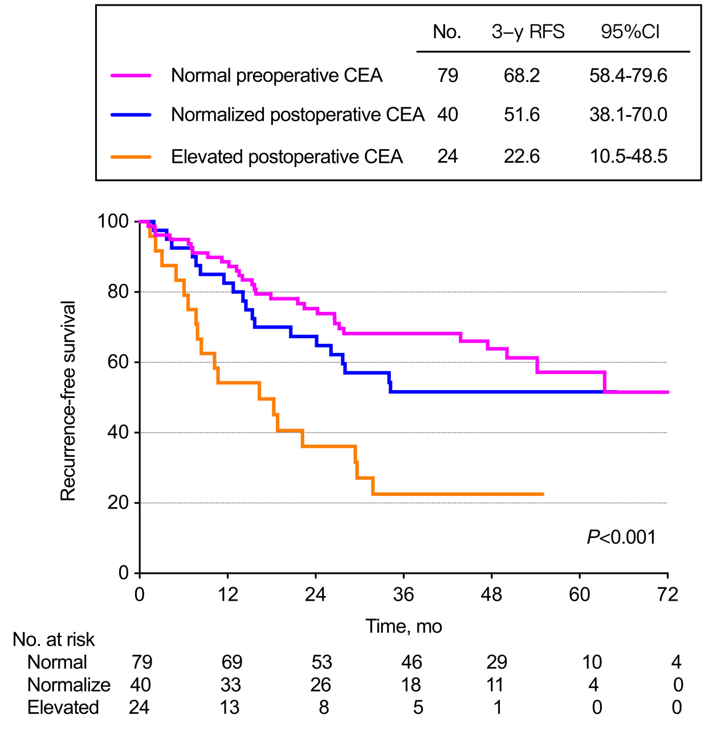

eFigure 2. Kaplan-Meier Curves for RFS in Patients With Normal Preoperative, Normalized Postoperative, or Elevated Postoperative CEA, Grouped by N Disease Stage

