Appendix 1: Wavelet transform coherence
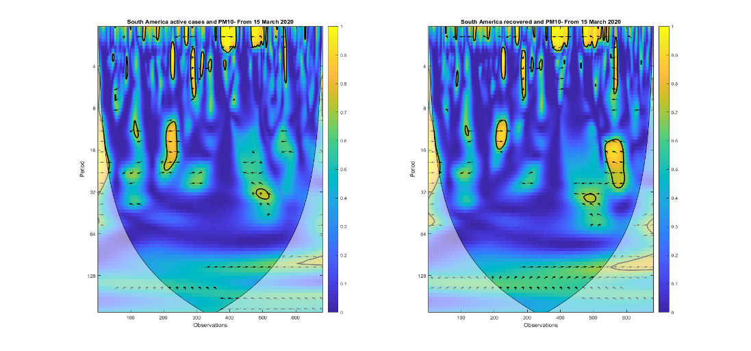 | 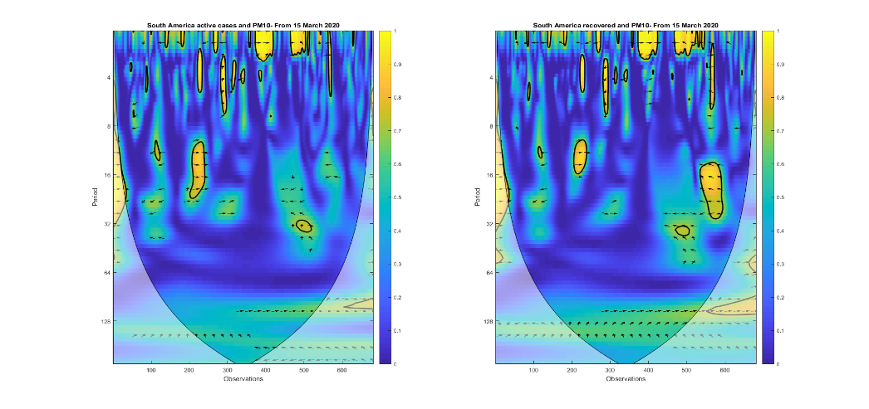
Figure 1a. Active cases and PM₁₀ | Figure 1b. Recoveries and PM₁₀
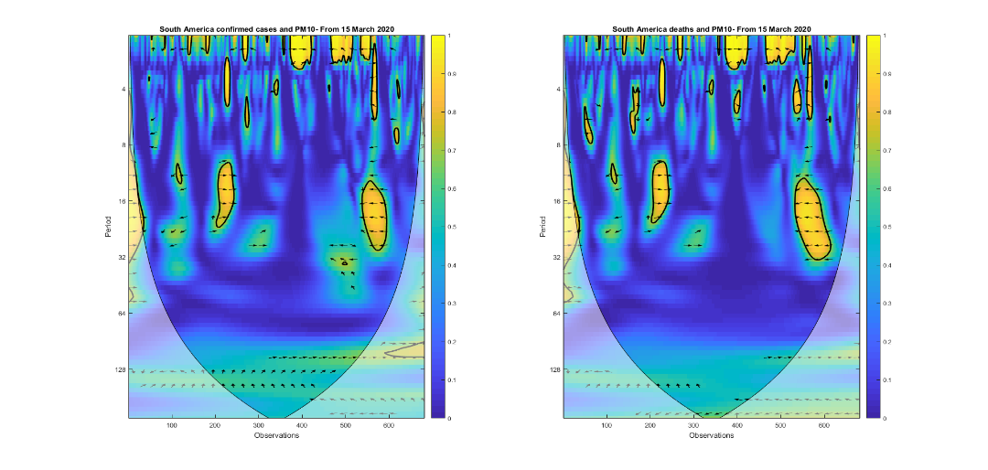 | 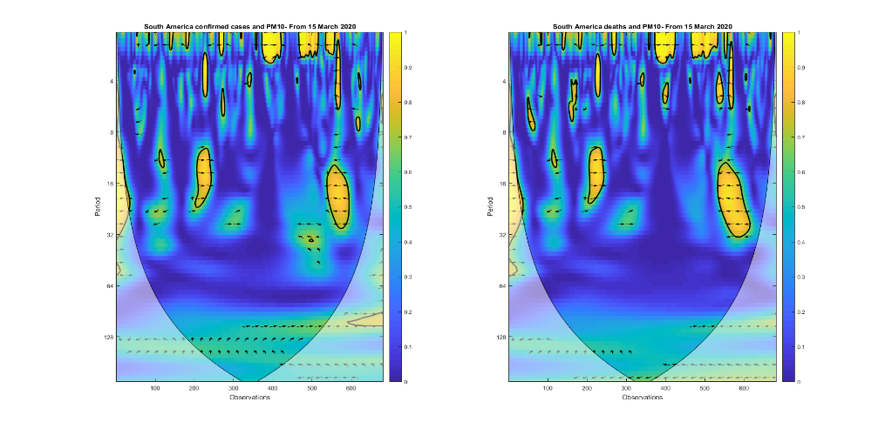
Figure 1c. Confirmed cases and PM₁₀ | Figure 1d. Deaths and PM₁₀

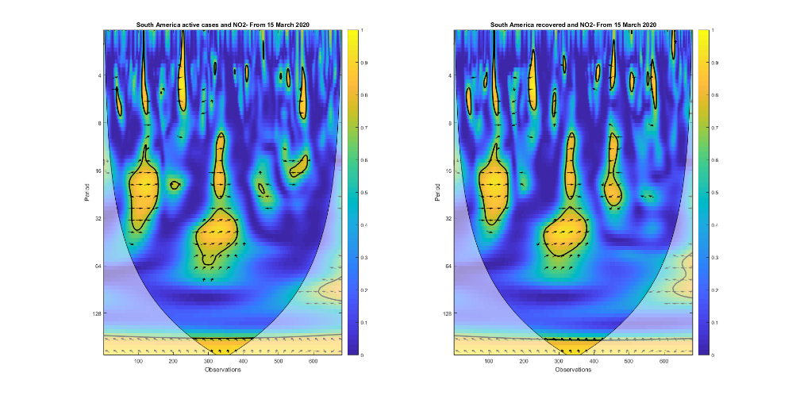 | 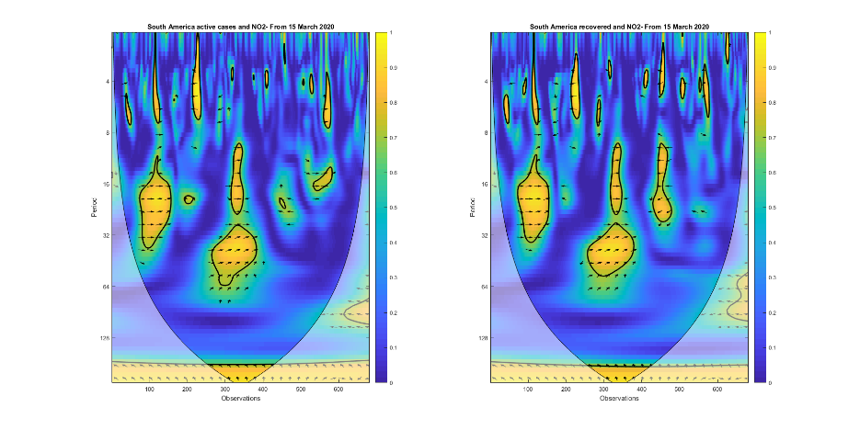
Figure 2a. Active cases and NO₂ | Figure 2b. Recoveries and NO₂
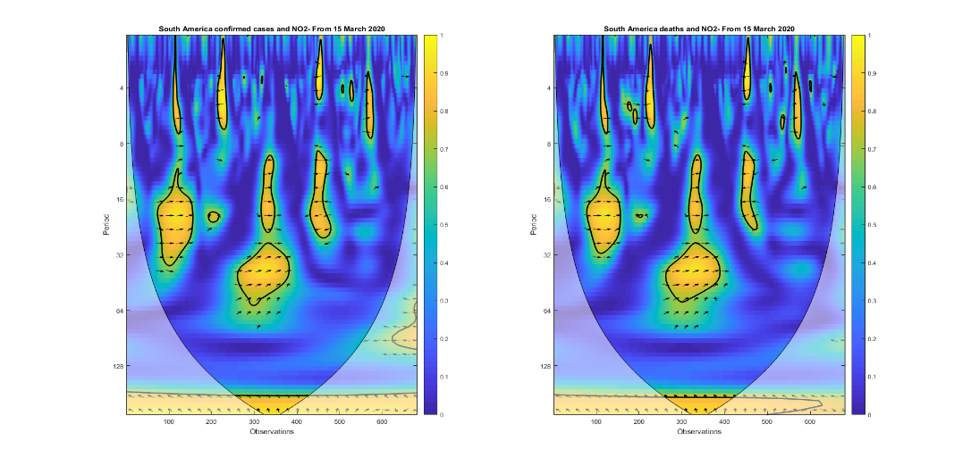 | 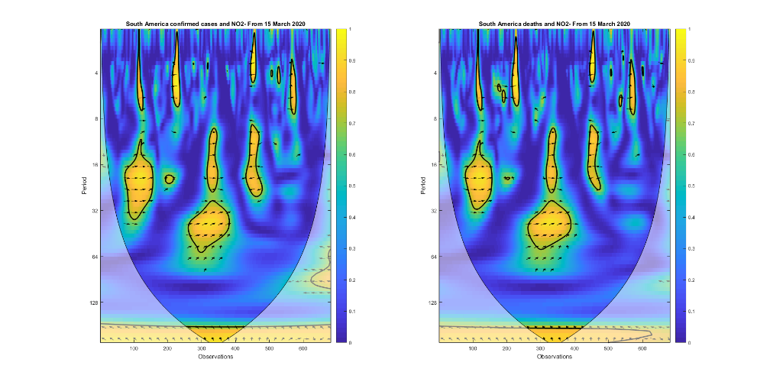
Figure 2c. Confirmed cases and NO₂ | Figure 2d. Deaths and NO₂

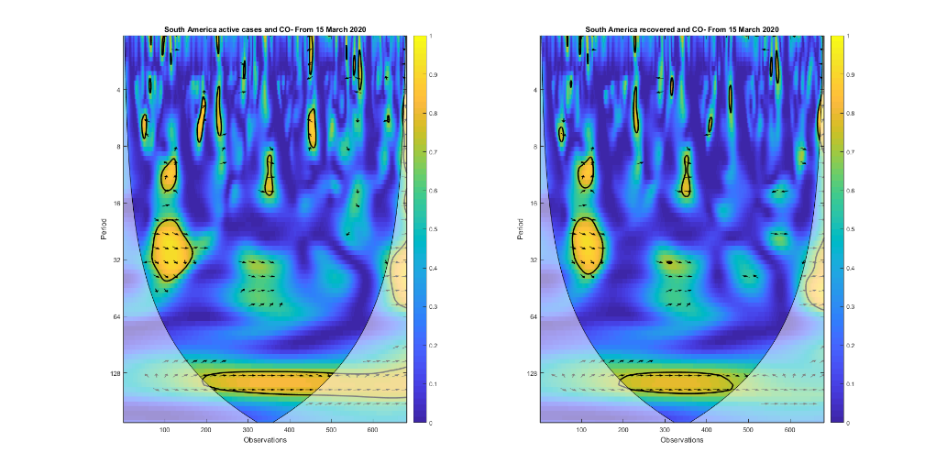 | 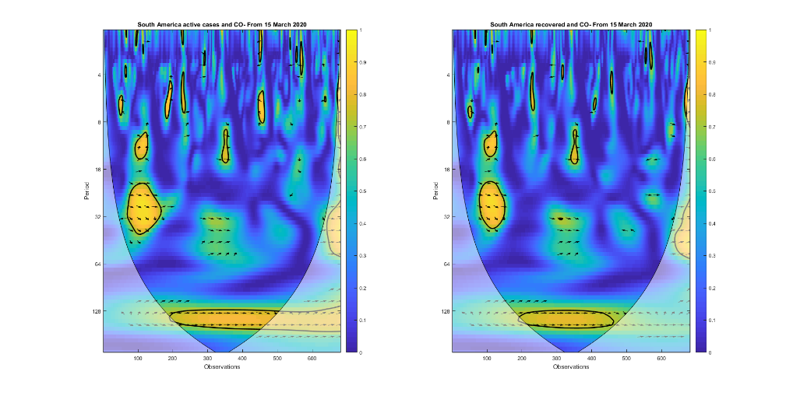
Figure 3a. Active cases and CO | Figure 3b. Recoveries and CO
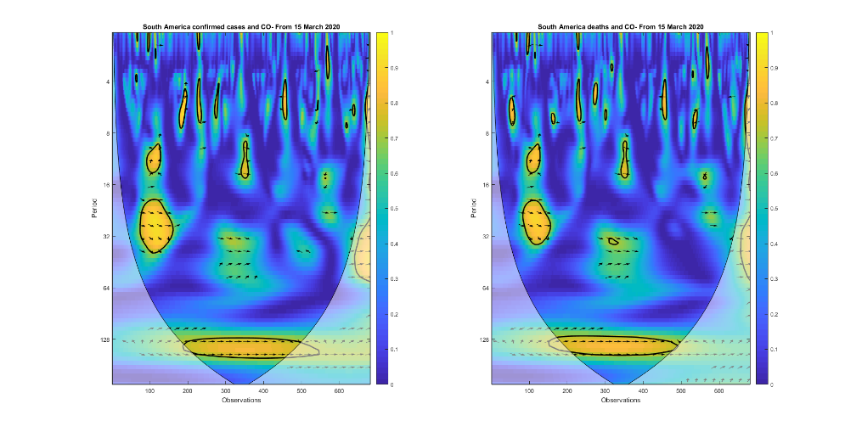 | 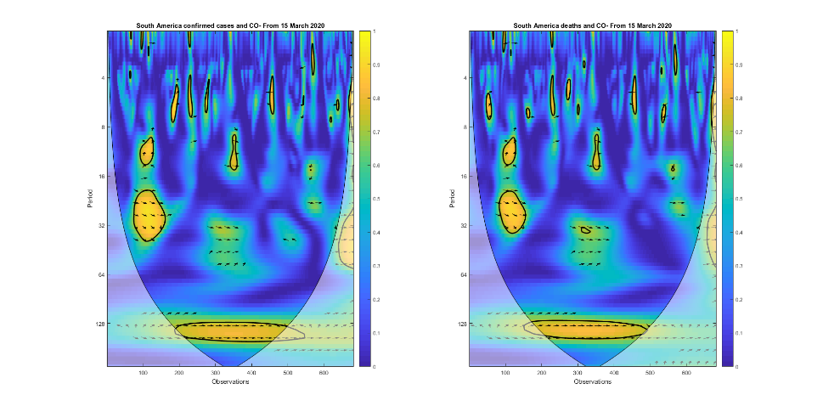
Figure 3c. Confirmed cases and CO | Figure 3d. Deaths and CO

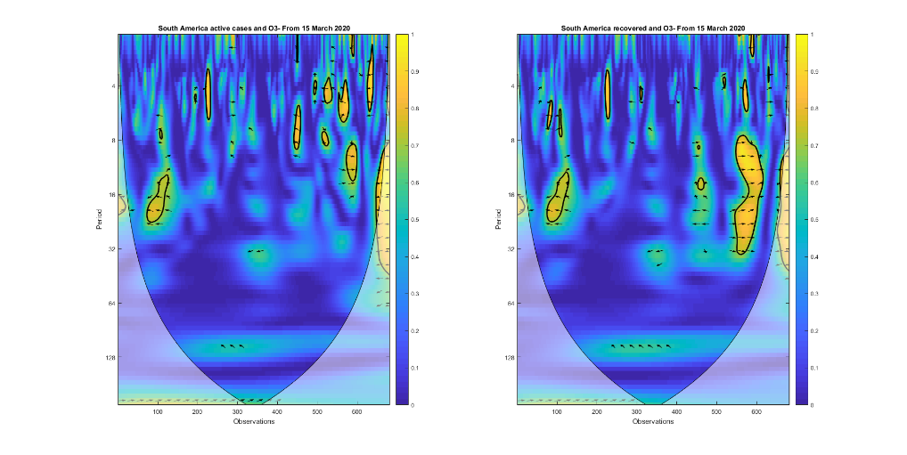 | 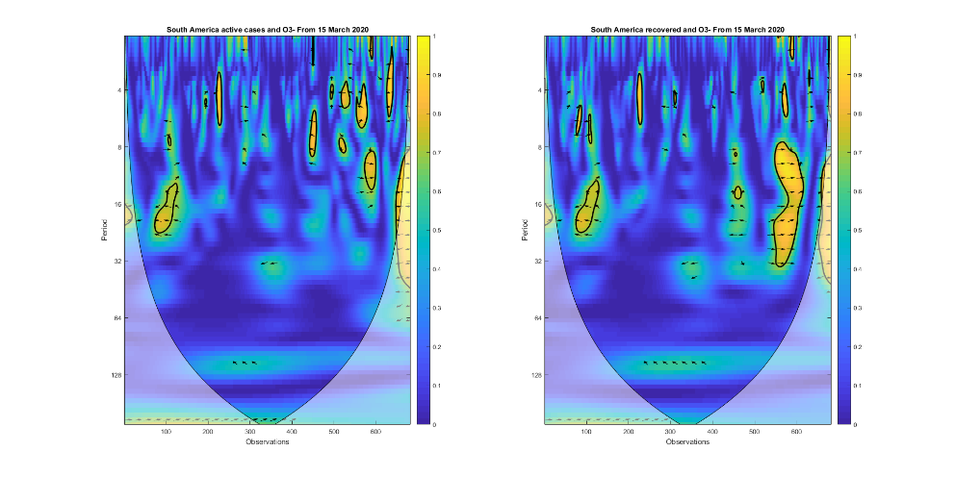
Figure 4a. Active cases and O₃ | Figure 4b. Recoveries and O₃
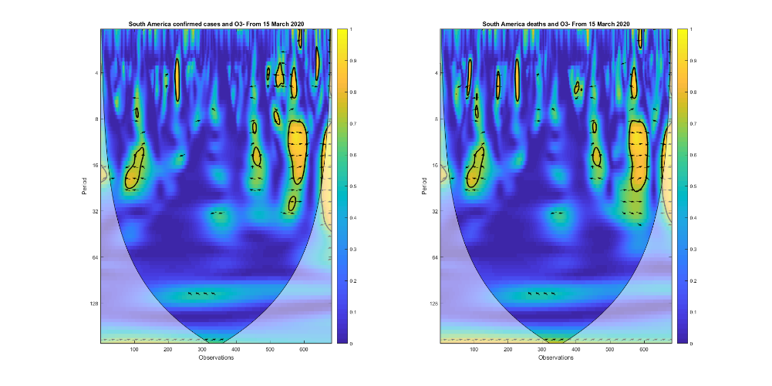 | 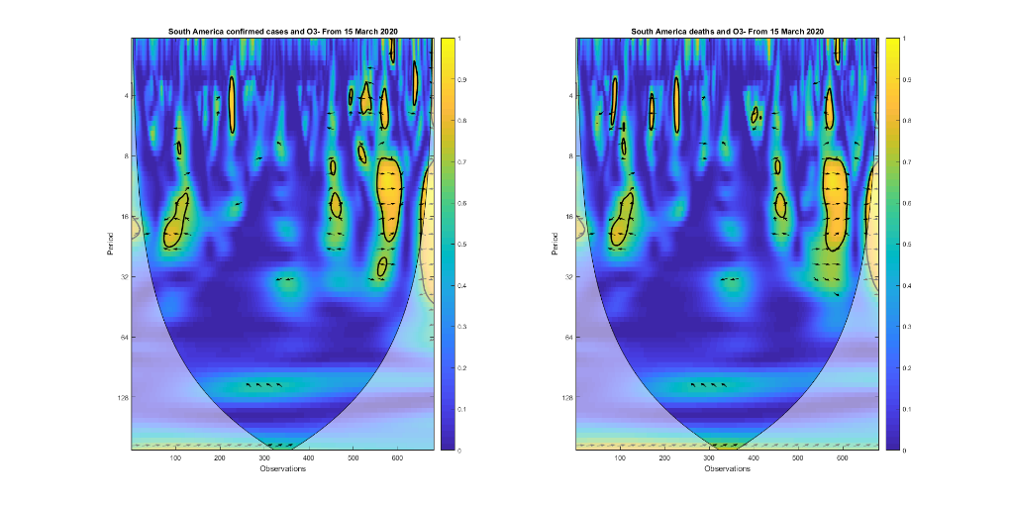
Figure 4c. Confirmed cases and O₃ | Figure 4d. Deaths and O₃

