Supplementary materials

Supplementary Methods
Cerebral blood flow measurements
A laser speckle contrast imager (PeriCam PSI HR System, Perimed, Sweden) was used to monitor cerebral blood flow (CBF). Mice were anesthetized and then fixed on a stereotaxic frame with the skull exposed. Laser speckle images were acquired through a photo detector at a working distance of 10cm from the skull surface. The baseline CBF imaging has been recorded before dMCAO and after occlusion (at right CCAO, and at right distal MCAO), all of the mice underwent a continuous imaging monitoring of CBF respectively. Regions of interesting (ROIs) representing relative CBF (rCBF) changes in the corresponding hemisphere.

Supplementary Figure

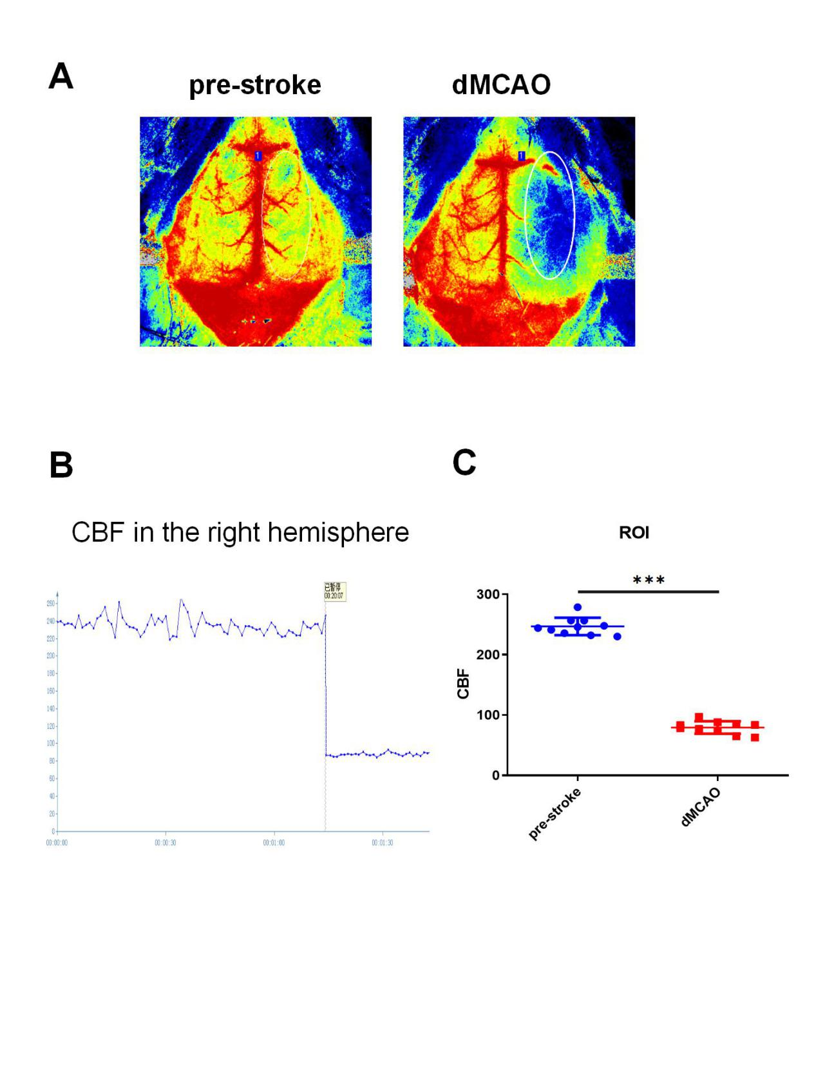

Supplementary figure legend
Figure S1. Permanent focal cerebral ischemia was successfully conducted.
(A) Two-dimensional laser speckle images show cortical CBF before dMCAO (baseline) and after dMCAO. The white circle indicated the approximate boundaries of the ipsilateral peri-infarct area.
(B) Quantified cerebral blood flow in the ipsilateral peri-infarct area.
(C) Statistical analyses of CBF quantification in the ROI (region of interest) before and after dMCAO. *** P< 0.001 by unpaired Student's t test, n=10 mice per group.

