Supporting Information
Table S1 List of primers used in this study
Genes | Forward primer (5′–3′) | Reverse primer (5′–3′)
β-actin | CATGGATGACGATATCGC | CATGAGGTAGTCTGTCAGG
FPN | TCCGTGAACTTGAATGTGAA | AGGCGTACCCTGTAGTGATA
Hamp2 | GAAGAAAGCAGGGCAGACAT | CACAACAGATACCACAGGAGG
FtH | TGGAACTGCACAAACTGGCTACT | ATGGATTTCACCTGTTCACTCAGATAA
DMT1 | TTAGCGTGGCTTATTTGACC | GACTTTCGAGATGCTTACCG
IRP2 | TGAAGAAACGGACCTGCTCT | GCTCACATCCAACCACCTCT
ZIP14 | TGGAGTAGAGCCAGTGGATAA | CTCGCCAGAAGACAAACAAAG
SPCA1 | CCTGCGGACTTACGCTTATTT | AGGCGATGTTACTTCTTGACG
SLC30A10 | GGAAGAAAGCAGCAGGAGG | ACTGCCAGTTACACGGGTCT

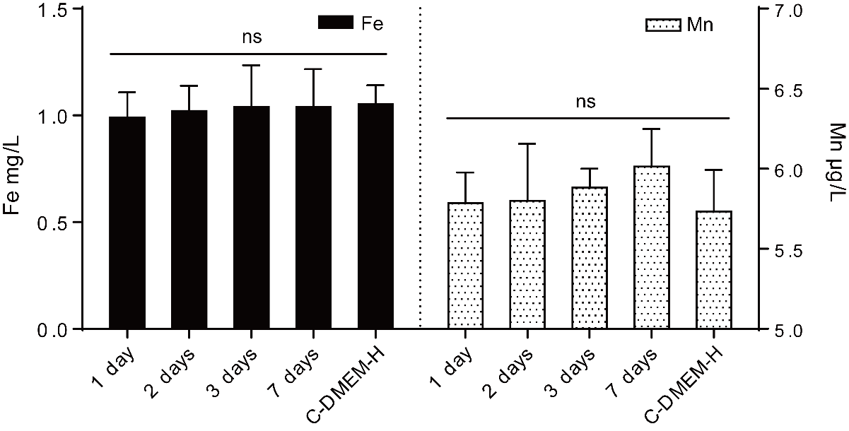
Figure S1 The Fe and Mn ions contents of cell medium containing Mn-IONPs. The fresh C-DMEM-H media was used as negative control. ns, not significant.
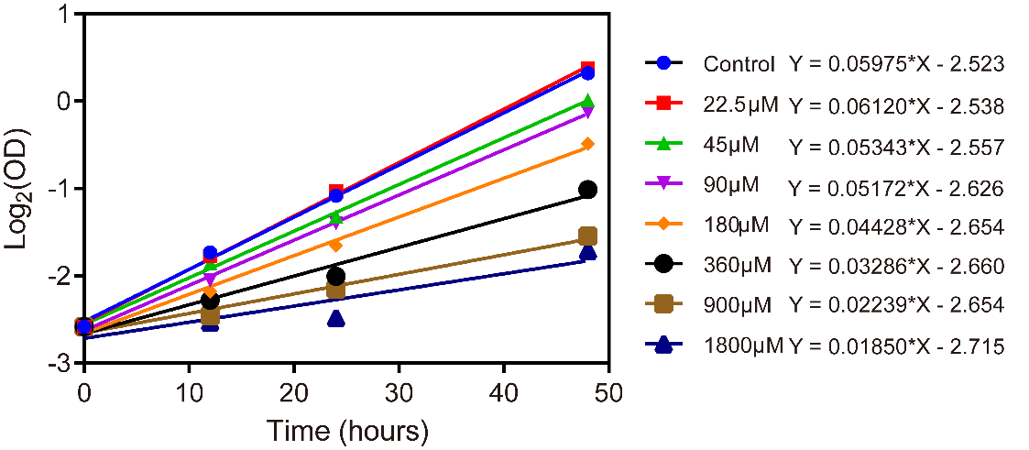
Figure S2 Cell proliferation of RAW264.7 cells exposed to different concentrations of Mn-IONPs (Fe concentration: 0, 22.5, 45, 90, 180, 360, 900 and 1800 μM) were evaluated using the linear regression: plots of Log₂(OD) vs Time. A representative of three biological repeats.

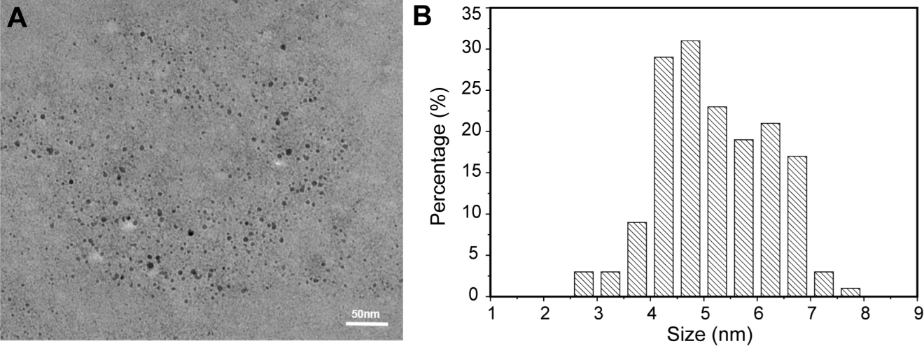
Figure S3 TEM image (A) and size distribution (B) of the Mn-IONPs collected from the cell medium which have nourished P1 cells for 48 hours.

