Supplementary materials
Figure S1 The radio-resistance characteristic of CR cells.
- Clonogenic assay for radio-sensitivity of CNE2 and CR cells (n = 3; p<0.05). (b)The percent of apoptotic CNE2 and CR cells was assayed by flow cytometry and shown in a bar graph. The cells were irradiated at a dose of 2 Gy and assayed 48h post radiation (n = 3; p<0.001).

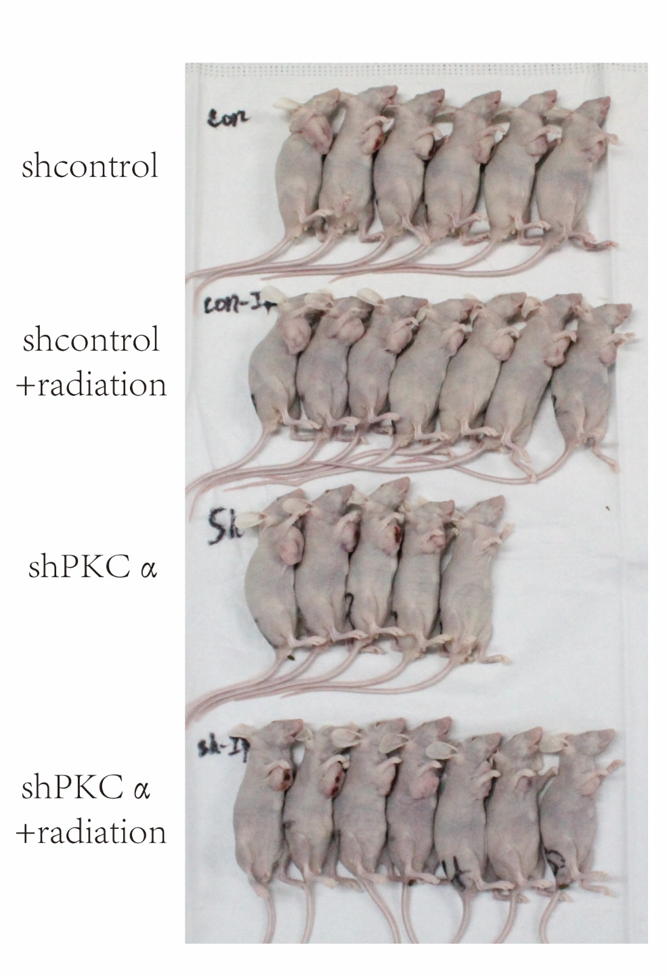
Figure S2 Tumor growth status in the nude mouse.

