SUPPLEMENTARY DATA
Eduarda Fernandes et al

Lipid nanosystems and serum protein as biomimetic interfaces: predicting the biodistribution of a caffeic acid-based antioxidant

Eduarda Fernandes¹, Sofia Benfeito², Fernando Cagide², Hugo Gonçalves³, Sigrid Bernstorff⁴, Jana B. Nieder⁵, M. Elisabete C.D. Real Oliveira¹, Fernanda Borges² and Marlene Lúcio^{1,6}
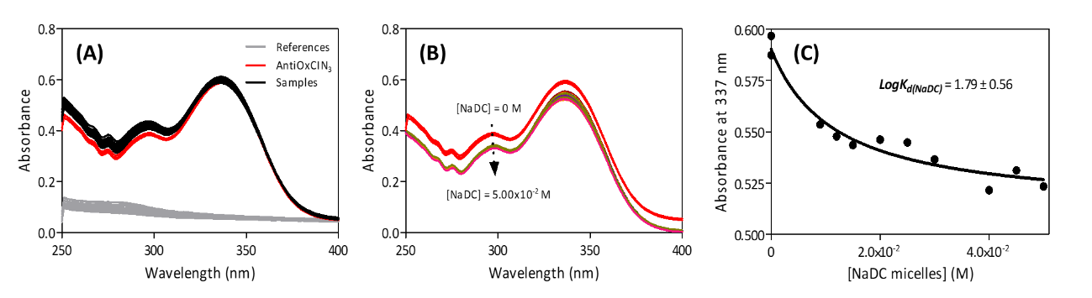
Figure S1 - Schematic representation of the derivative spectrophotometric determination of AntiOxCIN₃ distribution coefficient in NaDC micelles as biliary salts model systems: (A) AntiOxCIN₃ (2.0×10⁻⁴ M) absorption spectra in aqueous buffered phase pH=7.4 (red spectrum) and after incubation with increasing concentrations of NaDC micelles (0 - 5.0×10⁻² M) (black spectra) or absorption spectra of NaDC micelles (0 - 5.0×10⁻² M) in the absence of AntiOxCIN₃ (grey spectra - references); (B) Resultant spectra after NaDC references subtraction; (C) Non-linear fitting by Equation 1 of derivative absorbance at λ=337 nm as a function of NaDC micelles concentration.

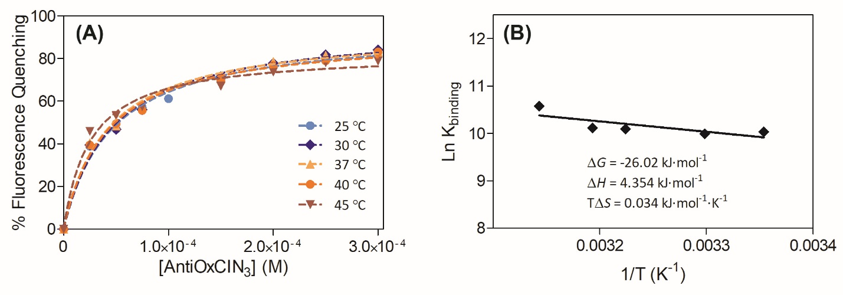
Figure S2 - (A) Graphical representation of HSA (2.0×10⁻² M) percentage of fluorescence quenching promoted by increasing concentrations of AntiOxCIN₃ (0 to 3.50×10⁻⁴ M), at several temperatures represented with different colors (see legend), including the non-linear fitting with Equation 6 (dashed colored lines). (B) Graphical representation of the linear van’t Hoff relation and thermodynamic parameters obtained (Equation 9 and 10).

Table S1 - Distribution coefficient of AntiOxCIN₃ in PC membrane model system (LogK_{d(PC)}) at different pH values. The values presented are mean ± standard deviation of at least three independent experiments.
 | LogK_{d(PC)}
pH 2.0 | 3.98 ± 0.22
pH 3.0 | 3.93 ± 0.43
pH 4.0 | 3.98 ± 0.63
pH 5.0 | 3.02 ± 0.14
pH 6.0 | 3.46 ± 0.25

Table S2 - Thermodynamic parameters of AntiOxCIN₃ distribution in PC membrane system.
Temperature (˚C) |  | LogK_{d(PC)} | ΔH_{aq→mem} (KJ∙mol⁻¹) | TΔS_{aq→mem} (KJ∙mol⁻¹)
L_{β} phase | 30.0 | 3.40 ± 0.12 | -14.92 | 0.012
L_{β} phase | 33.0 | 3.36 ± 0.15 | -14.92 | 0.012
L_{β} phase | 37.0 | 3.34 ± 0.02 | -14.92 | 0.012
L_{α} phase | 40.0 | 3.35 ± 0.05 | 43.93 | 0.200
L_{α} phase | 45.0 | 3.52 ± 0.04 | 43.93 | 0.200

Table S3 - Stern-Volmer constant (K_{SV}) obtained from measurements of fluorescence quenching of n-AS by AntiOxCIN₃ in PC membrane system.

Probe | Temperature (ºC) | K_{sv} (M⁻¹)
3-AS | 30 | 13.30
3-AS | 37 | 11.25
3-AS | 45 | 9.85
6-AS | 30 | 2.30
6-AS | 37 | 1.54
6-AS | 45 | 1.20
9-AS | 30 | 3.21
9-AS | 37 | 2.99
9-AS | 45 | 1.83
12-AS | 30 | 3.12
12-AS | 37 | 2.90
12-AS | 45 | 1.76

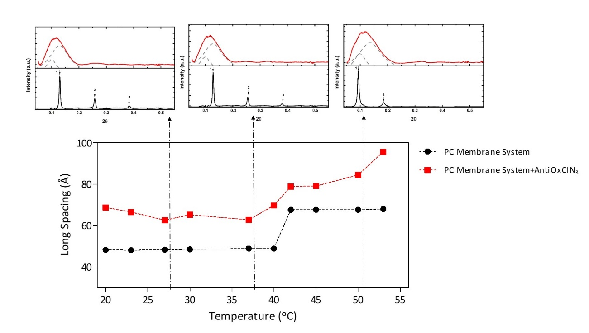

Figure S3 - Graphical representation of long spacing (d_{L}) as a function of temperature obtained from SAXS patterns in the absence (black) and presence of AntiOxCIN₃ (red). The insets represent the SAXS patterns of PC membrane model in the absence (solid black lines) and in the presence of AntiOxCIN₃ (solid red lines) in the gel (27˚C), ripple gel (37˚C) and fluid (50˚C) phases (ordered from left to right). Dashed grey lines give the best fit of the Lorentzian’s analysis model to the scattered intensities.
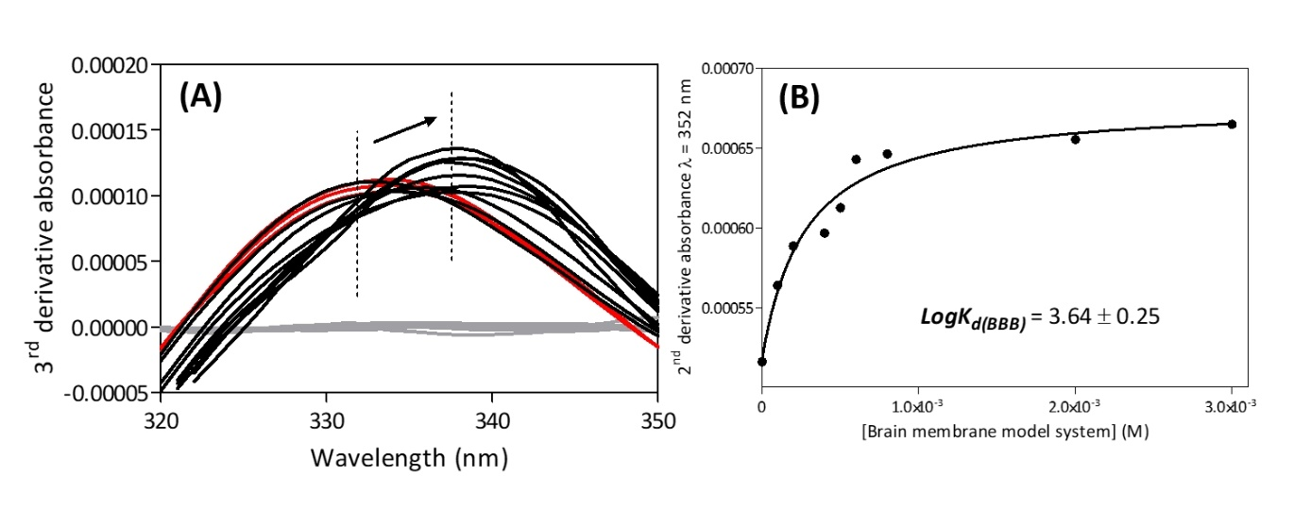
Figure S4 - Schematic representation of BBB membrane model system partition coefficient of AntiOxCIN₃ (2.0×10⁻⁴ M) by derivative spectrophotometry: (A) A section of the third derivative of the absorbance spectra of AntiOxCIN₃ in aqueous buffered phase pH=7.4 (red spectrum), after incubation with increasing concentrations of BBB membrane model system (0- 3.0×10⁻³ M) prepared in the same conditions (black spectra) and increasing concentrations of BBB membrane model system (0- 3.0×10⁻³ M) in the absence of AntiOxCIN₃ (grey spectra), highlighting the observed shift in the maximum peak with increasing membrane model concentrations; (B) Non-linear fitting by Equation 1 of derivative absorbance at λ=352 nm as a function of BBB membrane model system concentration.

