Supplemental materials
Figure captions
Figure S1 Preparation process of halofuginone hydrobromide-TPGS polymer micelles (HTPM)
Figure S2 Effect of HTPM on apoptosis of Eph-ev cells
Figure S3 Apoptosis and cell cycle change of MCF-7 cells induced by different concentrations of HTPM
Figure S4 Effect of HTPM on reactive oxygen species (ROS) and mitochondrial membrane potential (MMP) of MCF-7 cells

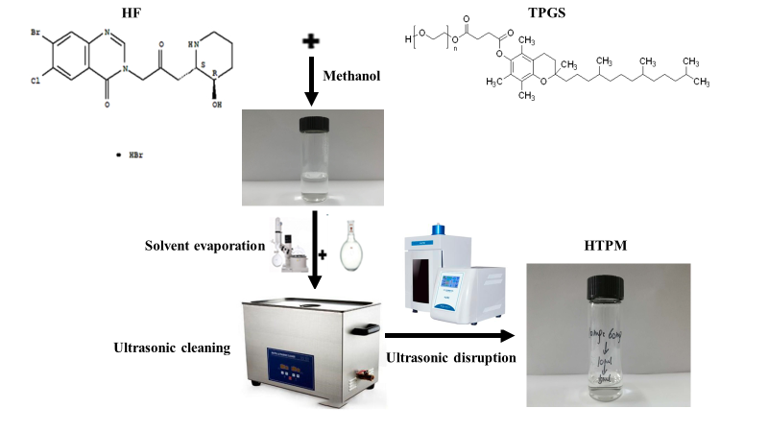
Figure S1

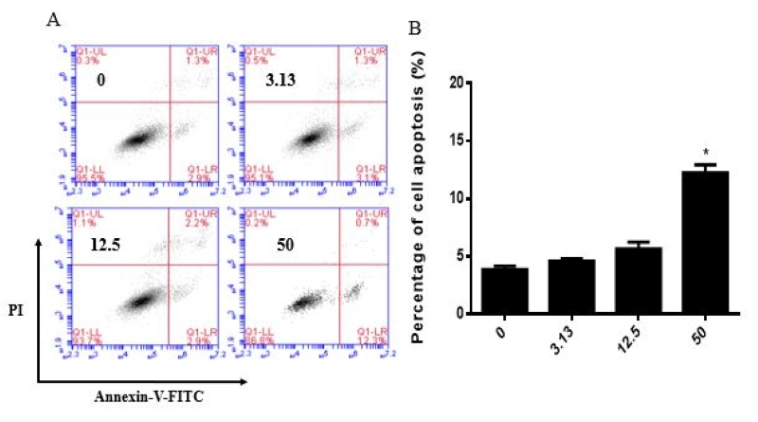
Figure S2

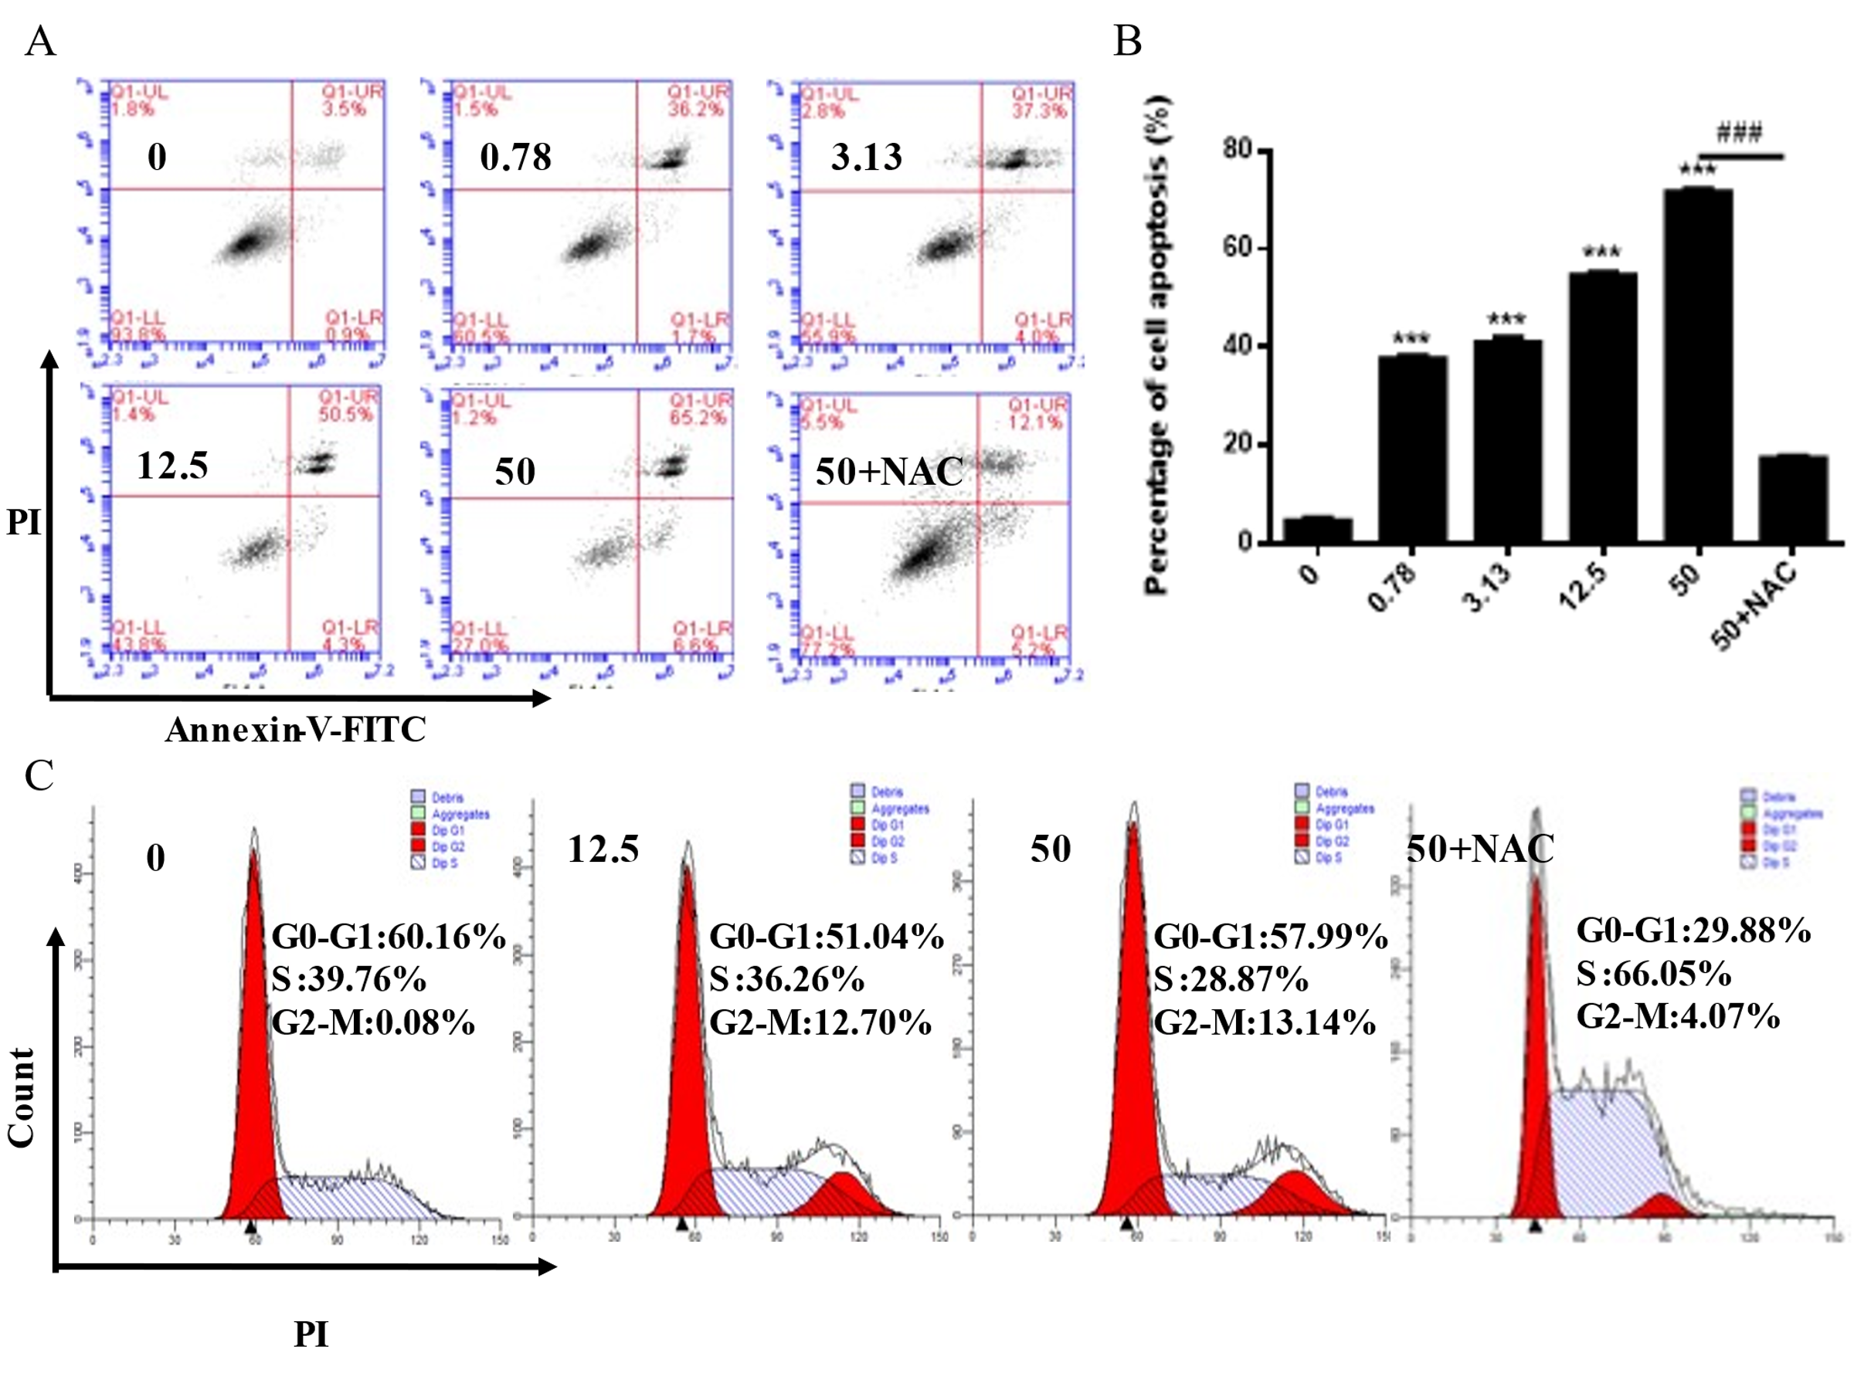
Figure S3

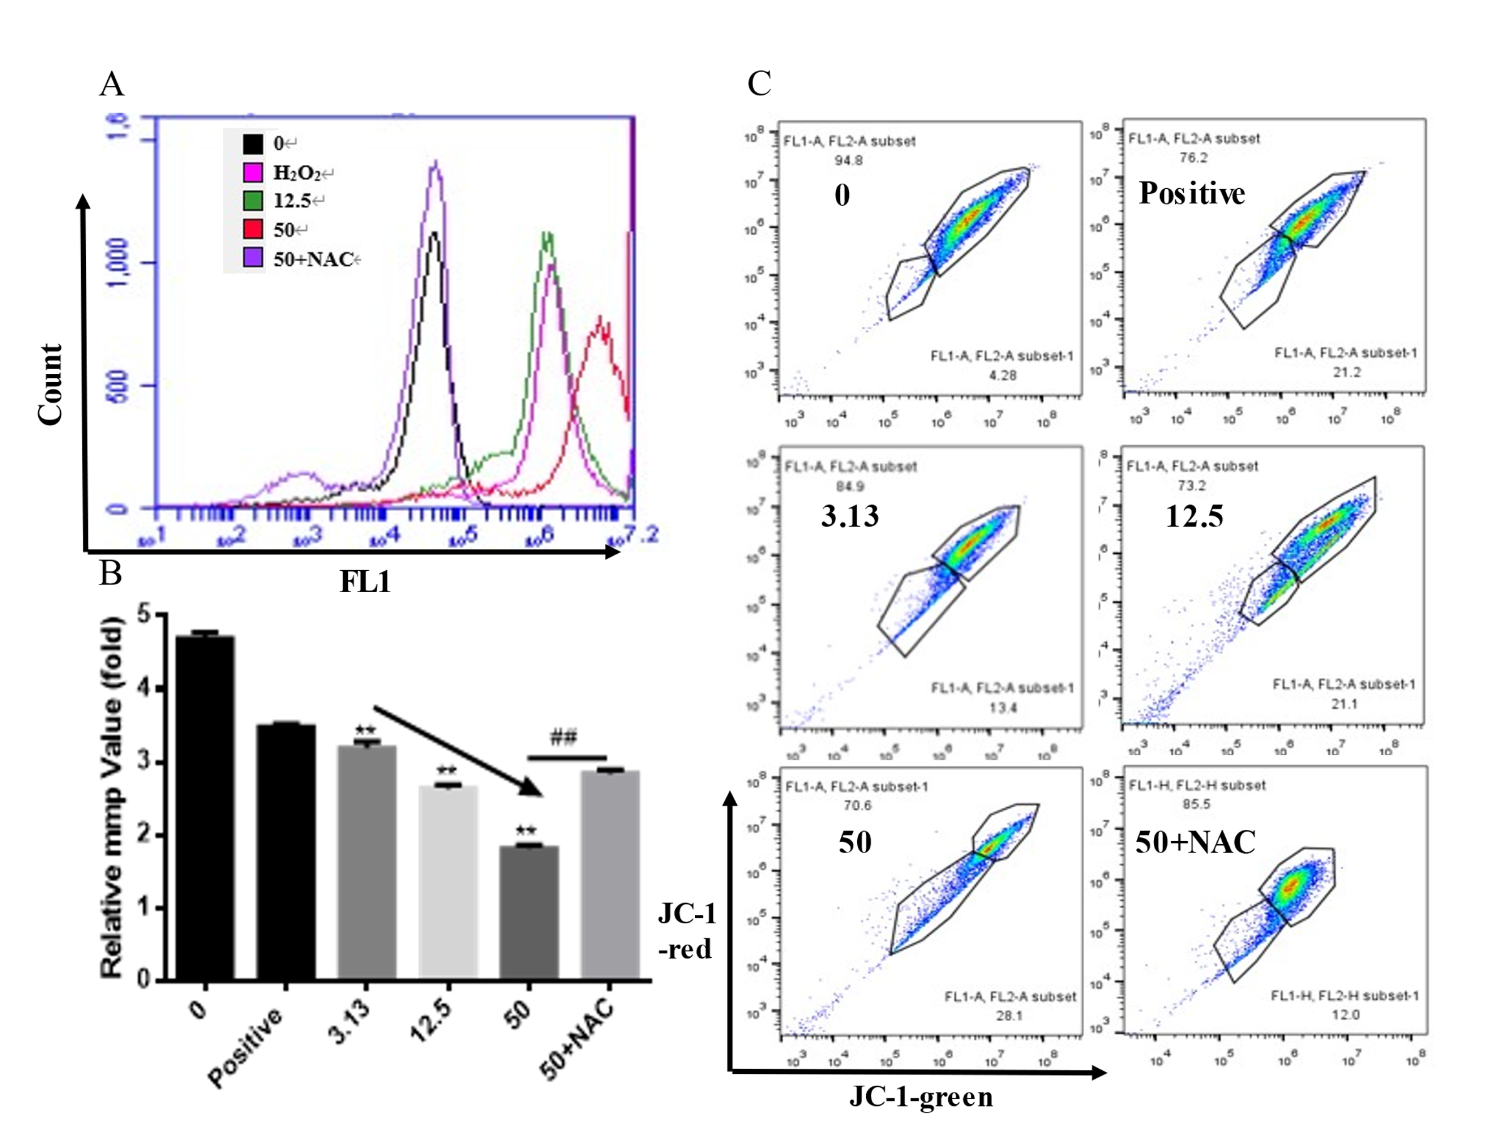
Figure S4

