Supplementary material Figure 1 Ultrasound combined with nerve stimulator for lumbar plexus block
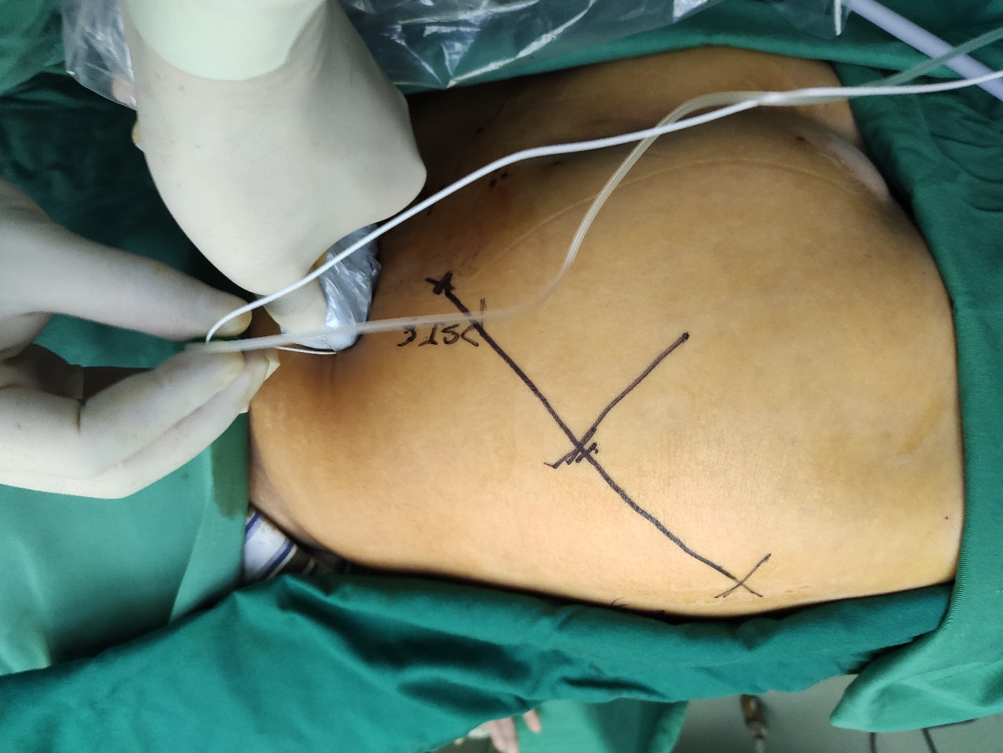
Supplementary material Figure 2 Ultrasound combined with nerve stimulator for sacral plexus block
