Supporting Information
tLyP-1 Peptide Functionalized Human H Chain Ferritin for Targeted Delivery of Paclitaxel

Protein sequences of tLyP-1-HFtn and M-tLyP-1-HFtn
tLyP-1-HFtn
CGNKRTRGGGGSMTTASTSQVRQNYHQDSEAAINRQINLELYASYVYLSMSYYFDRDDVALKNFAKYFLHQSHEEREHAEKLMKLQNQRGGRIFLQDIKKPDCDDWESGLNAMECALHLEKNVNQSLLELHKLATDKNDPHLCDFIETHYLNEQVKAIKELGDHVTNLRKMGAPESGLAEYLFDKHTLGDSDNES

M-tLyP-1-HFtn
CGNARTAGGGGSMTTASTSQVRQNYHQDSEAAINRQINLELYASYVYLSMSYYFDRDDVALKNFAKYFLHQSHEEREHAEKLMKLQNQRGGRIFLQDIKKPDCDDWESGLNAMECALHLEKNVNQSLLELHKLATDKNDPHLCDFIETHYLNEQVKAIKELGDHVTNLRKMGAPESGLAEYLFDKHTLGDSDNES

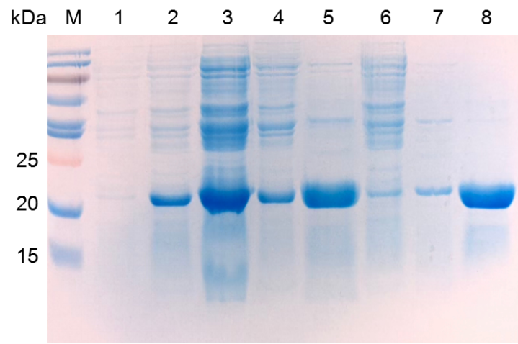

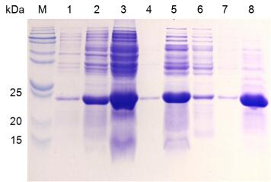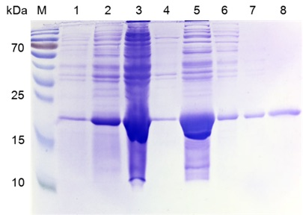

Fig. S1. Electrophoretic monitoring of the HFtn, tLyP-1-HFtn and M-tLyP-1-HFtn protein purification. Lane M: Marker. Lane 1: Before induction. Lane 2: After induction. Lane 3: Soluble fraction. Lane 4: Insoluble fraction. Lane 5: Flow through. Lane 6: Wash 1. Lane 7: Wash 2. Lane 8: Purified protein.

Table S1. Characteristics of various PTX-loaded NPs (n=3)
Formulations | Mean diameter (nm) | Encapsulation efficiency (%) | Loading capacity (%)
HFtn-PTX | 12.0 ± 0.50 | 18.4 ± 0.31 | 3.0 ± 0.42
tLyP-1-HFtn-PTX | 12.6 ± 0.25 | 19.0 ± 0.52 | 2.9 ± 0.22
M- tLyP-1-HFtn-PTX | 12.8 ± 0.32 | 18.3 ± 0.41 | 2.7 ± 0.31

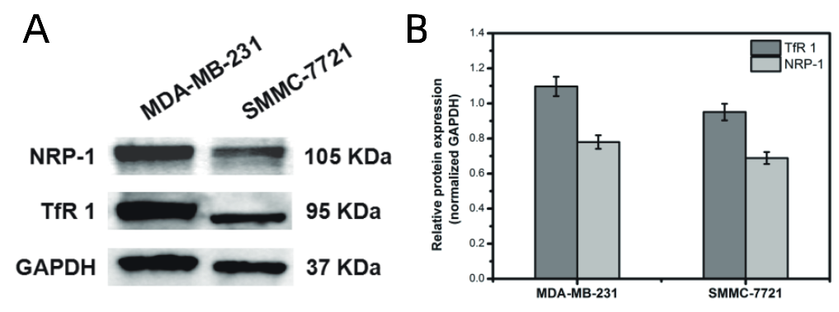
Fig. S2. Western blot analysis of TfR1 and NRP-1 expression in MDA-MB-231 and SMMC-7721 cells.

Table S2. IC50 values of various PTX formulations (n=3)
 | tLyP-1-HFtn-PTX (μg/mL) | HFtn-PTX  (μg/mL) | PTX  (μg/mL)
SMMC-7721 | 1.60 ± 0.05 | 1.73 ± 0.01 | 1.10 ± 0.07
MDA-MB-231 | 1.47 ± 0.02 | 1.67 ± 0.10 | 1.07 ± 0.15
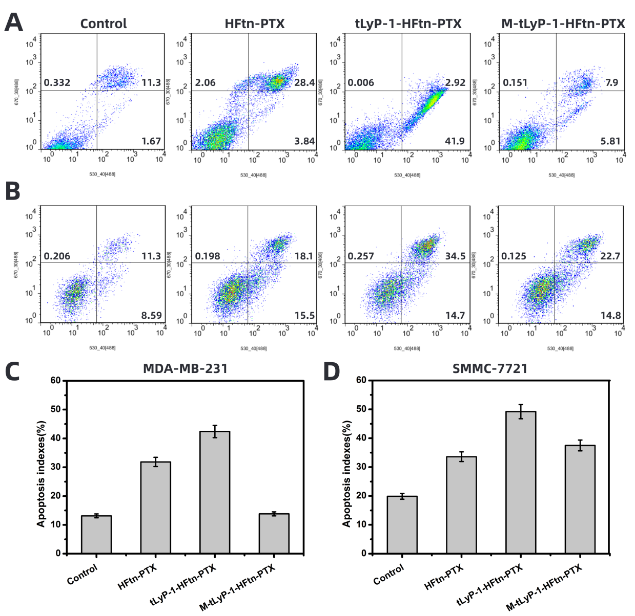
Fig. S3. Apoptotic profiles of the nanoparticles after incubation with MDA-MB-231 and SMMC-7721 cells for 24 h were (A) and (B), respectively. (C, D) Apoptosis indexes were defined as early and late apoptotic cells (n = 3).

