Supplementary Figures
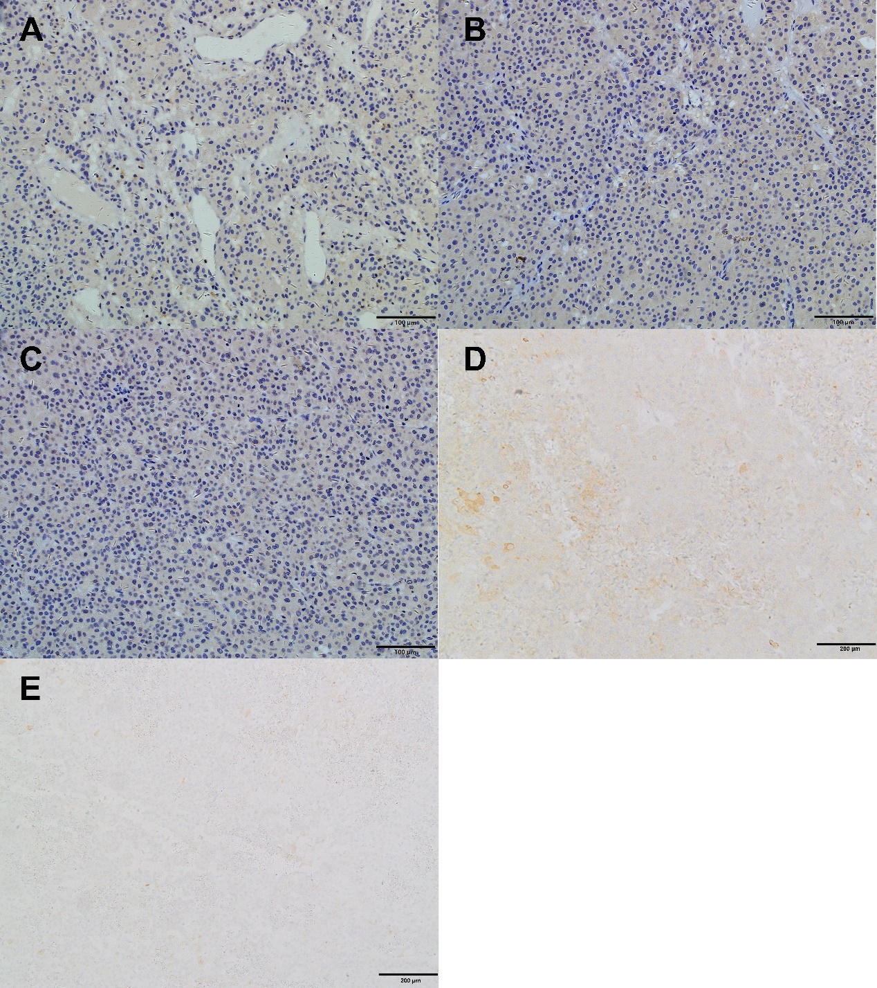
Supplementary Figure 1: Immunohistochemical figures for case 1. A, negative stain for P16(×200). B, negative stain for P53(×200). C, negative stain for PAX8(×200). D, negative stain for ER(×100). E, negative stain for PR(×100).

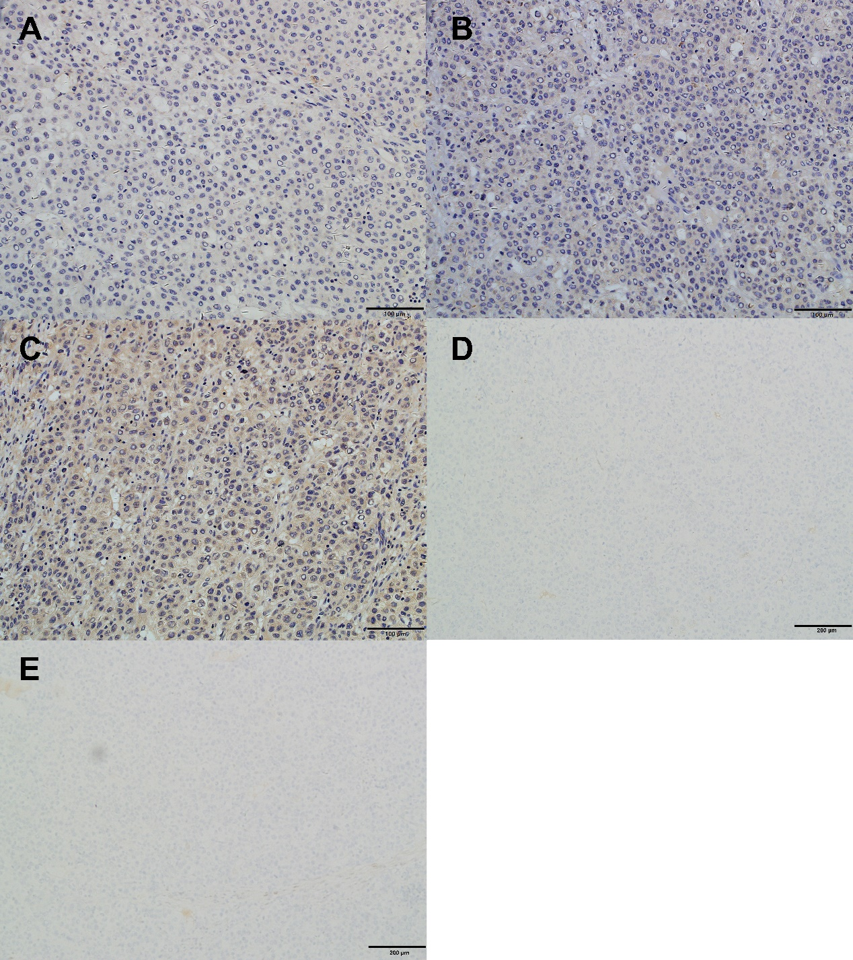
Supplementary Figure 2: Immunohistochemical figures for case 2. A, negative stain for P16(×200). B, negative stain for P53(×200). C, negative stain for PAX8(×200). D, negative stain for ER(×100). E, negative stain for PR(×100).

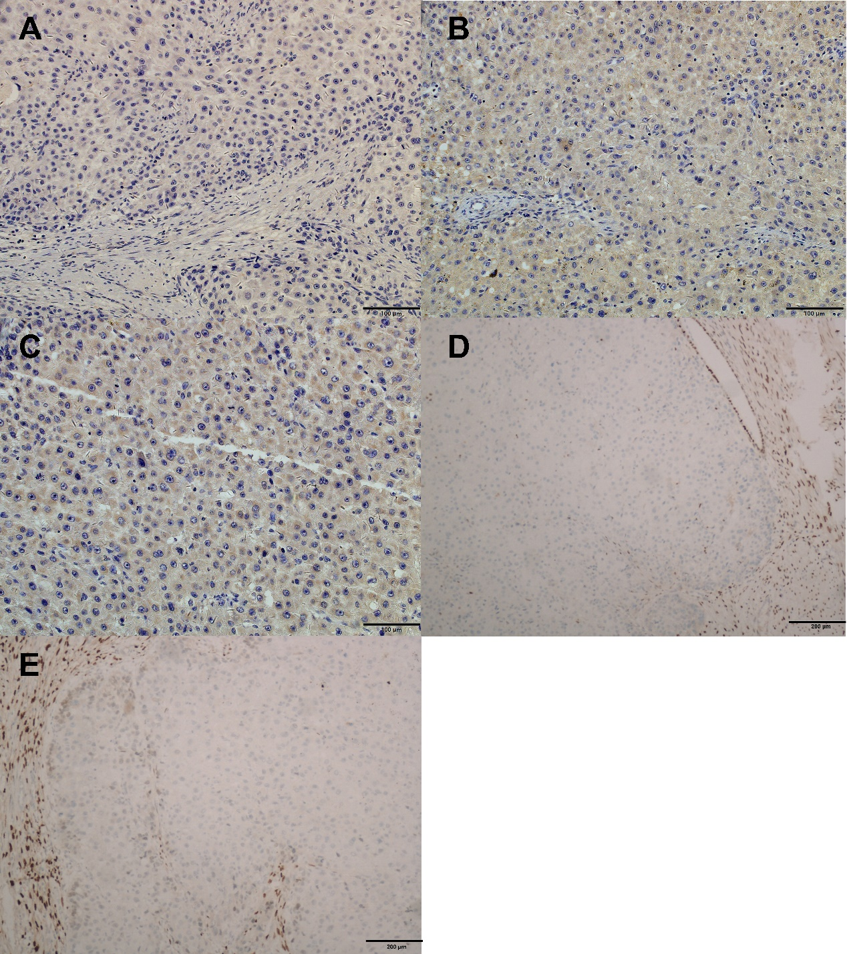
Supplementary Figure 3: Immunohistochemical figures for case 3. A, negative stain for P16(×200). B, negative stain for P53(×200). C, negative stain for PAX8(×200). D, negative stain for ER(×100). E, negative stain for PR(×100).

