Figure S1
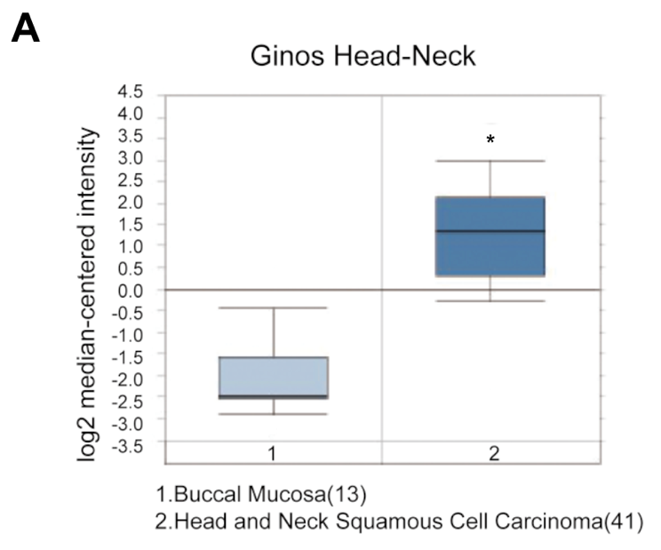
Figure S1 IDO gene analysis in oral squamous cell carcinoma (Oncomine database).
Box plots derived from gene expression data in Oncomine comparing expression of IDO gene in buccal mucosa (left plot) and head and neck squamous cell carcinoma (right plot). (*P < 0.05)

Figure S2
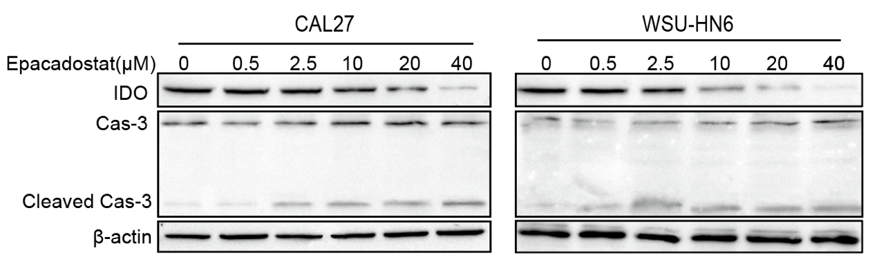
Figure S2 IDO inhibition promoted apoptosis of OSCC cells.
OSCC cells were treated without or with epacadostat (0.5, 2.5, 10, 20 or 40 μM) for 24 h. Representative Western blots show the expression of caspase-3 and IDO in epacadostat-treated CAL27 and WSU-HN6 cells.

Figure S3
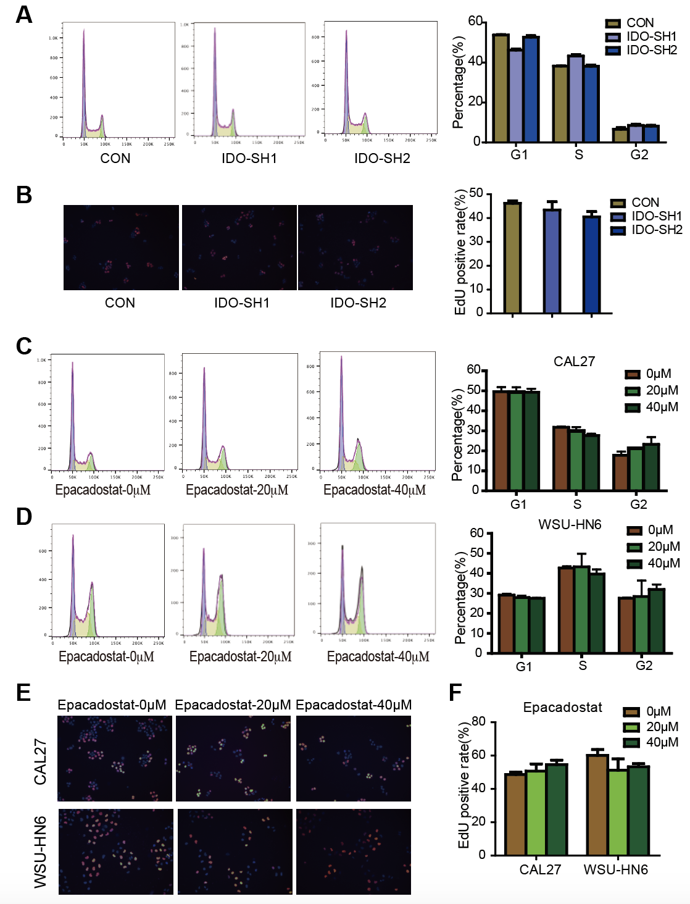
Figure 3S IDO inhibition had no influence on proliferation of OSCC cells.
(A) Effects of IDO knockdown on the cell cycle of OSCC cells. The cell cycle was analyzed by flow cytometry.
(B) Effects of IDO knockdown on the EdU incorporation of OSCC cells. The cells were incubated with a 50 μM concentration of EdU for 2 hours which was detected using a click reaction with Alexa Fluor 488 azide.
(C, D) Effects of Epacadostat on the cell cycle of OSCC cells. CAL27 and WSU-HN6 cells were treated with 0,20 and 40 μM of epacadostat for 24 hours. The cell cycle was analyzed by flow cytometry. (E, F) Effects of epacadostat on the EdU incorporation of OSCC cell. CAL27 and WSU-HN6 cells were treated with 0,20 and 40 μM of epacadostat for 24 hours. The cells were incubated with a 50 μM concentration of EdU for 2 hours which was detected using a click reaction with Alexa Fluor 488 azide.

Figure S4
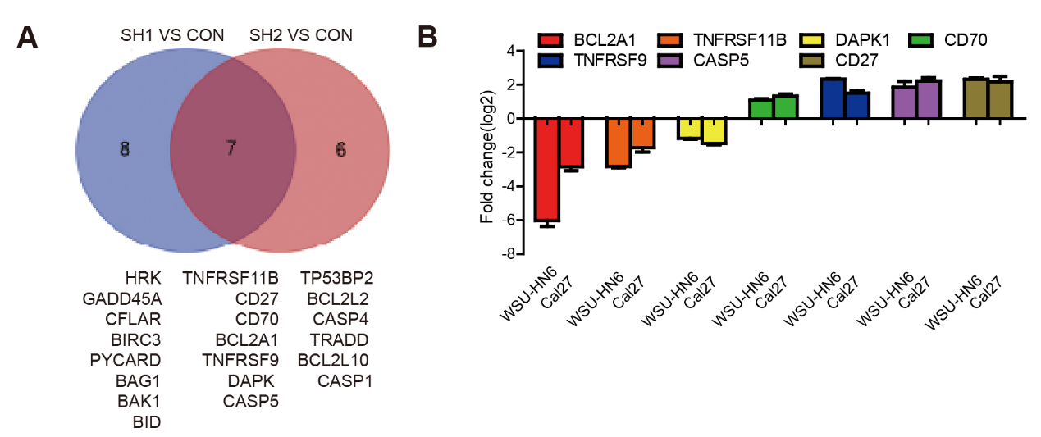
Figure S4 The apoptosis PCR array analysis of IDO knockdown and control CAL27 cells.
(A) Genes of which expression changed more than 2 folds and involved in apoptosis regulation were presented by Venn graph.
(B) Top consistently down-regulated and up-regulated genes were individually verified in WSU-HN6 and CAL27 cells treated with epacadostat by qPCR.

Figure S5
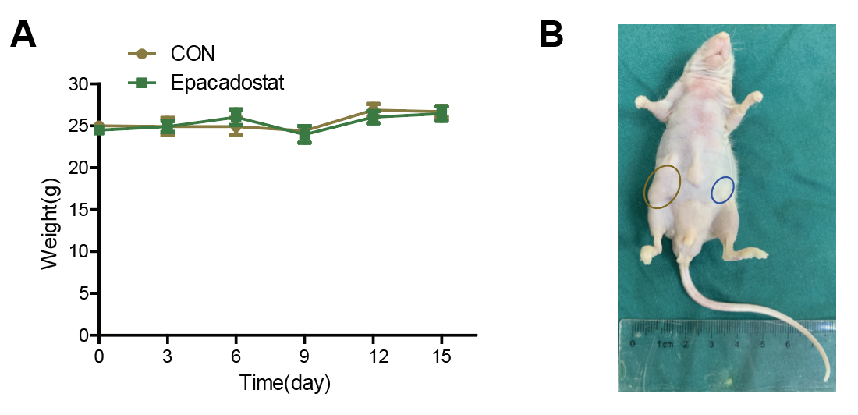
Figure S5 IDO inhibition suppressed OSCC xenograft growth.
(A) Epacadostat treatment had no obvious side effects on mice weight.
(B) Representative image of IDO knockdown (brown cycle) and control CAL27 cells (blue cycle) tumor on a mouse.

