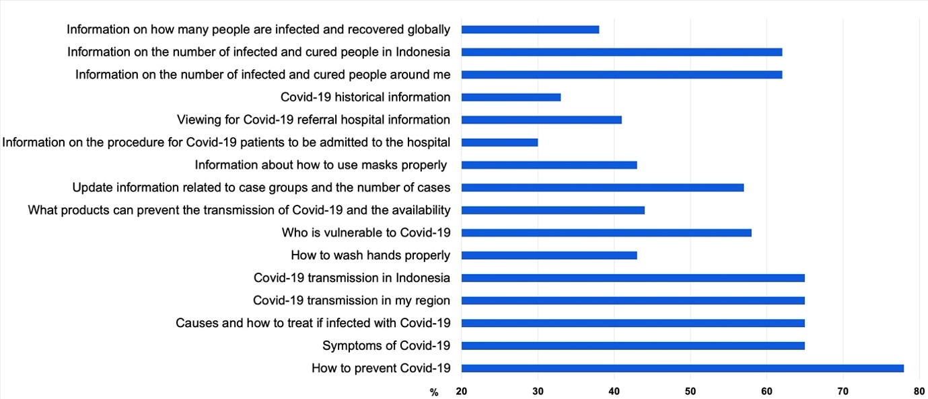

Figure S1. The type of information sought during the COVID-19 pandemic (N=816).

