The Effect of Nintedanib on T cell Activation, Subsets and Functions
Kenia Ubieta¹, Matthew James Thomas¹, Lutz Wollin¹
SUPPLEMENTARY MATERIALS
Supplementary Figure 1. Nintedanib blocks the release of anti-CD3-stimulated IFN-γ, IL-4, IL-5, IL-10, IL12p70 and IL-13 from PBMCs
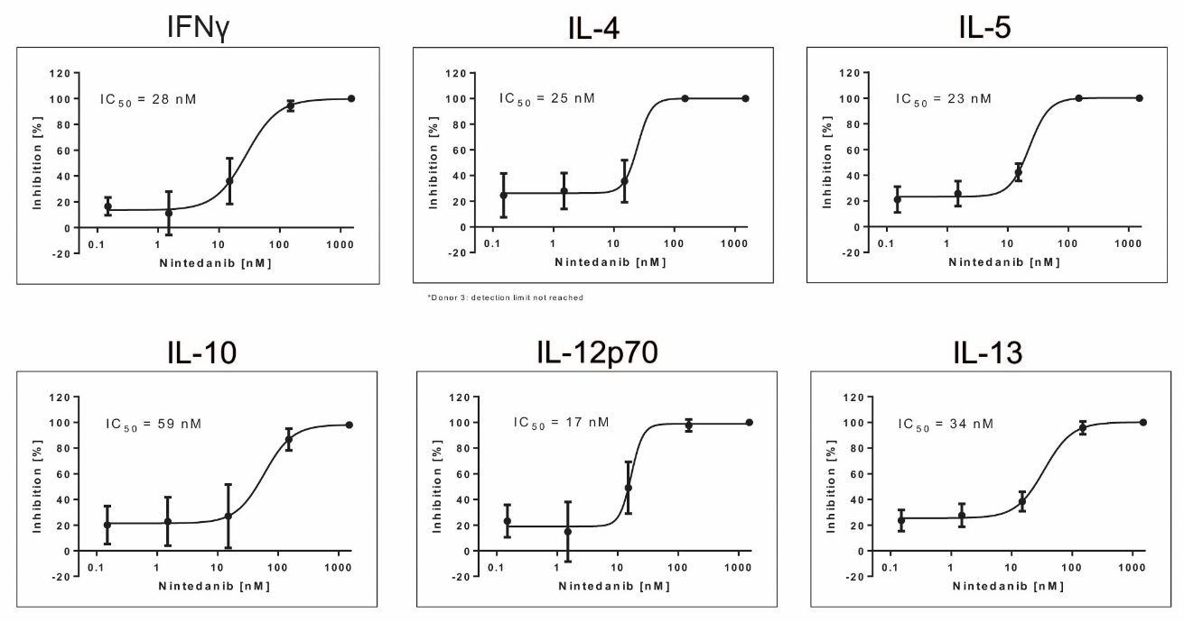

Cytokines were determined in the cell culture supernatants from primary PBMCs from healthy donors pre-treated for 20 min with nintedanib and stimulated for 24 hours with anti-CD3. All data are presented as mean ± SD of n = 4 donors, except the IL-4 curve with only n = 3 donors because the detection limit was not reached with the cells from one donor.
IC₅₀: half-maximal inhibitory concentration; IFN-γ: interferon-gamma; IL: interleukin; PBMC: peripheral blood mononuclear cell; SD: standard deviation.
Supplementary Figure 2. Nintedanib blocks the release of anti-CD3/anti-CD28-stimulated IFN-γ, IL-4, IL-5, IL-10, IL12p70 and IL-13 from PBMCs
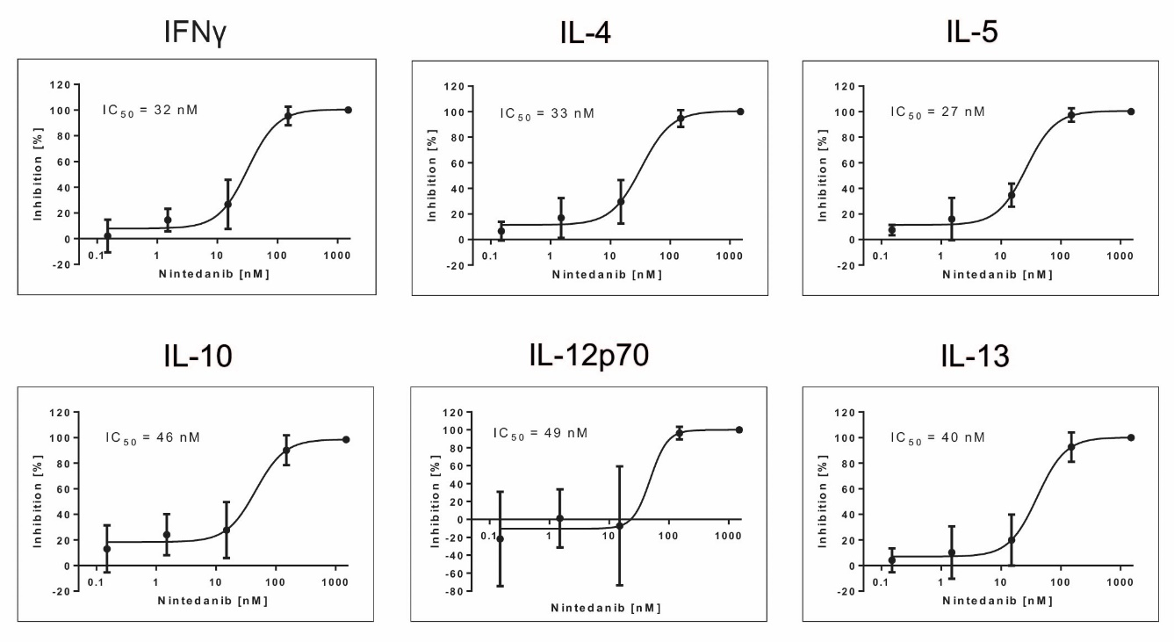
Cytokines were determined in the cell culture supernatants from primary PBMCs from healthy donors pre-treated for 20 min with nintedanib and stimulated for 24 hours with anti-CD3/anti-CD28. All data are presented as mean ± SD of n = 4 donors.
IC₅₀: half-maximal inhibitory concentration; IFN-γ: interferon-gamma; IL: interleukin; PBMC: peripheral blood mononuclear cell; SD: standard deviation.
Supplementary Figure 3. Nintedanib blocks the release of anti-CD3-stimulated IFN-γ, IL-4, IL-5, IL-10, and IL-13 from PBMCs
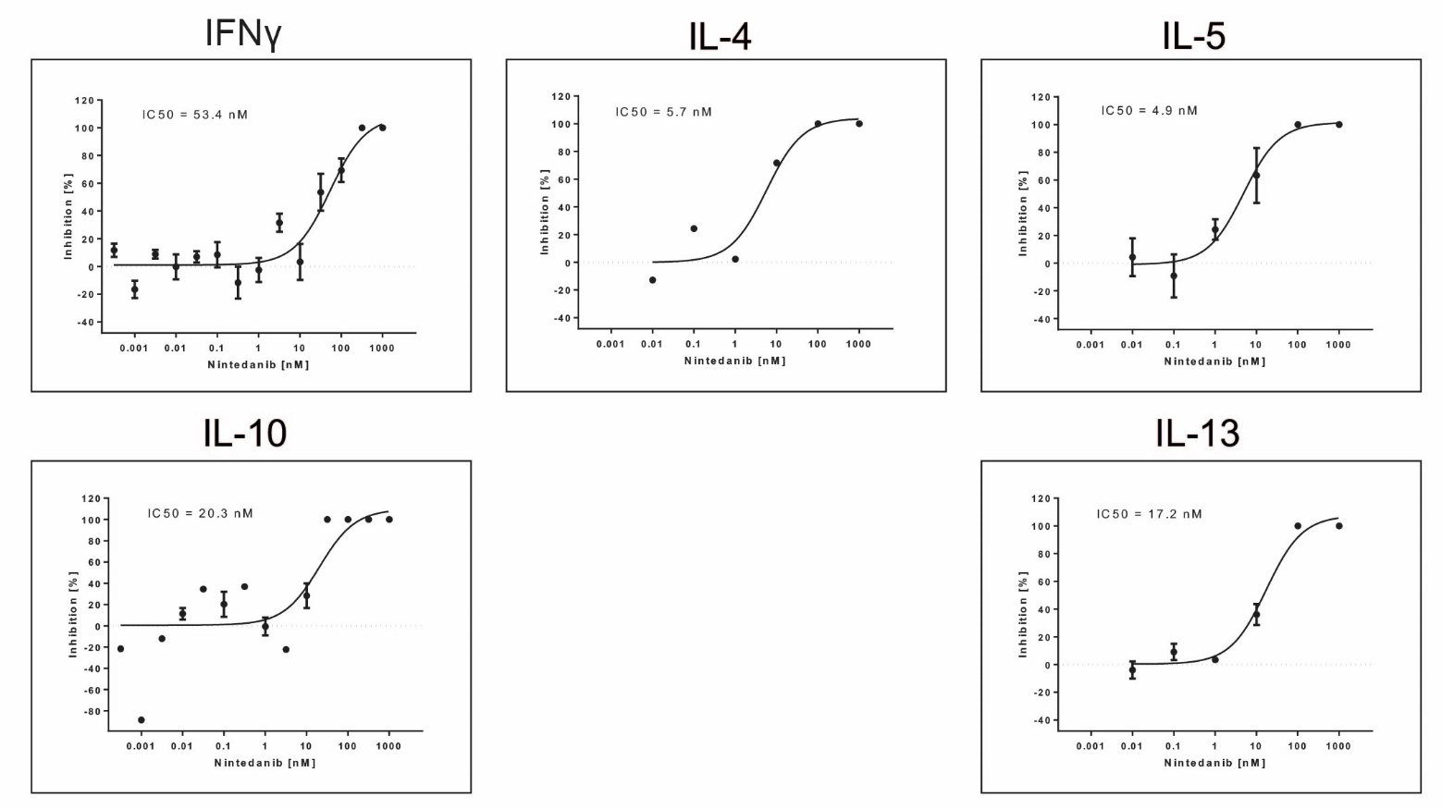
Cytokines were determined in the cell culture supernatants from primary PBMCs from healthy donors pre-treated for 20 min with nintedanib and stimulated for 24 hours with anti-CD3. All data are presented as mean ± SD. Donors with cytokine levels below detection limit were excluded. Number of donors for IFN-γ = 8, IL-4 = 1, IL-5 = 3, IL-10 = 4, IL-13 = 3
IC₅₀: half-maximal inhibitory concentration; IFN-γ: interferon-gamma; IL: interleukin; PBMC: peripheral blood mononuclear cell; SD: standard deviation.
Supplementary Figure 4. Nintedanib blocks the release of anti-CD3/anti-CD28-stimulated IFN-γ, IL-4, IL-5, IL-10, IL12p70 and IL-13 from T cells
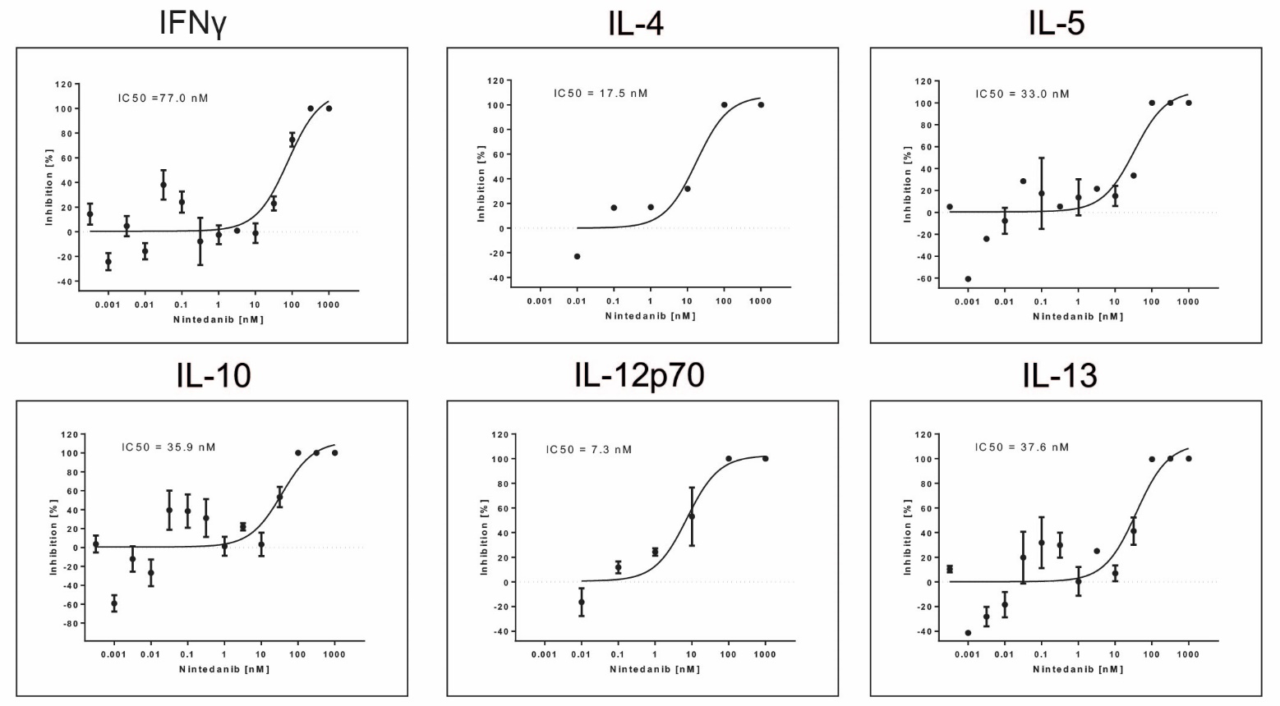
Cytokines were determined in the cell culture supernatants from primary PBMCs from healthy donors pre-treated for 20 min with nintedanib and stimulated for 24 hours with anti-CD3/anti-CD28. All data are presented as mean ± SD. Donors with cytokine levels below detection limit were excluded. Number of donors for IFN-γ = 8, IL-4 = 1, IL-5 = 4, IL-10 = 6, IL12p70 = 3, IL-13 = 5
IC₅₀: half-maximal inhibitory concentration; IFN-γ: interferon-gamma; IL: interleukin; PBMC: peripheral blood mononuclear cell; SD: standard deviation.
Supplementary Figure 5. No change in T-cell proliferation after pretreatment with nintedanib
T cells from blood of healthy donors were isolated and pretreated with different concentrations of nintedanib at 10, 30 and 100 nM for 20 minutes. Then, cells were stimulated with αCD3/αCD28, αIL-4, αIFN-γ and IL-2 and cultured in microtiter plates for 24 hours. Subsequently, BrdU was added and the cells were incubated for 18 hours. BrdU incorporation was determined by measuring the absorbance of the samples in an ELISA reader at 450 nM. n=4–6 donors. Bars represent mean values ± standard error of mean, *P<0.05.
BrdU: bromodeoxyuridine; ELISA: enzyme-linked immunosorbent assay; IFN-γ: interferon-gamma; IL: interleukin.
Supplementary Figure 6. Unchanged CD4+ and CD8+ T-cell number after pretreatment with nintedanib
Flow cytometry analyses of CD4+ and CD8+ T cells in CD3+ T-cell culture from healthy donors pre-treated for 20 min with or without nintedanib at 10, 30 and 100 nM and stimulated for 24 hours with αCD3/αCD28, αIL-4, αIFN-γ and IL-2. (A) FACS dot plots show one representative experiment. Percentage of the total (B) CD4+ and (C) CD8+ T-cell population in total CD3+ T-cell culture (n=4–6). Absolute number of (D) CD4+ and (E) CD8+ T cells. Bars represent mean values ± standard of error mean, *P<0.05.
FACS: fluorescence-activated cell sorting; IFN-γ: interferon-gamma; IL: interleukin.
Supplementary Figure 7. Number of Th1- and Th2-like polarized CD4+ T cells after pretreatment with nintedanib
Flow cytometry analyses of CD4+ T cells in CD3+ T-cell culture from healthy donors pre-treated for 20 min with or without nintedanib at 10, 30 and 100 nM and stimulated for 24 hours with αCD3/αCD28, IL-2 and IL-12 (Th1-like cells) or IL-4 (Th2-like cells) and. (A) Percentage of the total CD4+/IFN-γ+ T cells and (B) CD4+/IL-4+ in total CD3+ T-cell culture (n=4–6). Bars represent mean values ± standard error of mean, *P<0.05.
IFN-γ: interferon-gamma; IL: interleukin.
Supplementary Figure 8. Absolute cell number of Th1- and Th2-like cells after pretreatment with nintedanib and Th17 stimuli
Flow cytometry analyses of CD4+ T cells in CD3+ T-cell culture from healthy donors pre-treated for 20 min with or without nintedanib at 10, 30 and 100 nM and stimulated for 24 hours with αCD3/αCD28, αIL-4, αIFN-γ and IL-2. (A) Absolute number of the total CD4+/IFN-γ+ T cells and (B) CD4+/IL-4+ T cells in total CD3+ T-cell culture (n=4–6). Bars represent mean values ± standard error of mean, *P<0.05.
IFN-γ: interferon-gamma; IL: interleukin.

