Supplemental material
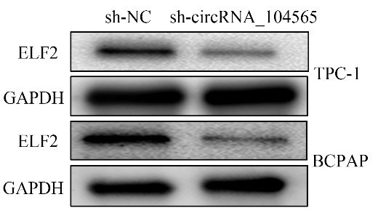
Figure S1. silencing circRNA_104565 suppressed ELF2 expression in PTC cells.

