Supplemental material for:
Evaluating outcomes associated with disease-modifying treatments
for multiple sclerosis in DMT-naïve patients

Corresponding author: Leorah Freeman, MD, PhD [leorah.freeman@austin.utexas.edu]

Figure S1. Index medication.
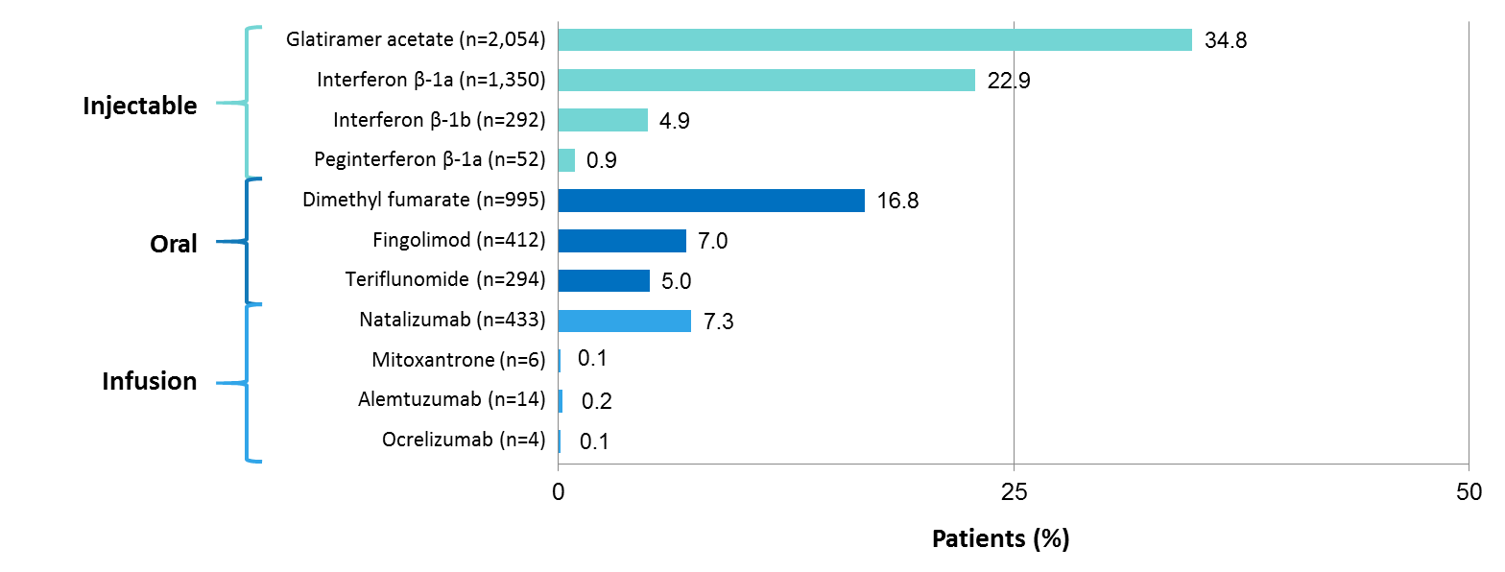

Figure S2. Patient adherence (A) and patient persistence (B) on DMT.
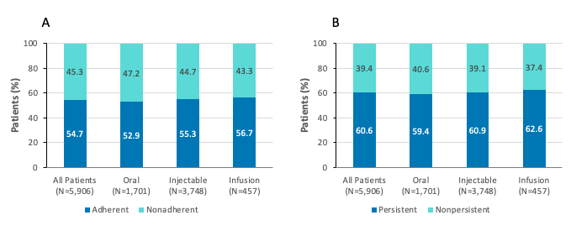
DMT, disease-modifying therapy.
Figure S3. Proportion of patients experiencing relapses in the pre-index and post-index periods.

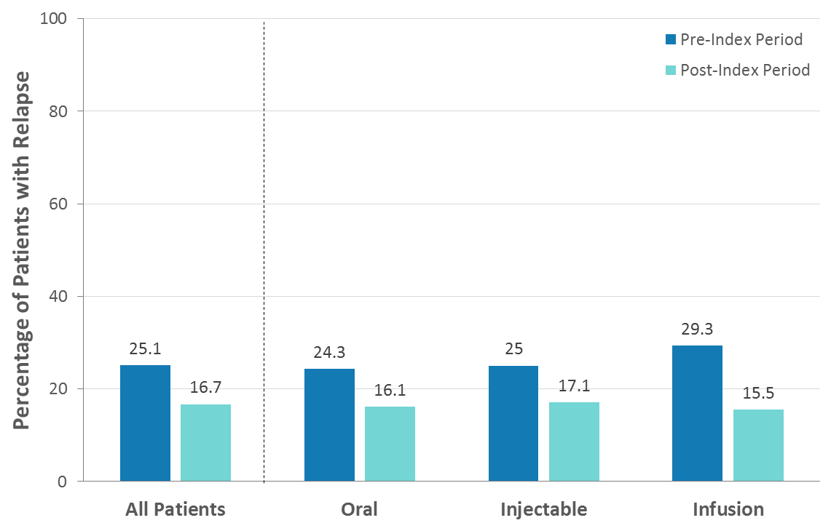

Figure S4. All-cause and MS-related costs in the post-index period.
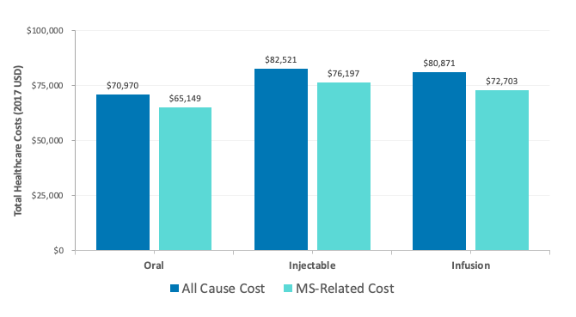
MS, multiple sclerosis.

