Decreasing incidence of alcohol-related liver disease in Denmark: a 25-year nationwide study
Frederik Kraglund, Thomas Deleuran, Gro Askgaard, Kate Fleming, Peter Jepsen

Supplementary material
Supplementary Figure S1: Proportions of different ALD diagnosis by calendar year 1994-2018.
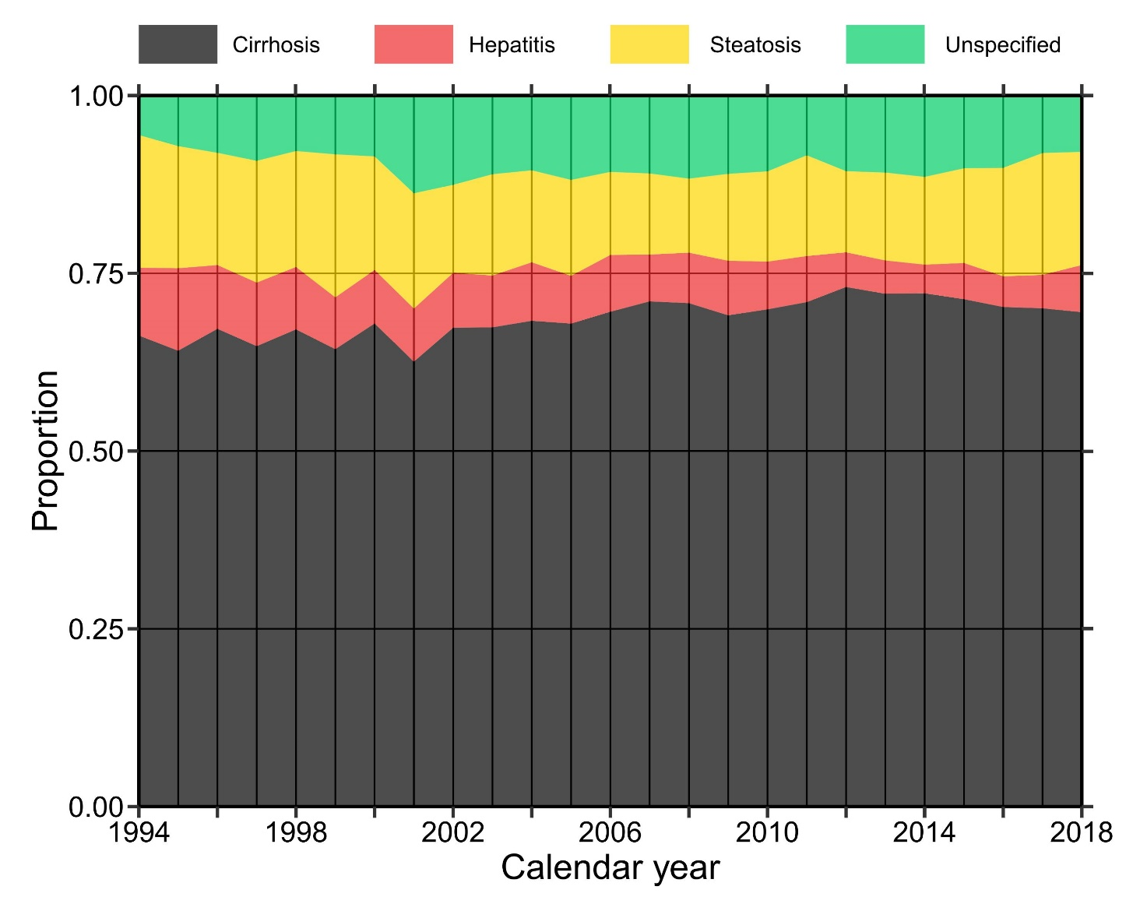

Supplementary Figure S2: Incidence rates of ALD per 1,000,000 Danish population by 5-year age groups from 30 to 79 years (colors) and 5-year birth cohorts from 1930 to 1979 (x-axis).
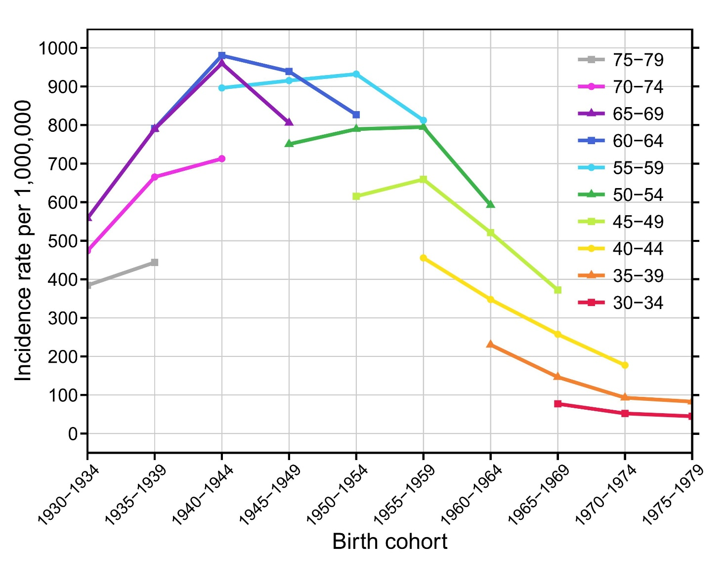
Supplementary Figure S3. Proportions of the different routes of ALD diagnosis by year 1994-2018. The routes of diagnosis are either elective (outpatient clinic or elective admission) or emergent (emergent admission or emergency room).
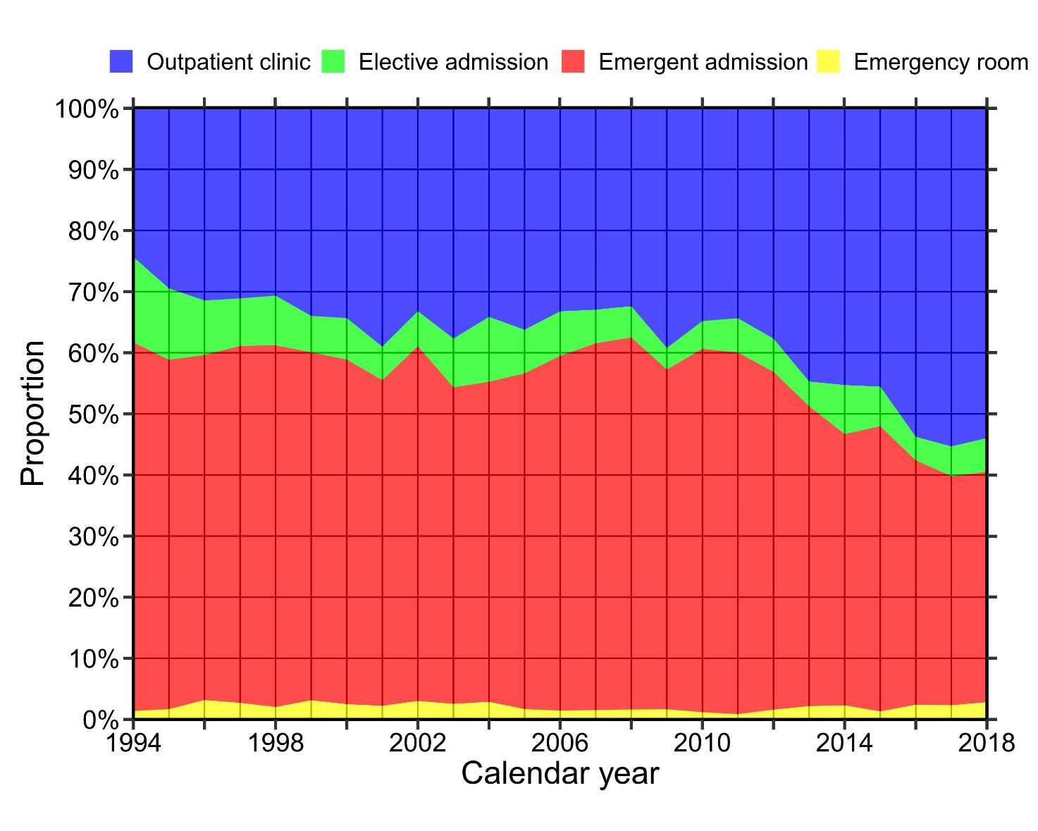

Supplementary Figure S4. Kaplan-Meier estimates of crude mortality from first ALD diagnosis stratified by ALD diagnosis.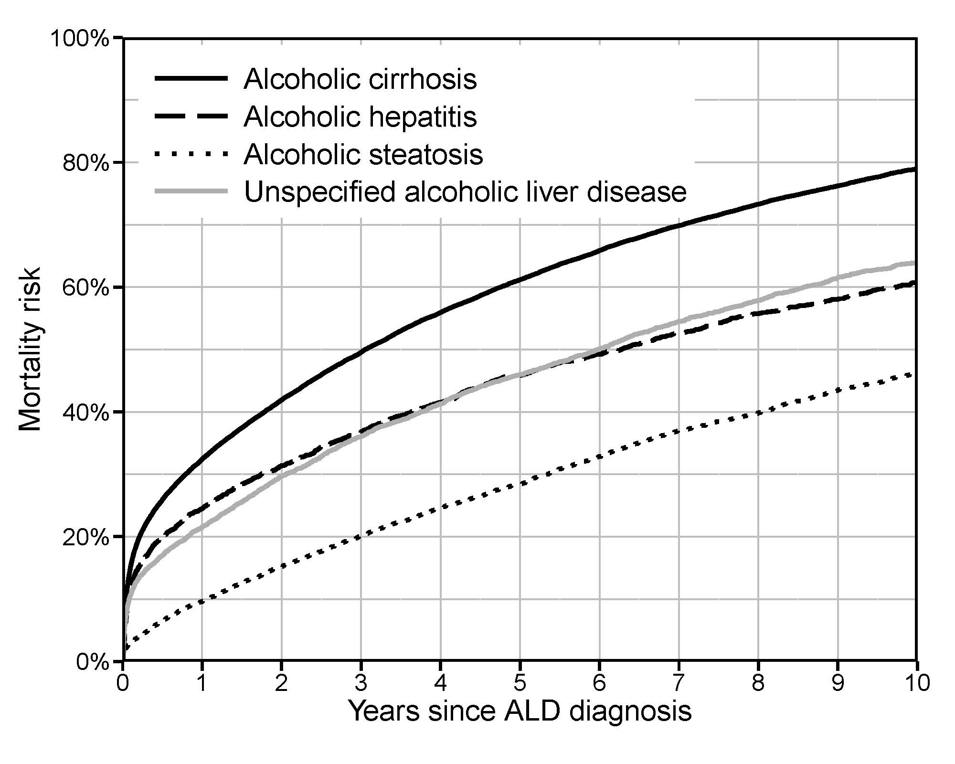

Supplementary Fig. S5. Sex-, age-, and ALD diagnosis-standardized 1-year mortality, overall and by route of diagnosis 1994-2018.
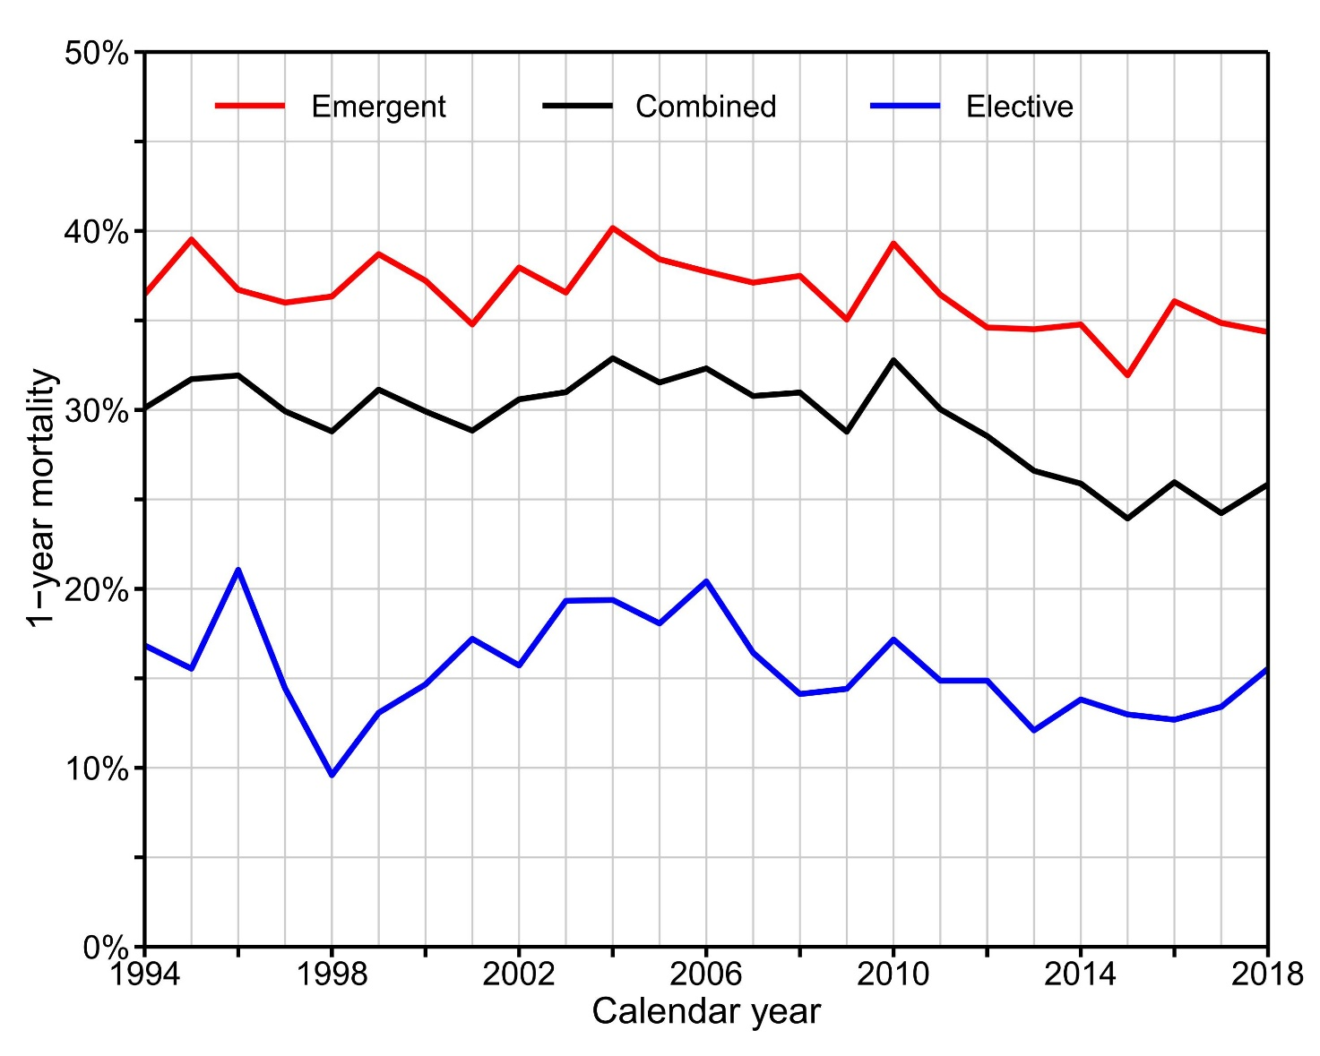
Supplementary Figure S6. Proportions of participants in the Danish National Health Surveys who exceed the high-risk threshold of 252/168 grams of pure alcohol per week (for men/women) defined by the Danish Health Authority by sex (left) and age group (right). Data source: the Danish National Health Survey (database online, last accessed 20 October 2020).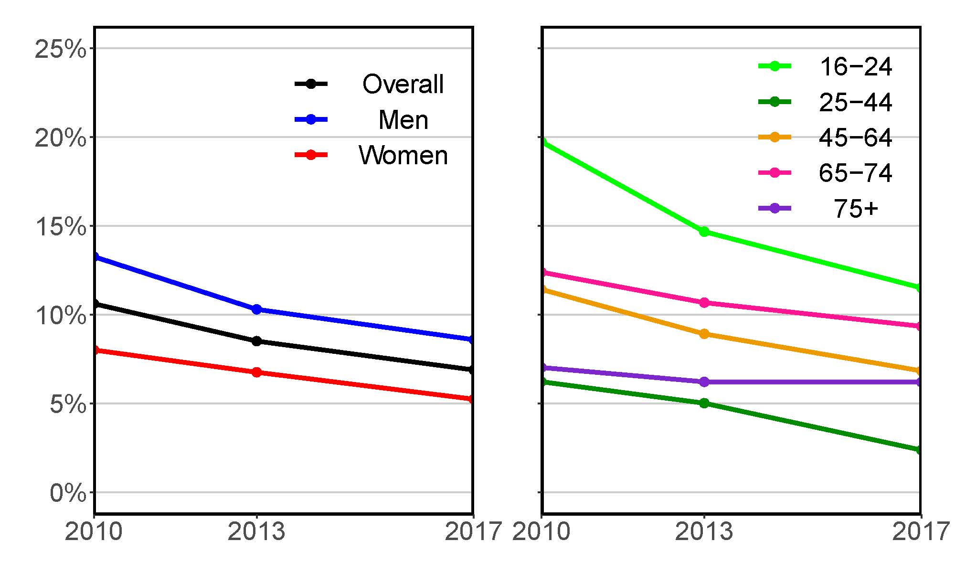

Supplementary tables
Supplementary Table S1. The Danish population on 1 January 2018 by sex and 5-year age groups.
 | Men | Women | Overall
Age in years
Overall | 2,876,473 | 2,904,717 | 5,781,190
0-4 | 154,359 | 146,439 | 300,798
5-9 | 165,691 | 156,990 | 322,681
10-14 | 172,571 | 164,520 | 337,091
15-19 | 177,279 | 168,701 | 345,980
20-24 | 199,939 | 191,633 | 391,572
25-29 | 197,346 | 189,431 | 386,777
30-34 | 172,227 | 165,430 | 337,657
35-39 | 170,855 | 168,153 | 339,008
40-44 | 189,519 | 188,736 | 378,255
45-49 | 196,926 | 194,163 | 391,089
50-54 | 214,363 | 210,648 | 425,011
55-59 | 183,854 | 183,759 | 367,613
60-64 | 169,081 | 172,514 | 341,595
65-69 | 158,023 | 165,605 | 323,628
70-74 | 156,330 | 167,763 | 324,093
75-79 | 98,169 | 113,479 | 211,648
80-84 | 58,646 | 77,280 | 135,926
85-89 | 28,903 | 47,225 | 76,128
90-94 | 10,280 | 24,311 | 34,591
95-99 | 1958 | 6998 | 8956
100-104 | 147 | 891 | 1038
105 + | 7 | 48 | 55

Supplementary Table S2. The distribution of sex, age groups, and diagnoses among the patient population who received an ALD diagnosis in 2013.
 | Alcoholic cirrhosis | Alcoholic hepatitis | Alcoholic steatosis | Unspecified alcoholic liver disease
Women
15-44 years | 19 | 5 | 8 | 6
45-64 years | 232 | 18 | 44 | 35
65+ years | 133 | 5 | 30 | 23
Men
15-44 years | 48 | 16 | 14 | 8
45-64 years | 525 | 38 | 76 | 83
65+ years | 263 | 10 | 37 | 29

