Supplementary Materials
A Carrier-free Ursolic Acid/Methotrexate Nanodelivery System with Folate Receptor-Targeted for Synergetic Anticancer Therapy
Jin-Shuai Lan^{1,2,}*, Yan-Hong Qin^{2,}*, Li Liu², Rui-Feng Zeng², Yang Yang³, Kai Wang³, Yue Ding^{1,2} , Tong Zhang^{1,2} and Rodney J. Y. Ho⁵

Table S1. Entrapment efficiency (EE %) and loading efficiency (LE %) of UA-MTX NPs
 | UA | MTX
EE% | 96.86% | 91.69%
LE% | 80.79% | 19.21%

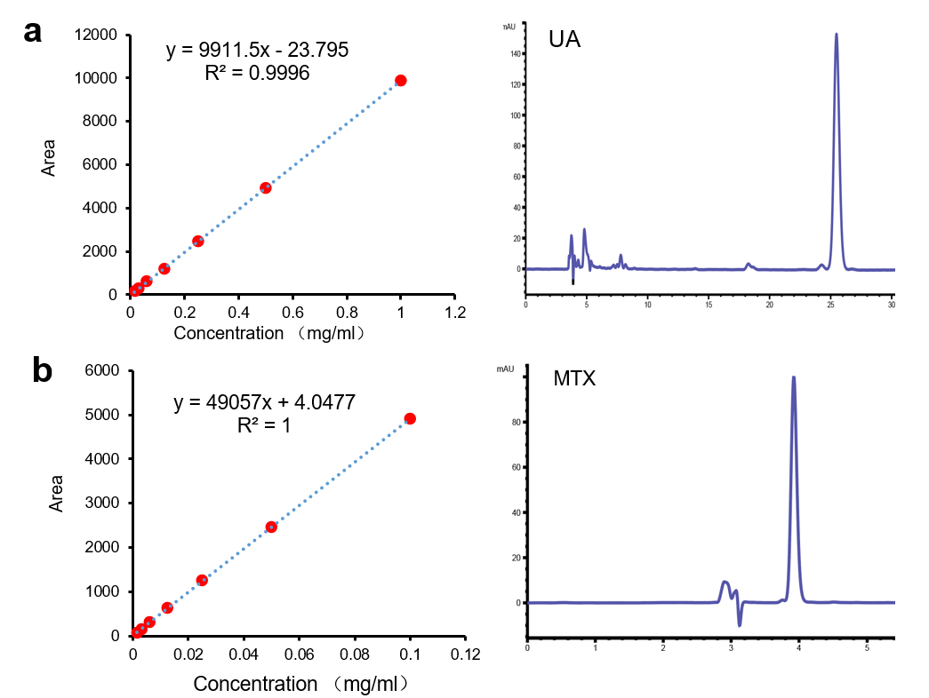
Figure S1. (a) High Performance Liquid Chromatography and standard curve of UA; (b) High Performance Liquid Chromatography and standard curve of MTX.
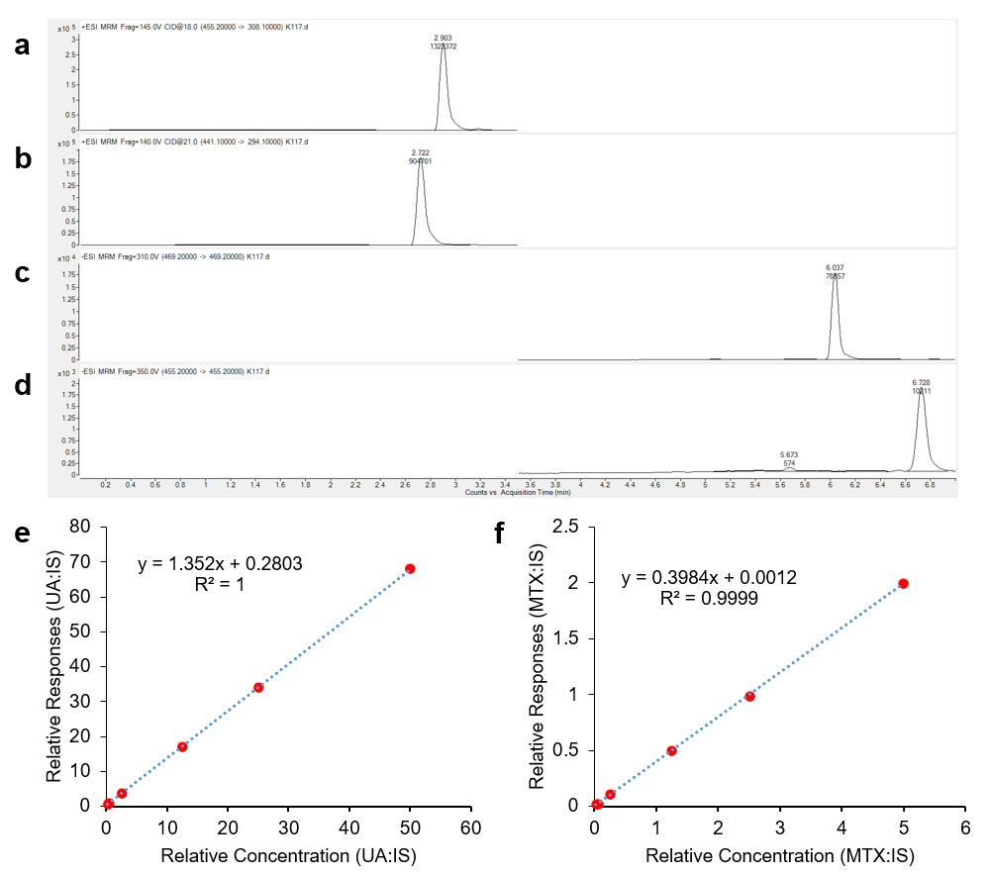
Figure S2. (a) UPLC-MS/MS Chromatography of MTX; (b) UPLC-MS/MS Chromatography of aminopterinum (internal standard, IS); (c) UPLC-MS/MS Chromatography of UA; (d) UPLC-MS/MS Chromatography of enoxolone (internal standard, IS); (e) Standard curve of UA; (f) Standard curve of MTX.

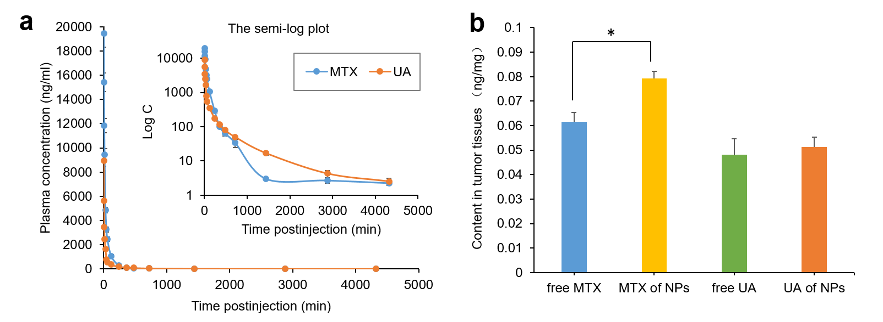
Figure S3. (a) Mean concentration–time curve of MTX and UA in plasma after intravenous injection of MTX-UA NPs in rats (n=5); (b) Mean drug concentration in tumors (n=5). * p < 0.05.

Table S2. Pharmacokinetic parameters of UA-MTX NPs
Parameters | MTX-UA NPs
Parameters | MTX | UA
AUC (mg/L*h) | 40859.49±15821.83 | 17314.17±1179.09
MRT_{0-t} (h) | 1.75±0.40 | 5.41±3.29
t_{1/2}z (h) | 15.60±4.23 | 9.89±7.76
CLz (L/min/kg) | 0.033±0.014 | 0.07±0.005
Vz (L/kg) | 44.44±17.04 | 58.27±45.43
C_{max} (mg/L) | 19.44±6.33 | 8.94±2.69

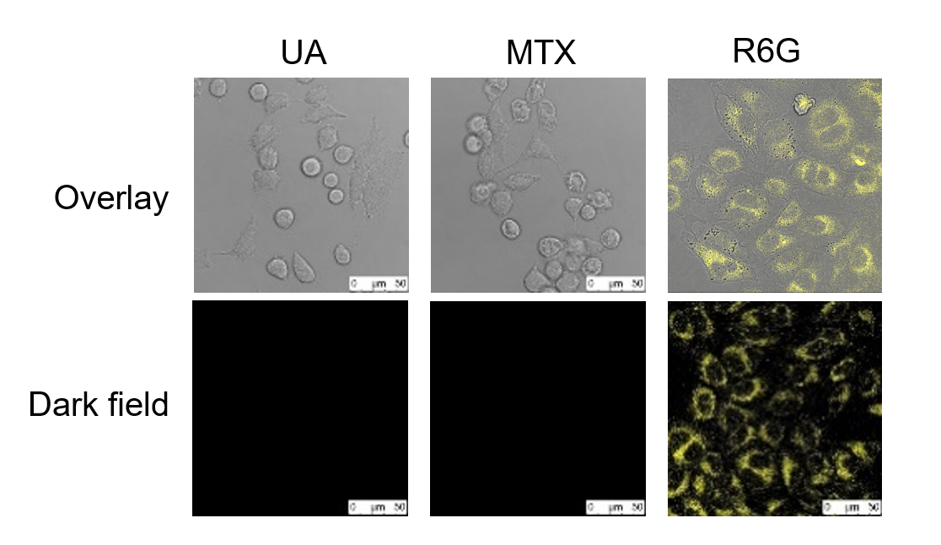
Figure S4. CLSM images of incubation with UA,MTX and Rhodamine 6G.

Table S3. The PDI and Zeta potential of UA-MTX-R6G NPs and UA-R6G NPs
NPs | UAª (mL) | MTX^{b} (mL) | R6G^{c} (mL) | H₂O  (mL) | Size (nm) | PDI
UA-MTX-R6G NPs | 0.4 | 0.5 | 0.05 | 1.5 | 147.9 | 0.169
UA-R6G NPs | 0.4 | 0 | 0.05 | 2 | 148.6 | 0.174
a The concentration of UA is 5 mM.
b The concentration of MTX is 1 mM.
c The concentration of R6G is 0.5 mM.

