Supplemental Table 1 Genetic (G) and environmental (E) factors 2*4 fork analysis.
Gª | E^{b} | Case | Control | OR (95%CI); P-value | Reflecting information
AA vs. GG | Smoking
+ | + | 7 | 5 | 1.74(0.54, 5.57); 0.347 | G, E combined effect
+ | - | 11 | 7 | 1.95(0.74, 5.14); 0.170 | G alone effect
- | + | 66 | 93 | 0.88(0.61, 1.28); 0.508 | E alone effect
- | - | 166 | 206 | 1.00 (reference) | Common control
GA vs. GG | Smoking
+ | + | 60 | 47 | 1.58(1.03, 2.44); 0.037 | G, E combined effect
+ | - | 69 | 74 | 1.16(0.79, 1.70); 0.459 | G alone effect
- | + | 66 | 93 | 0.88(0.61, 1.28); 0.508 | E alone effect
- | - | 166 | 206 | 1.00 (reference) | Common control
AA vs. GG | Drinking
+ | + | 9 | 6 | 2.00(0.69, 5.75); 0.193 | G, E combined effect
+ | - | 9 | 6 | 2.00(0.69, 5.75); 0.193 | G alone effect
- | + | 102 | 126 | 1.08(0.76, 1.52); 0.673 | E alone effect
- | - | 130 | 173 | 1.00 (reference) | Common control
GA vs. GG | Drinking
+ | + | 51 | 41 | 1.66(1.04, 2.65); 0.035 | G, E combined effect
+ | - | 78 | 80 | 1.30(0.88, 1.91); 0.186 | G alone effect
- | + | 102 | 126 | 1.08(0.76, 1.52); 0.673 | E alone effect
- | - | 130 | 173 | 1.00 (reference) | Common control
ª G (+): TIMD-4 rs7700994 variants (Heterozygous or homozygous); G (-): wild type
^{b} E (+): smoking/drinking; E (-): non-smoking/non-drinking
Bold values are statistically significant (P < 0.05).

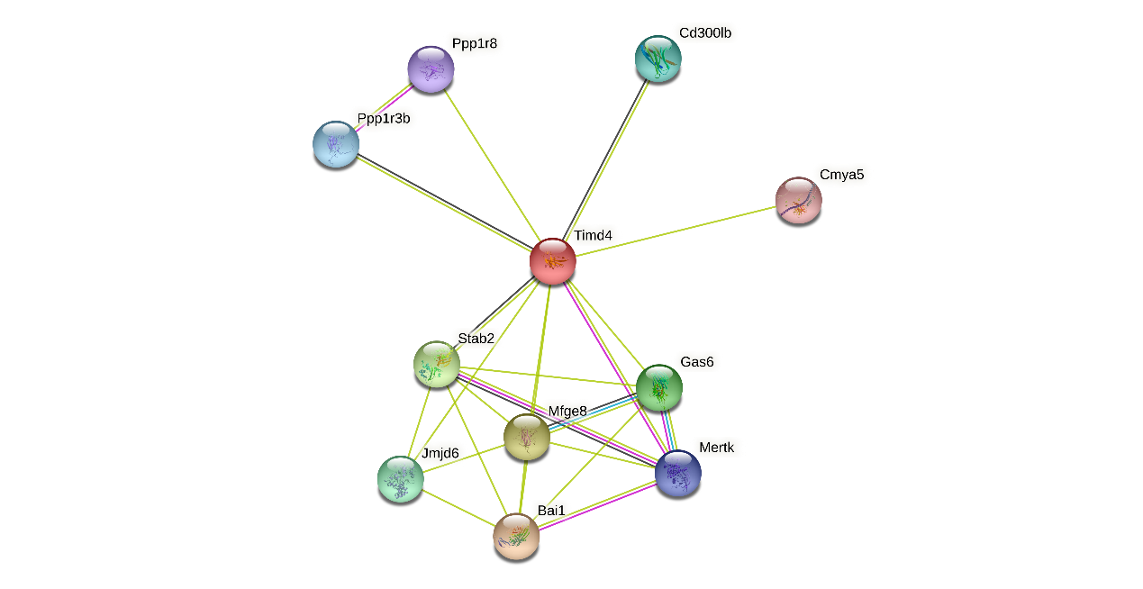

Supplemental figure 1. TIMD-4 interactions with other genes obtained from the String server. The following genes participate in gene-gene interactions: BAI-1, Adhesion G protein-coupled receptor B1; MFGE8, Lactadherin; STAB2, Stabilin-2; GAS6, Growth arrest-specific protein 6; JMJD6, Bifunctional arginine demethylase and lysylhydroxylase JMJD6; CD300LB, CMRF35-like molecule 7; PPP1R3B, Protein phosphatase 1 regulatory subunit 3B; MERTK, Tyrosine-protein kinase Mer; PPP1R8, Nuclear inhibitor of protein phosphatase 1; CMYA5, Cardiomyopathy-associated protein 5.

