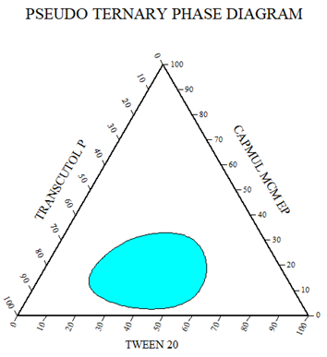
Figure S1: Pseudo ternary phase diagram

b
a
c
Figure S2: Various 3-D response plots for response (a) globule size, (b) % CDR and (c) self-emulsification time.

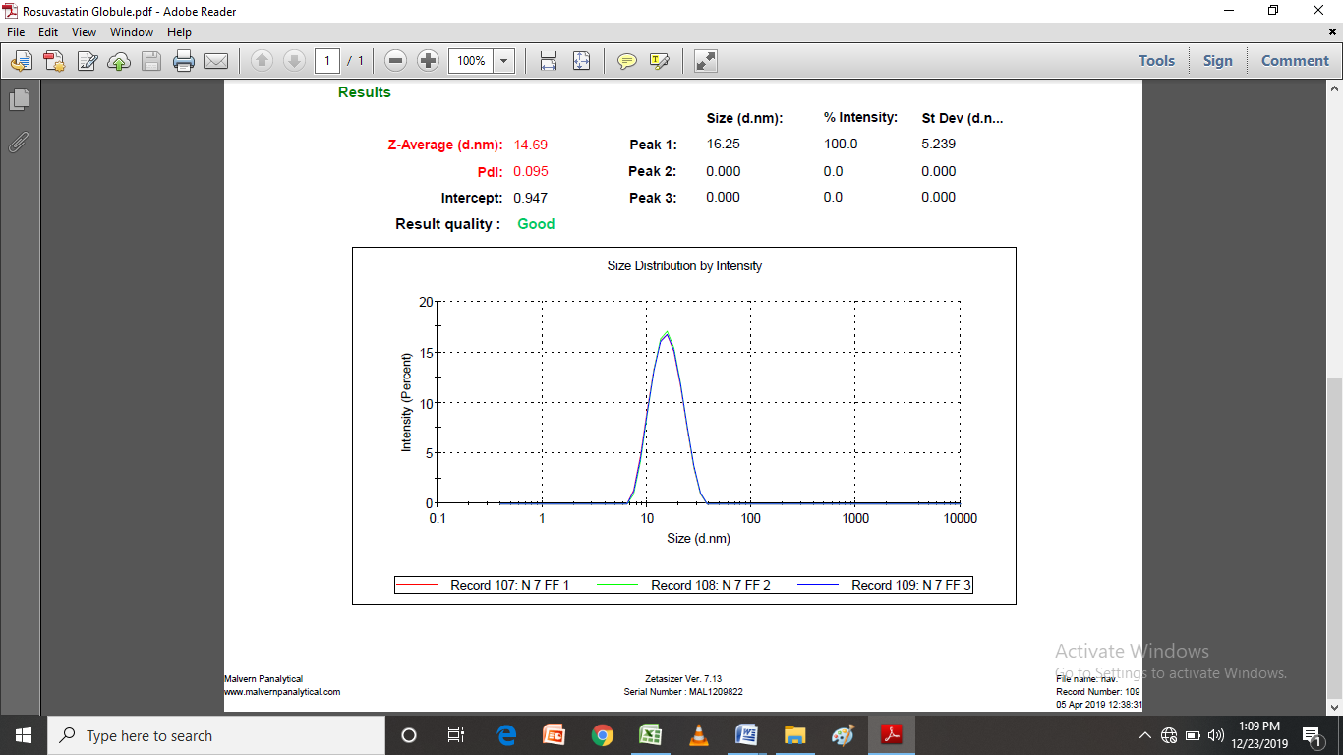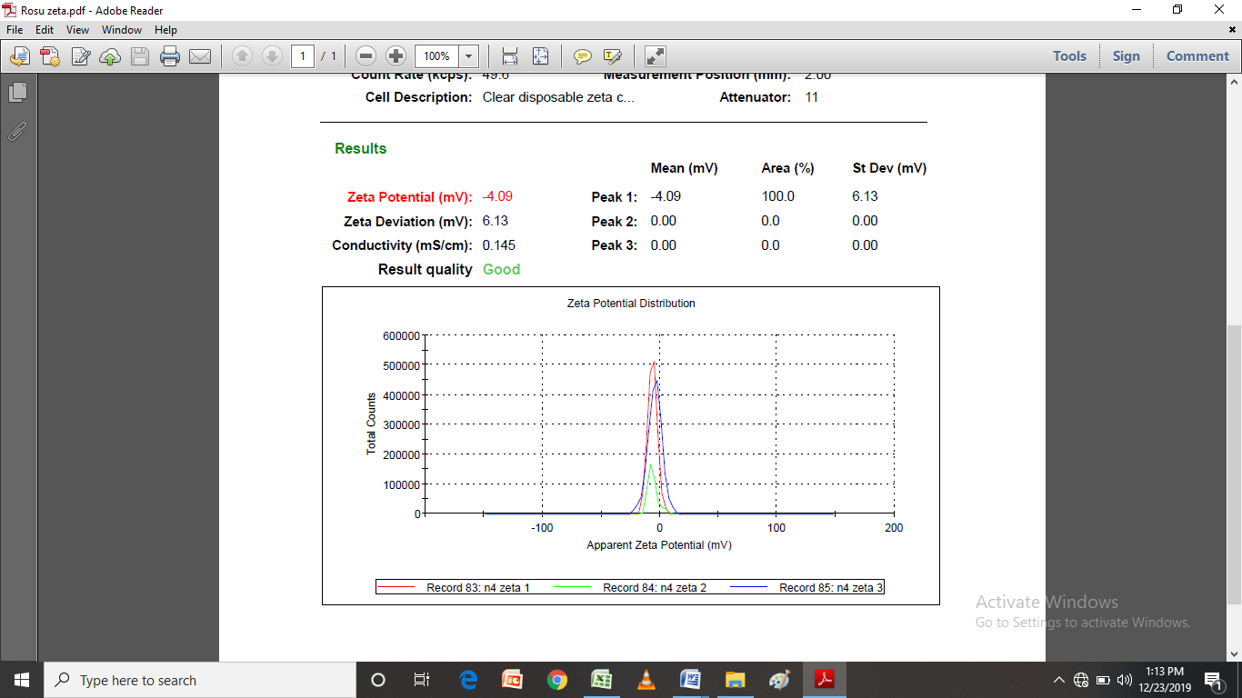
b
a
Figure S3: (a) Globule size and PDI, (b) Zeta potential of optimized formulation.

Table S1: Solubility of Rosuvastatin in various dissolution media (n=3)
S. No. | Dissolution media | Solubility (μg/ml)
1. | pH 1.2 buffer | 19.5±1.1
2. | pH 4.5 Acetate buffer | 25.5±1.2
3. | pH 6.6±0.05 citrate buffer solution | 268±1.3

Equation corresponding to the D-optimal design
The coded equation of significant model for globular size:
-3402.56X₁-757.22X₂-198.23X₃+9816.58X₁X₂+7732.17X₁X₃ +2149.20 X₂X₃-16262.51X₁X₂X₃ +5671.68X₁X₂(X₁-X₂)+1226.25X₁X₃(X₁X₃) +1718.78 X₂X₃(X₂-X₃) Equation S1
%CDR:
+1483.43X₁-9.53X₂+208.13X₃-2433.37X₁X₂-2442.75X₁X₃-5.15 X₂X₃+2150.41X₁X₂X₃-1848.08X₁X₂(X₁-X₂)-465.9 X₁X₃(X₁-X₃)+337.53 X₂X₃(X₂-X₃) Equation S2
Self-emulsification time:
+2.90X₁-89.10X₂-174.39X₃+454.33X₁X₂+1013.00X₁X₃+577.45X₂X₃-3134.66X₁X₂X₃-833.87X₁X₂(X₁-X₂)-130.11 X₁X₃(X₁-X₃)-272.52X₂X₃(X₂-X₃) Equation S3
Where
X₁= Concentration of Capmul MCM EP, X₂= Concentration of Tween 20, and X₃= Concentration of Transcutol.

