Table S1. Some properties of the fabricated silver nanoparticles.
Parameters | AgNPs
Parameters | AgNP10 | AgNP20 | AgNP75
Maximum of optical density, nm | 400 | 410 | 413
Silver concentration, mM | 7.1 | 6.9 | 7.4
Apparent molar extinction coefficient, L/mol*cm | 10200 | 8900 | 9840
Size, nm | 8-12 | 18-20 | 71-84
Shape | Spherical | Spherical | Spherical
Dissolved Ag ions | <1% | <1% | <1%

Table S2. Comparative biocidal activity of AgNPs.
AgNPs | E. coli К802 treated with 20 µM AgNPs for 3 h; CFU/mL
AgNPs | Control cell culture | Treated cell culture (survival, %)
AgNP10 | 10⁸ | 5×10^{4*}  (0,05%)
AgNP20 | 10⁸ | 5×10^{5*}  (0,5%)
AgNP75 | 10⁸ | 5×10^{6*}  (5%)
* relative uncertainty is about 10%

Table S3. Body weight, and ALT and AST levels in blood serum of mice after AgNPs treatment.
Group of the mice | Body weight, g | Enzyme concentration, U/L
Group of the mice | Body weight, g | ALT | AST
Control | 25.7 ± 0.9 | 41.2 ± 18.3 | 38.9 ± 9.8
Treated with AgNP10 | 26.3 ±0.7 | 43.2 ± 21.2 | 46.3 ± 13.9
Treated with AgNP20 | 24.9 ± 1.1 | 26.4 ± 7.4 | 48.7 ± 16.7
Treated with AgNP75 | 25.7 ± 1.3 | 30.3 ± 15.1 | 36.5 ± 17.9

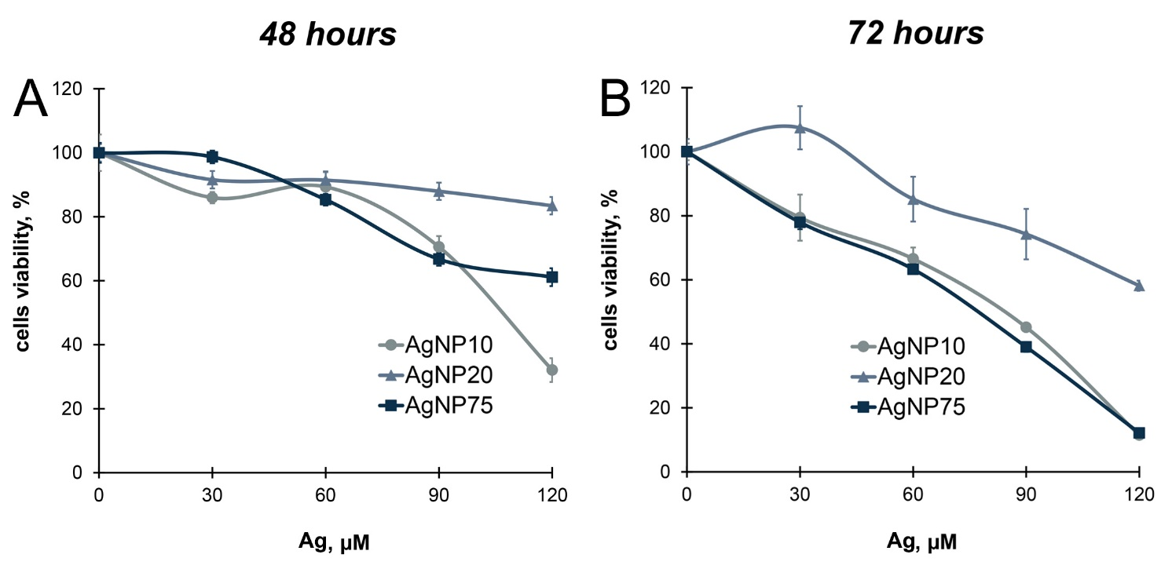

Figure S1. Survival of A549 cells during the incubation with various concentrations of AgNPs for 48 (A) and 72 (B) hours. AgNPs of all the sizes showed little or no cytotoxicity during the first 48 hours at silver concentrations below 60 μM. At higher concentrations (120 μM) AgNP10 demonstrated more pronounced cytotoxic properties, while AgNP20 were generally the least cytotoxic. When the time of exposure was extended to 72 hours, cytotoxic effect of AgNP10 and AgNP75 was notably enhanced. This was observed already at a silver concentration of 30 μM and grew with an increase of AgNP’ concentration. Again, AgNP20 displayed the weakest cytotoxicity. More than half of the cells exposed to 120 μM of AgNP20 for 72 hours were still viable. The data showed that the toxicity of the tested AgNPs to the cultured lung epithelial cells was dose and time-dependent for the nanoparticles of the same size. However, no correlation between AgNP’s size and their toxicity was observed. Perhaps, the value of these cell culture experiments is limited because in vivo interaction between cells and AgNPs occurs in a microenvironment, which is not readily reproducible in vitro by artificial cell culture media.

