Supplementary Information

Graphene oxide theranostic effect: conjugation of phothermal and photodynamic therapies based in an in vivo demonstration

María Paulina Romero, Hilde Harb Buzzá, Mirian Denise Stringasci, Bianca Estevão, Cecília de Carvalho Castro e Silva, Marcelo A. Pereira-da-Silva, Natalia Mayumi Inada and Vanderlei Salvador Bagnato
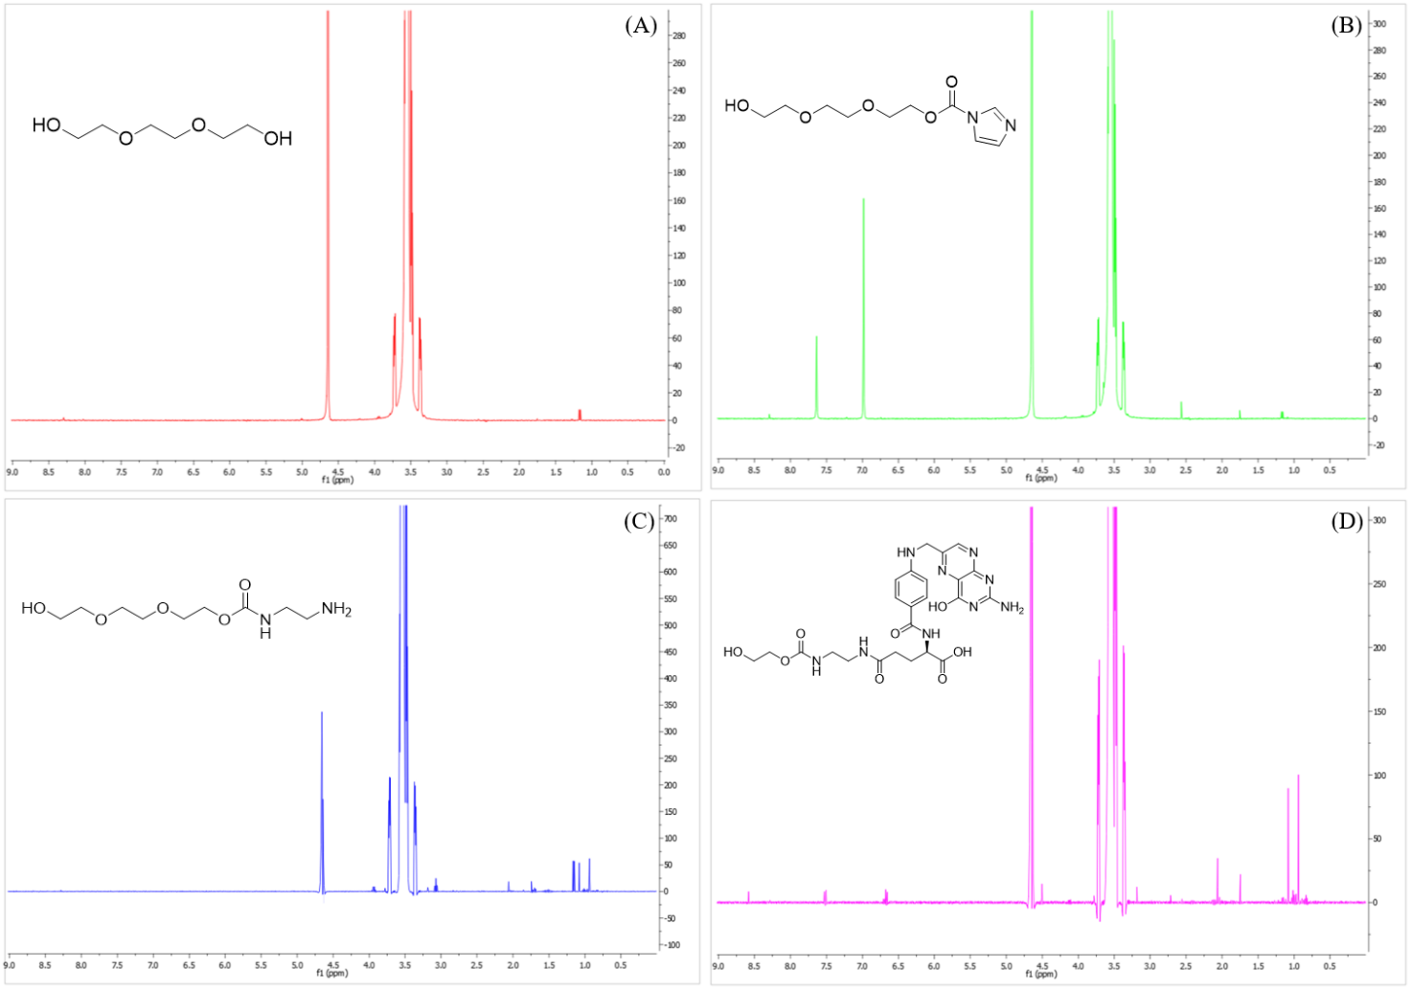
Figure S1. 1 H NMR Spectra of (A) PEG, (B) PEG-CDI, (C) PEG-NH₂ and PEG-FA. All carried out with 600 μL of D2O.

Figure S2. FTIR spectra of PEG, PEG-CDI, PEG-NH2 and PEG-FA. All samples were run in KBr pellet.

Figure S3. FTIR spectra of GO, GO-RhodB, GO-PEGFA-RhodB and GO-PEGFA-IcG. All samples were run in KBr pellet and performed at the same concentration.
Figure S4. Hydrodynamic diameter obtained from DLS measurements.

