Acidic Monetite Complex Paste for In-depth Occlusion of Dentinal Tubules with Bleaching Property
Bolin Liª, Chunyan Liu^{a,c}, Ze-hui Fang^{b}, Ying Cao^{b}, Zheng Zhou, ^{c} * Haiyan Luª *
^{a．}College ＆ Hospital of Stomatology, Hebei Medical University, Shijiazhuang , 050017, China
^{b．}College ＆ Hospital of Stomatology, Anhui Medical University, Hefei, 230032, China
^{C.} School of Dentistry, University of Detroit Mercy, Detroit, Michigan, USA 48208

* Corresponding Author
Zheng Zhou
Job title: Associate professor,
Email: zhouzh1@udmercy.edu

Tel: (+) ：1-313-494-6667
Fax :(+) ：1-313-494-6666
Address: 2700 Martin Luther King Jr. Blvd, Detroit, Michigan, USA 48208

Haiyan Lu

E-mail: luhaiyan67@163.com

Job title: professor

Tel: (+) ：0311-86265748

Fax :(+) ：0311-86265748

Address: 383 Zhongshan East Road Shijiazhuang Hebei China 050017

Supporting information
1. Statement of ethical agreement
All the following experimental methods and protocols on humans and/or the use of human tissue samples were carried out in accordance with relevant guidelines and regulations, and were approved by the Independent Ethics Committee of the Hospital of Stomatology affiliated to Hebei Medical University (document No. [2019]030).
The informed consents were obtained from all subjects/participants or their legal guardians according above ethic document No. [2019]030.
2. The mineralizing complex paste inducing enamel mineralization
The same protocol was carried out as the main manuscript described, namely the followings.
2.1 Enamel Slice Preparation
Sound human third molars were collected from patients requiring extraction with informed consent. The teeth were stored at 4 °C in 0.9% NaCl plus 0.1% thymol solution (pH 7.0) prior to processing. Tooth crowns containing enamel and dentin were cut perpendicular to the longitudinal axis of each tooth using a low-speed diamond saw (IsoMet Low Speed Saw, Buehler, Lake Bluff, IL, USA) and cooled with water to reach a thickness of 1.5 mm. The tooth slice surface was mirror-polished using 600–2000 mesh sandpapers, and the tooth specimens were ultrasonically cleaned with acetone, ethanol and deionised water (5 min each for three times). Each tooth slice was split into two parts. One part was used for experimental treatment, and the other was used as a baseline control for comparison. All specimens were stored in distilled water until used for the experiment to avoid dehydration.
2.2 Mineralization Protocol
The tooth slices were treated with 37% H₃PO₄ for 20 s. The tooth slices were rinsed thrice with deionized water using ultrasound after acid etching and were placed in a sealed 24-well culture plate. Each specimen surface was covered with a certain amount of the synthesized complex paste and co-cultured at 37 °C. After 8 h of co-culturing, half of the specimens were removed and ultrasonically cleaned with deionized water (thrice for 5 min each) until the water cleared. Afterward, they were dried with absorbent paper for evaluation. The rest were subjected to continuous co-culturing for 24 h, after which the samples were treated in the same manner as above for subsequent evaluation.
Samples of each group after mineralizing were used for SEM observation. The fractography and surface morphology features of the dental slices were examined through SEM after the specimens were dried and sputter-coated with gold.
2.3 Results
The enamel surface showed a fish-scale-like structure after acid etching. Enamel prisms characterised by parallel bundles of hydroxyapatite crystals were easily detected (Figure S1).
Figure S1. SEM micrographs of the enamel surface after acid-etching
Figure S2 shows the experimental group after mineralizing for 8 and 24 h. Crystals precipitated on the enamel surface in the experimental group, making the enamel prism difficult to identify after treating for 8 h (Figures S2 a and b). After treating for 24 h, the enamel surface was fully covered by a dense and thick layer of precipitates, and the original structure of the enamel could not be observed (Figure S2 c). On the superficial layer of the precipitate, the crystals were less oriented, and their morphology was similar to that of the bleaching gel (Figures S2 c and e). By contrast, in the deep layer of the precipitate, the crystals were oriented and well developed (Figures S2 d, f and h), and their morphology was also different from that of the superficial layers (Figures S2 e). The transverse section of experimental samples after 24 h treating showed that the precipitated crystals were densely packed and tightly bundled together. In addition, the orientation of the precipitated crystals was almost perpendicular to the surface of the underlying natural enamel (Figures S2 g and h). A seamless interface, which showed a tight agglomeration and fusion, was observed between the new-formed crystal layer and the underlying enamel (Figure S2 h). This finding suggested that the precipitates on the enamel surface were not the residual paste substances remained after treatment and the mineralizing complex paste had induced the enamel surface to remineralize.
In conclusion, the mineralizing complex paste is effective for enamel remineralizing
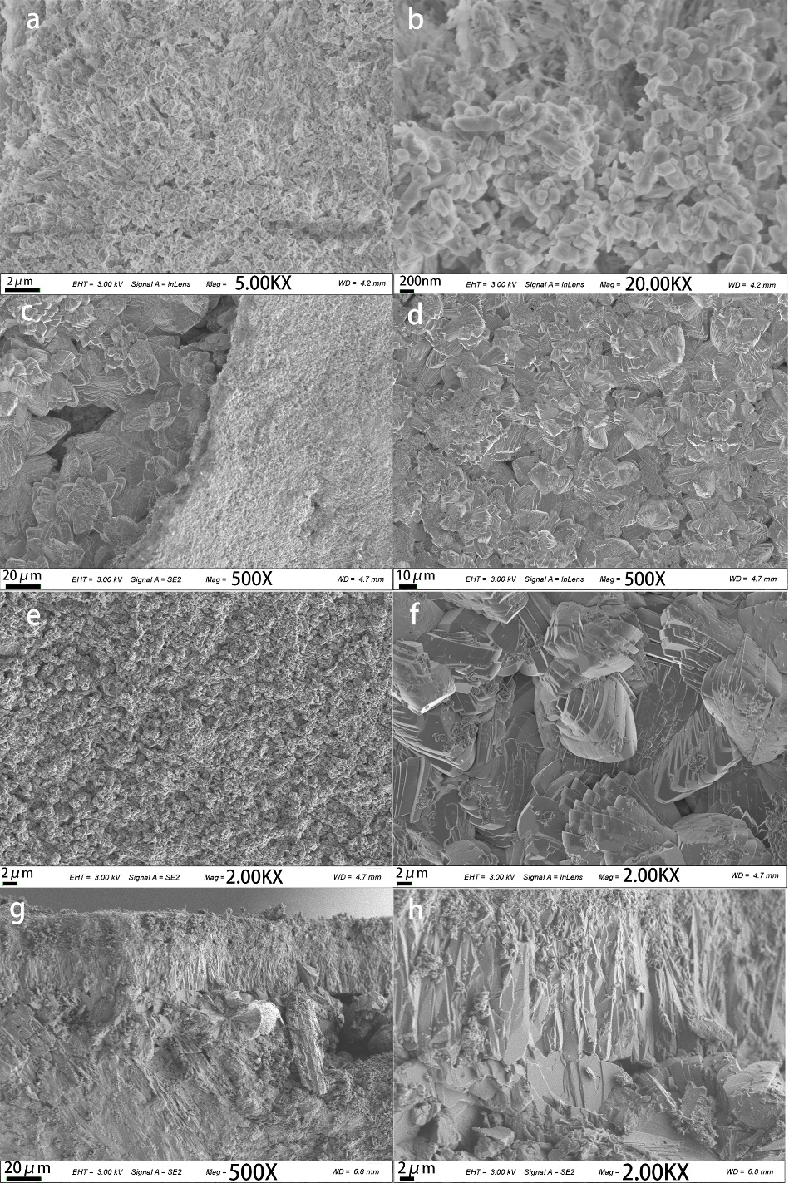
Figure S2. SEM micrographs of the enamel surface of the experimental group after treating for 8 (a and b) and 24h (c–h). Panel c shows the deep layer structure of the precipitate where a part of the superficial layer is exfoliated. Panel d shows the deep layer structure of the precipitate of panel c. Panel e is a magnified view of c, showing the superficial layer structure of the precipitate. Panel f is a magnified view of d. Panels g and h are the transverse section view, and panel h is a magnified view of panel g.

