Supplementary information
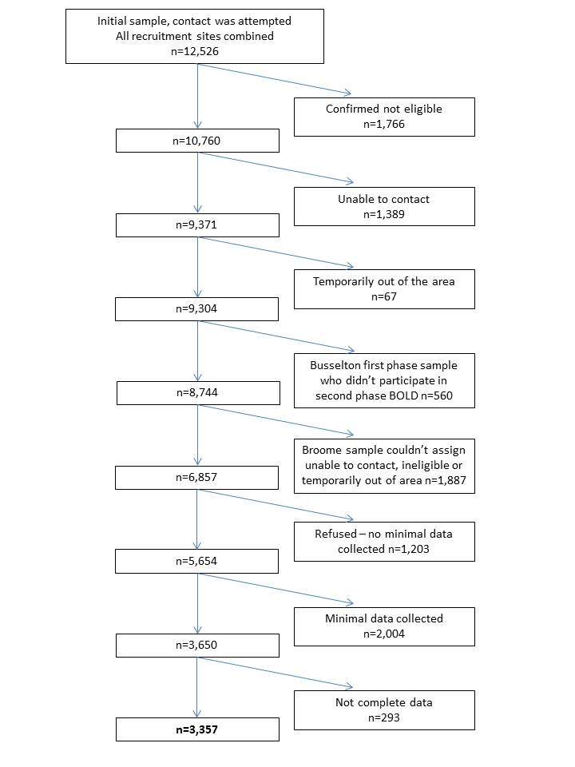
Figure S1: Flowchart of inclusion and exclusion criteria.

S1: Description of variables based on questions from BOLD core questionnaire.
Smoking Status:
Have you ever smoked cigarettes?
How old were you when you first started regular cigarette smoking?
If you have stopped smoking, how old were you when you last stopped?
On average over the entire time that you smoke(d), about how many cigarettes per day do (did) you smoke?
Occupational Exposure:
Have you ever worked for a year or more in a dusty job?
For how many years have you worked in dusty jobs?
Symptoms: based on presence or absence of symptom(s)
Cough
Do you cough on most days for as much as three months each year?
Phlegm
Do you bring up phlegm on most days for as much as three months each year?
Wheezing/whistling
Have you had wheezing or whistling in your chest at any time in the last 12 months?
SOB
Are you troubled by shortness of breath when hurrying on the level or walking up a slight hill?
Exacerbation risk:
Have you ever had a period when you had breathing problems that got so bad that they interfered with your usual daily activities?
For how many of these episodes did you need to see a doctor in the past 12 months?
For how many of these episodes did you get hospitalized in the past 12 months?
Self-reported clinical diagnosis of COPD:
Has a doctor or other health care provider ever told you that you have emphysema?
Has a doctor or other health care provider ever told you that you have chronic bronchitis?
Has a doctor or other health care provider ever told you that you have COPD?

Table S1: Comparison of participant characteristics between recruitment sites.
Characteristic | Sydney, NSW  (n = 541) | Rural NSW  (n = 522) | Melbourne, Vic  (n = 599) | Tasmania  (n = 559) | Busselton, WA  (n = 597) | Broome, WA  (n = 539)
Mean age, years (SD) | 58.8 (12.4) | 59.4 (10.2) | 58.9 (11.1) | 59.2 (10.8) | 63.2 (13.4) | 53.5 (9.54)
Gender, male | 2.65 (49.0) | 253 (48.5) | 303 (50.6) | 256 (45.8) | 291 (48.7) | 250 (43.4)
Ever smoked | 275 (50.8) | 230 (44.1) | 284 (47.4) | 299 (53.5) | 302 (50.6) | 359 (66.6)
Post-bronchodilator spirometry ª, mean (SD)  - FEV₁, L  - FEV₁, % predicted (GLI)  - FEV₁/FVC (%) | 2.75 (0.9)  95.5 (17.2)  76.4 (9.0) | 2.86 (0.8)  95.6 (16.4)  78.1 (7.3) | 3.01 (0.8)  99.6 (15.0)  79.3 (7.2) | 2.88 (0.8)  97.5 (16.3)  75.1 (8.8) | 2.82 (0.8)  99.8 (15.5)  75.4 (8.0) | 2.90 (0.8)  94.3 (16.4)  76.8 (8.3)
Respiratory symptoms^{b}  - Chronic cough  - Chronic phlegm  - Wheeze  - SOB | 38 (7.0)  31 (5.7)  137 (25.4)  136 (27.4) | 54 (10.3)  45 (8.6)  153 (29.3)  153 (29.3) | 56 (9.4)  41 (6.8)  169 (28.2)  111 (18.5) | 63 (11.3)  40 (7.2)  189 (33.8)  153 (27.4) | 65 (10.9)  39 (6.5)  137 (23.0)  149 (25.0) | 57 (9.9)  52 (9.7)  192 (35.6)  109 (20.2)
Using inhaler for a respiratory condition^{c} | 88 (16.3) | 144 (27.6) | 112 (18.7) | 105 (18.8) | 112 (18.8) | 97 (18.0)
Co-morbidities  - CVD^{d}  - Diabetes  - Asthma | 208 (38.5)  50 (9.2)  96 (17.7) | 250 (47.9)  52 (10.0)  123 (23.6) | 206 (34.4)  35 (5.8)  127 (21.2) | 218 (39.0)  40 (7.2)  113 (20.2) | 234 (39.2)  63 (10.6)  93 (15.6) | 176 (32.7)  54 (10.0)  149 (27.6)
Mean BMIe, kg/m² (SD) | 28.0 (5.1) | 28.9 (5.3) | 27.6 (4.6) | 27.8 (5.1) | 27.9 (4.5) | 27.4 (5.5)
Mean SF-12 component score^{f} (SD)  - PCS  - MCS | 49.7 (10.0)  51.5 (9.8) | 49.6 (9.5) 53.1 (9.0) | 52.5 (8.2)  52.3 (8.1) | 49.5 (9.5)  52.1 (9.1) | 49.8 (8.6)  54.6 (7.6)
Data are presented as n (%), unless stated otherwise. BMI: body mass index; COPD: chronic obstructive pulmonary disease; CVD: cardiovascular disease; FEV₁: forced expiratory volume in one second; FVC: forced vital capacity; MCS: mental component score; NSW: New South Wales; PCS: physical component score; SD: standard deviation; SF-12: 12-item short-form health survey; SOB: shortness of breath; WA: Western Australia. ª: 3,355 (99.9%) had post-bronchodilator FEV₁ data with pre-bronchodilator only for 1 participant. For this participant pre-bronchodilator measures were used in place of post-bronchodilator. ^{b}: 3,356 (99.9%) responded to questions relating to cough and wheeze and, 3,178 (94.7%) responded to SOB with 179 unable to walk due to reason other than SOB. ^{c}: Of those who took medications, 1,057 responded to the formulation of their medication question which included use of inhaler(s). Assumed all non-responders did not use an inhaler. ^{d}: CVD included heart disease, hypertension and stroke. ^{e}: BMI was calculated in 3,289 (98.0%). ^{f}: PCS and MCS were calculated in 2,811 (83.7%). Participants in Broome were not asked to complete the 12 items of the SF-12.

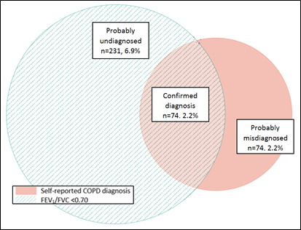
Figure S2: Euler diagram showing proportion of the sample with FEV₁/FVC < 0.70 and self-reported COPD diagnosis.

Table S2: Predictors of probably undiagnosed COPD (versus normal lung function) using fixed cut-off only.
 | OR | 95% CI | p-value
Age  - <60 years (reference)  - 60 – 75 years  - ≥75 years | 1.00  8.42  22.27 | 5.51 – 12.87  13.94 – 35.58 | <0.001  <0.001
Gender, male | 1.90 | 1.38 – 2.61 | <0.001
Ever smoker | 1.34 | 0.98 – 1.82 | 0.06
Chronic cough | 1.80 | 1.07 – 3.02 | 0.03
Chronic phlegm | 0.77 | 0.41 – 1.45 | 0.42
Wheeze | 1.70 | 1.22 – 2.36 | 0.002
SOB | 0.95 | 0.67 – 1.36 | 0.79
BMI <25 kg/m² | 1.65 | 1.19 – 2.30 | 0.003
BMI: body mass index; CI: confidence intervals; OR: odds ratio; SOB: shortness of breath. Bold p-values indicate statistical significance.

Table S3: Predictors of probably misdiagnosed COPD (versus confirmed diagnosis of COPD) using fixed cut-off only.
 | OR | 95% CI | p-value
Age  - <60 years (reference)  - 60 – 75 years  - ≥75 years | 1.00  0.33  0.26 | 0.11 – 0.99  0.07 – 0.90 | 0.05  0.03
Gender, male | 0.29 | 0.11 – 0.77 | 0.01
Ever smoker | 0.33 | 0.10 – 1.11 | 0.07
Chronic cough | 1.31 | 0.47 – 3.65 | 0.61
Chronic phlegm | 0.74 | 0.27 – 2.03 | 0.56
Wheeze | 0.27 | 0.11 – 0.66 | 0.005
SOB | 0.50 | 0.20 – 1.28 | 0.15
BMI <25 kg/m² | 0.30 | 0.12 – 0.77 | 0.01
BMI: body mass index; CI: confidence intervals; OR: odds ratio; SOB: shortness of breath. Bold p-values indicate statistical significance. In addition, we also ran a regression that included never smokers as an additional covariate, however for these 8 participants, this perfectly predicted being in the misdiagnosed group (hence non-convergence of logistic regression when smoking status included).

Table S4: Predictors of probably undiagnosed COPD (versus normal lung function) excluding those with asthma.
 | OR | 95% CI | p-value
Age  - <60 years (reference)  - 60 – 75 years  - ≥75 years | 1.00  2.68  2.50 | 1.75 – 4.08  1.30 – 4.80 | <0.001  0.006
Gender, male | 1.03 | 0.69 – 1.54 | 0.88
Ever smoker | 3.01 | 1.91 – 4.75 | <0.001
Chronic cough | 1.64 | 0.84 – 3.18 | 0.15
Chronic phlegm | 1.36 | 0.68 – 2.72 | 0.39
Wheeze | 3.02 | 1.99 – 4.75 | <0.001
SOB | 2.05 | 1.34 – 3.14 | 0.001
BMI <25 kg/m² | 2.51 | 1.65 – 3.82 | <0.001
BMI: body mass index; CI: confidence intervals; OR: odds ratio; SOB: shortness of breath. Bold p-values indicate statistical significance.

Table S5: Predictors of probably misdiagnosed COPD (versus confirmed diagnosis of COPD) excluding those with asthma.
 | OR | 95% CI | p-value
Age  - <60 years (reference)  - 60 – 75 years  - ≥75 years | 1.00  0.35  0.09 | 0.06 – 2.04  0.01 – 1.19 | 0.24  0.07
Gender, male | 0.10 | 0.02 – 0.78 | 0.006
Chronic cough | 2.33 | 0.40 – 13.38 | 0.34
Chronic phlegm | 0.69 | 0.13 – 3.59 | 0.66
Wheeze | 0.09 | 0.02 – 0.45 | 0.003
SOB | 0.13 | 0.02 – 0.78 | 0.03
BMI <25 kg/m² | 0.25 | 0.02 – 0.51 | 0.006
BMI: body mass index; CI: confidence intervals; OR: odds ratio; SOB: shortness of breath. Bold p-values indicate statistical significance. In addition, we also ran a regression that included never smokers as an additional covariate, however for these 8 participants, this perfectly predicted being in the misdiagnosed group (hence non-convergence of logistic regression when smoking status included).

Figure S3: ROC curve – probably undiagnosed versus normal model (Table 2)
Figure S4: ROC curve – probably misdiagnosed versus confirmed diagnosis model (Table 3)

S2: Definitions of remaining spirometrically defined diagnostic groups.
- FEV₁/FVC <0.70 only: below fixed cut-off. LLN criteria not met and no self-reported COPD diagnosis.
- FEV₁/FVC <LLN only: lower than LLN. Fixed cut-off not met and no self-reported COPD diagnosis.
- FEV₁/FVC <0.70 & self-reported COPD: below fixed cut-off and self-reported COPD diagnosis. LLN criteria not met.
- FEV₁/FVC <LLN & self-reported COPD: lower than LLN and self-reported COPD diagnosis. Fixed cut-off criteria not met.
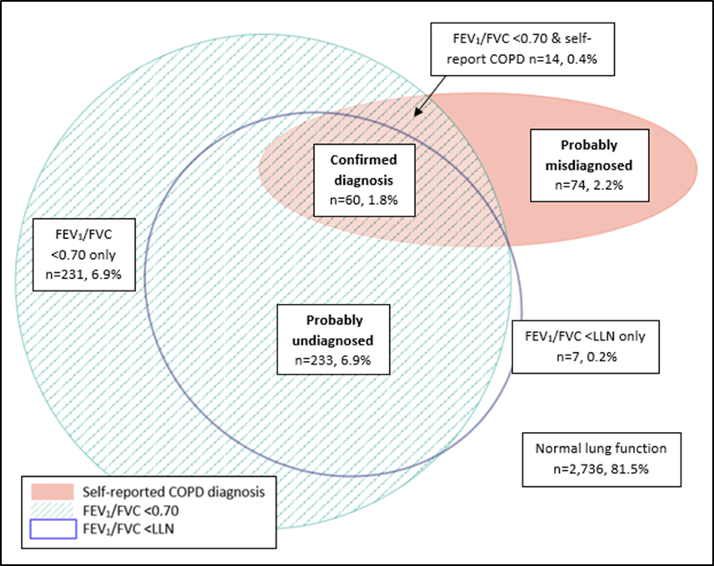
Figure S5: Euler diagram showing proportion of the sample within each spirometrically defined diagnostic group.

Table S6: Participant characteristics of remaining spirometrically defined diagnostic groups and confirmed diagnosis group.
Characteristic | Confirmed diagnosis  (n = 60) | FEV₁/FVC <0.70 only  (n = 231) | FEV₁/FVC <LLN only  (n = 7) | FEV₁/FVC <0.70 &  self-reported COPD  (n = 14)
Mean age, years (SD)  - <60 year  - 60 – 75 years  - ≥75 years | 67.1 (11.0)  15 (25.0)  32 (53.3)  13 (21.7) | 70.9 (9.5)  31 (13.4)  118 (51.1)  82 (35.5) | 43.0 (1.8)  7 (100)  0 (0)  0 (0) | 70.2 (6.7)  1 (7.1)  8 (57.1)  5 (35.7)
Gender, male | 35 (58.3) | 144 (62.3) | 2 (28.6) | 13 (92.9)
Ever smoked | 55 (91.7) | 135 (58.4) | 3 (42.9) | 12 (85.7)
Post-bronchodilator spirometry ª, mean (SD)  - FEV₁, L  - FEV₁, % predicted (GLI)  - FEV₁/FVC (%) | 1.65 (0.7)  60.9 (20.1)  50.8 (10.4) | 2.43 (0.7)  90.5 (16.1)  67.3 (2.1) | 2.63 (0.7)  87.6 (10.9)  70.9 (0.8) | 2.33 (0.7)  79.5 (15.5)  65.8 (1.5)
Respiratory symptoms^{b}  - Chronic cough  - Chronic phlegm  - Wheeze  - SOB | 18 (30.0)  19 (31.7)  47 (78.3)  40 (72.7) | 31 (13.4)  18 (7.8)  83 (35.9)  58 (25.6) | 1 (14.3)  0 (0)  4 (57.1)  2 (28.6) | 3 (21.4)  4 (28.6)  5 (35.7)  5 (38.5)
Using inhaler for a respiratory condition^{c} | 44 (78.6) | 44 (22.5) | 3 (75) | 7 (53.9)
Co-morbidities  - CVD^{d}  - Diabetes  - Asthma | 31 (51.7)  8 (13.3)  28 (46.7) | 120 (52.0)  31 (13.4)  38 (16.5) | 0 (0)  0 (0)  4 (57.1) | 11 (78.6)  3 (21.4)  3 (21.4)
Mean BMIe (kg/m²) (SD) | 26.0 (5.4) | 27.8 (4.9) | 25.8 (3.6) | 30.3 (6.0)
Mean SF-12 component score^{f} (SD)  - PCS  - MCS | 38.4 (12.8)  51.3 (11.4) | 47.5 (9.8)  55.5 (7.2) | 55.9 (2.3)  57.2 (3.7) | 42.5 (14.5)  53.1 (10.2)
Data are presented as n (%), unless stated otherwise. BMI: body mass index; COPD: chronic obstructive pulmonary disease; CVD: cardiovascular disease; FEV₁: forced expiratory volume in one second; FVC: forced vital capacity; GLI: Global Lung Initiative; MCS: mental component score; PCS: physical component score; SEIFA: socio-economic indexes for areas; SF-12: 12-item short-form health survey; SOB: shortness of breath. ª: 3,355 (99.9%) had post-bronchodilator FEV₁ data with pre-bronchodilator only for 1 participant. For this participant pre-bronchodilator measures were used in place of post-bronchodilator. ^{b}: 3,356 (99.9%) responded to questions relating to cough and wheeze and, 3,178 (94.7%) responded to SOB with 179 unable to walk due to reason other than SOB. ^{c}: Of those who took medications, 1,057 responded to the formulation of their medication question which included use of inhaler(s). Assumed all non-responders did not use an inhaler. ^{d}: CVD included heart disease, hypertension and stroke. ^{e}: BMI was calculated in 3,289 (98.0%). ^{f}: PCS and MCS were calculated in 2,811 (83.7%).

Table S7: Further participant characteristics.
Characteristic | Total  (n = 3,357) | Confirmed diagnosis  (n = 60) | Probably undiagnosed  (n = 233) | Probably misdiagnosed  (n = 74)
Occupational exposures (worked 1year or more in a dusty job) | 1,144 (34.1) | 30 (50.0) | 98 (42.1) | 31 (41.9)
Risk of moderate to severe exacerbationª  - Low  - High | 599  646 | 17 (28.3)  17 (28.3) | 47 (20.2)  50 (21.5) | 15 (20.2)  16 (21.6)
SEIFA quintile^{b}  - 1, most disadvantaged  - 2  - 3  - 4  - 5, least disadvantaged | 839 (25.0)  447 (13.3)  1,103 (32.9)  325 (9.7)  641 (19.1) | 21 (35.0)  9 (15.0)  18 (30.0)  2 (3.3)  10 (16.7) | 66 (28.3)  38 (16.3)  76 (32.6)  22 (9.4)  31 (13.3) | 29 (39.2)  12 (16.2)  21 (28.4)  3 (4.1)  9 (12.2)
Rurality^{c}  - Major cities  - Inner regional  - Outer regional  - Remote  - Very remote | 1,141 (34.0)  1,514 (45.1)  162 (4.8)  450 (13.4)  89 (2.7) | 19 (31.7)  27 (45.0)  5 (8.3)  6 (10.0)  3 (5.0) | 65 (27.9)  108 (46.4)  9 (3.9)  39 (16.7)  12 (5.2) | 13 (17.6)  39 (52.7)  5 (6.8)  15 (20.3)  2 (2.7)
Data are presented as n (%), unless stated otherwise. SEIFA: socio-economic indexes for areas. ª: Exacerbation risk assessed according to GOLD 2019 criteria with ‘high’ being at least two presentations (to primary care) with worsening symptoms or at least one episode leading to hospital admission and ‘low’ being a maximum of one presentation (to primary care) with worsening symptoms ²¹. ^{b}: 3,355 (99.9%) could be linked to SEIFA. ^{c}: 3,356 (99.9%) responded to rurality related question(s).

