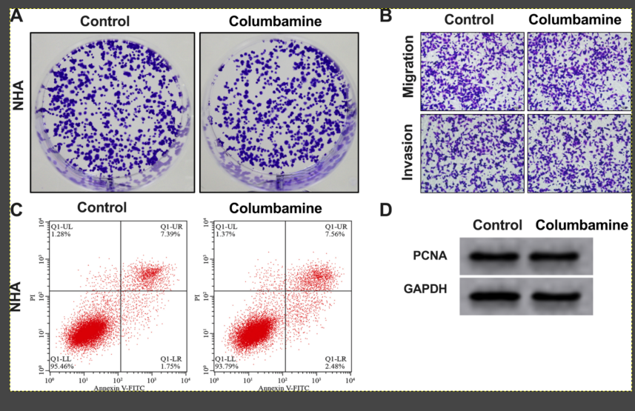

Figure S1 The effect of columbamine on the development of NHA cells. A. The proliferation of NHA cells was detected. B. The migration and invasion ability of NHA cells was detected by transwell. C. The apoptosis level of NHA cells was explored by flow cytometry. D. The protein level of PCNA was detected in NHA cells.

